**Culvert V6.0.1**

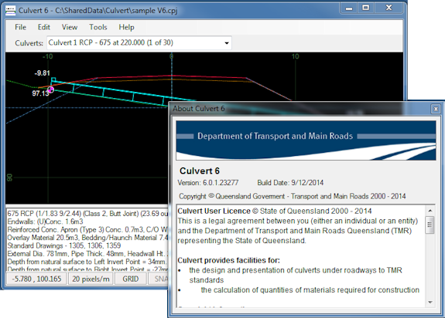

What's new:

**Culvert V6.0**

* Added PRECAST RCP and PRECAST RCBC culvert types supporting TMR Standard drawing number 1243 - Precast Headwalls for RCP and RCBC culverts.
* The graphical editor for culvert has been upgraded.
* Hydraulic calculations are no longer supported, the function has been removed.

Culvert 12d macro V6.0

* The chainage list in the Design tab has been changed to a grid.
* Grids containing the culvert list for a project have been used on the Schedule and Plot Xsect. tabs of the macro to enable the selection of culverts required for output.
* There is a change to model naming in Culvert V6; model names are in the form:

**"Culvert [Alignment String Name] [Chainage]"**

C:\Users\lasilve\AppData\Local\Temp\msohtmlclip1\02\clip_image002.png**Installation and run notes:**

* Uninstall Culvert V5.x. if existing.
* Download, unzip and run the installation file "Culvert 6.msi".
* The default installation path is C:\[Program Files]\TMR\Culvert 6

Start > All Programs



On first run The program initialises the folder 'Culvert 6' in the user Documents folder and creates an empty user defined Culvert specification file, a sample cpj file as well as a dump of the Standard culvert specification file than can be used to reference the current Culvert dimension settings.



**Running the Culvert V6 12d Macro.**

The culvert program runs stand-alone, however it is best used from within 12d Model using the Culvert 12d macro.

With this version of Culvert there is no need to move the Culvert 6 12d macro to 12d UserLib, or set any 12d env variables. The Culvert macro is installed to, and runs from the main Culvert installation folder.

To configure 12d Model to run the Culvert 12d macro, run the main Culvert program using "Start > All Programs > Culvert 6" and then use Tools > Options > 12d usermenu to insert a user menu item to launch the Culvert macro from 12d. (For more information on running the Culvert in 12d Model, search for "12d usermenu" in the Culvert 6 Help file.)

**Main Culvert Program >  Tools > Options > 12d usermenu**

Machine generated alternative text:
Open 
TMR 
TMR 
Vehicle P & h 
speed 
TMR 
Picke 
TMRGub,Pt 
a by 

**Culvert V6 12d Macro launched from within 12d Model**

