Minjerribah (North Stradbroke Island) Public Transport Strategy

2024

The Department of Transport and Main Roads (TMR) respectfully acknowledges the Traditional Owners and Custodians of the land and waterways. We pay respect to their Elders past, present and emerging. TMR recognises those whose ongoing effort to protect and promote Aboriginal and Torres Strait Islander cultures will leave a lasting legacy for future First Nations people.

Copyright Information
© State of Queensland (Department of Transport and Main Roads) 2024. All rights reserved.

Disclaimer: While every care has been taken in preparing this publication, the State of Queensland accepts no responsibility for decisions or actions taken as a result of any data, information, statement or advice, expressed or implied, contained within. To the best of our knowledge, the content was correct at the time of publishing.

The Queensland Government is committed to providing accessible services to Queenslanders of all cultural and linguistic backgrounds. If you have difficulty understanding this publication and need a translator, please call the Translating and Interpreting Service (TIS National) on 13 14 50 and ask them to telephone the Queensland Department of Transport and Main Roads on 13 74 68.
Contents
Introduction 4
Background 4
Purpose 4
Strategy development 5
Context 6
Regional 6
Quandamooka Country 7
Minjerribah Context 7
Minjerribah as a tourist destination 9
Existing Transport Network 11
Existing Services 11
What you told us 12
Public Transport Survey 12
Community Information Sessions 15
Looking to the future for passenger transport 17
Vision 17
Goals 17
Challenges 18
Opportunities 19
Priorities 21
Priority 1: Make it easier to pay fares 21
Priority 2: Improve passenger information 25
Priority 3: Provide quality passenger transport infrastructure 29
Priority 4: Efficient network and services 35
Priority 5: Encourage more people to choose passenger transport for their mobility needs to, from and on Minjerribah 40
Priority 6: Support appropriate private sector passenger transport services and sustainable tourism opportunities 49
Where to from here 53

Introduction

Background
Minjerribah (North Stradbroke Island) is the world’s second largest sand island and is situated in Moreton Bay, within the Redland City Council local government area. The Island’s economy was supported by sand mining, tourism and education for more than 70 years.

As decades of sand mining concluded on 31 December 2019, a pathway has been collectively mapped to transition Minjerribah and its residents and workers towards a thriving, more sustainable economy, with a pristine natural environment. Minjerribah Futures extends the work of the former North Stradbroke Island Economic Transition Strategy and represents the Queensland Government’s significant investment in the transition of the Island to a globally recognised cultural and eco-tourism destination.

The Minjerribah Futures approach is guided by the values and aspirations of the Quandamooka people. These values are articulated in Gudjundabu Marumba Gubiyiyanya (Tourism for a Glad Tomorrow): A five-year strategy for sustainable tourism on Quandamooka Country.

The Minjerribah (North Stradbroke Island) Public Transport Strategy (the Strategy) has been developed in coordination with Minjerribah Futures initiatives. The Strategy supports Minjerribah initiatives including Gudjundabu Marumba Gubiyiyanya (Tourism for a Glad Tomorrow) and other Quandamooka-led strategies such as Jara Marumba Yaga (Make good Country): Quandamooka Country Sustainability Strategy.

Purpose
The purpose of the Strategy is to identify opportunities for improving the public transport network to, from and on Minjerribah. The Strategy provides a broad framework for improving the public transport network and identifies potential detailed investigations required to confirm the viability of improvements.

The Strategy supports Minjerribah Futures objectives by identifying opportunities for improving public transport access for visitors and for those who commute to the mainland for employment. This approach also benefits residents more broadly through improved access to the mainland and around the Island.

The Strategy considers not only the public transport system provided by government but also walk-on and other passenger transport services provided by the private sector for tourists and residents. It identifies elements of the broader passenger transport system that could be enhanced and provides a guide for public transport investment decisions.

Minjerribah’s natural environment and cultural heritage are key attractors for visitors. Improving access to the Island is a vital component of balanced tourism development. Once visitors have arrived, it is just as important they are able to move around the Island to enjoy the breadth of experiences that Minjerribah has to offer.

Promoting public transport to and on the Island will contribute to protecting its natural assets and supporting cultural values. Improvements to on-Island travel will assist visitors without cars and provide better solutions for residents who require public transport.

Strategy development
Stage 1: Current network assessment
Stage 2: Future requirements and service gaps
Stage 3: Options development and assessment
Stage 4: Draft Public Transport Strategy—Public Consultation
Final Public Transport Strategy

Context

Regional
Minjerribah is situated in Moreton Bay, within the Redland City Council local government area. The Island is approximately 40 kilometres south-east of the Brisbane Central Business District (CBD) and the nearest major centre is Cleveland. The location in south-east Queensland provides a significant local tourism market and considerable employment opportunities for Island residents.

Figure 1 shows the regional context of Minjerribah. Toondah Harbour at Cleveland is the mainland gateway to the Island from Brisbane and surrounding areas, with Gumpi (Dunwich) and One Mile ferry terminals the primary entry points on Minjerribah for people and goods. Access from locations such as the Brisbane central business district (CBD), the Brisbane Airport and the Gold Coast are important for Minjerribah as they provide broader tourism market opportunities.

The Strategy considers connectivity between Minjerribah and surrounding centres. It identifies potential options for improving integration between elements of the passenger transport network (such as rail, ferry and bus), as well as opportunities to integrate with other transport modes such as cycling, walking and private vehicles.

Figure 1: Minjerribah regional context
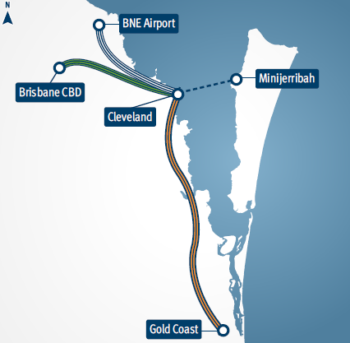

Quandamooka Country
The Quandamooka People have occupied the islands of Moreton Bay, including Minjerribah and mainland adjacent to Moreton Bay, for more than 40,000 years.

The Quandamooka people include the Nunagal, Goenbal and Ngugi People. Quandamooka Country includes the waters and lands around Mulgumpin (Moreton Island), Minjerribah, the Southern Moreton Bay Islands and South Stradbroke Island, as well as areas of the mainland.

On 4 July 2011, the Federal Court of Australia made two native title consent determinations recognising the Quandamooka People’s native title rights and interests over land and waters on and surrounding Minjerribah.

The Quandamooka Yoolooburrabee Aboriginal Corporation (QYAC) is the Registered Native Title Body Corporate created under the Native Title Act 1993 to manage the Native Title rights and interests of the Quandamooka People. QYAC’s vision for Minjerribah is for the Island to be a global eco cultural tourism destination that showcases the Island’s natural beauty and Quandamooka cultural heritage.

The Quandamooka people have an important connection to Minjerribah and are a key partner in the delivery of Minjerribah Futures initiatives.

Minjerribah Context
Minjerribah covers an area of approximately 275 square kilometres, with the Naree Budjong Djara National Park covering approximately half of this area.

The three Island townships of Gumpi, Pulan (Amity Point) and Mulumba (Point Lookout) accommodate the majority of the resident population and are the focus of commercial uses and community facilities. East Coast Road connects Gumpi and Mulumba and supports private vehicles, public transport and bicycle access for tourists and residents.

Demographics
Minjerribah is a unique community with demographic trends that are specific to the Island. Although its resident population is relatively small, the Island experiences significant and variable visitor and tourist numbers, making the delivery of an effective passenger transport network challenging.
Minjerribah had an estimated resident population of 2151 persons as of 30 June 2016. As shown in Table 1, projected population growth on the Island is less than that expected for Queensland overall. The below average population growth
trend is expected to continue in the future with the population on Minjerribah projected to increase by 0.7 per cent per annum on average, to a total of 2489 persons by 2036a.

Table 1: Key demographic statistics for Minjerribah
Description | Minjerribah | Queensland
Resident population at 2016 | 2,151 a | 4,848,877 c
Predicted growth rate | 0.7% a | 1.6% c
Projected population at 2036 | 2,489 a | 6,686,604 c
Median Age | 49.2 b | 37
% population 65 and over | 23.6% b | 14.7%
Aboriginal and/or Torres Strait Islander peoples | 20.2% d | 4% d
% population with internet access | 81.4% e | 83.7%
Median weekly total household income | $1,028 f | $1,402

a Based on Queensland Government Statistician’s Office (2018), Queensland Government population projections, 2018 edition, unpublished data.
b Based on Australian Bureau of Statistics (2018), Estimated Resident Population, Customised Report: Age, by Sex, by all SA1s in Queensland and Tweed Shire, 2011 to 2017, time series spreadsheet, viewed 21 August 2019, http://www.qgso.qld.gov.au/products/tables/erp-age-sex-sa1-qld-consult/index.php.
c Based on Queensland Government Statistician’s Office (2018), Queensland Government population projections, 2018 edition, spreadsheet, viewed 21 August 2019, http://www.qgso.qld.gov.au/subjects/demography/population-projections/tables/proj-pop-age-group-sex-qld/index.php.
d Based on Australian Bureau of Statistics (2017), 2016 Census of Population and Housing, General Community Profile: Table G07 Indigenous Status by Age by Sex, by Place of Usual Residence.
e Based on Australian Bureau of Statistics (2018), 2016 Census of Population and Housing, TableBuilder data: Dwellings, by Dwelling Internet Connection, by Number of Persons Usually Resident in Dwelling.
f Australian Bureau of Statistics (2017), 2016 Census of Population and Housing, General Community Profile: Table G02 Selected Medians and Averages. g Queensland Government (2021). Minjerribah Visitor Research Program: Round 3 Report.

Minjerribah as a tourist destination
Minjerribah is a major tourist destination, with estimated tourist visitation of between 390,000 and 450,000 people in 2019g. The highest levels of visitations occur during peak holiday seasons such as Easter, spring and summer school holiday periods.

Passenger ferry (water taxi) patronage increased by 10.7 per cent in 2019, but declined by 34.1 per cent in 2020 due to COVID-19 travel restrictions. Visitation has been gradually recovering, with 2022 patronage approaching pre-COVID-19 levels.

Passenger transport has an important role to play in connecting attractors on the Island, such as the townships of Gumpi, Pulan and Mulumba—along with associated residential and commercial areas—and popular beaches and tourist attractions.

The majority of attractions on Minjerribah are focused in and around the townships or along East Coast Road, which is serviced by the Minjerribah bus and shuttle service to Pulan. There are also a number of attractions, including camp grounds, Bummiera (Brown Lake) and Karboora (Blue Lake) for which the dominant mode of access is private vehicle and in some cases four-wheel drive vehicles only.

Minjerribah Futures represents the Queensland Government’s investment to support the transition of the Island to a leading cultural and eco-tourism destination, built on a foundation of Quandamooka culture and sustainability.

More than 20 projects across Country, culture and people make up the current Minjerribah Futures program. The Minjerribah Public Transport Strategy aims to support the Island’s economic transition by identifying potential improvements to its public transport system and improving access for residents and visitors.

Key Findings from the Minjerribah Visitor Research Program (part of Minjerribah Futures)

Total visitation for 2019 is estimated at between 390,000 to 450,000 based on ferry patronage, occupancy data and responses to the Visitor Survey.
Visitor numbers grew steadily from 2009 to 2019.
Results indicate a high rate of repeat visits (70%) and show that the majority of visitors came for a holiday (80.5%).
Day trippers made up 38.3% of visitors to the Island. The mean length of stay for overnight visitors was 3.4 nights.
Minjerribah is a popular family destination with 37.7% travelling with family.
Before COVID-19 restrictions, the majority (95%) of visitors were domestic, while a relatively small proportion (4.5%) were international visitors.
The majority of all visitors came from Queensland (91%) with a majority of domestic visitors coming from within a 50km radius of Gumpi
The most common international source markets are Western Europe, the United States of America, New Zealand and the United Kingdom
Peak visitor periods occur during the Easter (March–April), spring (late September/early October) and summer (late December/early January) school holiday periods.

Existing Transport Network

Existing Services
The current transport network servicing Minjerribah has multiple transport modes operating across three parts of the journey:
- Mainland transport connections to Toondah Harbour
- Water based transport to and from the Island
- Transport options around the Island.

Figure 2 shows the transport mode options for each of the three parts of the journey. Toondah Harbour, Gumpi and One Mile ferry terminals are the main gateway between the mainland and Minjerribah.

On the Island, passenger transport is generally focussed on connecting the townships and servicing coastal tourist destinations. The passenger transport network servicing both residents and tourists on the Island includes bus and taxi, with passenger ferries connecting the Island and the mainland.

Mainland services providing connection to Toondah Harbour include both public and privately operated bus services. These services are supported by a broader network, including rail, that connects to Cleveland and provide for interchange opportunities across the region. The passenger transport network of rail, bus, ferry and taxi is supported by a range of dedicated tourist services provided by private operators which offer full-service day trips from the Brisbane CBD through to specialised activities on the Island, such as sandboarding and diving. Many of these tourism services offer the convenience of an integrated transport and tourist product often enabling pick up and drop off from Brisbane CBD at a premium price point.

Figure 2: Modes in current transport network servicing Minjerribah
Mainland transport options | Active transport (walking, cycling)  Passenger transport (bus, train, taxi)  Private transport (cars and motorcycles, for example)
To and from the island | Water-base transport (barge and passenger ferry)
Island transport options | Active transport (walking, cycling)  Passenger transport (bus, taxi)  Private transport (car and motorcycles, for example)

What you told us
The Strategy has been informed by community and stakeholder input captured through a series of community engagement activities and events, including a public transport survey and community information sessions.

Public Transport Survey
A Public Transport Survey was undertaken by the Department of Transport and Main Roads (TMR) to support development of the Strategy. The survey identified existing transport patterns to, from and on the Island and the transport needs of visitors and residents.

Carried out in April and May of 2018, the survey sought visitor,
resident and business input on what aspects of the passenger transport network are working well and where there are areas for improvement.

Survey respondents
The survey received a high response rate with a total of 726 responses. A majority of survey responses were from residents (53 per cent) followed by visitors to the Island (35 per cent) as shown in Figure 3.

The majority of residents who responded to the survey live in Mulumba, followed by 24 per cent living in Pulan and 23 per
cent living in Gumpi.

Survey responses indicate the preferred transport mode for residents is private vehicle, with 85 per cent undertaking the mainland portion of their trip in a private vehicle and 92 per cent using a private vehicle on Minjerribah. This suggests use of the bus services on the Island and the mainland are not highly used by residents. It also suggests a primary function of bus services is catering for tourist demand, which is consistent with the seasonal variations observed in the Minjerribah bus service data.

Of the 35 per cent of survey responses provided by visitors to Minjerribah, 91 per cent were domestic visitors travelling for leisure, recreation or tourism purposes and 9 per cent were domestic visitors travelling to the Island for work or business. Only one respondent identified as an international visitor. A majority of visitors came from the Redlands and Brisbane regions, as shown in Figure 4.

Similar to residents, almost all visitors travelled by private vehicle to Toondah Harbour (91 per cent). However this figure drops on Minjerribah to 70 per cent, with more people using the bus service to get around the Island.

Figure 3: Breakdown of survey respondents
Description | Percentage
Full-time resident | 36%
Occasional resident (e.g. holiday home owner) | 14%
Local resident & business operator 3 | 3%
Local business operator & mainland resident | 1%
Visitor (AUS) for work/business | 3%
Visitor (AUS) for recreation/tourism | 32%
Overseas visitor | 0%
Skipped | 1%
Other | 9%
Source: Public Transport Survey, 2018

Figure 4: Visitor origin on mainland
Location | Percentage
Brisbane CBD | 11%
Elsewhere in the Brisbane Region | 25%
Cleveland/Nandeebie | 25%
Elsewhere in the Redlands Region | 21%
Morton Bay Region | 8%
Sunshine Coast Region | 1%
Gold Coast Region | 4%
Logan Region | 3%
Ipswich Region | 2%
Interstate | 0%
Other | 0%
Source: Public Transport Survey, 2018

Views on the passenger transport system
Of those that responded to the survey, 86 per cent provided their views on the current passenger transport network servicing the Island by rating their level of agreement or disagreement with statements about key network features.

As shown in Figure 5, respondents tended to agree the Island’s public transport services are usually on time and that ferry terminals are easy to access.

Respondents showed less agreement that purchasing fares across different transport modes is easy and that services are generally affordable.

Survey respondents were also asked to identify their top three priorities for improving the passenger transport network servicing Minjerribah, with 89 per cent of respondents providing a response.

The most frequently identified priority areas were:
- Better integration of fares and ticketing across different passenger transport modes
- Greater span of passenger transport services across the day and night
- More affordable passenger transport services.

Figure 5: Survey respondent views on public transport system
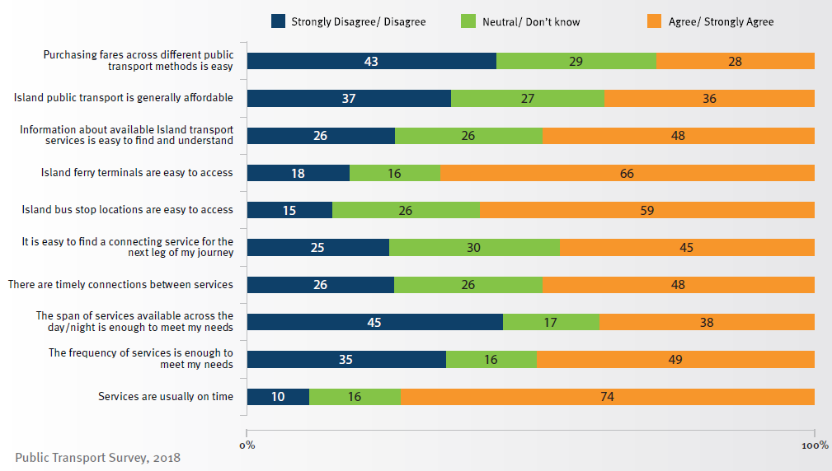

Priority areas for improvement and the percentage of respondents who identified those areas are provided in Figure 6.

Figure 6: Priorities for improving the passenger transport system
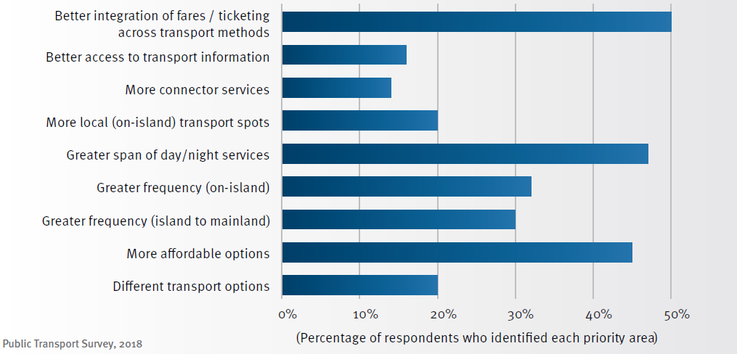

Community Information Sessions
Three community information sessions were held on Minjerribah, at Pulan, Gumpi and Mulumba on 12 and 13 July 2018. The sessions provided a forum for the project team to share information about the scope of the study and results from the Public Transport Survey while discussing community input on the challenges identified and potential solutions.

Key points raised
The sessions provided further information on challenges for the passenger transport system and identified a number of potential areas for improvement such as:
- Better integration of fares and ticketing across different public transport modes
- A ticketing system to make ticketing more efficient, speed up the boarding process and improve reliability of the services
- Better integration of scheduling across different transport modes
- More information and flexibility around journey management for residents and visitors alike
- Greater span of public transport services across the day and night, primarily for residents, but with a view to increasing access to the Cleveland CBD for residents, and to Minjerribah for those wishing to attend events
- Improved connectivity between local towns, venues and attractions
- Affordable group transport options to and from the Island
- Parking at ferry terminals on the mainland and Minjerribah.

Improved connections to Pulan was also suggested at the Pulan session, where a number of participants expressed a desire for improved service to provide an alternative to private vehicles and attract tourists to the township.

A particular focus at the Mulumba and Gumpi sessions was concern about the affordability of the vehicle barge and a perceived lack of competition. While the Strategy focusses on walk-on passenger transport services (rather than vehicular services), concerns about affordable access to the Island have been considered in its preparation.

Another concern is the impact from potential significant growth in people accessing the Island by private vehicles and maritime vessels. This concern will need to be addressed through investigations outside the Strategy.

A future bridge connecting the Island to the mainland was raised, with community members expressing divided views. Delivery of a bridge connection to Minjerribah is not currently being considered and is not in keeping with protecting and promoting the Island’s unique and sensitive ecological and cultural features.
Community and visitor feedback has been used to inform the Vision, Goals and Priorities for passenger transport discussed in the next section, along with potential actions identified to improve the Minjerribah passenger transport system.

Looking to the future for passenger transport

Vision
Passenger transport enhances Minjerribah as a tourism destination of choice in SEQ for local, national and international visitors, and supports mobility of the resident population.

Goals

Enhance customer experience
Passenger transport to, from and on Minjerribah will provide a travel experience that is safe, comfortable and user-friendly. The passenger transport system will be tailored to respond to the needs of both residents and visitors with respect to passenger information, payment options and customer service.

Provide an efficient network and services
The network supporting passenger transport services to, from and on Minjerribah will be an efficient multi-modal network, which is legible, well integrated, and services key destinations for both residents and visitors. Services are reliable and provide for integration at key terminals on Minjerribah and the mainland.

Support connected communities
Passenger transport to, from and on Minjerribah provides access to key tourist destinations while addressing the need for residents to access employment and services. The network and services are responsive to the land use pattern on the Island, efficiently and reliably connecting the Island’s communities, key tourist destinations and the mainland.

Technology and innovation
Fit-for-purpose responses to passenger transport challenges and opportunities will be encouraged. Innovative approaches to the provision of passenger transport will be facilitated to ensure they contribute to the Vision for passenger transport on Minjerribah and respond to community need.

Challenges
The geographical location of Minjerribah, mix of resident and tourist demands, number of transport modes and service providers, and need to interchange between services, are key challenges for the Island’s passenger transport network. However, this also presents opportunities for improvements to certain aspects of the passenger transport system.

Fare payment and ticketing
The fare payment and ticketing systems vary across the passenger transport modes, potentially resulting in confusion for visitors who are not familiar with the passenger transport system.

The Public Transport Survey undertaken by TMR identified that passengers expect integrated payment options when transferring from one service to another. The separate fare payment and ticketing systems for each leg of the transport journey can impact on the efficiency of services and customer experience, particularly for the bus services during peak periods.

Integration between modes
The passenger transport network to, from and on Minjerribah consists of a range of modes and a three-part journey (mainland, water crossing and Island transport) requiring interchange between modes and services provided by both public and private operators. Coordinating services to enable seamless interchanging is a challenge for this multi-component network of services.

Cash-only payments for Minjerribah bus services can result in long boarding times during busy periods, and potentially result in late-running services. In turn, this can result in delayed ferry departure times, due to the need to wait for passengers traveling to terminals by bus, or else result in passengers missing ferry services all together.

Familiarity with the transport network
There is a mix of public and private services that make up the passenger transport network to, from and on Minjerribah. This presents a challenge when undertaking trips to the Island, particularly for visitors who are not familiar with the passenger transport network and do not know where to find relevant, up-to-date information. A lack of familiarity with the transport network can potentially result in long waiting times for those arriving early at stops or missed services for those arriving late. Translink’s journey planning app and website have been updated to incorporate and support trips to, from and on Minjerribah.

Reliable services
Reliable services are essential in encouraging people to use passenger transport. However, challenges relating to peak period demand, payment of fares and integration between modes can impact on service reliability and coordination.

Fluctuating demand
The number of residents, workers and visitors using passenger transport services to, from and on Minjerribah is variable and influenced by a range of seasonal factors, including holidays, events and good weather. Passenger boarding data indicates that use of the passenger ferries is less susceptible to seasonal demands than bus patronage on Minjerribah. However, variation in demand presents a challenge for all modes in providing a timetable that provides enough certainty to passengers while allowing flexibility to accommodate fluctuations in demand and patronage.

Fit for purpose facilities
Safe, comfortable and fit-for-purpose facilities can enhance user experience and encourage travel by passenger transport. For example, well-lit terminals and stops with appropriate seating and shelter can enhance the feeling of safety and comfort, while bicycle storage facilities and raised platforms can enhance access to services for those who cannot drive and those with mobility impairments respectively.

Given the range of passenger transport modes and facilities, providing fit-for-purpose facilities which support tourism goals for the Island would require significant investment. Variations in passenger demand (depending on time of year and weather conditions) and the need to coordinate with potentially changing future land uses present challenges to the provision of fit-for-purpose facilities which provide value for money and justify significant investment.

Opportunities
The nature of the current passenger transport network servicing Minjerribah presents opportunities for value-for-money enhancements, which have the potential to make significant positive impacts. Other Minjerribah Futures initiatives, such as the Gumpi Master Plan, also provide opportunities for the future of passenger transport on the Island.

Increased visitor numbers outside of peak periods
The focus on increasing visitor numbers outside of peak periods presents an opportunity to encourage more visitors to use passenger transport and promote sustainable year-round patronage of passenger transport services.
Increased passenger volumes outside peak periods would support further investment in planning and delivery of improvements to the passenger transport network, which benefits both visitors and residents.

Investment in eco-tourism
The focus and planned investment in eco-tourism is consistent with increasing the use of the passenger transport network. Passenger transport services provide a sustainable alternative to the use of private vehicles by visitors and residents and have the capacity to move visitors more sustainably than private vehicles.

Private tourism operator investment in zero or low-emission services (such as through electric buses and ferries) could help protect Minjerribah’s natural environment and would be consistent with a focus on eco-tourism.

Reinforcing gateways on mainland and Minjerribah
Toondah Harbour and Gumpi represent the gateways to Minjerribah from a transport perspective. There is an opportunity to support these locations as gateways, gain network efficiencies and enhance customer experience, through the provision of quality passenger transport facilities and services at these locations.

Growth in the education and training sector
Minjerribah Futures identifies growth in the education and training sector on Minjerribah as a way of diversifying the Island’s economy. While still seasonal due to academic term times, growth in the education and training sector presents an opportunity to increase passenger transport demand during off-peak periods, and is less variable and susceptible to peak seasonal demands of tourism.

Led by QYAC, the old secondary school campus in Gumpi has been transformed into the Minjerribah education, employment and training centre known as Minjerribah Ganaba (Place to Hear, Think and Understand). Passenger transport will play an important role in supporting this and other education and training opportunities.

Zero and low-emission ferries
The first hybrid (diesel-electric) passenger/vehicular ferry service commenced in Scotland in 2013. Since then, Scandinavia has led the world in the implementation of electric ferry services, with the first all-electric service commencing in Norway in 2015. Electric ferries offer a range of benefits over existing diesel-powered vessels, including significantly less CO2 emission, less noise and lower operating costs.

Priorities
Six priorities have been identified to support the Vision and Goals for the future of passenger transport to, from and on Minjerribah.

These priorities have been informed by the challenges and opportunities identified and in response to feedback from the community and key stakeholders.

Each priority identifies objectives, along with potential further investigations required to achieve the objectives.

Priorities
Priority 1 Make it easier to pay fares
Priority 2 Improve passenger information
Priority 3 Provide quality passenger transport infrastructure
Priority 4 Efficient network and services
Priority 5 Encourage more people to choose passenger transport for their mobility needs, to, from and on Minjerribah
Priority 6 Support appropriate private sector passenger transport services and sustainable tourism opportunities

Priority 1: Make it easier to pay fares
Improvements to ticketing and the integration of fares across the mainland, water-crossing and Island services was the most requested and discussed item throughout community engagement activities. Integration of fares and ticketing across transport modes was identified by 50 per cent of survey respondents as one of their top three priorities.

Making it easier for passengers to pay fares will significantly improve customer experience. Easier payment of fares will also have positive impacts on the efficiency and reliability of the bus service on Minjerribah and provide a consistent experience for passengers.

Priority 1 supports:
Goal 1: Customer experience
Goal 2: Efficient network and services
Goal 4: Technology and innovation
Queensland Tourism and Transport Strategy
• Theme 3: Ticketing and products
Transport Coordination Plan 2017–2027
• Customer experience and affordability key area
• Efficiency and productivity key area
Minjerribah Futures Tourism initiative—Enhance the visitor experience

Objective 1.1: Customers are provided with an increased range of payment options on passenger transport services

Additional payment options was the element most frequently raised by the community in engagement activities. The cash-only arrangement on the Minjerribah bus service was a particular issue and did not align with passenger expectations with regard to payment options. It may also have resulted in negative experiences of the Island as a tourist destination for day visitors, should they not been able to board their desired connecting bus due to not having cash. The cash only payment for bus fares also impacted the reliability of the bus timetable due to the impacts on boarding times.

'An integrated ticketing system would be great. The cash for public bus holds up the bus services and the bus drivers.'

Introducing a variety of payment methods on the bus service in particular is anticipated to significantly decrease boarding times and improve customer experience.

'Electronic ticketing/passes will speed up bus services as biggest delay at peak times is boarding and paying fares.'

Smart Ticketing presents a significant opportunity to increase the range of payment options available to passengers using the bus and train services to travel to, from and on Minjerribah. The project provides a medium term solution delivering increased choice of payment options available to passengers.

Smart Ticketing
The Queensland Government allocated $371.1 million in June 2018 to design, develop, build and implement a new ticketing solution for all of Queensland’s urban public transport networks.

Minjerribah’s public transport network will be included in the system rollout.

The solution will allow all public transport customers to use, in addition to existing go cards and paper tickets, their contactless debit or credit cards, smart phones and smart watches to pay for trips.

Customers will also benefit from an improved digital experience, including an integrated payment and ticketing, and are already benefiting from journey planning app and website, with precise real time information.

The project has finalised detailed planning, with design and development commencing in 2018. Trialing of elements of Smart Ticketing commenced on Minjerribah in 2019.

Objective 1.2: Ticketing is integrated across passenger transport modes through an easy to use platform

Currently, separate fares and payment methods exist across the three components of the passenger transport journey (mainland connections, water crossing and Island services). The separation of fares is likely to be more accepted by passengers should there be integration of ticketing and payment options with greater choice in how passengers can pay for a ticket.

As private services, the fare and payment system for the passenger ferries is not regulated by the state government and is not part of the TransLink network. The Smart Ticketing project provides an opportunity in the medium to long terms to enable third party services run by private operators, such as the passenger ferries, to be paid for using a customer’s choice of payment method.

Working with ferry operators to investigate opportunities for customers to pay for the passenger ferry using their choice of payment method presents an opportunity for a seamless transfer, without the need to pay for fares separately.

Objective 1.3: Ticketing products are tourist friendly
The Queensland Tourism and Transport Strategy is focused on improving ticketing products and enabling tailored tourist tickets to be developed, which make it easier for visitors to travel on passenger transport in Queensland. There is an opportunity in the medium to long term to develop a tourist ticket that makes it easier for visitors to travel on passenger transport to, from and on Minjerribah. This ticket could be tailored to Minjerribah visitors or part of a broader South-East Queensland tourist ticket.

Challenges
- Inconsistent mobile coverage on the Island limits implementation and use of smart devices and apps to assist journey planning and wayfinding
- Integrating payment options across public and privately operated passenger transport services.

Opportunities
- Capitalising on improvements made to the system as part of the Smart Ticketing project
- Addressing on-time running challenges by increasing payment options available to passengers.

Opal Pay
Sydney has an extensive ferry and water taxi network provided by both subsidised public transport and private operators. Ferry routes and water taxis operated privately are subject to an independent fare structure separate to the Opal ticketing system (the equivalent of a TransLink go card).

In January 2018 ‘OpalPay’ was rolled out on three of the private ferry routes in Sydney operated by SeaLink and Captain Cook Cruises to Manly, Watsons Bay and Lane Cove (including the Manly Fast Ferry). ‘OpalPay’ is the first extension of the
NSW public transport ticketing system to the private sector. Passengers now have the option to purchase the private ferry operators fare using the available balance on their Opal card by tapping on at the point-of-sale device on board.

This offers a single form of payment and no cash or other payment type is required which offers an increased level of convenience for passengers. However, the agreement does not provide customers with integrated ticketing or incorporate ‘best fare’ arrangements into transfers between modes and relevant incentive schemes and discounts do not apply.

Actions:
Action | Description | Proposed  Lead | Proposed  Partners | Indicative  Timeframe
1.1 | Implement a variety of payment methods on current bus and train services through the Smart Ticketing project. | TMR | Bus and train  operators | Short to  medium
1.2 | Investigate opportunities to integrate passenger ferry payment options with the Translink network. | TMR | Ferry operators | Medium
1.3 | Tourism operators to work with TMR to develop a tourist ticket or product that includes access to passenger transport services (e.g. bus and ferry) to, from and on Minjerribah. | Tourism  operators | TMR  DTS | Medium

Priority 2: Improve passenger information

A key element of the passenger experience is the quality of information provided to assist passengers in:
- making the choice to travel by passenger transport especially when for certain components of a trip there are cost and time competitive alternatives
- undertaking their journey
- finding their destination easily.

Improved passenger information can enhance customer experience by making it easier for passengers to plan their journey and tailor their trip on passenger transport services. Use of online platforms and applications can enable alignment with existing journey planner tools and maximise the opportunity for innovation.

Priority 2 supports:
Goal 1: Customer experience
Goal 4: Technology and innovation

Queensland Tourism and Transport Strategy
• Theme 1: Visitor information

Transport Coordination Plan 2017–2027
• Customer experience and affordability key area

Minjerribah Futures Tourism initiative—Enhance the visitor experience

Objective 2.1: Journey planning and passenger information is readily available, easy to use, consistent and reliable.
Information about passenger transport to, from and on Minjerribah is currently available across a number of different websites and platforms. This has been highlighted by passengers as a challenge when planning their journey.

'Information, communicated clearly and well in advance, is necessary at all points.'

Minjerribah’s transport network has been incorporated into Translink’s Journey Planner. There is an opportunity to build on Translink’s Journey Planner, for a better customer outcome.

'For tourists it’s very difficult to go to one site for information on how to travel to North Stradbroke Island [Minjerribah]...'

Providing a centralised, consistent and reliable source of information about all passenger transport services to, from and on Minjerribah will help to improve awareness of available services, and share information about timetables, fares, payment options and service updates.

'Easier to access timetable information online and at stops (particularly for bus)'.

Journey planning tools such as stop timetables, online journey planning and real-time updates on services contribute to making it easier for passengers to figure out how they can get to where they need to go.

Objective 2.2: Wayfinding tools, such as signage, clearly show passengers where and how they can access passenger transport services

Improved wayfinding on Minjerribah is identified in Minjerribah Futures as key to enhancing the visitor experience. The passenger transport information signage on Minjerribah lacks consistency, with limited information provided at ferry terminals and bus stops. Information is not readily accessible to passengers, which can impact on visitors in particular who are not familiar with the Island.

The provision of wayfinding signage at ferry terminals was raised during community consultation as a way to assist visitors who are unfamiliar with the Island. It was suggested improved wayfinding signage at ferry terminals and signage directing visitors to the Gumpi centre would help visitors to access goods and services and spend more time in Gumpi.

Providing wayfinding tools, such as signage, will support passengers in accessing passenger transport services on the Island, and knowing where they can access goods and services and how to get there. Strategies for enhancing residents and visitors’ experience through improved wayfinding have been considered as part of the Gumpi Master Plan.

Queensland Tourism and Transport Strategy
'Understanding the local public transport network is the most significant challenge for visitors. The fare structure and ticketing system can be confusing, information difficult to access and often not in their native language.'
Tourism and Transport Forum

Challenges
- Inconsistent mobile coverage on the Island limits implementation and use of smart devices and apps to assist journey planning and wayfinding
- Sharing and coordination of service data across different systems, such as TransLink, Qconnect and privately-run services.

Opportunities
- Link to movement, connectivity and wayfinding strategies and transport projects in the Gumpi Master Plan.
- Continue to share data with private sector web developers to encourage development of new journey planning platforms and applications, providing the opportunity to provide information on public and private sector transport services in a combined journey planning platform
- The Smart Ticketing project provides the platform for the future potential enhancement of digital wayfinding and real-time passenger information systems
- Reinforce Gumpi as the gateway to Minjerribah through wayfinding tools.

Actions:
Action | Description | Proposed  Lead | Proposed  Partners | Indicative  Timeframe
2.1 | Provide mainland transport, passenger ferry and Minjerribah bus information on one journey planning platform, as part of the Smart Ticketing solution, to enable end-to-end trip planning. | TMR | Service  operators | Completed
2.2 | Work with partner agencies to develop a signage strategy which includes wayfinding and passenger information signage at various locations, supports cultural diversity and enhances accessibility for languages other than English. Wayfinding and passenger information will be considered at:  • Cleveland Train Station and Cleveland CBD bus stops  • Bus stops and ferry terminals at Toondah Harbour  • Ferry terminals on Minjerribah  • Bus stops on Minjerribah  • Mulumba, Pulan and Gumpi. | TMR | RCC  QR  DSDI  QYAC | Medium
2.3 | Investigate the feasibility of rolling out stop-specific timetables for all  bus stops on Minjerribah. | TMR | Bus operator | Completed
2.4 | Continue to share public transport timetable information with third-parties,  to facilitate development of integrated journey planners that  may also include private tourist services. | TMR | Service  operators | Medium
2.5 | Implement real-time information on Minjerribah bus services to  support journey planning. | TMR | Service  operators | Completed
2.6 | Investigate the feasibility of including the Minjerribah bus service in  the South East Queensland TransLink zones system. | TMR |  | Medium

Priority 3: Provide quality passenger transport infrastructure

The passenger experience is influenced by the quality of passenger transport facilities. Investigations aimed at improving the passenger transport network should consider the quality of existing facilities (particularly in terms of safety) as well as the effectiveness of their current location.

While they accommodate the current service arrangement, bus stops on the Island could be improved through better passenger information, facilities such as seating, and in some cases, disability access requirements.

The quality of current bus stops was also raised during community consultation as an area for improvement. It was noted that many bus stops had no shade or protection from the elements, which made them unpleasant to wait at.

Similarly, ferry terminals could be improved through better wayfinding and other passenger information that would make journeys easier, particularly for visitors. There is an opportunity to make a strong entrance statement through improvements to Toondah Harbour and Minjerribah ferry terminals and thereby enhance visitor experience. The Gumpi Master Plan represents an opportunity to explore ferry terminal upgrades on Minjerribah.

Active transport (walking and cycling) and parking facilities can also play a role in supporting passenger transport. While development of a broad and comprehensive approach to active transport and parking facilities on the Island is not included in the Strategy, the need for further investigation of potential opportunities at key locations is acknowledged.

Priority 3 Supports:
Goal 1: Customer experience
Goal 2: Efficient network and services
Goal 3: Connected communities

Queensland Tourism and Transport Strategy
• Theme 2: Transport services

Transport Coordination Plan 2017–2027
• Customer experience and affordability key area
• Efficiency and productivity key area

Minjerribah Futures Tourism initiative—Enhance the visitor experience

Objective 3.1: Passenger transport facilities are provided as part of a coordinated network that meets passenger needs
Establishing a clear network of passenger transport facilities, with a consistent approach to features such as seating, shade and passenger information, can improve the legibility of the passenger transport network and enhance customer experience. A clear network and hierarchy of facilities will also guide investment to ensure that available funding for upgrades delivers value for money.

Objective 3.2: Bus access to key locations and ferry terminals is prioritised, seamless and safe
Current access to ferry terminals and some bus stops on Minjerribah and at Toondah Harbour is difficult for buses and other passenger transport options such as taxis and ride share.

The configuration of certain bus stops, particularly the bus stop in the SeaLink terminal at Toondah Harbour, presents safety and service efficiency challenges. This can make it difficult for bus operators to safely exit and enter the flow of traffic and
impact upon the safe and efficient boarding of passengers.

Mainland and island ferry terminals should have clear access routes for buses to access the bus stops at these locations. Currently, access for bus services conflicts with parking and drop off zones for private vehicles. This makes it difficult for buses to enter and exit the ferry terminals safely, to pick up and drop off passengers.

Objective 3.3: Improved access to key passenger transport facilities by walking or cycling
Infrastructure upgrades in proximity to key locations (such as ferry terminals) can support passenger transport. Enabling people to use active transport (walking and cycling) to get to and from bus stops and ferry terminals is an important element of building an effective passenger transport system, and ensuring that passenger transport services are accessible for all.

Providing clear pathways and connections to ferry terminals and bus stops can improve access by walking and cycling, encouraging a shift away from private vehicles. Improvements to the pedestrian and cyclist environment in proximity to ferry terminals and key bus stops can make passenger transport services accessible to more people (including those unable to drive) and reduce the need for people to use a private vehicle.

'Encourage walking. Plant more shade trees.'

Improved lighting at ferry terminals and key bus stops can significantly improve the real and perceived safety and security of these areas, improving the customer experience. There is lighting available at the ferry terminals and some bus stops on the network. However, a number of bus stops do not have lighting and the pedestrian routes to the ferry terminals and bus stops are not well lit, resulting in potential tripping hazards and safety concerns.

Gumpi Master Plan
The Gumpi Master Plan identifies key movement pathways through and around the township. This presents an opportunity for access to the ferry terminals to be considered and reviewed as well as stronger connections to the town centre to be established, providing for better integration of land use and transport.

Objective 3.4: Parking at ferry terminals is fit for purpose and sustainable
The focus of the Strategy is to promote and improve passenger transport to, from and on Minjerribah. When considered as part of a suite of access opportunities, the provision of car parking at passenger transport facilities is an important consideration. Car parking at Toondah Harbour and the ferry terminals at One Mile and Gumpi provide access to the passenger ferries and also interface with the movement of buses, cyclists and pedestrians in these locations.

Parking at ferry terminals was consistently highlighted as an issue through the Public Transport Survey and community information sessions. Feedback from some in the community highlights that parking at the ferry terminals at Toondah Harbour, Gumpi and One Mile is not meeting the needs of those that drive. This is reflected in some of the feedback provided in the Public Transport Survey quoted below.

'More access to public parking at ferry and barge terminals, in particular One Mile ferry.'

'It would be great to see provision for long term and short term parking.'

Addressing the challenges with car parking at Toondah Harbour, One Mile and Gumpi ferry terminals needs to be considered to ensure the needs of residents and visitors (both short and long stay) are balanced against the provision of strong active and public transport links. A parking solution that provides for sustainable long term
management of private vehicles, responds to various parking needs (long term, short term) and does not impose upon or preclude access by buses, cyclists or pedestrians is required.

'People leave cars for weeks at a time in 24 hr turn around spots and travellers who travel everyday park miles away with no lighting at night for people to walk to their cars, very unsafe.'

Weinam Creek Car-Share Scheme
Following a successful six-month trial, Redland City Council has commenced the Weinam Creek Car-Share Scheme. The scheme allocates 8 parking spaces in close proximity to the ferry terminal and includes a lease agreement for Bay Island Car Share to conduct their car-share business within the parking spaces. The Redlands Coast Transport Strategy identifies car-share as having the potential to reduce demand for parking and private vehicle ownership, and increase the turnover and effective supply of parking.

Challenges
- Balancing needs of private vehicle users against passenger transport and active transport users
- Achieving compliance with the Disability Discrimination Act and Disability Standards for Accessible Public Transport
- Significant works required to address some accessibility issues.

Opportunities
- Promote sustainable transport options that are compatible with the Island’s ecological and cultural values, such as buses, taxis, cycling and walking
- Identify key passenger transport and active transport movement corridors as part of the Gumpi Master Plan
- Potential to provide passenger transport facilities tailored to Minjerribah with specific branding
- Upgrades to bus and ferry fleet to focus on customer experience, such as luggage racks and on-board information.

Actions:
Action | Description | Proposed  Lead | Proposed  Partners | Indicative  Timeframe
3.1 | As part of the Gumpi Master Plan, consider parking facilities and identify opportunities for improved access to ferry terminals by walking, cycling, buses and taxis, including appropriate longer-term bicycle storage locations at Gumpi and One Mile ferry terminals. | DSDILGP | TMR  RCC | Completed
3.2 | Review Minjerribah bus stops to improve operations of the bus service and customer experience. | TMR | RCC | Short
3.3 | Investigate appropriate locations for bicycle storage (such as bike racks) at Toondah Harbour. | RCC | TMR  DSDI  Ferry operators | Short
3.4 | Consider the need for interim bicycle storage (such as bike racks) at Gumpi and One Mile ferry terminals, until a more permanent bike storage solution is provided. | RCC | Ferry  operators | Short
3.5 | Review parking facilities including safety, access and availability and develop in partnership with key stakeholders a parking policy position for transport facilities such as at Toondah Harbour. | RCC | TMR | Medium to  long
3.6 | Consider interim opportunities to enhance access to ferry terminals and bus stops for pedestrians and bike riders, including consideration of improved lighting along key pedestrian routes to enhance safety and security. | RCC | TMR | Medium
3.7 | Consider opportunities to enhance safe and efficient access to Toondah Harbour ferry terminals for buses, taxis, pedestrians and cyclists. | RCC | TMR  Ferry operators | Medium to  long
3.8 | Review the fleet type provided by the Minjerribah bus system to ensure that any replacement vehicles meet the unique requirements of tourists and residents, including carriage of tourist luggage, provision of tourist information and improved driver and passenger safety systems. | TMR | Bus operator | Medium

Priority 4: Efficient network and services
An efficient passenger transport network makes the best use of the timetabled services and available facilities. Efficient services are reliable and have clear routes and stopping patterns, providing a level of certainty to passengers.

Minjerribah is serviced by a multi-modal network with multiple journey components. As a result, reliable services are essential in ensuring integration between modes and journey components.

Priority 4 Supports:
Goal 1: Customer experience
Goal 2: Efficient network and services

Queensland Tourism and Transport Strategy
• Theme 2: Transport services

Transport Coordination Plan 2017–2027
• Customer experience and affordability key area
• Efficiency and productivity key area

Objective 4.1: A passenger transport network with clear and consistent services and routes
A network of services that are easy to use and have clear, consistent routes is important for both visitors and residents to have confidence in the reliability of passenger transport services.

Providing certainty to passengers by having defined routes and clear stopping patterns (such as set stops) promotes confidence in the network and may encourage more people to use passenger transport.

Visitors to Minjerribah can potentially benefit from the simple and direct nature of the passenger ferries and bus services on the Island, as it makes an unfamiliar location easier to navigate. This can be further improved by having clear and consistent stops that are well located and connected to key attractions.

Objective 4.2: Sustainable response to variable demand
A challenge in providing efficient services to, from and on Minjerribah is the highly variable nature of passenger numbers, which is influenced by school holidays, events and good weather. While the capacity and frequency of services provided cater for demand most of the time, significant increases in demand for passenger transport (particularly for bus services) during peak periods can be difficult to manage and service efficiently.

One of the long-term goals for tourism on Minjerribah is to spread visitor trips more evenly throughout the year so that peaks are less pronounced. This will provide more consistent demand for passenger transport services and make it easier to provide a sustainable transport network. However, recognition of the different levels of demand within and outside of peak times will still be needed.

Objective 4.3: Services are well integrated across passenger transport modes
Connections between the different modes (bus, passenger ferry and rail) are crucial in the Minjerribah passenger transport network. Passengers expect to be able to make the journey from the mainland to their Island destination, and vice versa, seamlessly and without missing connections.

Responses to the Public Transport Survey highlighted the importance of integrated services, with many regularly undertaking journeys with three or more interchanges.

Gumpi as Gateway to Minjerribah
Minjerribah Futures recognises potential opportunities for Gumpi as the gateway to Minjerribah. These could include opportunities to develop the local economy, enhance tourism, culture, education, research and service business opportunities.

Reinforcing Gumpi as the primary entry point to Minjerribah is an important element in providing a clear entrance statement, especially for visitors. The ferry terminals at Gumpi (Junner Street) and One Mile (Yabby Street) do not present a clear entrance statement to Minjerribah, which is considered a missed opportunity.

The geographic separation of the ferry terminals at Toondah Harbour and more significantly at Gumpi and One Mile can result in confusion for passengers, impacting on the efficiency of the Minjerribah bus service.

Consolidating passenger ferry services at Gumpi is a potential option for addressing these issues.

Currently these connections, when running to timetable, work well. However, delay in a timetabled service can disrupt the connections and result in a lack of integration. This is particularly prevalent in peak times where the time required to board a higher number of passengers can impact on the on-time running of services, particularly the bus service on Minjerribah. The hourly frequency across services to, from and on Minjerribah also mean there is a long wait time if a connection is missed, as evidenced by feedback provided in the Public Transport Survey.

'Simple clockface timetabling and fare integration using a go card both to and on the Island would make it much easier to use…I don’t believe any infrastructure change is needed, just ticketing, fares, timetables, and information.'

The physical integration of services, such as the bus and ferry on both mainland terminals, is also important. Clear pathways and wayfinding to assist passengers in locating where they need to go is important to meet connections and ensure an integrated journey.

The operation of two ferry terminals in close proximity (at Gumpi and One Mile) has an impact on the efficiency of the Island’s bus service, with two stops required to load and drop off passengers connecting with the ferry services. The challenges associated with access to the bus stops, particularly at One Mile, exacerbate these efficiency impacts. A combined terminal for the passenger ferry services would address efficiency impacts and provide a clear gateway to Minjerribah as well as reducing confusion for passengers who are not aware of which service goes to which ferry terminal.

Objective 4.4: Services that are reliable
Reliability of service is vital to a quality passenger transport system. Passengers expect that services are punctual and that journey times are consistent. This is particularly important in the Minjerribah passenger transport network due to the multiple connections required to undertake a full journey using passenger transport, as discussed above. Late-running of services can have major impacts on the ability of passengers to meet their connecting services.

There are a number of factors slowing the boarding process, which make it difficult for the bus timetable to be achieved in peak times. These factors include:
- payment options for tickets
- loading of luggage
- questions from visitors about stops and attractions.

To offset this and maximise reliability, there are a number of potential solutions across the following areas:
- increased payment options
- buses with luggage storage areas that are easy to access and use
- improved passenger information.

Challenges
- Responding to variation in demand for passenger transport services across peak and non-peak times
- Achieving seamless integration across a number of interchanges.

Opportunities
- A clear and consistent network will benefit journey planning activities and focus investment in infrastructure
- Potential to increase awareness of bus stop locations
- Better use of existing services and infrastructure
- Improvements to fares and ticketing will result in improvements to service efficiency.

Seasonal timetable
There are examples of the variability of demand impacting the reliability of services in peak times. A seasonal timetable can address some of the on-time running challenges by providing a more realistic timetable in peak times. Development of a seasonal timetable would need to reflect the increased travel time on the Minjerribah bus route during peak times. This would reduce pressure on the bus operator with regard to on-time running and provide greater certainty to passengers regarding the travel time at peak times.

Actions:
Action | Description | Proposed  Lead | Proposed  Partners | Indicative  Timeframe
4.1 | As part of any future network review of the Minjerribah bus service, identify key timing points on bus routes to support management of bus service performance. | TMR | RCC | Short to  medium
4.2 | Consider changes to public transport demand as part of regular reviews of the Minjerribah bus service, including:  - Investigating the feasibility of seasonal timetables that account for increases in patronage and changes in travel time during periods of high demand  - Maintaining an appropriate level of service during non-peak periods. | TMR | Bus operator | Short
4.3 | As part of the Gumpi Master Plan, consider community feedback for:  - The Gumpi (Junner Street) ferry terminal to function as a single integrated facility for all regular passenger ferry  - The One Mile (Yabby Street) terminal being retained for use by recreational users, Volunteer Marine Rescue Stradbroke Island and emergency services. | DSDILGP |  | Completed
4.4 | Develop concept designs for an upgraded Gumpi (Junner Street) ferry terminal including a new pontoon, shelters and improved landscape and arrivals area. | TMR | Australian  Government  RCC | Medium

SEQ City Deal
The South East Queensland (SEQ) City Deal represents the Australian Government, Queensland Government and Council of Mayors’ (SEQ) commitment to delivering enhanced investment and generating long-lasting benefits for the community of SEQ. Key objectives of the SEQ City Deal include accelerating future jobs across SEQ, delivering a faster, more connected SEQ region, a more liveable SEQ and creating thriving communities.
The SEQ City Deal outlines 31 commitments, including a $41 million investment toward upgrade of the Gumpi (Junner Street) Ferry Terminal. The Australian Government, Queensland Government and Redland City Council will upgrade the Ferry Terminal at Gumpi (Junner Street) to include a new pontoon, shelters, retail and commercial premises, improved landscape and arrivals area. The upgraded infrastructure and services will improve connectivity and promote tourism to the Island. The SEQ City Deal was signed on 21 March 2022.

Priority 5: Encourage more people to choose passenger transport for their mobility needs to, from and on Minjerribah
Encouraging more people to use the passenger transport system to get to, from and on Minjerribah will contribute to more sustainable use of transport infrastructure. This aligns with the shared goal for the Island’s future identified in Minjerribah Futures: to make Minjerribah Australia’s most accessible and sustainable island community.

Encouraging a mode shift to passenger transport modes such as buses, passenger ferries and taxis provides an opportunity to move more people more sustainably and reduce the use of private vehicles.

Important elements in encouraging more people to use passenger transport more often are reliable services that offer flexibility and get people where they need to go.

With a low base demand for passenger transport on Minjerribah, there is an opportunity for alternative delivery models to be explored which provide flexible services that reach outside of the current route along East Coast Road.

Priority 5 supports:
Goal 2: Efficient network and services
Goal 3: Connected communities
Goal 4: Technology and Innovation
Queensland Tourism and Transport Strategy
• Theme 2: Transport services
Transport Coordination Plan 2017–2027
• Customer experience and affordability key area
• Efficiency and productivity key area

Objective 5.1: Increase flexibility in services
The passenger transport task to, from and on Minjerribah is highly variable and influenced by school holidays, events and weather. While the capacity and frequency of services provided cater for demand most of the time, there is limited flexibility in the current fixed timetable to provide for the significant variation in patronage and the high demand for access to the Island in peak times.
An extended span of hours (i.e. earlier and later services) was raised consistently throughout the stakeholder engagement activities as a desired outcome for the future passenger transport network.

'Make the buses later in the evening and start earlier (at least on business days.'

Extension of the bus network to meet all passenger ferry services would provide additional morning and evening services. Further investigation would be required to confirm demand for new services and would need to be informed by detailed patronage data and understanding of driver and vehicle utilisation.

The current passenger transport system on Minjerribah is consistent with a traditional service delivery model. However, the seasonal fluctuations in demand, as well as the requirement to address the needs of residents and tourists, suggest an opportunity for alternative delivery models that could support the passenger vision and goals.

Connections to Pulan
Increased frequency of bus services to Pulan was raised consistently in the community information sessions and Public Transport Survey. The Pulan service currently experiences low patronage as could be expected by the low residential population. However, feedback from the community has been that the low frequency of the bus service is seen as a barrier to people using the service regularly, and for tourists wanting to access Pulan.

'I work my trips around the existing bus and ferry times. Any later services leaving/to Amity [Pulan] would be appreciated.'

Increased frequency of bus services to Pulan would require additional investment on a route that is currently recording very low patronage. Despite this, the opportunities for increased patronage, improved transport offerings for visitors to access attractions at Pulan and the potential for reduced parking at the passenger ferry terminals at Gumpi and One Mile are considered significant enough to explore improved services further in the medium term.

Further investigation would be required to confirm demand for improved services and will need to be informed by detailed patronage data and understanding of driver and vehicle utilisation.

'More frequent access to Amity [Pulan] via bus or boat.'

Objective 5.2: Extend the coverage of passenger transport services
Respondents to the Public Transport Survey listed improved access to Pulan and other residential areas as gaps in the bus network on the Island. Reliable access to mainland attractors – particularly health and education – was also highlighted.

'On-island transport needs: Bus connections from Tramican Street, Cumming Parade and George Nothing Drive at Point Lookout [Mulumba]... Possibly also from Rainbow Crescent, Illawong Drive and other streets in Dunwich [Gumpi]. More connections to Amity Point [Pulan] from Dunwich [Gumpi] and Point Lookout [Mulumba]'

'...a shuttle bus service...to link up with the bus service that runs between Point Lookout [Mulumba] and Dunwich [Gumpi].'

The current bus network on the Island provides consistent access from Gumpi to Mulumba, with bus services focussed on connecting visitors with attractions at Mulumba. Visitor attractions and accommodation located along the East Coast Road corridor are well serviced by the current bus route. However, there are a number of attractions that are not accessible by public transport, including Bummiera (Brown Lake) and Karboora (Blue Lake).

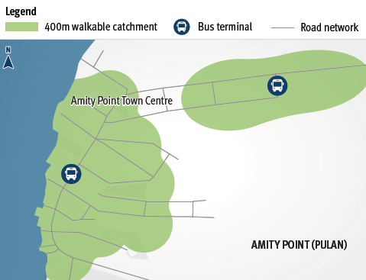
Walkable catchment areas: Pulan bus service

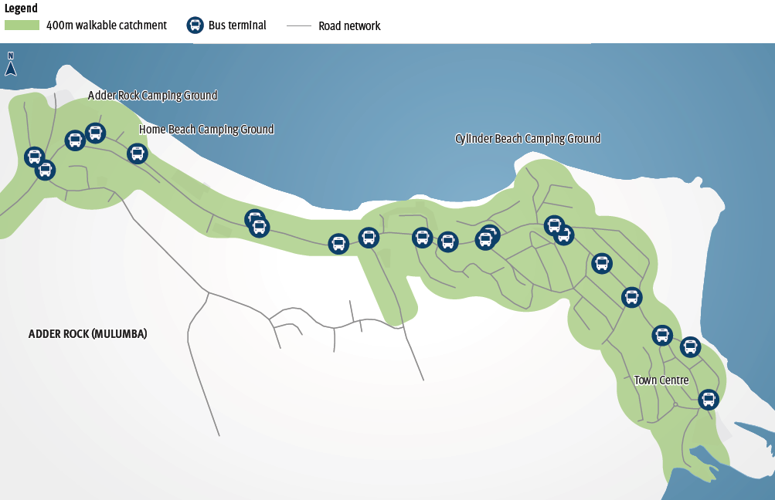
Walkable catchment areas: Mulumba bus service

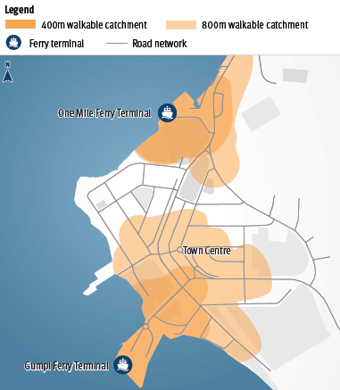
Walkable catchment areas: Gumpi and One Mile ferry terminals

Walkable catchment areas: Gumpi and One Mile bus service
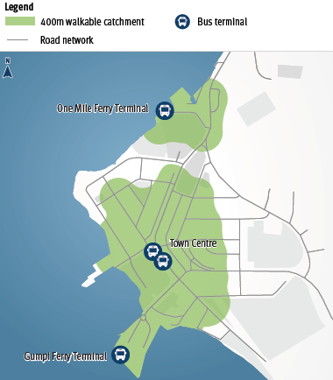
For residents, the coverage of the current bus route does not extend to all residential areas of Gumpi and Mulumba. As a result of the topography in these areas, the walk to the nearest bus stop can be seen as unattractive and a barrier to using the bus by some residents. It is considered that more flexible passenger transport services, such as Demand Responsive Transport, may provide future opportunities.

'In the holidays, there could be a little shuttle bus that circulates around Point Lookout [Mulumba] on an hourly basis maybe.'

Providing ‘last mile’ transport connections to enable people to access the Minjerribah bus and/or passenger ferry terminals without a private vehicle is key to encouraging improved passenger transport mode share and reducing the parking challenges at the ferry terminals.

While community feedback indicates there is a desire to facilitate new service delivery models in the short term, a medium to long term need for the Minjerribah passenger transport system is to consider and leverage future mobility solutions. This could include the concept of mobility management and accessing a range of mobility services through a single platform such as Mobility as a Service (MaaS).

Mobility as a Service (MaaS)
TMR is exploring the concept of MaaS, which reduces reliance on personal cars by offering more integrated mobility solutions. MaaS is the combination of public and private transportation services accessed via an application which provides personalised journey planning, booking and payment. The european island communities of Arran and Orkney in Scotland, Madeira in Portugal, Crete in Greece, Gran Canaria in the Canary Islands and Elba in Italy are among the first locations for trials of MaaS. While the population and number of tourists attracted to these areas varies compared to Minjerribah, they share a number of characteristics including:
- High seasonal demand
- Disparate origins and few concentrated destinations
- Low overall use of public transport
- Correspondingly large use of private vehicles
- Fragmentation of information, marketing, accessibility and cooperation.

MaaS in a tourist island setting could help to encourage sustainable transport modes (such as public transport, e-mobility and ride-sharing) and add to the attractiveness, sustainability and accessibility of the island for visitors.

Challenges
- Low patronage and low base demand for services
- Different needs across passenger groups such as visitors and residents.

Opportunities
- Increased span of hours and improved passenger transport catchments can encourage mode shift to passenger transport and improve mobility outcomes
- Explore additional options for transporting visitors to Minjerribah including new service offerings and non-traditional passenger transport services.

Actions:
Action | Description | Proposed  Lead | Proposed  Partners | Indicative  Timeframe
5.1 | Explore the opportunity for more flexible passenger transport options to increase sustainable mobility options for residents and visitors to Pulan. | TMR | Bus operator | Medium
5.2 | Investigate the feasibility of additional bus services that connect with earlier ferries, and later services from Gumpi/One Mile. | TMR |  | Medium
5.3 | Investigate opportunities to enhance access to:  public transport services, using active transport urban areas not currently serviced, using flexible transport. | RCC  TMR | Private sector | Short to medium
5.4 | Undertake a human-centred design workshop with Minjerribah stakeholders to understand travel needs from a customer perspective and look to inform a possible MaaS proof-of-concept that could be tested. | TMR |  | Short to medium
5.5 | Investigate opportunities to improve active transport and passenger transport connections between Toondah Harbour and the Cleveland CBD, based on growth and demand. | RCC (active  transport)  TMR  (passenger  transport) |  | Medium

Priority 6: Support appropriate private sector passenger transport services and sustainable tourism opportunities
The Queensland Tourism and Transport Strategy recognises that public and private partnerships with a commercial focus can be key to achieving desirable transport outcomes.

Minjerribah is already supported by private sector investment in passenger transport, with both passenger ferries and the vehicle barge being privately owned and operated. There is currently no Government regulation over the passenger ferry crossing.

There is also a wide range of integrated transport and tourism products available that make use of the passenger ferry or vehicle barge marine infrastructure on Minjerribah, such as privately-operated Island tours which include transport to, from and around the Island as part of their package.

Efficiently servicing both the Island’s low base-demand for passenger transport services and peak-period visitor demand is a key challenge for the passenger transport network. However, there is potential for additional private-sector passenger transport services to cater for demands that cannot be efficiently met by the existing network.

There is significant opportunity for improvements to passenger transport to, from and on Minjerribah to be led by the private sector with guidance and support from the state government where required.

For example, in July 2019, the Queensland Government announced it would partner with Australian Jet Boats Pty Ltd in a $2.1 million project to build 4 new jet boats, to be used to enhance visitor access to Moreton Bay.

The new jet boats have been used to provide a privately run tour between central Brisbane and tourist destinations in Moreton Bay, including Minjerribah. The first of four locally-built boats was launched in February 2020.

There is also a wide range of integrated transport and tourism products available that
make use of the passenger ferry or vehicle barge marine infrastructure on Minjerribah.

Priority 6 supports:
Goal 1: Enhance customer experience
Goal 2: Efficient network and services
Goal 3: Connected communities
Goal 4: Technology and innovation
Queensland Tourism and Transport Strategy
• Theme 2: Transport services
• Theme 4: Planning and investment
Transport Coordination Plan 2017–2027

Objective 6.1: Support appropriate private sector investment in tourism-focused passenger transport services
The state government is supportive of leveraging private sector investment and innovation to develop a sustainable passenger transport network and achieve good economic and social outcomes.

A number of factors and opportunities suggest the private sector is well placed to invest in tourism-focussed passenger transport services.

With no government regulation over the passenger ferry crossing, there are opportunities for private operators to establish new service offerings from a range of mainland destinations, such as Brisbane or the Gold Coast.

'Allow Quandamooka Coast and other island tours to grow, particularly the international market on week days (low season) supporting year round stability in economy.'

This could involve, for example, private entities developing tourist packages which include marine transport between popular tourist locations on the mainland (such as Raby Bay and the Gold Coast) and Minjerribah. This could enhance the appeal of Minjerribah for visitors by making the marine journey a focus of the visitor experience.

Challenges
- Responding to variation in demand for passenger transport services across peak and non-peak times
- Low patronage and low base demand for services
- Different needs across passenger groups (resident and visitor).

Opportunities
In developing the Strategy a number of potential connections for visitors between Minjerribah and the mainland were identified. These connections are not currently appropriate for the State to provide but may be feasible for delivery by the private sector. Suggested connections are shown in Figure 7.

Figure 7: Potential private sector tourist connections to Minjerribah
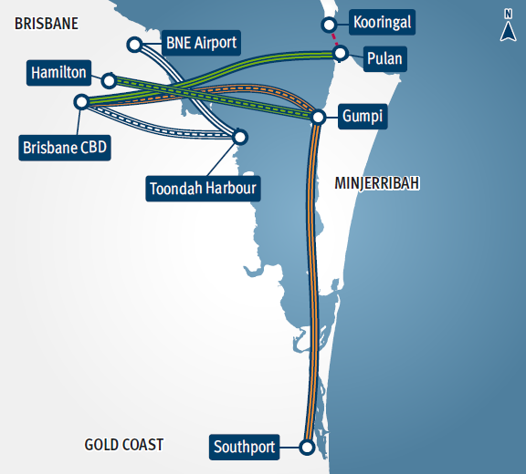

Actions:
Action | Description | Proposed  Lead | Proposed  Partners | Indicative  Timeframe
6.1 | Promote the opportunity for private sector delivery of new or refreshed transport connections that align with community, cultural, and environmental values to, from and on Minjerribah for tourists and visitors. | DTS | RCC  QYAC  TMR | Short to medium
6.2 | Explore use of zero and low-emission vehicle fleets such as electric bus and ferries. | Private operator | TMR  DTS | Medium to long

Where to from here
This Strategy identifies a range of priority improvements to Minjerribah’s passenger transport network, along with objectives and potential further investigations aimed at achieving these priority improvements.

The priority improvements aim to support Minjerribah Futures by supporting better access to, from and on Minjerribah for visitors and residents. In addition, these priority improvements support a more sustainable transport system, which is compatible with the Island’s ecological and cultural values.

The Queensland Government will continue to work with key partners and collaborate with industry to determine further short term investigations and explore innovative ways to deliver on the medium and long term opportunities.

Image credits
Front cover | Deadmans Beach, Tourism and Events Queensland.

Acronyms
CBD | Central Business District
DSDI | Department of State Development and Infrastructure
DSDILGP | The former Department of State Development, Infrastructure, Local Government and Planning (to December 2023)
DTS | Department of Tourism and Sport
MaaS | Mobility as a Service
QGSO | Queensland Government Statistician’s Office
QYAC | Quandamooka Yoolooburrabee Aboriginal Corporation
RCC | Redland City Council
SCoC | Straddie Chamber of Commerce
TMR | Department of Transport and Main Roads

