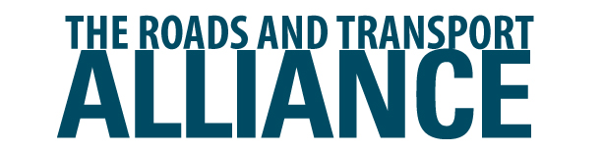

Statewide Capability Development Fund (SCDF)

Project Completion Report

This template is to be used by local government and RRTGs for approved projects funded through the TIDS SCDF to:
- Summarise key project details, including timing, cost and outcomes
- Show the extent to which the project has contributed to program objectives (capability and capacity building)
Note: this report is not required for training courses/workshops funded through the SCDF.

RRTG details
RRTG details
RRTG/s
Local Government/s

Principal contact person
First name |  | Last name
Position title |  | Phone
Email

Project details / outcomes
Project details
Project (title)
Project key deliverables and outcomes – please summarise:

Project dates
Estimated Project Start Date | dd/mm/yyyy | Actual Project Start Date | dd/mm/yyyy
Estimated Project Completion Date | dd/mm/yyyy | Actual Project Completion Date | dd/mm/yyyy

Project budget
Original / Estimated |  | Final / Actual
SCDF component | $ | SCDF claimed | $
Co-contribution | $ | Co-contribution | $
Other funding (if any) | $ | Other funding (if any) | $
Total project budget | $ | Total project cost | $
If the final Total Project Cost at time of completion is over or under the original estimate, please provide an explanation for the variance.

Project learnings
How did this project improve/ increase capability and capacity across the core functions?

How did this project benefit your region?

How will you transfer learnings across your region?

Detail key outcomes and outputs delivered by this project - e.g. innovative practice/material use; collaboration/resource sharing/joint purchase

Were there any learnings/challenges associated with this project?

Please email/submit this report to your Roads and Transport Alliance Project Team representative or to roads.alliance.communications@tmr.qld.gov.au upon project completion.

