Structure Id |  |  |  |  |  |  |  | Name
8086
Crossing Name |  |  |  |  |  |  |  | Alt. Name
Smothering Creek
Structure Type |  |  |  |  |  |  |  | Owner
Bridge |  |  |  |  |  |  |  | TMR Department of Transport and Main Roads
Construction Type |  |  |  |  |  |  |  | District
Girder/Beam |  |  |  |  |  |  |  | 12 - Wide Bay District
Construction Material |  |  |  |  |  |  |  | LGA Id
Timber |  |  |  |  |  |  |  | 228 - Fraser Coast Regional Council
Inspector |  |  |  |  |  |  |  | Date
Evan T Matthews |  |  |  |  |  |  |  | 18/05/2015
Inspection |  | Level 2 |  |  | Programmed
 |  | Level 3 |  |  | Exceptional |  |  |  |  |  | Underwater
Road Section |  |  |  |  |  |  |  | Start |  | End |  |  | TDist
Id | Description |  | S | Cway |  |  | S | RPC | Dist | RPC |  | Dist | Start | End
487 | BROOWEENA - WO |  | C | 1 |  |  | C | 4 | 0.000 | 4 |  | 0.018 | 28.151 | 28.169

Structure Id |  | Name |  |  |  | Inspection date |  |  | Inspection Level
8086 |  |  |  |  |  | 18/05/2016 |  |  | 2 | 3 | Programmed | Exceptional |  |  |  | Underwater
Film/Exposure No. | Sketch No. |  | Location |  |  |  |  | Description of Defects  - Deck Surface (full width and alignment)  - Side View (waterway, spans, piers, etc)  - Underside (deck and pier construction)  - Deficient Component and Major Defects  - Undefined Elements |  |  |  |  |  |  |  |  | Id
 |  |  | Modification |  | Group | Component
1 |  |  | O |  | AP1 | AP |  | Surface on CH |  |  |  |  |  |  |  |  | 319632
2 |  |  | O |  | S1 | W |  | Sideview LHS D/S |  |  |  |  |  |  |  |  | 319633
3 |  |  | O |  | AP1 | GR |  | Not connected or to standards |  |  |  |  |  |  |  |  | 319635
4 |  |  | O |  | AP1 | AP |  | Settlement to 30mm & bleeding |  |  |  |  |  |  |  |  | 319639
5 |  |  | O |  | S1 | WS |  | WS cracking due to loose deck planks |  |  |  |  |  |  |  |  | 319640
6 |  |  | O |  | S3 | WS |  | WS cracking due to loose deck planks |  |  |  |  |  |  |  |  | 319641
7 |  |  | O |  | AP2 | AP |  | Settlement to 40mm & bleeding |  |  |  |  |  |  |  |  | 319642
8 |  |  | O |  | S1 | D |  | Rotten end LHS over G1 |  |  |  |  |  |  |  |  | 319643
9 |  |  | O |  | S1 | D |  | Rotten end RHS over G5 |  |  |  |  |  |  |  |  | 319645
10 |  |  | O |  | P1 | P1 |  | Spliced to current standard |  |  |  |  |  |  |  |  | 319646
11 |  |  | O |  | S1 | G1 |  | Band fitted to splice E2 |  |  |  |  |  |  |  |  | 319647
12 |  |  | O |  | P1 | P4 |  | Band fitted to cracking top |  |  |  |  |  |  |  |  | 319649
13 |  |  | O |  | P1 | COR4 |  | Band & gan nail fitted E1 |  |  |  |  |  |  |  |  | 319652
14 |  |  | O |  | P1 | H1 |  | Band & end cap fitted E1 |  |  |  |  |  |  |  |  | 319653
15 |  |  | O |  | A1 | P1 |  | WP1 53% consumed at top |  |  |  |  |  |  |  |  | 319655
16 |  |  | O |  | A2 | P1 |  | WP1 59% consumed at top |  |  |  |  |  |  |  |  | 319657
17 |  |  | O |  | A2 | P2 |  | WP2 Consumed & burnt at top |  |  |  |  |  |  |  |  | 319658

 | Structure Id | Name |  |  | Inspection date |  |  | Inspection Level
 | 8086 |  |  |  | 18/05/2016 |  |  | 2 | 3 | Programmed | Exceptional |  |  |  | Underwater
Pictures
** All images printed for this report
Field |  |  | Data |  |  |  | Image
Id |  |  | 319632 |  |  |  | 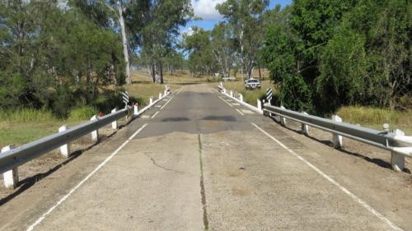
Date |  |  | 42508
Film/Exposure No. |  |  | 1
Sketch No.
Description |  |  | Surface on CH
Mod |  |  | O
Category |  |  | AP
Number |  |  | 1
Comp code |  |  | AP
Comp No
Id |  |  | 319633 |  |  |  | 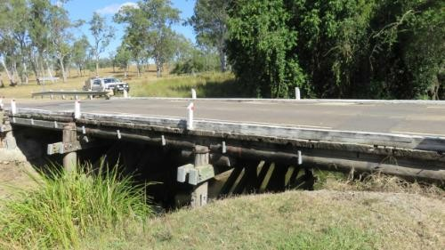
Date |  |  | 42508
Film/Exposure No. |  |  | 2
Sketch No.
Description |  |  | Sideview LHS D/S
Mod |  |  | O
Category |  |  | S
Number |  |  | 1
Comp code |  |  | W
Comp No
Id |  |  | 319635 |  |  |  | 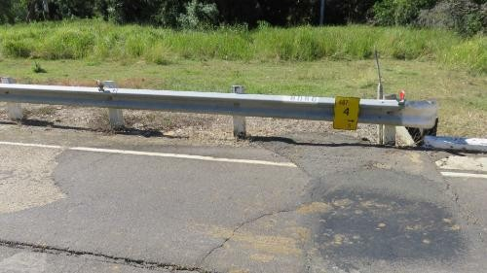
Date |  |  | 42508
Film/Exposure No. |  |  | 3
Sketch No.
Description |  |  | Not connected or to standards
Mod |  |  | O
Category |  |  | AP
Number |  |  | 1
Comp code |  |  | GR
Comp No
Id |  |  | 319639 |  |  |  | 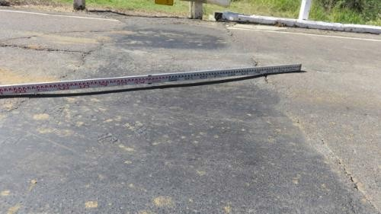
Date |  |  | 42508
Film/Exposure No. |  |  | 4
Sketch No.
Description |  |  | Settlement to 30mm & bleeding
Mod |  |  | O
Category |  |  | AP
Number |  |  | 1
Comp code |  |  | AP
Comp No
Id |  |  | 319640 |  |  |  | 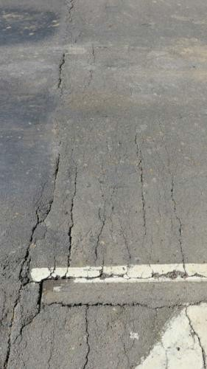
Date |  |  | 42508
Film/Exposure No. |  |  | 5
Sketch No.
Description |  |  | WS cracking due to loose deck planks
Mod |  |  | O
Category |  |  | S
Number |  |  | 1
Comp code |  |  | WS
Comp No
Id |  |  | 319641 |  |  |  | 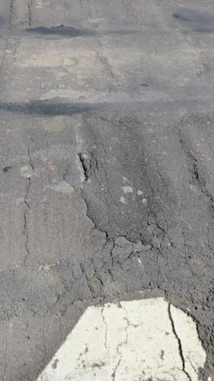
Date |  |  | 42508
Film/Exposure No. |  |  | 6
Sketch No.
Description |  |  | WS cracking due to loose deck planks
Mod |  |  | O
Category |  |  | S
Number |  |  | 3
Comp code |  |  | WS
Comp No
Id |  |  | 319642 |  |  |  | 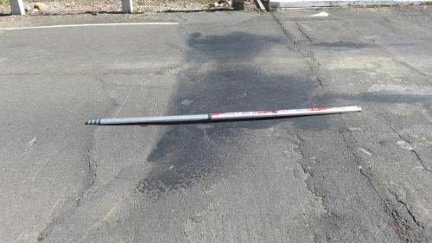
Date |  |  | 42508
Film/Exposure No. |  |  | 7
Sketch No.
Description |  |  | Settlement to 40mm & bleeding
Mod |  |  | O
Category |  |  | AP
Number |  |  | 2
Comp code |  |  | AP
Comp No
Id |  |  | 319643 |  |  |  | 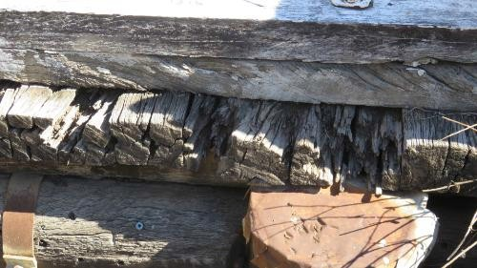
Date |  |  | 42508
Film/Exposure No. |  |  | 8
Sketch No.
Description |  |  | Rotten end LHS over G1
Mod |  |  | O
Category |  |  | S
Number |  |  | 1
Comp code |  |  | D
Comp No
Id |  |  | 319645 |  |  |  | 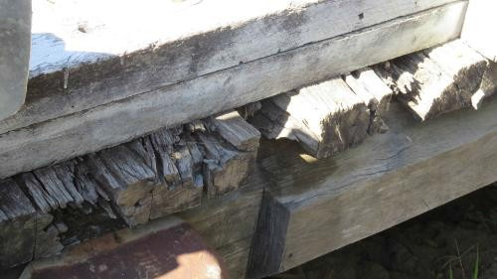
Date |  |  | 42508
Film/Exposure No. |  |  | 9
Sketch No.
Description |  |  | Rotten end RHS over G5
Mod |  |  | O
Category |  |  | S
Number |  |  | 1
Comp code |  |  | D
Comp No
Id |  |  | 319646 |  |  |  | 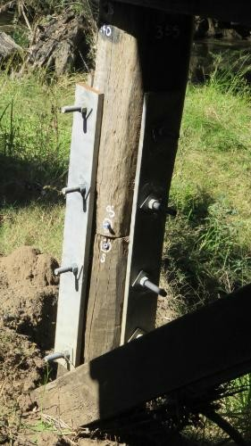
Date |  |  | 42508
Film/Exposure No. |  |  | 10
Sketch No.
Description |  |  | Spliced to current standard
Mod |  |  | O
Category |  |  | P
Number |  |  | 1
Comp code |  |  | P1
Comp No
Id |  |  | 319647 |  |  |  | 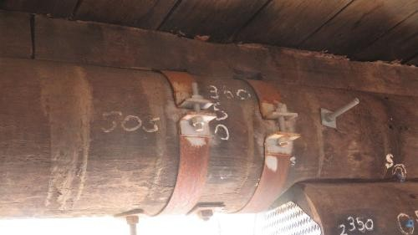
Date |  |  | 42508
Film/Exposure No. |  |  | 11
Sketch No.
Description |  |  | Band fitted to splice E2
Mod |  |  | O
Category |  |  | S
Number |  |  | 1
Comp code |  |  | G1
Comp No
Id |  |  | 319649 |  |  |  | 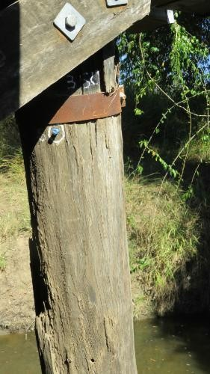
Date |  |  | 42508
Film/Exposure No. |  |  | 12
Sketch No.
Description |  |  | Band fitted to cracking top
Mod |  |  | O
Category |  |  | P
Number |  |  | 1
Comp code |  |  | P4
Comp No
Id |  |  | 319652 |  |  |  | 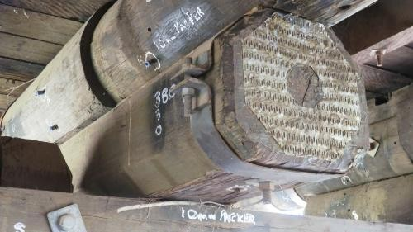
Date |  |  | 42508
Film/Exposure No. |  |  | 13
Sketch No.
Description |  |  | Band & gan nail fitted E1
Mod |  |  | O
Category |  |  | P
Number |  |  | 1
Comp code |  |  | COR4
Comp No
Id |  |  | 319653 |  |  |  | 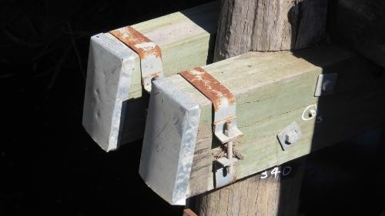
Date |  |  | 42508
Film/Exposure No. |  |  | 14
Sketch No.
Description |  |  | Band & end cap fitted E1
Mod |  |  | O
Category |  |  | P
Number |  |  | 1
Comp code |  |  | H1
Comp No
Id |  |  | 319655 |  |  |  | 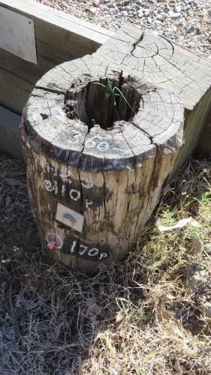
Date |  |  | 42508
Film/Exposure No. |  |  | 15
Sketch No.
Description |  |  | WP1 53% consumed at top
Mod |  |  | O
Category |  |  | A
Number |  |  | 1
Comp code |  |  | P1
Comp No
Id |  |  | 319657 |  |  |  | 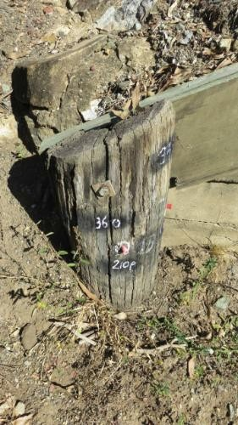
Date |  |  | 42508
Film/Exposure No. |  |  | 16
Sketch No.
Description |  |  | WP1 59% consumed at top
Mod |  |  | O
Category |  |  | A
Number |  |  | 2
Comp code |  |  | P1
Comp No
Id |  |  | 319658 |  |  |  | 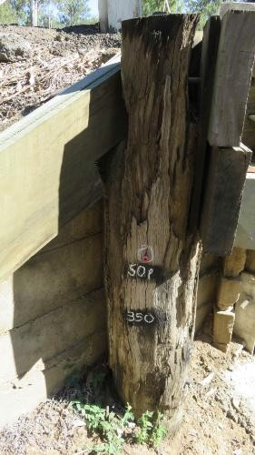
Date |  |  | 42508
Film/Exposure No. |  |  | 17
Sketch No.
Description |  |  | WP2 Consumed & burnt at top
Mod |  |  | O
Category |  |  | A
Number |  |  | 2
Comp code |  |  | P2
Comp No

