Job Number @ Type here

Functional Specification Template

C7521 – Infrastructure Sustainability Requirements Options Analysis / Preliminary Evaluation Specification Addendum

December 2021
- To be used as a guide when compiling project-specific specifications.
- @ = project-specific detail required.
- For clauses / items not required – insert text “Not Required” in clause heading, do not delete clause.
- Delete this table when document finalised.

Contents
1 Infrastructure Sustainability – Introduction 1
1.1 Definition of terms 1
1.2 Reference documents 1
1.3 Quality system requirements 1
1.3.1 Hold Points, Witness Points and Milestones 1
1.4 General 3
1.4.1 Sustainability representative 3
1.4.2 Transport and Main Road’s Environmental Sustainability Policy 3
1.4.3 Infrastructure sustainability integration 4
1.4.4 Principal retained infrastructure sustainability deliverables 4
1.5 Infrastructure sustainability as part of decision making 4
2 Infrastructure sustainability in preliminary evaluation 5
2.1 Scope of assessment 5
2.2 Boundaries and base case assumptions 5
2.3 Supporting information for infrastructure sustainability 5
3 Infrastructure sustainability deliverables 5
3.1 Infrastructure sustainability weightings assessment 5
3.2 Project sustainability commitments / objectives 6
3.3 Community engagement plan 6
3.4 Preliminary climate change risk assessment 6
3.5 Preliminary infrastructure sustainability evaluation of options 7
3.6 Infrastructure sustainability management plan (Planning) 8
3.7 Infrastructure sustainability cost estimation 8
3.8 Documentation 8
4 Payment 9
Appendix A: Environmental Sustainability Policy 10
Appendix B: Guide to incorporating sustainability into project decision making 11
Appendix C: Guidance Note – Infrastructure Sustainability Base Case Framework 12
Appendix D: Supporting information for infrastructure sustainability 13
Appendix E: Sustainability business as usual assessment and recommended credits 15
Appendix F: Guidance Note – Project sustainability commitments and objectives 16
Appendix G: Infrastructure sustainability management plan outline 17

Infrastructure Sustainability – Introduction
This Functional Specification applies to the Department of Transport and Main Road's requirement for the Consultant’s preliminary evaluation to contribute to the Infrastructure Sustainability Council (ISC) ratings of not less than excellent, independently verified by ISC for the design and construction. The term preliminary evaluation will be used throughout this document to align with the Queensland Government's Project Assessment Framework terminology.

Definition of terms
The terms used in this Preliminary Evaluation Functional Specification shall be as defined in Table 1.1 below.
Table 1.1 – Definitions
Term | Definition
ISC | Means the Infrastructure Sustainability Council.
ISMP | Means the Infrastructure Sustainability Management Plan.
Rating Tool | Means ISC's Infrastructure Sustainability Rating Tool v1.2, details of which are available at the website Infrastructure Sustainability Council (iscouncil.org)
Sustainability Representative | Means the Consultant’s Infrastructure Sustainability Accredited Professional under ISC who must have a minimum of two years’ experience delivering ISC ratings on linear infrastructure projects.
Weightings Assessment | Means the Weightings Assessment in accordance with ISC IS Technical Manual, v1.2.

Reference documents
Reference documents in this Preliminary Evaluation Functional Specification are listed in Table 1.2.
Table 1.2 – Reference documents
Reference | Title
Environmental Sustainability Policy | Transport and Main Roads' published Environmental Sustainability Policy (refer Appendix A).
IS Technical Manual, v1.2 | Infrastructure Sustainability Council’s Infrastructure Sustainability Technical Manual, v1.2.
IS Scorecard | Infrastructure Sustainability Council’s Infrastructure Sustainability Scorecard, v1.2.

Quality system requirements

Hold Points, Witness Points and Milestones
General requirements for Hold Points, Witness Points and Milestones are specified in MRTS01 Introduction to Technical Specifications. The Hold Points, Witness Points and Milestones applicable to this Project Specific Technical Specification are summarised in Table 1.3.1.
Table 1.3.1 – Hold Point, Witness Point and Milestones
Project Manager: delete / add relevant Hold Points, Witness Points and Milestones as applicable.

Clause | Hold Point | Witness Point | Milestone
3.1 |  |  | @ Type here  The Sustainability Representative shall undertake an Infrastructure Sustainability Weightings Assessment for the project.
3.2 | @ Type here  The Consultant shall seek endorsement of the proposed project-specific infrastructure sustainability objectives from the Principal.
3.3 | @ Type here  The Consultant shall submit the Community Engagement Plan to the Principal for suitability prior to proceeding with any community engagement activities.
3.4 |  |  | @ Type here  The Consultant shall integrate a preliminary climate change risk assessment into the preliminary evaluation risk assessment processes.
3.6 | @ Type here  Submission of ISMP(P) for deemed suitability from Principal.
3.7 |  |  | @ Type here  The Consultant shall ensure that all relevant costs are incorporated into the Preliminary Evaluation Report.
3.8 |  | @ Type here  The Consultant shall prepare a brief of evidence from the preliminary evaluation process that relates to the future infrastructure sustainability rating for the project.
 | @ Type here | @ Type here | @ Type here

General
As part of the Queensland Government’s commitment to ensuring the long-term sustainability of infrastructure investment, this project, and all state government projects valued at more than $100 million, will be subject to a sustainability assessment.
The terms in this Functional Specification shall be read in conjunction with those identified in the IS Technical Manual, v1.2, unless IS Technical Manual, v2.1 is referenced for a specific purpose.
Where required by the methodologies prescribed in IS Technical Manual, v1.2, the assessment shall consider the whole of life of the asset.
While the Preliminary Evaluation phase will not involve the formal registration of the project with ISC, the assessment and documentation undertaken at this phase is expected to set the project up for success in the later project phases through the provision of supporting evidence.

Sustainability representative
The Consultant must engage a Sustainability Representative for the preliminary evaluation contract. The Consultant must also ensure that sufficient resources are provided to address infrastructure sustainability and achieve the defined ISC rating. The Sustainability Representative must consult and liaise with ISC and the Consultant regarding infrastructure sustainability.

Transport and Main Road’s Environmental Sustainability Policy
Appendix A provides the department's published Environmental Sustainability Policy to set a clear direction for the project.
Further, the department actively supports and strives to contribute to the state government’s objectives for the community, which are:
- safeguarding our health
- supporting jobs
- backing small business
- making it for Queensland
- building Queensland
- growing our regions
- investing in skills
- backing our frontline services, and
- protecting the environment.

Infrastructure sustainability integration
The Principal draws the Consultant's attention to the number of 'touch points' between ISC's Rating Tool requirements and other deliverables for the preliminary evaluation. The infrastructure sustainability assessment shall be considered within the broader context of the contract. The Consultant shall address the applicable infrastructure sustainability rating requirements relevant to all tasks being undertaken during the contract such as:
- stakeholder engagement
- cultural heritage assessment
- environmental assessment
- landscape design assessment
- road design, and
- hydraulics.

Principal retained infrastructure sustainability deliverables
The Principal may undertake the tasks specified in Table 1.4.4 below.
Table 1.4.4 – Project specific Principal-retained responsibilities
Project Manager: delete / add relevant credits as applicable.

ISC Credit | Benchmark Level | Deliverable / Evidence | Timeframe for Delivery
@ Type here  Example: Sta-1  Stakeholder Engagement | @ Type here | @ Type here  Community engagement plan | @ Type here
@ Type here  Example: Pro-1 and Pro-2  Sustainable Procurement | @ Type here | @ Type here  Engagement with local suppliers to communicate sustainability intent.  Advise of environmental policy and sustainability policy requirements for future phases. | @ Type here
@ Type here | @ Type here | @ Type here | @ Type here

Infrastructure sustainability as part of decision making
The Consultant shall incorporate infrastructure sustainability into decision-making processes for significant decisions into the preliminary evaluation assessments (that is, economic, environmental and social outcomes are considered). This shall be documented to ensure it is available as evidence for achieving the formal ISC rating for the project (refer to Man-7). Appendix B provides guidance and a template for incorporating sustainability into decision-making to address ISC requirements.
The output of this deliverable includes the documentation (forms, templates and tools) used for preliminary evaluation assessments showing the infrastructure sustainability considerations incorporated. A copy of the evidence collected for this deliverable shall be included in the Preliminary Evaluation Report.

Infrastructure sustainability in preliminary evaluation
The intent of the infrastructure sustainability assessment for the preliminary evaluation is the assessment of the proposed options in relation to infrastructure sustainability and identification of potential sustainability strategies to achieve infrastructure sustainability outcomes. The infrastructure sustainability assessment in the preliminary evaluation involves undertaking a self-assessed gap analysis of the option 'business as usual' sustainability score and the targeted excellent rating. Once the gap has been identified, the intent is to identify potential strategies and measures that could be applied to improve the sustainably outcomes with the intent of achieving an excellent score. The preliminary evaluation and project cost estimate should incorporate the costs and benefits of the sustainability strategies.

Scope of assessment
The scope of the infrastructure sustainability assessment for preliminary evaluation shall incorporate consideration and assessment of the infrastructure sustainability parameters of:
- the whole of life benefits and impacts of the asset, including design, procurement, construction and operation, and
- the whole of life costs of the asset (not just the capital cost of construction).

Boundaries and base case assumptions
The Consultant shall refer to the Principal's Guidance Note: Infrastructure Sustainability Base Case Framework provided in Appendix C to determine the most appropriate boundaries and business as usual assumptions for the project.

Supporting information for infrastructure sustainability
Appendix D includes a suite of guidance materials and supporting documentation relating to infrastructure sustainability that the Consultant shall consider and/or reference where appropriate.

Infrastructure sustainability deliverables

Infrastructure sustainability weightings assessment
The Consultant shall undertake an infrastructure sustainability weightings assessment. The weightings assessment shall identify assumptions and determinations for the concept design. The Principal has previously developed a default weightings assessment applicable to most Transport and Main Roads projects.
The Consultant shall review the default assessment and amend assessments to account for specific conditions. The default assessment is found in Appendix E Sustainability Business as Usual Assessment and Recommended Credits.
The output of the assessment shall be the completed weightings assessment in the IS Scorecard Milestone and discussion of the weightings of key credits within the Preliminary Evaluation Report.

Project sustainability commitments / objectives
The Infrastructure Weightings Assessment shall inform the development of specific sustainability objectives. Appendix F: Guidance Note – Project sustainability commitments and objectives provides guidance on sustainability objectives that could be considered. The Consultant shall develop recommended sustainability objectives and targets based on the guidance note and the outcomes of the weightings assessment.
Hold Point – The Consultant shall seek endorsement of the proposed infrastructure sustainability objectives from the Principal.
The endorsed infrastructure sustainability objectives shall be documented in the Preliminary Evaluation Report.

Community engagement plan
Where the Consultant is responsible for delivery of community and stakeholder engagement, the Consultant shall develop a Community Engagement Plan in accordance with the department's Community Engagement Plan template. The Consultant shall ensure that evidence collated from community and stakeholder engagement and planning activities is documented in accordance with evidence requirements of IS Technical Manual, v2.0.
Hold Point – The Consultant shall submit the Community Engagement Plan to the Principal for suitability prior to proceeding with any community engagement activities.

Preliminary climate change risk assessment
The Consultant shall integrate a preliminary climate change risk assessment into the preliminary evaluation risk assessment processes.
In undertaking the preliminary climate change risk assessment, the Consultant shall refer to the following Principal's publications:
- Engineering Policy 170 Climate Change Risk Assessment Methodology for guidance on nominated scope of the assessment; and
- Transport and Main Roads Climate Change Risk and Adaptation Assessment Framework for Infrastructure Projects. The Consultant does not need to undertake adaptation planning at this stage but needs to consider whether adaptation measures should form part of the various options to achieve the service level standards.
The preliminary climate change assessment shall:
- Identify future climate conditions over the whole of design life of the asset. This shall incorporate a short-term climate projection and long-term climate projection.
- Identify the projected climate change hazards applicable to the asset over its design life.
- Assess the impact of the projected climate change hazards on the:
- service requirements of the asset, and
- resilience of the transport network to achieve the relevant level of service.
- Assess climate-related risks and opportunities to the asset over the whole of life.
From the preliminary climate change risk assessment, the material climate-related impacts and risks shall be identified. Milestone The resilience of the various options should be incorporated into the multi-criteria analysis if there is a material difference.
The Preliminary Evaluation Report shall document the outcomes of the preliminary climate change risk assessment.

Preliminary infrastructure sustainability evaluation of options
The Consultant shall undertake a preliminary infrastructure sustainability evaluation of the planning options. Based on the outcomes of the weightings assessment and contract-specific infrastructure sustainability objectives, the Consultant shall select material infrastructure sustainability parameters for incorporation into the multi-criteria analysis of options, using the guidance and template provided in Appendix B. Where the multi-criteria analysis incorporates existing economic, social and environmental parameters these may be considered part of the sustainability parameters.
The Consultant shall incorporate infrastructure sustainability principles in the value engineering and options analysis workshops. Some suggested parameters for the preliminary infrastructure sustainability evaluation are listed in Table 3.5 below.
Table 3.5 – Suggested preliminary infrastructure sustainability evaluation parameters
Parameter | Consideration | Suggested Scoring Scale (1–5)
Comparative materials footprint | Calculate the respective carbon footprints of each option using the ISC materials calculator. | Lowest greenhouse gas footprint – 5  Each 5% increase in greenhouse gas footprint – lowers score by 1
Climate change-related risk | Undertake a climate change risk vulnerability assessment of each option based on the department's climate change risk assessment guidance. | Severe risks to asset – 1  Medium risks only – 3  No or low risk only – 5
Climate change resilience | Undertake a risk assessment of the consequence of failure due to climate change. | Severe consequence(s) from asset failure – 1  Low consequences from asset failure – 5
Whole of life costs | Calculate whole of life costs, taking into consideration repair, rehabilitation, replacement. | Lowest cost – 5  Every 5% increase in cost – lowers score by 1
Heritage outcomes | Compare project options benefits and adverse impacts in relation to heritage conservation and enhancement. | Significant adverse impacts – 1  No change – 3  Significantly enhanced and improved – 5
% of project on previously disturbed land | Compare project options in relation to Lan-1 of ISC Technical Manual.
Ecology | Compare the outcomes of the project options in relation to habitat connectivity and ecological value on site. | Significant adverse impacts – 1  No change – 3  Significantly enhanced and improved – 5
Stakeholder Agreement | Compare the project options in relation to stakeholder opinions and agreement.

The output of the preliminary infrastructure sustainability evaluation of project options shall be documented in the Preliminary Evaluation Report and input into the multi-criteria analysis.
A guide and methodology for the evaluation of significant decisions is provided in Appendix B. This tool ensures that sustainability considerations are incorporated into significant decisions as required under credit Man-7.

Infrastructure sustainability management plan (Planning)
The intent of the Infrastructure Sustainability Management Plan (ISMP) is that it provides a living document of infrastructure sustainability targets, management measures, and evidence requirements identified for the project.
The Consultant shall develop an Infrastructure Sustainability Management Plan (Planning) ISMP(P) in accordance with the template in Appendix G, unless an alternate structure is approved by the Project Manager. The Consultant shall maintain the continuity of intent of previous plans, studies and assessments and include enough additional actions and documentation to deliver the ISC design rating of excellent.
The Consultant shall consider all previous infrastructure sustainability assessments (for example a climate change risk assessment) when developing their ISMP(P).
The ISMP(P) shall be:
- endorsed by the Consultant’s Sustainability Representative as suitable for achieving the nominated credit and levels
- submitted to the Principal for a direction as to its suitability within 30 business days of award of contract Hold Point
- in place for the duration of the contract, and
- reviewed and updated at least quarterly through the duration of the detailed design. Updates to the ISMP(P) shall be submitted to the Principal through the Consultant’s monthly report.
The Consultant shall ensure that the ISMP(P) and the associated sustainability strategies and actions are adequate to obtain an excellent design rating.
The Contractors ISMP(P) shall be maintained, reviewed, and updated to capture decisions and targets as they evolve through the contract.

Infrastructure sustainability cost estimation
As part of incorporating infrastructure sustainability into the Preliminary Evaluation, the Consultant shall ensure:
- the costing of externalities includes the appropriate costing and cost-avoidances of infrastructure sustainability related impacts and benefits, and
- whole of life costs have been evaluated including maintenance, decommissioning and network operations.
The infrastructure sustainability related costs and benefits shall be incorporated into the Preliminary Evaluation project cost estimate. Milestone

Documentation
The Consultant shall document infrastructure sustainability assessments undertaken as part of the Preliminary Evaluation in a manner suitable for evidence in later stage ISC submissions. The Consultant shall ensure that the required infrastructure sustainability documentation is generated from the Preliminary Evaluation phase.
In addition to documentation of the infrastructure sustainability assessment and outputs within the Project Evaluation Report, the Consultant shall be responsible for preparing a handover evidence package from the Preliminary Evaluation process that relates to the future infrastructure sustainability rating for the project.
Evidence shall be recorded of:
- multi-criteria analysis and decision making incorporating social, environmental and sustainability outcomes
- stakeholder engagement processes, feedback and responses (where applicable)
- preliminary evaluation management team consideration and monitoring of sustainability outcomes throughout the design
- evaluation of energy and carbon footprint and methodology of calculation
- climate change risk assessment
- procurement strategies for sub-Consultants (geotechnical investigations), and
- all other evidence as required by the rating submission and verification process.
The brief shall include a summary of tasks and outcomes achieved in relation to each ISC credit.
The outputs of the infrastructure sustainability assessments shall be documented in the Project Evaluation templates for Preliminary Evaluation. Witness Point

Payment
Project Manager: include the associated Item No. for infrastructure sustainability.

The Lump Sum for Item No. PD @ Type here XX Infrastructure Sustainability shall include all works specified in Clause 3 of this Supplementary Specification – Preliminary Evaluation.

Appendix A: Environmental Sustainability Policy
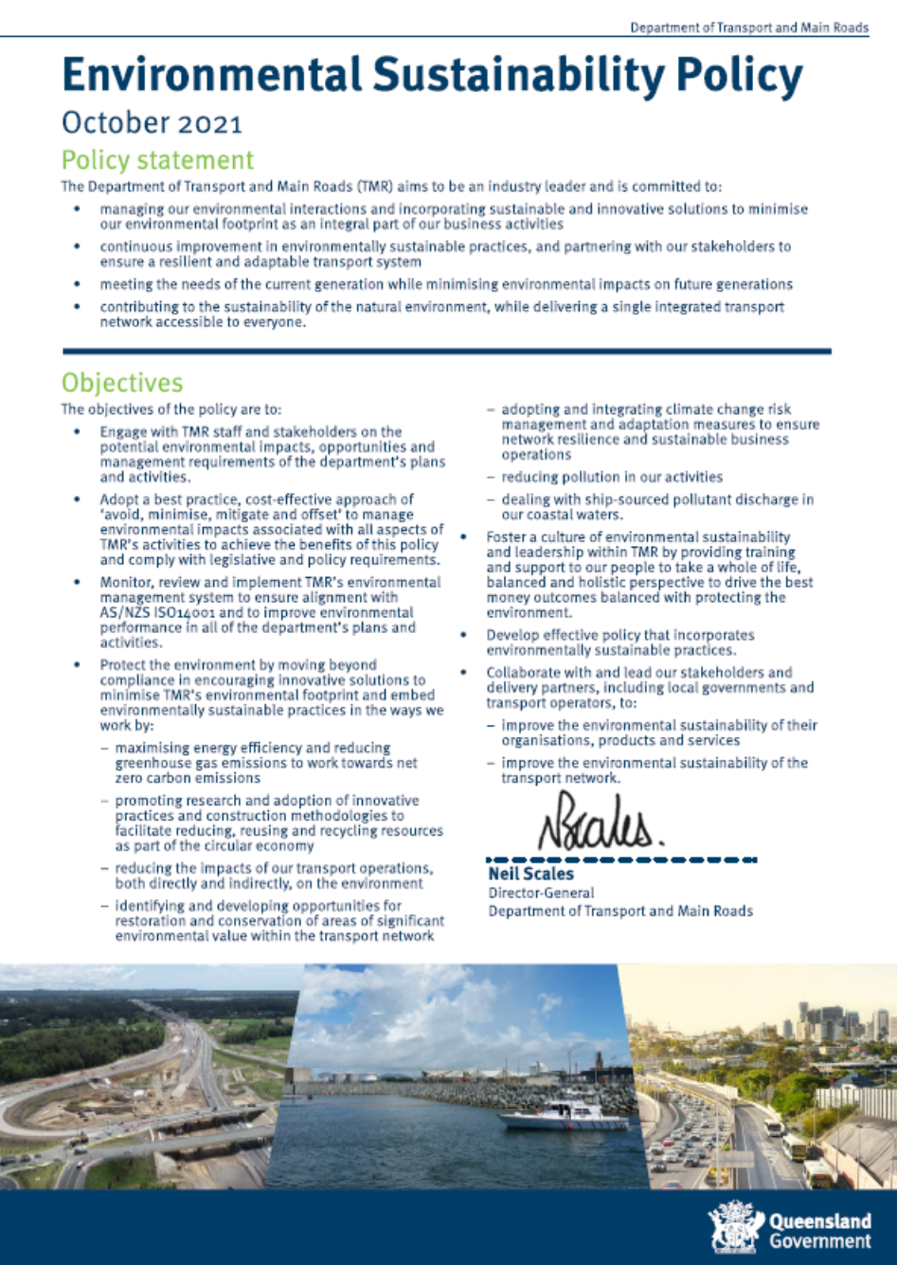

Appendix B: Guide to incorporating sustainability into project decision making

Appendix C: Guidance Note – Infrastructure Sustainability Base Case Framework

Appendix D: Supporting information for infrastructure sustainability
Table D1 – Queensland Government guidance and policy
Reference | Title
Protection of Great Barrier Reef | Reef 2050 Plan, Australian and, Queensland Government
Queensland Waste Management and Resource Recovery Strategy | Waste Management and Resource Recovery Strategy for Queensland, Queensland Government
Business Case Development | Business Case Development Framework, 2021
Queensland Procurement | Queensland Procurement Policy 2021, Queensland Government, Department of Housing and Public Works
Ethical Supplier Mandate | Ethical Supplier Mandate 2021, Office of the Chief Advisor – Procurement, Queensland Government
Indigenous Employment Policy | Queensland Indigenous (Aboriginal and Torres Strait Islander) Procurement Policy, Queensland Government
Climate Change Policy | Climate Change Adaptation Strategy 2017 - 2030, Queensland Government  Climate Change Transition Strategy, Queensland Government

Table D2 – Transport and Main Road's guidance and policy
Reference | Title
Transport and Main Roads Sustainability BAU Assessment and Recommended Credits | Transport and Main Roads Sustainability Business As Usual Assessment and Recommended Credits_Default – Appendix G
Hydraulic Climate Change Requirements | Road Drainage Manual, Transport and Main Roads
EP170 | Engineering Policy EP170 Climate Change Risk Assessment Methodology, Transport and Main Roads
Climate Change Risk and Adaptation Assessment Framework for Infrastructure Projects | Climate Change Risk and Adaptation Assessment Framework for Infrastructure Projects, March 2020, Transport and Main Roads

Appendix E: Sustainability business as usual assessment and recommended credits

Appendix F: Guidance Note – Project sustainability commitments and objectives

Appendix G: Infrastructure sustainability management plan outline

