School Transport Assistance Scheme Policy

  - May 2023
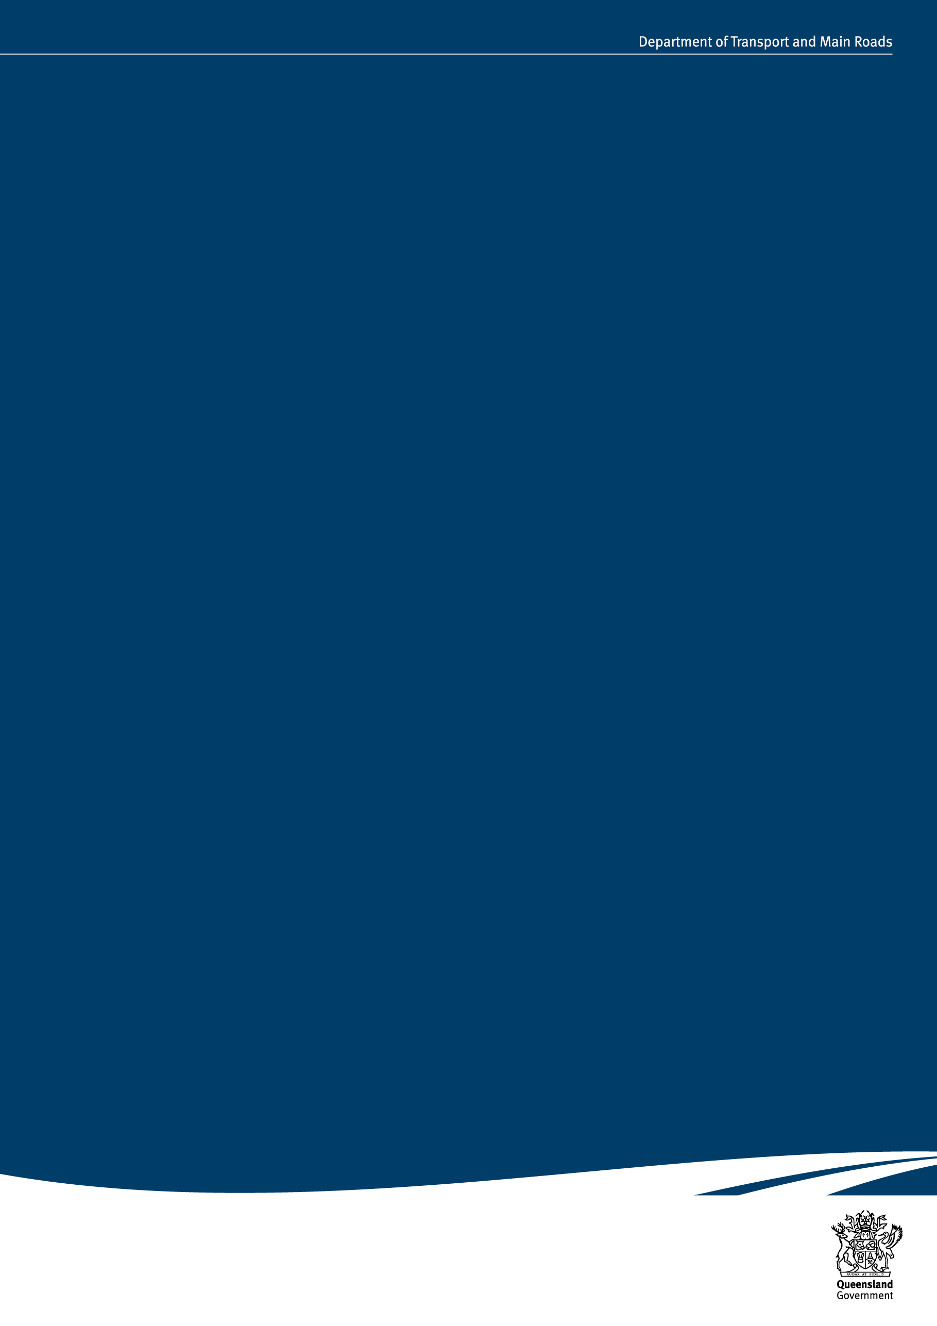

Table of Contents

Table of Contents 2

What is the School Transport Assistance Scheme? 3
Policy Objectives 3

Part 1: General Conditions 4
1.1 Eligibility 4
1.2 Conditions of travel 6
1.3 Applications for assistance 6

Part 2: Types of assistance 7
2.1 Bus assistance 7
2.2 Rail safety-net assistance 8
2.3 Conveyance allowance 8
2.4 Assistance for students living in isolated areas 10
2.5 Other forms of transport assistance 12

Part 3: Types of school bus services and their conditions of operation 13
3.1 Kilometre-based school bus services 13
3.2 Fares-based school bus services 14
3.3 School bus services – conditions of operation 14
3.4 Administrative arrangements 16

Definitions 17

Department of Transport and Main Roads Translink Regional offices 19

The information contained in this document is correct at the time of publication, however, may be subject to change. The latest version of the School Transport Assistance Scheme Policy is available at translink.com.au/schooltransport.

What is the School Transport Assistance Scheme?
The Queensland Government recognises there are students whose access to schools may be impeded by distance or financial disadvantage. While it is the responsibility of parents to make suitable travel arrangements for their children to attend school, the School Transport Assistance Scheme (STAS) helps parents to meet their legal obligation of ensuring their children are enrolled in and attending an approved school.
STAS provides assistance to school students on rail, bus and ferry services and through the payment of conveyance allowance to parents as a contribution towards the cost of transporting their children to and from school. Assistance covers the journey between home (the principal place of residence) and the nearest school.

Policy Objectives
The Queensland Government’s policy objective in providing assistance under STAS is to assist families in meeting their legal obligations of ensuring school aged children are enrolled in, and attending, school by:
- providing transport assistance to families who do not have a school in their local area;
- providing transport assistance to financially disadvantaged families who reside close to their nearest school.
Further information about STAS can be obtained by contacting the Department of Transport and Main Roads (the department) – refer to page19.

Part 1: General Conditions
Unless stated otherwise, students must be able to travel independently and satisfy these general conditions to be eligible to receive school transport assistance (assistance).

1.1 Eligibility

Approved school
To be eligible for assistance students must be undertaking primary, secondary or special education at an approved school in Queensland.
An approved school is a state school or accredited non-state school listed in the Department of Education Schools Directory at eq.edu.au.
The nearest state school to the student's residence offering the required year level is used to determine eligibility even if the student is unable to access that school. The location of a Queensland Academy, however, will not be considered unless a student is enrolled at that academy.
Queensland residents living close to the Queensland/New South Wales border with students attending a school in New South Wales may be eligible for STAS, provided the school attended is the nearest state school, or non-state school of type, to their residence.

Non-state schools
For students attending non-state schools the nearest school of type is considered when determining eligibility and levels of assistance. The following non-state schools are considered to be of the same type:
- all catholic schools
- all grammar schools established under the Grammar Schools Act 1975
- all schools of the same religious denomination or run by the same school governing body.
The nearest non-state school of type is used to determine eligibility even if the student is unable to access that school. The only exception is gender specific schools which are not considered when determining eligibility for a student of a different gender.

Alternative education programs
Students attending alternative education programs approved by the Department of Education may qualify for assistance.

Age of student
Students who are 19 years or older are not eligible for assistance unless they are in full time secondary education which commenced prior to turning 19.

Guardianship
Applications for assistance will only be accepted from a student's parent/guardian. A parent/guardian is the legal guardian or person who has financial responsibility for the student.
Students may claim independent status provided they are able to verify this at time of application.

Residency
Parents/guardians must be a resident of Queensland.
Fee paying international students as well as interstate and exchange students are not eligible for assistance.

Address
Eligibility for assistance is based on the principal place of residence of the parent/guardian applying for assistance.

Alternative addresses
Assistance is not available for travel to more than one school facility or to an address that is not the principal place of residence of the student's parent/guardian.

Shared care arrangement
Students in shared care arrangements can apply for assistance from two residential addresses for travel on public transport (bus, rail, or ferry). Each address must be the principal place of residence of one of the student's parents/guardians.
Payment of conveyance allowance for private travel is, however, not able to be approved for a student in shared care arrangements if they are already in receipt of school transport assistance from either parent/guardian address.

Designated bus service
To receive assistance, students must travel on the designated bus service for their area. The designated bus service has a school bus catchment area determined by the department. School bus catchment areas may not align with school catchment boundaries determined by the Department of Education.
Where separate primary or secondary services are provided, the student must travel on the designated bus service for their year level. In some circumstances, a student's designated service may not travel to their nearest state school. In these instances, the service will transport students to the nominated school as determined by the department.
If a student does not live within a school bus catchment area, the designated service will be the service nearest the student's residence which travels to a school offering the required year level.
Assistance can only be provided for travel on a designated bus service which is provided under a service contract and funded by government.

Distance measurements
A Geographic Information System (GIS) is used to measure distance.
The distance between the student’s residence and nearest state school or non-state school of type, or the nearest bus service, is measured by the shortest trafficable route over roads for public use, and averaged. For example, distance from school to the residence and return, divided by two.
The following Queensland Government datasets are used:
- Department of Transport and Main Roads approved digital road network;
- Department of Resources Property Address Queensland database, commonly referred to as the Property Location Index (PLI);
- Department of Education defined school location points.
The datasets for PLI and school location points are available on the Queensland Government Open Data Portal at data.qld.gov.au

New schools
As a key criterion for assistance is the distance from a student’s residence to their nearest school, when a new state school opens, this can mean a student is no longer eligible for assistance. If this occurs, the student can continue to receive assistance under grandfather arrangements until the end of their current schooling (i.e. primary or secondary) or until there is a change of circumstances.
Any new application received for assistance, including from siblings of grandfathered students, will be assessed based on the distance to the nearest school.

Change of circumstances
Eligibility for assistance must be reassessed whenever there is a change of circumstances such as a change of school or address, or the opening of a new school or road.
Students are reassessed for assistance when they move from primary to secondary education, even if they remain at the same school.

Withdrawal of assistance
The department may withdraw assistance and recover monies paid if investigations determine that students are ineligible.

1.2 Conditions of travel

Bus passes
Bus passes must be produced to the driver upon request and must only be used by the students named on the pass. The initial pass must be issued at no cost, however, service providers may charge a reasonable deposit for an electronic bus pass, provided it is refunded upon return of the pass in good order and condition.
A replacement fee may be charged for passes that are lost or damaged, but not where a pass is defective.
Bus passes must be returned to the bus company when a student stops travelling on the bus.
Personal information printed on a pass should be limited to a student’s name, school attended and year level. Information which may help to identify the bus stop at which the student boards/alights the bus, or the number of zones/sections travelled, is acceptable.
The above guidelines do not apply to passes issued by Integrated Mass Transit Area (IMTA) service providers as they have separate guidelines for the issue of passes to school students.

Code of conduct for school students travelling on buses
All school students travelling on buses are expected to comply with the Code of Conduct for School Students Travelling on Buses (the Code). The Code is available at translink.com.au

Fare evasion
Passengers are expected to pay a fare for each journey undertaken. Instances of student fare evasion will be handled in accordance with the Code.

1.3 Applications for assistance
Applications for assistance can only be accepted for the current school year and can be submitted online at qld.gov.au
Paper forms can be accessed under the heading Types of assistance at translink.com.au or from your local service provider.
Retrospective claims for travel in previous years will not be approved.

Part 2: Types of assistance

2.1 Bus assistance

2.1.1 Distance-based assistance
Distance-based assistance may be available for students who do not have an educational facility within their local area. To receive distance-based assistance:
- primary students must live more than 3.2km from the nearest state school offering primary education.
- secondary students must live more than 4.8km from the nearest state school offering secondary education.
- non-state school students must live more than the required distance from both the nearest state and the nearest non-state school of type offering the required year level.

Conditions
Service providers assess eligibility and provide interim approval (if appropriate). Final approval is provided by the department. Approval is ongoing until a student completes either primary or secondary education or there is a change of circumstances affecting eligibility.

Level of assistance

Kilometre-based school bus services (refer Section 3.1)
Students receive government funded travel to the nearest state school on the approved route of the designated kilometre-based school bus service for their area.
Non-state school students receive government funded travel to the nearest state school on the approved route of the designated kilometre-based school bus service for their area, provided they are not bypassing a nearer non-state school of type. Assistance cannot be transferred to other services.

Fares-based school bus services (refer Section 3.2)
Students travelling on the designated fares-based school bus service receive government funding for the journey to the nearest state school, or nearest non-state school of type, whichever is the closest.

2.1.2 Safety-net assistance
Safety-net assistance may be available for financially disadvantaged students who live close to their nearest school. To be eligible:
- primary students must live 3.2km or less from the nearest state school offering primary education.
- secondary students must live 4.8km or less from the nearest state school offering secondary education.
- non-state school students must live less than the required distance from either the nearest state or the nearest non-state school of type offering the required year level.
- the student must be listed as a dependant on the applicant’s current concession card or be the holder of a current concession card. Accepted concession cards are:
  - Health Care Card issued by Services Australia; or
  - Pensioner Concession Card issued by Services Australia; or
  - Pensioner Concession Card issued by Department of Veterans’ Affairs.
Students under a Child Protection Order administered by Child Safety Services may also qualify.
The student must not be in receipt of any other STAS assistance.

Conditions
The department assesses eligibility and provides approval. Data matching is undertaken at the end of each school year with Services Australia to confirm eligibility. If the concession entitlement is still current, assistance will continue the following year. If the concession entitlement is no longer current, assistance will cease at the end of that school year.

Level of assistance

Kilometre-based school bus services (refer Section 3.1)
Students receive government funded travel to the nearest state school on the approved route of the designated kilometre-based school bus service for their area.
Non-state school students receive government funded travel to the nearest state school on the approved route of the designated kilometre-based school bus service for their area, provided they are not bypassing a nearer non-state school of type. Assistance cannot be transferred to other services.

Fares-based school bus services (refer Section 3.2)
Students travelling on the designated fares-based school bus service receive assistance in the form of a weekly amount paid direct to the service provider. The amount comes off the student's total weekly travel cost. Parents/guardians are responsible for the payment of any fares above the weekly amount.

2.2 Rail safety-net assistance
Safety-net assistance may be available for financially disadvantaged students who travel on Translink rail services to and from school. Assistance is government funded travel from the rail station nearest the student's residence to the rail station nearest the school attended. To be eligible:
- the student must be listed as a dependant on the applicant’s current concession card or be the holder of a current concession card. Accepted concession cards are:
  - Health Care Card issued by Services Australia; or
  - Pensioner Concession Card issued by Services Australia; or
  - Pensioner Concession Card issued by Department of Veterans’ Affairs.
Students under a Child Protection Order administered by Child Services may also qualify.

Conditions
The department assesses eligibility and provides approval. Data matching is undertaken at the end of each school year with Services Australia to confirm eligibility. If the concession entitlement is still current, assistance will continue the following year. If the concession entitlement is no longer current, assistance will cease at the end of that school year.

2.3 Conveyance allowance
Parents/guardians who make private arrangements for students to travel to and from school may receive a conveyance allowance to assist with travel costs. To receive conveyance allowance:
- primary students must live more than 3.2km from the nearest state school offering primary education.
- secondary students must live more than 4.8km from the nearest state school offering secondary education.
- non-state school students must also live more than the required distance from both the nearest state and the nearest non-state school of type offering the required year level. However, non-state school students that live outside the Brisbane City Local Government Area (LGA) must live more than the required distance from the nearest non-state school of type only to qualify for Class D.
Payment of conveyance allowance is based on the distance from the student’s residence to the:
- nearest state school; or
- nearest non-state school of type; or
- designated bus service,
whichever is the closest.
Payment rates are published in a School Transport Information Statement available at tmr.qld.gov.au

Types of conveyance allowance and levels of assistance
Class | Eligibility | Level of assistance | Conditions
A | Payable for students who are driven to and from school in a private motor vehicle. | Paid on a sliding scale, based on the average one-way distance between the residential property and nearest state school or nearest non-state school of type; whichever is closer.  Paid per vehicle. | Students must live 3.2km or more from a kilometre-based school bus service that provides transport for the required year level.
B | Payable for students who must pay a fare to travel on the designated fares-based bus or ferry service to and from school or to the nearest railway station from where the student catches a train to school. | Paid as a reimbursement of the assessed fare for travel to and from the nearest state school or nearest non-state school of type, whichever is the lesser, or to the nearest railway station. | Only available in limited instances where payment is not made directly to a Service Provider for eligible students. For example, Transport for Brisbane services.  Students must live 3.2km or more from a kilometre-based school bus service that provides transport for the required year level.  Documentation verifying payment of fares may be requested.
C | Payable for students who are driven in a private motor vehicle more than 3.2km to the nearest point of an approved bus service, or the nearest railway station. | Paid on a sliding scale, based on the average one-way distance between the residential property and the nearest point on the designated bus service, or the nearest railway station.  Paid per vehicle. | Students must live 3.2km or more from their designated school bus service.
D | Available to non-state school students living outside the Brisbane Local Government Area, provided they live over the distance criteria from their nearest non-state school of type.  Payable when students are driven in a private motor vehicle to and from school or more than 3.2km to the nearest point from which another form of transport is available which can transport the student to school. | Paid at a flat weekly rate irrespective of the distance travelled.  Paid per vehicle. | Not available for a student who qualifies for Class A or Class C for the same journey.  Students must live 1.6km or more from the route of a kilometre-based school bus service on which the student is eligible to travel at no cost to a non-state school of type.
Drought | Additional conveyance allowance is available to families who qualify for conveyance allowance Class A or C and who live on a drought declared primary producing property. | Paid as an additional payment of conveyance allowance Class A or C.  Paid per vehicle. | Payable during the period that the primary producing property remains on the drought declared list and for a further two years after the property is removed from the list (provided the student still qualifies for Class A or C). The drought status of properties is verified on a yearly basis.
I | Available to students who reside in defined isolated parts of Queensland and are driven to and from school or to a school bus service. | Paid on a sliding scale, based on the average one-way distance between the residential property and the nearest point on the designated bus service, or the nearest state or non-state school of type, whichever is closer.  Paid per family. | Must reside more than 16km from the nearest state and the nearest non-state school of type, and more than 16km from the nearest bus service.

2.4 Assistance for students living in isolated areas
The Queensland Government provides assistance to eligible families under the school transport isolation package. To receive assistance, students must:
- live more than 16km from both the nearest state school and the nearest non-state school of type; and the nearest bus service which can transport the student to a state school or non-state school of type with the required year level;
and
- live outside the south-east Queensland school transport zone (see map on page 11);
and
(3a) live in the seven week summer vacation zone, as defined by the Department of Education under the school holidays policy at education.qld.gov.au
or
(3b) live more than 50km, measured by the shortest trafficable route from the main post office in each of the following centres:
Atherton | Cairns | Hervey Bay | Kingaroy | Maryborough | Rockhampton | Townsville
Ayr | Dalby | Home Hill | Mackay | Mossman | Sarina | Tully
Bowen | Gladstone | Ingham | Malanda | Proserpine | Stanthorpe | Warwick
Bundaberg | Gympie | Innisfail | Mareeba | Ravenshoe | Toowoomba

Types of assistance

Class I conveyance allowance
Students may receive payment of Class I if they travel to and from school, or an approved bus service by private arrangement.
Class I is not payable for a student who is receiving Class A, C or D or drought assistance for the same journey.
Class I is paid at a higher rate than other classes of conveyance allowance and is paid on a per family basis to allow for carpooling.

Subsidised bus services in isolated areas
Seven eligible students (from at least three different families) are needed to establish a subsidised school bus service in isolated areas.

Designated bus service
The designated bus service for a student living in an isolated area can be:
- the service nearest the student’s residence that transports students of the required year level, or
- a service that transports the student to the nearest state school.
A student does not have a designated bus service if the distance to the nearest bus service providing transport for the required year level is further than the distance to the nearest school offering the required year level.

Assistance for senior secondary students travelling to P-10 schools
Some students living in isolated areas may not have access to schools offering Years 11 and 12. These students may receive assistance to undertake tutoring at their nearest P-10 school. To be eligible, a student must:
- have completed their compulsory years of schooling (to year 10)
- live in an isolated area of the state
- meet the STAS eligibility criteria
- attend their nearest P-10 facility for tutoring and assistance at one of the following schools:
Alpha | Baralaba | Dirranbandi | Doomadgee | Inglewood | Injune | Mornington Island
Normanton | Palm Island | Quilpie | Richmond | Tambo | Taroom | Texas

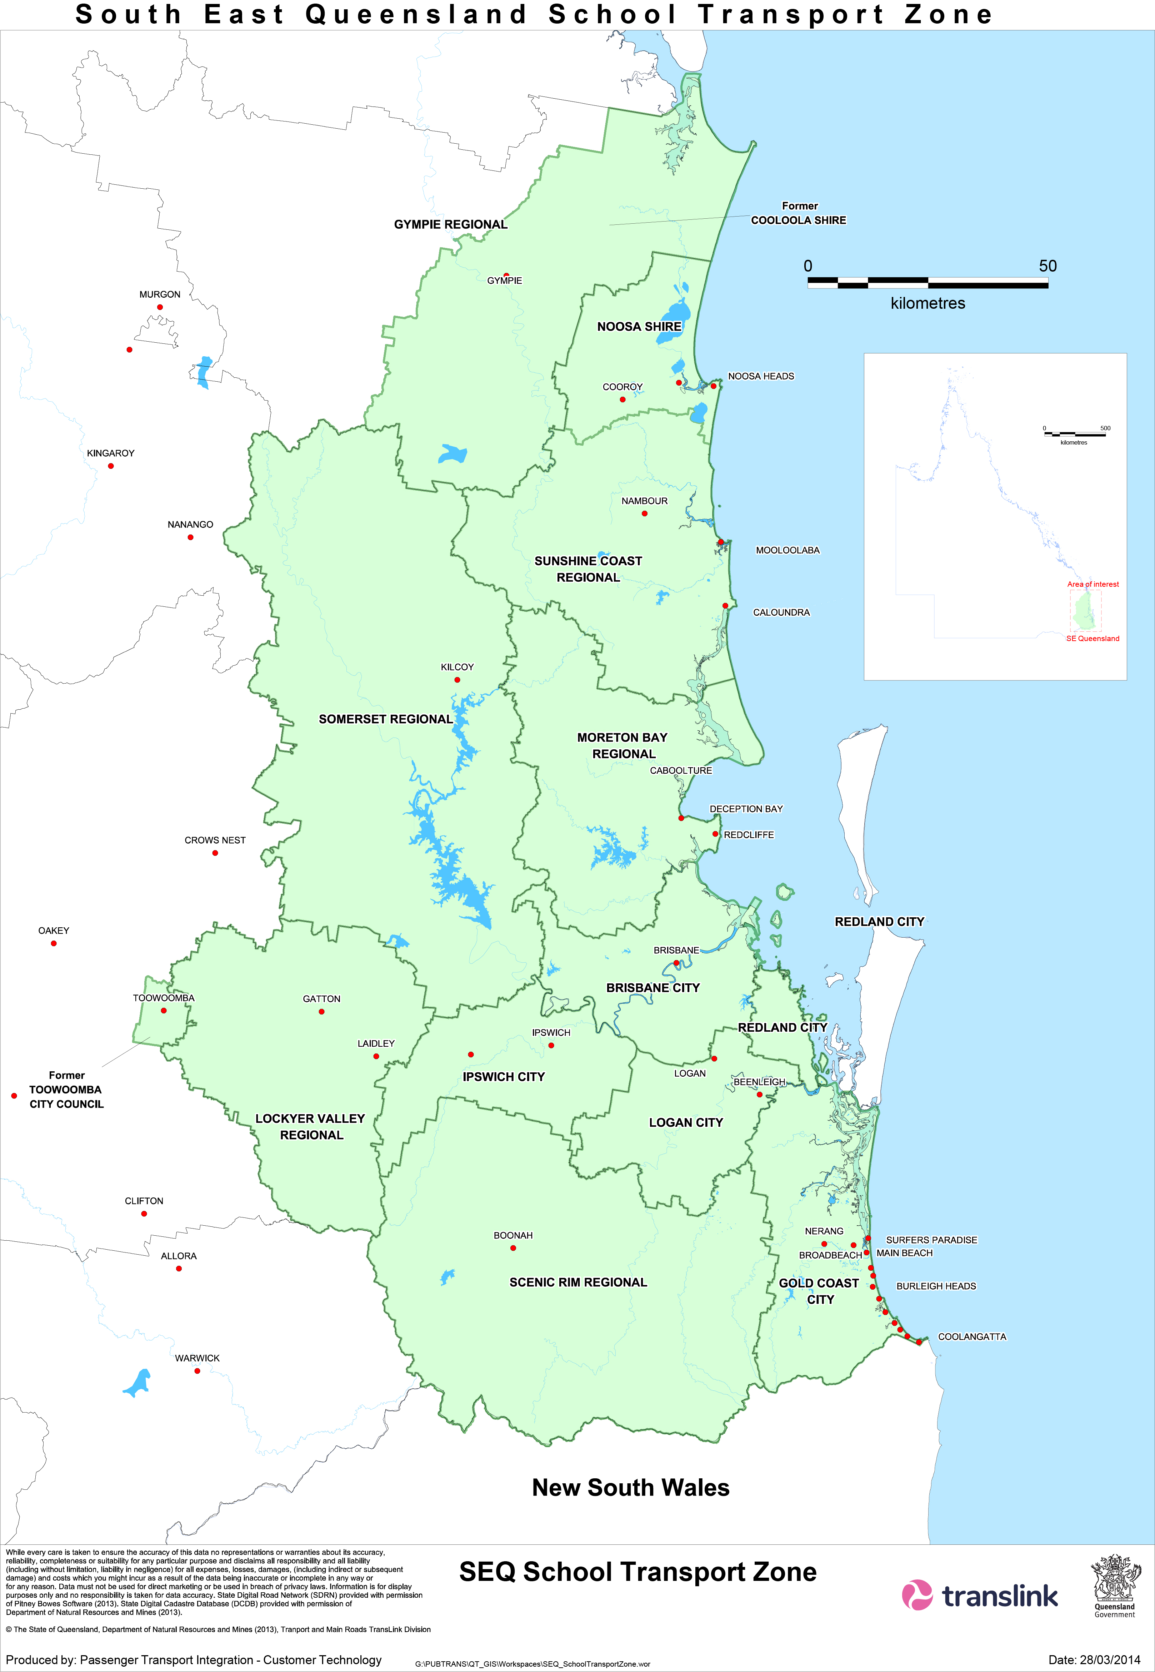
South East Queensland School Transport Zone

2.5 Other forms of transport assistance
The Department of Education has policy and budgetary responsibility for transport assistance provided to:
- Students with disability
- English as an additional language or dialect students.
All enquiries about transport assistance for these students should be directed to the school attended or the relevant Department of Education district office.
Students who do not qualify under the Department of Education funded program can apply for STAS, provided they are able to travel independently.

Part 3: Types of school bus services and their conditions of operation

3.1 Kilometre-based school bus services
Kilometre-based school bus services are funded by government based on the size of vehicle needed to carry eligible students and the distance of the route travelled. The department approves the route and determines payment rates for these services with student numbers assessed on a case by case basis.
Kilometre-based school bus services generally transport students to the nearest state school offering the required year level, however, in some circumstances the service may transport students to other than the nearest state school. When this occurs, the service will transport students to the nominated school as determined by the department.
There are a limited number of ferry services throughout Queensland which operate under similar conditions.
    - Individual kilometre-based school bus services
Individual kilometre-based school bus services generally operate in rural and regional areas. These services operate as an individual route and carry students to the nearest state school on the approved route.

Establishing a new service
An individual kilometre-based school bus service may be established under certain circumstances and there is no other transport service. Generally, an average of nine students are required who travel daily.
To establish a new service, application can be made to the local Translink Regional office by a relevant stakeholder such as a parent/guardian or local school principal. The following factors are considered when assessing an application:
- the number of eligible students who will use the service
- predicted school enrolment numbers (including consideration of students currently in kindergarten)
- the number of eligible students who live more than 6.4km from the nearest school – generally 50% of students must live over this distance
- the suitability of roads
- the estimated cost of the service as determined by the department
- service delivery – including length of route, timetable and travel times
- impact on existing services
- future planned development, including new schools or road network changes
- local demographics and overall passenger transport requirements in the area.

Bus route
Requests for extensions to the approved route should be submitted to the department in writing by the service provider.
The department must be advised immediately when any section of the route is no longer required.

Student variations
The number of students on a service may change over time. Where student numbers increase, changes to operational arrangements may be required.
Where student numbers decrease significantly, the viability of the service may need to be considered. The department may consider closing a service if:
- eligible student numbers fall below six; or
- it is determined that costs for the service have become excessive with declining numbers.

Conveyance committee
Conveyance committees are made up of the parents/guardians of eligible students travelling on an individual kilometre-based school bus service. They are not mandatory but may be formed to assist service providers with the administration of services, providing input to ensure the service meets the specific transport needs of individual rural, regional and remote communities. Parents/guardians fulfil this role on a voluntary basis.
Conveyance committee members are covered under the Queensland Government Indemnity Guideline and Queensland Government Insurance Fund.
The roles and responsibilities of a conveyance committee are contained in the Conveyance Committee Information Kit available online at ttmr.qld.gov.au

Priority for travel
On kilometre-based school bus services, priority is granted to:
- students eligible for distance-based assistance and special eligible students
- students eligible for safety-net assistance
- all other fare paying students.
Access to services by other members of the community should only be considered after the needs of all students have been met.

3.1.2 Cluster kilometric school bus services
Cluster kilometric services are kilometre-based school bus services that operate in more densely populated areas as an integrated network of routes operated by the same service provider.
The department and the service provider work together to determine the routes and respond to changes in travel demand, with departmental approval required prior to implementation of any service changes.
The primary focus of cluster kilometric services is the transport of eligible students with the priority for travel the same as for individual kilometre-based services.

3.2 Fares-based school bus services
Fares-based school bus services generally operate in urban and densely populated areas across the State and are funded by government paying individual fares for eligible students. These services are being progressively phased out as the department transitions to kilometre-based school bus services.
Students living within the designated area of a kilometre-based school bus service are not eligible for assistance on fares-based services.
The service provider is responsible for determining routes and responding to an increase in travel demand – which may be through the provision of additional or extended services. Consultation should occur with the local Translink Regional office on additional or extended services.

Fares for eligible students
The department accepts responsibility for payment of fares for all approved eligible school students. Payment for distance eligible students is based on the STAS Fare Schedule and is made direct to the service provider. The department also pays the service provider the weekly benefit amount for each approved safety-net student.
Parents/guardians are responsible for the payment of any fares above the amount funded by government.

3.3 School bus services – conditions of operation
School bus services are operated under contract to the State Government and must comply with contract conditions.
Prescribed school service contract providers are not permitted to pick up fare paying passengers in declared areas or routes unless the service provider has written authorisation from the service contract holder. A declared area or route is an area or route declared in accordance with Section 42 of the Transport Operations (Passenger Transport) Act 1994 for which a service contract is required to provide a public passenger service. Declarations made under Section 42 have generally been limited to areas or routes which are the subject of urban service contracts.
Information on declared areas and routes can be found on the department's website at tmr.qld.gov.au.
The following general conditions of operation apply to both kilometre and fares-based school bus services.

Service provider responsibilities
A service provider has responsibilities in delivering contracted school bus services. These include:
- providing services for eligible students on all school days
- delivering students to their destination whether that is a school, a bus stop or a bus interchange
- ensuring the wellbeing and safety of students travelling on their buses
- following the processes outlined in the Code
- operating services in accordance with legislative requirements
- operating services in accordance with the STAS Service Provider Operations Manual.

Top-up fares
Students who undertake travel in excess of that funded by the government will be required to pay a top-up fare.
For distance eligible students, a top-up fare is payable on any excess distance travelled beyond the nearest state school, or nearest non-state school of type, whichever is the closest This also applies to safety-net students travelling on kilometre-based school services.
For safety-net eligible students on fares-based services, a top-up fare is payable if the student's weekly travel cost exceeds the weekly safety-net amount funded by government.
Top-up fares must be charged in accordance with the conditions outlined under Fares below.

Fare paying passengers
Where spare capacity exits, service providers may carry students who do not qualify for STAS assistance, and adults, as fare-paying passengers.
Continued availability of space cannot be guaranteed and will be monitored by the local service provider. Priority is to be given to students before adult passengers can be accommodated.

Fares
Fares are to be charged for
- STAS eligible students travelling beyond the journey that is funded by government
- students who are not STAS eligible
- adult passengers.
In areas where regional fares and zones have been implemented, regional urban bus contract holders must charge fares in accordance with the Translink Regional Ticketing and Fares Policy on the following service types:
- school services delivered through a regional urban bus contract
- school services delivered through a prescribed school service contract
In areas where regional fares and zones have not yet been introduced, regional urban bus contract holders should continue to charge fares as per current arrangements.
Other service providers with a standalone prescribed school service contract must charge fares in accordance with the department’s School Transport Maximum Cash Fare Schedule located at tmr.qld.gov.au.
Where prescribed school service contract providers charge fares that are below the maximum prescribed under the School Transport Maximum Cash Fare Schedule, they may be increased by up to 10 per cent each six months until the maximum fare is reached. Service providers must provide due notice to customers of planned fare increases.

Service changes due to emergencies
In instances of vehicle breakdown, adverse weather or other emergencies, it is an expectation that the service provider will put alternative transport arrangements in place. If this is not possible, service providers will advise schools immediately.

Change of school hours
Schools have flexibility to change the hours of operation to suit local conditions. Where this occurs, operating times of services can be varied, provided the general conditions of contract are met and that appropriate consultation has occurred with affected schools, parent groups and the department.

School closures
When a school is closed, either on a temporary or permanent basis, the transport arrangements for the area will be reviewed. The department will consult with the Department of Education and local service providers when determining future transport arrangements.

Bus stop areas
The bus service provider, in consultation with the local Translink Regional office is responsible for the regular review of designated set down and turnaround areas.

Timetables
The bus service provider is responsible for the timetable of a service.

Review of services
To ensure optimum operating efficiencies and accountable expenditure of public money, the department conducts operational reviews on a regular basis. If necessary, adjustments to services and routes may be undertaken. When this occurs, negotiation will occur with affected stakeholders, including the service provider, Department of Education and parent groups.
An operational review is not generally conducted in response to requests to change the school/s that are serviced by a school bus service.

3.4 Administrative arrangements
The department uses the School Transport Information Management System to administer STAS.
Access to this database is restricted to authorised officers of the department and is managed in accordance with the Information Privacy Act 2009.

Verification processes
To maintain accuracy of data held by the department and ensure correct payment occurs for eligible students, verification processes are undertaken with service providers. While service providers are required to immediately advise the department of any students no longer travelling, additional verification occurs throughout the year to check accuracy of passenger records.
A similar verification process is undertaken with the Department of Education to verify student enrolments and personal details such as address and guardians. This is authorised under Section 144 of the Transport Operations (Passenger Transport) Act 1994. A similar process occurs with non-state schools.
It is important to advise service providers, the department and schools of any changes to details. Assistance may be revoked if student details cannot be verified during the verification process.

Definitions
Term | Definition
alternative education program | Educational programs delivered under flexible arrangements outside the normal "mainstream" school setting and can include, but are not limited to, Positive Learning Centres and Flexible Learning Centres, or approved alternative education programs delivered at TAFE.
approved school | An approved school is a school listed in the Department of Education Schools Directory which is:  - A state school; or  - A non-state school accredited under the Education (Accreditation of Non-State Schools) Act 2017; or  - A state school only providing special education; or  - A program approved by the Department of Education for the delivery of alternative education.
approved bus service | A bus service provided under contract by the:  - urban service contact holder for the area; or  - prescribed school service contract holder for the area.
assessed fare | For class B conveyance allowance, the assessed fare is calculated using a weekly fare and is the lesser of:  - the bus fare to and from the nearest state school  - the bus fare to and from the nearest non-state school of type  Fares for students travelling on Translink services will be based on gocard concession fares.
department | Department of Transport and Main Roads.
Integrated Mass Transit Area (IMTA) | Service contract areas or routes in SEQ as prescribed in legislation (also known as the Translink service area).
primary education | Education offered in the preparatory year and years 1 to 6.
principal place of residence | The one place that is usually occupied for residential purposes by the parent/guardian (applicant). Documentation verifying an applicant’s principal place of residence may be required.
Queensland Academy | Queensland Academies are a set of three top-performing state high schools for highly capable students. Queensland Academies have a selective entry process.
school days | A school day is any day on which a school serviced directly or indirectly by a school bus service is open for instruction of students of that school; and is a day that is numbered on the school calendar published by the Department of Education for the current school year or is a student-free day that does not occur in the December-January summer vacation.
secondary education | Education offered in years 7 to 12.
service provider | a person or entity operating a school bus service.
special education | Educational programs and services –  - appropriate to the needs of persons with disability; and  - additional to, or otherwise different from, educational programs and services generally available to persons of the relevant age who are not persons with disability.
special eligible students | Students who qualify for transport assistance under the School Transport Assistance Program for Students with a Disability.
Translink rail services | Trains operated on the Queensland Rail Citytrain Network or the Gold Coast light rail tram network (G:link).

Department of Transport and Main Roads Translink Regional offices

Further Information
For more information, please contact your local Translink Regional Division office of the Department of Transport and Main Roads or go to translink.com.au

Translink SEQ  Gold Coast  PO Box 10420  Southport BC Qld 4215  Phone: 5585 1857  Fax: 2139 5081  Email:stgoldcoast@translink.com.au | Translink Southern  Toowoomba (Darling Downs)  PO Box 629  Toowoomba Qld 4350  Phone: 4639 0727  Fax: 2139 5072  Email:toowoomba@translink.com.au | Translink Central  Mackay  PO Box 62  Mackay Qld 4740  Phone: 4951 8673  Fax: 2139 5073  Email:mackay@translink.com.au
Ipswich  PO Box 630  Booval Fair Qld 4304  Phone: 3813 8613  Fax: 2139 5082  Email:stipswich@translink.com.au | Roma (South West)  PO Box 126  Roma Qld 4455  Phone: 4622 9509  Fax: 2139 5116  Email:roma@translink.com.au | Rockhampton  PO Box 5096  Red Hill  Rockhampton Qld 4701  Phone: 4931 1539  Fax: 2139 5062  Email:rockhampton@translink.com.au
Carseldine  GPO Box 1412  Brisbane Qld 4001  Phone: 3863 9849  Fax: 2139 5057  Email:carseldine.st@translink.com.au | Translink Sunshine Coast/  Wide Bay  Maryborough (Wide Bay Burnett)  PO Box 371  Maryborough Qld 4650  Phone: 4122 6115  Fax: 2139 5064  Email:maryborough@translink.com.au | Translink Northern  Cairns  PO Box 6542  Cairns Qld 4870  Phone: 4045 7099  Fax: 2139 5042  Email:cairns@translink.com.au
 | Sunshine Coast  PO Box 111  Mooloolaba Qld 4557  Phone: 5452 1800  Fax: 2139 5076  Email:maroochydore.st@translink.com.au | Townsville  PO Box 1089  Townsville Qld 4810  Phone: 4758 7544  Fax: 2139 5050  Email:pttownsville@translink.com.au

