Contract Administration System – Standard Forms
[Contract Name] – [Contract Number]

CAF001M: Administrator’s Surveillance Plan

January 2023

Document control sheet
Contact for enquiries and proposed changes
If you have any questions regarding this document or if you have a suggestion for improvements, please contact:
Contact Officer Ananda Pathirana
Title Principal Engineer
Phone 3066 8598
Version history
Version no. | Date | Changed by | Nature of amendment

Document sign off
The following officers have approved this document.
Customer
Name
Position
Signature |  | Date
Sponsor
Name
Position
Signature |  | Date

The following officer has endorsed this document.
Name
Position
Signature |  | Date

Contents
Document control sheet i
1 Introduction 1
2 Purpose 1
3 Scope 1
4 General 1
5 Definitions 1
6 References 2
7 Contract details 2
8 Stakeholders 2
8.1 List of stakeholders 2
9 Risk analysis 3
10 Surveillance requirements 3
11 Surveillance resource requirements 3
11.1 Administrator's site surveillance team 3
11.2 Specialist and other support staff 4
11.3 Delegation of responsibilities 4
11.4 Contact Lists 4
12 Implementation of the Surveillance Plan 4
12.1 Surveillance 5
12.1.1 Registers and issue management 5
12.1.2 Review and applicability 5
12.2 Systems audits 5
12.2.1 Internal audits 5
12.2.2 Administrator's audits 6
12.3 Product audit 6
12.3.1 Audit – product quality 6
12.3.2 Monitoring activity – product and material quality 6
12.3.3 Audit – material quality 6
12.4 Process audits 7
12.5 Communication management 7
12.5.1 External communication 7
12.5.2 Internal communication 7
12.5.3 Conferences 7
12.5.4 Records management 8
12.6 Principal Supplied Materials and Works management 8
12.7 Monitoring and review 8
13 Surveillance performance measurement 8
Appendix A – Contract details 9
Appendix B – List of stakeholders 10
Appendix C – Surveillance risk register 11
Appendix D – Responsibility matrix 12
Appendix E – Administrator’s Site Surveillance Team 15
Appendix F – Surveillance Schedule 16
Appendix G – Administrator's Surveillance Program 18
Appendix H – Specialists and Support Staff 19
Appendix I – Delegation of Responsibilities from the Administrator 20
Appendix J – Duty Statement for the Site Engineer 21
Appendix K – Duty Statement for the Inspector / Surveillance Officer 22
Appendix L – Contact List 23
Appendix M – Registers and Issue Management 24
Appendix N – Audit Program 25
Appendix O – Product Audit Program 26
Appendix P – Product and Material Monitoring Program 27
Appendix Q – Material Quality Audit Program 28
Appendix R – Process Audit Program 29
Appendix S – External Communications Plan 30
Appendix T – Internal Communications Plan 31
Appendix U – Key Result Areas and Key Performance Indicators 32

Introduction
This is the surveillance plan for the Administrator's surveillance team. It:
- sets out the relevant information for the provision of surveillance of the Contract
- reflects the risks associated with the Contract in respect to providing surveillance to the standard required to allow certification of the Works by the Administrator, and
- reflects the Contractor's construction program.

Purpose
This document details the surveillance required under the Contract to allow certification of the Works by the Administrator, focusing on risk-based analysis.

Scope
The scope is defined by the Contract Administration System (CAS) procedure Development of the Administrator’s Surveillance Plan (CAP002M) which is applicable to the Contract.

General
The Administrator’s Surveillance Plan will be reviewed and/or amended as needed from the Administrator’s internal Pre-start Conference until the Final Certificate is issued and takes into account the changing risk profile as the Works proceed.
This document must address all mandatory requirements outlined in the Contract and CAS Manual.

Definitions
A generic list of terms, abbreviations and acronyms follows. Add, amend or delete to suit project requirements and to match the subsequent text.
Table 5 – Terms and meaning
Terms | Meaning
CAR | Corrective Action Report
CAS | Contract Administration System
CP | Contract Plan (by Contractor)
DMS | Document Management System (records and archiving)
EMP | Environmental Management Plan (by Contractor)
GCoC | General Conditions of Contract
KPI | Key Performance Indicator
KRA | Key Result Area
MUTCD | Manual of Uniform Traffic Control Devices
NCR | Non-Conformance Report
QA | Quality Assurance
TIC | Transport Infrastructure Contract
RFI | Request for Information (by Contractor)
RoadTek | Commercial Operations Unit of the Department of Transport and Main Roads
TCP | Traffic Control Plan (by Contractor)
TMP | Traffic Management Plan (by Contractor)
WBS | Work Breakdown Structure
WHS | Workplace, Health and Safety – can refer to Workplace Health and Safety Queensland, or the Transport and Main Roads WHS Branch depending on the context

References
The following references were used to prepare this surveillance plan:
- Development of the Administrator’s Surveillance Plan (CAP002M) procedure
- Traffic Management for Construction and Maintenance Work Code of Practice 2008 (including referenced legislation)
- Project Risk Management Practice Guide.

Contract details
Refer to CAS procedure Development of the Administrator's Surveillance Plan (CAP002M) to include details.
Insert a description of the Works as outlined in the Contract.
Insert the Contractor's name and address; Date of Letter of Acceptance; Construction Period; Date for Practical Completion; and the Contract Sum.
The scope of Works needs to be defined to specify the extent of the main features of the Contract. This information will correspond to that used in the Pre-construction phase documentation of the Contract.
Out-of-scope Works need to be identified, as these Works may be delivered by the Principal but not form part of the Contract. This information may also be included in the pre-construction documentation.
Any information requiring attention which has been identified by the Project Manager or Contractor.
Assumptions that require clarification.
The Contract details including the ‘in scope’ and ‘out-of-scope’ Works are attached in Appendix A.

Stakeholders
Where applicable, reference should be made to the Principal, Contractor, Administrator, and community stakeholders listed in various documents generated during the pre-construction process. These may include but are not limited to adjacent land owners; environmental groups; emergency services; cultural heritage groups; community services clubs; local newspapers, radio and television organisations; private sector businesses; industries and Chambers of Commerce; and public transport service providers, such as bus, truck, taxi and school transport companies.

List of stakeholders
Stakeholders who may affect or be affected by the construction activities and their interests are listed in Appendix B, List of Stakeholders.

Risk analysis
This is the first step in writing the Administrator’s Surveillance Plan and a full understanding of Development of the Administrator’s Surveillance Plan (CAP002M) will assist.
Complete a risk analysis of the various Contract requirements and quality processes.
Reference should be made to the following:
- Risk Register in OnQ project management
- Project Risk Management Practice Guide on the departmental intranet
- Risk Management process on the departmental intranet
- The risk analysis assessment from the pre-construction process.
Also take into account the Contractor's Contract Plan, particularly the Safety and Traffic Management Plans, details of proposed Subcontractors, the Program of Works and the Lot Register (when available). The last two are essential for the assessed demand for surveillance staff throughout the life of the Contract.
Summarise the findings into the Surveillance Risk Register template (Appendix C, Surveillance Risk Register).
Note that risk will change during the Construction phase and monitoring / reviewing the ongoing risk may result in changes to the Administrator’s Surveillance Plan, which is described under Monitoring and Review. Refer to Section 3.5 of the Project Risk Management Practice Guide.
Emphasis needs to be given to communication and consultation activities to minimise the risk of having different perceptions and misinterpretations and avoid disputes at various stages of the Contract (refer Section 3.6 of the Project Risk Management Practice Guide).

The Surveillance Risk Register is attached as Appendix C, Surveillance Risk Register.

Surveillance requirements
Refer to CAS procedure Development of the Administrator’s Surveillance Plan (CAP002M) and include Contract specific details. Comment on general field, testing, survey and specialist surveillance.
Particular attention is required for areas known to be of high risk: traffic control operations, high risk activities requiring work method statements (work at height, confined spaces, work over and under water, electrical works for traffic signals and so on) and potential fraudulent testing practices.
Work backed by legislation has legal and professional indemnity repercussions (including such Acts as related to WHS, electrical safety, environment and cultural heritage).
Develop Appendix D Responsibility Matrix to establish the human resources required for the specific type of surveillance, ensuring offsite work is included.
In developing Appendix D Responsibility Matrix, the requirements of those providing engineering services as Registered Professional Engineers of Queensland (RPEQ) need to be taken into account.

The Contract surveillance Responsibility Matrix is attached as Appendix D Responsibility Matrix together with the required qualification or accreditation as specified in various Acts and Regulations.

Surveillance resource requirements
From Appendix D Responsibility Matrix and by reference to the Contractor's Contract Plan, Programme of Works and Lot Register, determine the time-based allocation of surveillance staff and the surveillance team's organisational structure.

Administrator's site surveillance team
The organisational structure of the Administrator's site surveillance team including specialist advisors and support staff is shown in Appendix E Administrator’s Site Surveillance Team.
Where legislation or regulations require site staff to have required qualifications or be accredited by legislation or regulations, those requirements are noted in the organisational chart.
Appendix F Surveillance Schedule details the surveillance requirements for critical work activities required to be the subject of more detailed surveillance. This includes Administrator's resources, frequency of surveillance, duration and anticipated start and finish time for those work activities.
Appendix G Administrator's Surveillance Program is a Gantt chart for the Administrator's site-based staff detailed against surveillance activities connected with the Contractor's Program of Works and the Lot Register. It includes the specialist advisors and support staff as required.

Specialist and other support staff
Add names of key support staff who will be involved in the project.
Some staff such as electrical engineers, accredited WHS advisors and environmental and cultural heritage officers are crucial to various audits required to be conducted due to legislative requirements or specialist skills not always present in site personnel.

For details of specialist and other support staff, refer to Appendix H Specialist and Support Staff.

Delegation of responsibilities
The Administrator’s functions may be delegated to the Administrator Representative(s). However, each function must not overlap if delegated to more than one Administrator’s Representative. For Contracts with multiple sites, it is possible to delegate the same function to different Administrator's Representatives, but it must be clearly indicated as to who is responsible for which site.
Further to this, specified delegations may be made with standard letter Appointment of Administrator’s Representative (CAL001M) to the Administrator’s Representative and similarly by standard letter Notice of Appointment of Inspector (CAL022M) to the Inspector.
The Contractor shall be advised of these delegations as it will be relevant to their work.

Standard letter (CAL001M) (Appendix I Delegation of Responsibility from the Administrator) lists those powers and duties from the Administrator to the Administrator's Representative.
Standard letters (CAL001M and CAL022M) list the duties and responsibilities for the Administrator’s Representative (Appendix J Duty Statement for the Site Engineer) and the Inspector / Surveillance Officer (Appendix K Duty Statement for the Inspector / Surveillance Officer).
The Contractor will be advised of these delegations of responsibilities.

Contact Lists
The Contact List for all Contract surveillance and Contract support staff is shown in Appendix L Contact List.

Implementation of the Surveillance Plan
The Implementation phase is discussed in detail in CAS procedure Implementation of the Administrator’s Surveillance Plan (CAP006M). An understanding of the processes outlined will facilitate the completion of the details in Section 12.1.

Surveillance
Surveillance in this plan includes monitoring and auditing. Where ‘monitoring’ is used, it means observing the Contractor's operations and procedures to satisfy the Surveillance Officer that the approved / agreed methods and procedures are being adhered to. ‘Auditing’ has its normal meaning as used in quality assurance.
The details of Appendix D Responsibility Matrix will assist in establishing the monitoring and audit processes.

Registers and issue management
There are numerous Registers currently referenced in the Standard Forms section of CAS. The contents of each Register need to be considered and used to manage issues where applicable.
The methodology of establishing systems for the control of such documents is seen as a Region / District specific issue with the only criteria being that there is a system that complies with departmental policies and instructions.
List the Registers to be used and the means of managing each Register.

The Registers to be used in the Contract and the means of management of each Register is included in Appendix M Registers and Issue Management.

Review and applicability
Regular review of the adopted system is required to confirm performance and continuing applicability. The methodology for review and applicability also needs to be documented in this plan. Some of this may flow from changes to risk as work proceeds and this is discussed in Section 12.7 Monitoring and Review. Also consider if this process can be added to an overall project auditing / monitoring Program of Works for completeness.

Systems audits
Audits on the Contractor's various management plans and systems (Quality Plan, Traffic Management Plan, Safety Plan, Environment Management Plan and so on) are carried out in accordance with legislative, departmental and regional requirements. Some audits can only be carried out by accredited personnel (for example, Safety Plans and Traffic Management Plans) and checks need to be made about these requirements at the time of developing the Contract.
Consider the use of one program of audits / monitoring for systems / product / process audits to obtain a complete picture of the total quality assurance process which would become a keystone to the development of the Surveillance Plan.

Internal audits
Contractor audits (systems, product and process) relate to self-certification. The Contractor's internal audit plan is to be included in the Contractor’s quality plan. Any non-conformances should appear on the Contractor’s NCR register.
Outline the process for dealing with these internal audits here.

Administrator's audits
The requirements for these audits in respect to scope, frequency, disposition and so on are covered in the Contract documents. Note that accredited auditors are required for some audits and that external legislation may mandate some of the audit requirements in respect to the auditor, content, frequency and disposition. The current legislative requirements must be established prior to completing this section. An example of this is the WHS-accredited auditor scheme.
Summarise the audit requirements in the relevant sections. Note also that, as the overall requirements for auditing / monitoring are a summary of all surveillance activities, the result may best be combined in one document to be stored in the records system. This would aid circulation to staff as a stand-alone document.

The Administrator's overall Audit Program is attached as Appendix N Audit Program.

Product audit

Audit – product quality
Product quality can be monitored / audited to determine if it meets technical specifications. The audit process to be used for the anticipated products needs to be established. (Product; on or offsite; frequency of audit [specification requirements]; disposition; and actions taken for conforming and non-conforming audits).
Note that specialist auditors may be required to conduct certain audits.
Audit details can be added here.
Appendix O Product Audit Program is attached.

Monitoring activity – product and material quality
Monitoring products and materials may vary from offsite to onsite.
Describe the strategy to deal with monitoring. This may vary as work proceeds and risks change.
Consider a higher than normal level of monitoring early in the Contractor's processes, product and material supply with a view to overcoming potential issues before full production occurs. Consider the use of external specialists to advise or train where expertise is not sufficient within the site-based staff.
Contractor's use of registered suppliers or items from these suppliers does not guarantee compliance, nor does it replace approval or acceptance of any item in accordance with the contract. There may be various quality assurance checks that are specified during manufacture of components, prior to inspection of completed product, to demonstrate compliance with the various Technical Specifications, for example approval of weld procedures, verification of weld preparations and supply of weld maps. All the necessary quality assurance checks must be carried out notwithstanding they may be from a registered supplier.
Appendix P Product and Material Monitoring Program is attached.

Audit – material quality
Define the materials (often components of products) requiring auditing on the Contract (including mix designs), the audit requirements and the dispositions of conforming and non-conforming audits. Again, early intervention in the supply of materials and the involvement of external specialists may be advantageous.
Appendix Q Material Quality Audit Program is attached.

Process audits
Process audits evaluate whether the established methods and procedures are being adhered to and may be onsite or offsite.
These audits may need to be assessed early in the Contract for high risk and/or critical processes. Early evaluation and/or the use of external specialists may assist in overcoming shortcomings in the Contractor's processes. Note earlier comments about high risk activities requiring work method statements – these are likely candidates for process audits because of the high risk.
Alternatively, these audits may be ordered on an as-required basis and if this is the case, define the general conditions that would trigger the audit. A reference to the monitoring program could be one such situation.
Define the various types of processes involved in the Contract (refer also to the various management plans), including survey, the audit requirements and the dispositions of conforming and non-conforming work.
Appendix R Process Audit Program is attached.

Communication management

External communication
Consider requirements for external stakeholders; Contractor; Public Utility Providers; local land owners; community groups; environmental groups; emergency services; cultural heritage groups; sporting / recreational / services groups; media outlets such as newspapers, radio and television organisations; private sector businesses; industries and Chambers of Commerce; and public transport, school transport, buses and taxis.

Appendix S External Communication Plan is attached.

Internal communication
Consider requirements for internal stakeholders; Regions / Districts and head offices; and any specialist personnel likely to be involved such as auditors, advisors, designers, engineers and technical staff.
Reference needs to be made to CAS Procedure Reports (CAP004M); and CAS Procedure Contract Closeout (CAP010M) for details of required reports and their disposition.

Appendix T Internal Communications Plan is attached.

Conferences
Describe the various Contract conferences, their purpose, frequency, who is to attend and details of records to be kept.
These include Internal Pre-start Conference; Pre-start Conference (with Contractor); Relationship / collaboration Workshop, Monthly Site Conference including details for relationships and KPI and KRA scoring if implemented; Pre- and Post-Audit Conference including process and documents for the audit; Team Conferences; and Post-Construction Conference including details of all documentation, operational plant or machinery maintenance manuals required at handover.
Pre-start Conferences have a specified format which gives consistency for all Contracts and needs to be edited to suit the specific Contract. Refer to Internal Pre-start Conference Agenda (CAF002M) and Pre-start Conference Agenda / Minutes (CAF003M).
Monthly Site Conferences can have specified formats throughout the Contract life and should include a review process of Contract risk at each meeting to cater for possible changing risk as the Contract progresses.

Records management
Details of the management for all project records need to be developed to allow all surveillance staff to become familiar with the system which must cover departmental policy and legislative requirements (such as the Document Management System).
Topics include the handling of emails; written correspondence; faxes; drawings; plans; records of verbal communication; minutes of formal and informal meetings; site instructions; registers mentioned in the section on Issue Management in this document; project plans; Extensions of Time claims and Variations (may be separate from other correspondence); Quality Assurance matters; Programs of Work; diaries and similar site records; photographs and videos.
This system is seen as a function of the Region's current operations if the Administrator is internal, however where the Administrator is an external appointment the system may be that of the consultant, in which case that system must integrate with the Region. Interfaces must also be identified and established.

Principal Supplied Materials and Works management
The details of the management of supply of Principal Supplied Materials and Works require coordination between those who may be involved externally with the process (generally the Project Manager) and the Administrator's site staff. Issues such as Quality Assurance for the product; timing of deliveries; when are the Materials to be accepted by the Contractor into the Works; clear definition of the Principal Contractor under WHS legislation where there are contiguous sites, or where there is multiple occupation of the site, insurances covering manufacture and transport and handling are typical considerations that need to be taken into account.
Where there is an external Administrator, attention needs to be given to the contractual relationship between the Administrator and the Principal.
Delete if not applicable.

Monitoring and review
Monitoring and reviewing the progress and associated contractual risks are an essential part of the surveillance process. These are best handled with the Contractor at Site Conferences. Identified changes to the risk profile of the Contract are managed from a surveillance perspective through realigning the surveillance program.
Changing risk may affect the Risk Register, the Responsibility Matrix, surveillance resource requirements, the Surveillance Schedule and the Administrator's Surveillance Program, the Contractor's Contract Plans, Program of Works and Lot Register which of course affects the surveillance activities.
The monthly Principal's Reports will need to discuss the impacts of changes to risk.
Statements recognising the potential impact of changing risk and how it is to be managed should be addressed here. This could include increased surveillance or parallel testing by the Principal for example.

Surveillance performance measurement
As an option, surveillance performance measurement may be carried out to obtain data on the success or otherwise of the surveillance process. Costs may also be included in the assessment.
If used, a maximum of six KRAs appears to be optimal for managing to give a practical outcome for a large project.

A tabulation of the KRAs and KPIs for the Contract are detailed in Appendix U Key Result Areas and Key Performance Indicators.

Appendix A – Contract details
Project Number:
Local Authority:
Road:
Location:
Scope of Work:
The existing carriageway is to be widened, with provision of noise barriers, fencing, and upgrading of drainage and traffic structures within the site.
The scope includes:
- asphalt overlay of the existing carriageway from
  - Ch3308 to Ch4500 (approx.)
  - Ch5120 (approx.) to Ch5650 (approx.)
  - Ch6300 (approx.) to Ch10500 (approx.)
- full reconstruction of the existing carriageway including lowering of the grade line from
  - Ch4500 to Ch5120 (approx.) (Sample Road)
  - Ch5650 (approx.) to Ch6300 (Example Avenue)
- minor widening into the median
- installation of detention ponds and gross pollutant traps
- upgrade of electrical installations.
Contractor:
Name:
Address:
Date of the Letter of Acceptance:
Schedule Date for Practical Completion:
Original Date for Practical Completion:
Contract Sum: $___________

Out of Scope:
For example: bus stops, rest area facilities, downstream drainage, replace / upgrade or refurbish electrical facilities (emergency phones, solar panels, signal controllers, and so on).

Appendix B – List of stakeholders
Chamber of Commerce
Department of Transport and Main Roads
Department of Environment and Resource Management
Emergency services (fire and rescue service, police, ambulance, and so on)
Environmental groups
Hospitals
Industries
Local government representatives
Media (newspaper, radio and television)
Ministers
Principal, Administrator and Contractor
Private sector businesses
Quarries
Schools
Shires / Councils
Transport organisations (trucking, rail, buses, taxis, and so on)

Appendix C – Surveillance risk register
Risk register template
Risk descriptions |  |  |  | Inherent risk assessment |  |  | Proposed controls | Target risk rating | Residual risk assessment |  |  | Person responsible | Review / reporting
Risk | Risk owner | Cause/s | Impact/s | Consequence (worst thing) | Likelihood (most likely situation) | Inherent risk rating | Mitigation description (Improvement controls and activities) | Acceptable risk rating after mitigation | Consequence (worst thing) | Likelihood (Most likely situation) | Residual risk rating | Manager responsible for actions | Report on risk treatment status
Example only
Inefficient use of existing staff | YZ | Underdeveloped workforce | Poor quality and inability to deliver Program of Works | Major | Almost certain | Extreme | Enterprise resource planning  Resource planning at project level | Possible | Major | High | Medium | XY | Status of resourcing planning  HR Committee  Quarterly
Fraudulent testing practices | C | Financial pressures | Poor quality | Major | Possible | High | Parallel testing by the Principal | Possible | Major | Possible | Medium | Joe Schmo | Performance meetings and performance reporting

Appendix D – Responsibility matrix
(actual requirements will vary from Contract to Contract)
Staffing Legend
PD | Principal's Delegate / Agent | SS | Survey Services | ST | Soil Tester
A | Administrator | QA | Quality Assurance Auditor | AT | Asphalt Tester
AR | Administrator's Rep. | ES | External Safety Auditor | CT | Concrete Tester
SE | Site Engineer | EG | Engineer (Geotechnical) | TO | Technical Officer
SI | Senior Inspector | ES | Engineer (Structures) | AO | Administration Officer
I | Inspector | EP | Engineer (Pavements) | SP | Specialist (Piling)
EA | Environmental Advisor | EC | Engineer (Construction) | PM | Project Manager
SA | Safety Advisor | EL | Engineer (Electrical) | C | Contractor

Responsibility Legend
A | Advise | CT | Consult | O | Coordinate | P | Primary responsibility | R | Review | C | Certify

Activity | Principal |  | Administrator’s Staff
 |  |  | Internal |  |  |  |  | Specialist Support Staff |  |  |  |  |  |  | External
 | PD | PM | A | AR | SE | SI | AO | SA | EO | ST | EL | SS | ES | TO | CT | ST | AT | ES
Issue the Letter of Acceptance*
Arrange Principal Supplied Materials
Preparation of Surveillance Plan
Develop Issues Register
Review Construction Plan
Review Environment Management Plan
Review Quality Plan
Review Traffic Management Plan
Review Community Liaison Plan
Review Surveillance Audits
Site Surveillance
Formal Process Audits
Survey Compliance Audits
Material Compliance Audits
Compaction Compliance Audits
Concrete Compliance Audits (Material)
Asphalt Compliance Audits (Laying and test procedure)
Pile Driving Records
Construction Diary
CAR
Site Conferences
Hold Point Release (approval to Proceed)
Photographic / video / voice file Records
Marking up ‘As Constructed’ Drawings*
Forward ‘As Constructed Drawings’ to Project Manager
Inspector Time and Dissection Sheets
Site Office Safety Audit
Site Office Inductions
Site Induction
*PD (in most circumstances, this is completed by Prequalification and Contracts Unit) must have appropriate financial delegation.

Appendix E – Administrator’s Site Surveillance Team

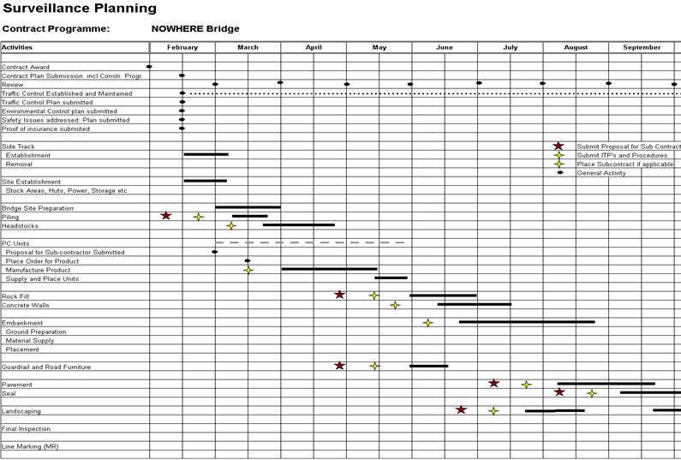
Appendix F – Surveillance Schedule

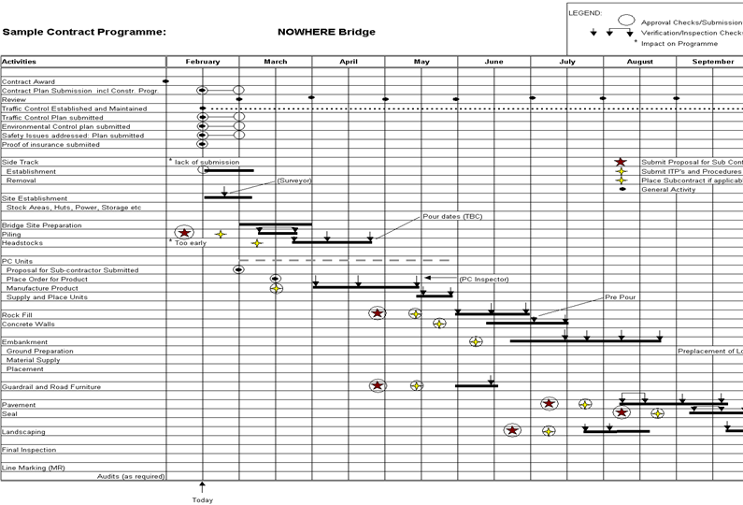
Appendix G – Administrator's Surveillance Program

Appendix H – Specialists and Support Staff

Appendix I – Delegation of Responsibilities from the Administrator

Appendix J – Duty Statement for the Site Engineer

Appendix K – Duty Statement for the Inspector / Surveillance Officer

Appendix L – Contact List

Appendix M – Registers and Issue Management

Appendix N – Audit Program

Appendix O – Product Audit Program

Appendix P – Product and Material Monitoring Program

Appendix Q – Material Quality Audit Program

Appendix R – Process Audit Program

Appendix S – External Communications Plan

Appendix T – Internal Communications Plan

Appendix U – Key Result Areas and Key Performance Indicators

