North Coast Line
Stabling Expansion
  - April 2025

Expanding stabling for our
newest trains
To support a significant increase to the state’s train fleet – which is needed to meet the growing demand for rail services – the Queensland Government is working to expand train stabling facilities across the network.
These stabling upgrades will improve network capacity and efficiency and are essential to accommodate the New Generation Rollingstock (NGR) trains and new trains being delivered by the Queensland Train Manufacturing Program (QTMP) in readiness for Cross River Rail.
The North Coast Line Stabling Expansion is part of the New Generation Rollingstock Compatible Stabling Yard Upgrades project.
It also delivers on the priority outcomes for the SEQ rail network including:
- Ready for Cross River Rail
- Better journeys for customers
- Easier access to more locations.

What is a train stabling facility?
A stabling facility is a depot where trains are parked when they are not in operation. Trains return to the stabling facility at the end of service and are parked on the site throughout the night (or when they are not in use).
At night, trains parked on the site are cleaned and prepared for the next day’s service. This can include minor maintenance, removing waste and routine inspections.

Greater efficiency, reduced costs,
improved services
By providing additional train stabling closer to the end of each line or where services start and end, the network will operate more efficiently, improving services and reducing costs.
Well-located stabling facilities:
- increase reliability
- reduce network operating costs
- improve network capacity (relieving pressures, junction conflicts and freeing up track space)
- ensure faster response times in case of track or train failure.

How are expansion locations chosen?
The Department of Transport and Main Roads (TMR) is currently investigating study areas for preferred upgrade locations as part of planning for the North Coast Line Stabling Expansion project.
Potential locations are assessed against various criteria including benefits for rail customers, rail network operational requirements and suitability, future network stabling needs, technical feasibility, environmental and social impact, constructability and cost.
The project team has identified potential upgrade options to expand existing stabling facilities at Nambour and Elimbah.
These sites are able to support safe and reliable rail services for customers, while minimising impacts on the community and environment.
Locations and timeframes will be confirmed as part of a comprehensive planning investigation and options analysis process.
The community will be informed as the project progresses and updated when planning is complete.
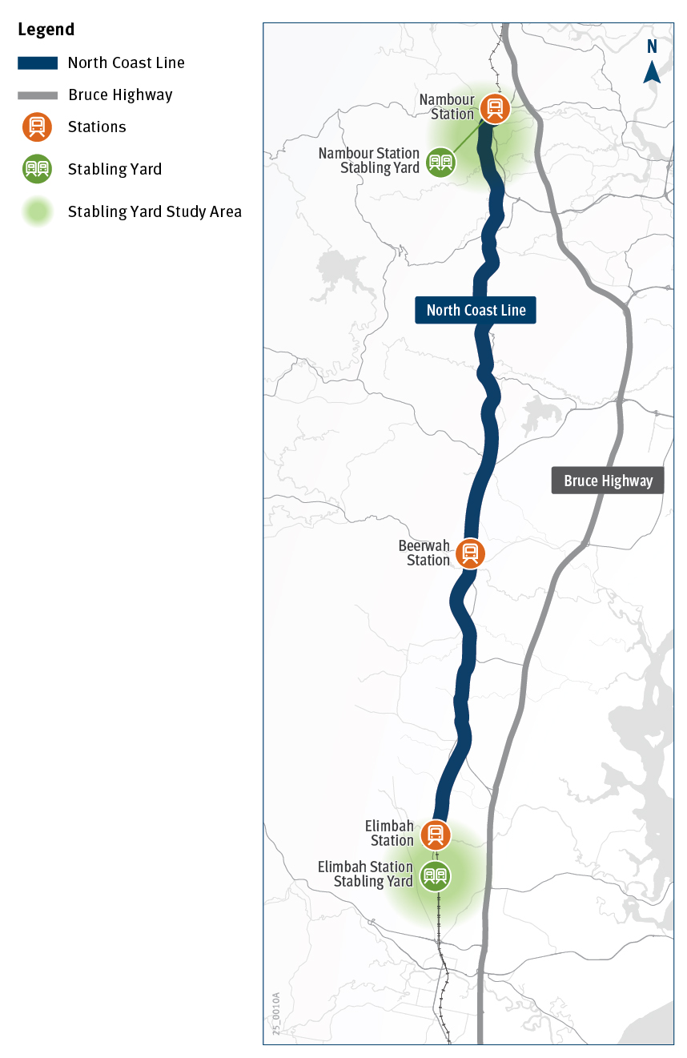

Contact us
Phone: 07 5451 7055 (Monday to Friday, 9am to 5pm)
Email: SCPublicTansport@tmr.qld.gov.au
Web: www.tmr.qld.gov.au/north-coast-line-stabling-expansion
Post: North Coast Line Stabling Expansion Department of Transport and Main Roads PO Box 1600, Maroochydore, Qld 4558

