

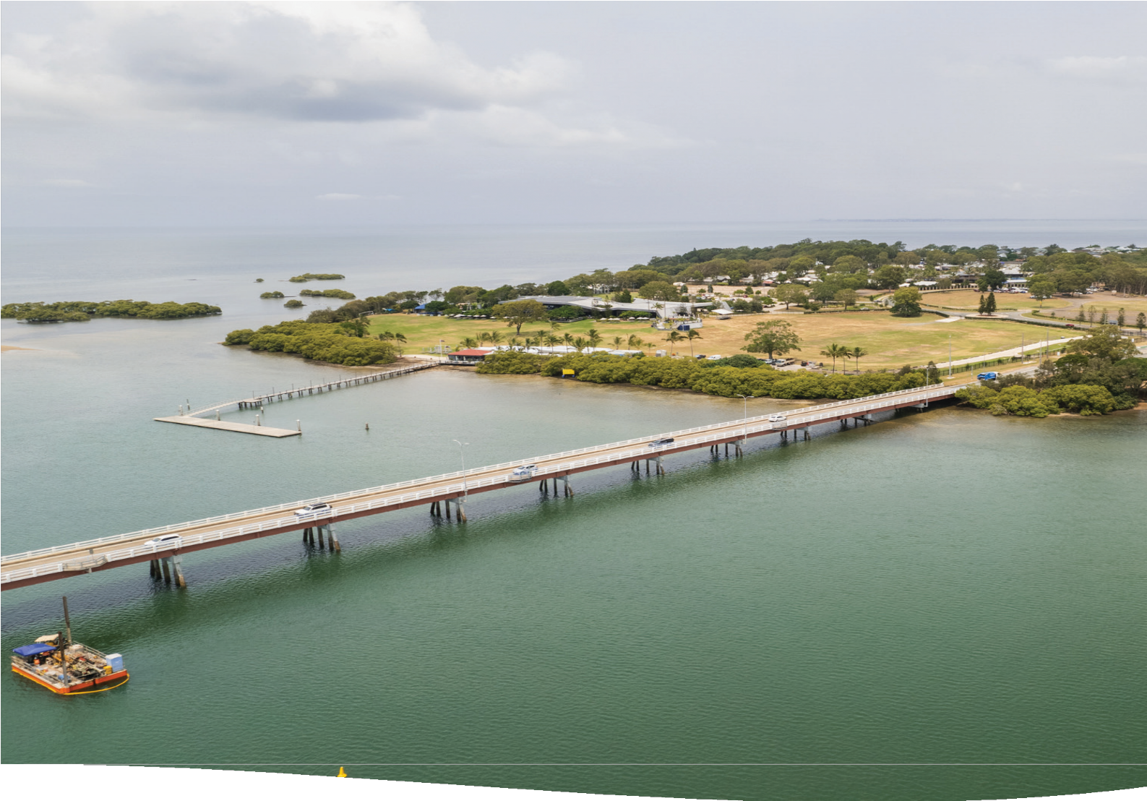

Department of Transport and Main Roads

Business Case Summary

Bribie Island bridge upgrade
April 2025




Aerial view of the existing Bribie Island bridge

Planning process
The Department of Transport and Main Roads (TMR) undertakes rigorous planning for major road and transport infrastructure in accordance with Queensland Treasury’s Project Assessment Framework (PAF) process.
The PAF process is used across government to ensure a common, rigorous approach to assessing projects at each stage of their lifecycle. The PAF ensures that a project meets strategic objectives and demonstrates value for money.
The PAF documents form the basis of advice to government and key decision makers and enable them to make an informed decision regarding whether to invest in the proposed project.
The Bribie Island bridge upgrade project has completed three phases of planning – a Strategic Assessment of Service Requirements (SASR), a Preliminary Evaluation and a Business Case. The SASR considers the transport issues and service requirements of the project area.
The Preliminary Evaluation considers and shortlists options to develop a preferred option.
The Business Case further develops the preferred option and provides justification for undertaking the project.
The business case is still a planning document, and more detail is required to further develop the project through detailed design. The next steps are subject to funding being allocated to progress the project.

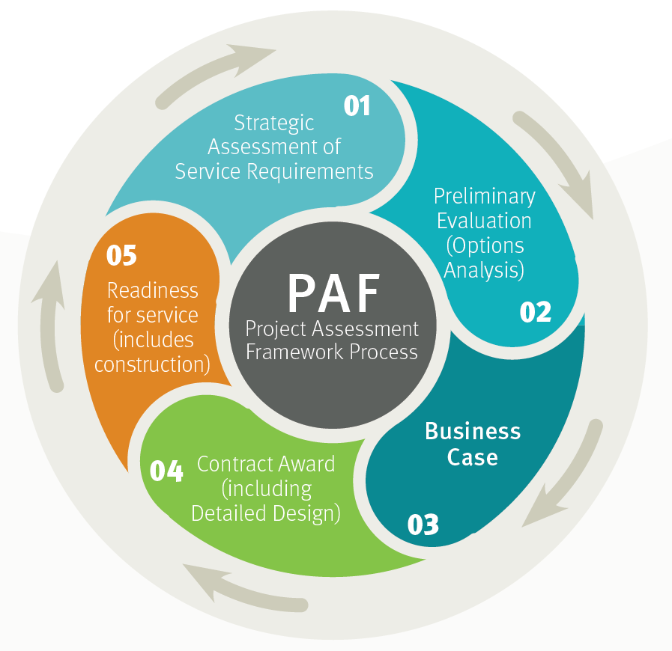

Overview
Caboolture-Bribie Island Road, a state-controlled road in the City of Moreton Bay local government area, connects Bribie Island, Sandstone Point, and Ningi to the Bruce Highway and Caboolture. The Bribie Island bridge, the focus of this planning, is situated at the eastern end of Caboolture-Bribie Island Road.

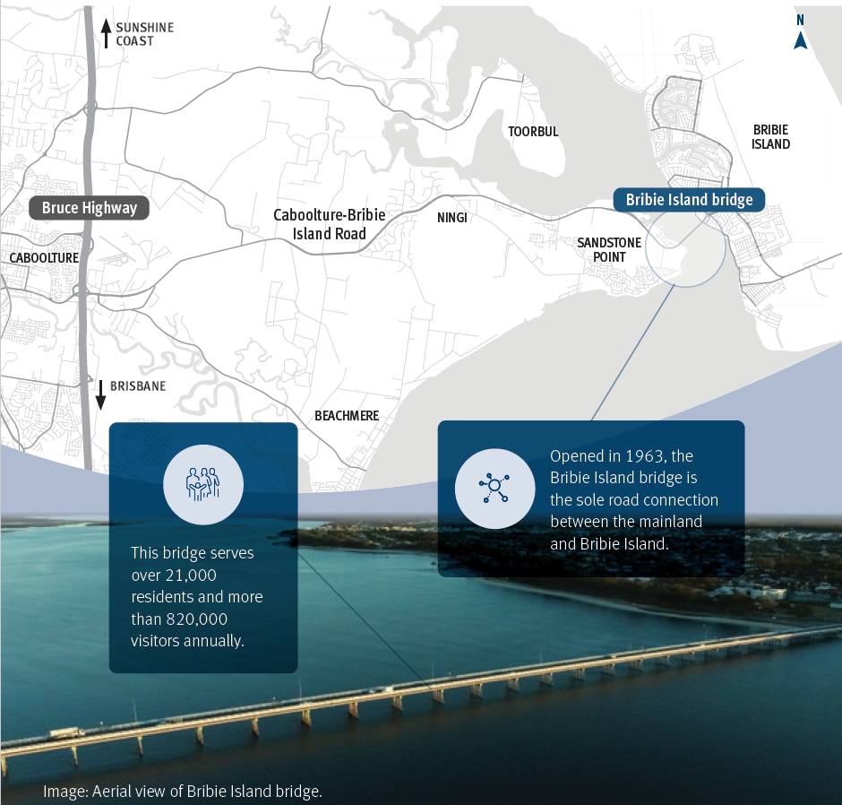

Overview
In 2023, approximately 27,200 vehicles crossed the bridge daily. The narrow bridge deck contributes to frequent crashes and restricts its functionality during incident management, causing lengthy delays and limiting emergency services access. After a crash or incident on the bridge, the recovery time until traffic flow is normalized, can be lengthy, with incident duration lasting up to two hours and recovery periods extending for many hours beyond that.
The current active transport path is narrow, offering a poor level of service for pedestrians and cyclists. When the railing is damaged, the path often remains closed for several days for repairs. These problems reduce the attractiveness of active transport as a mode of travel between the island and mainland.
Robust analysis and technical investigations recommend constructing a new two-lane bridge for eastbound traffic with an active transport path, while reconfiguring the existing bridge for westbound traffic.
Upgrades will also be made to the bridge approaches and adjacent intersections at Sandstone Point Hotel and Sylvan Beach Esplanade to enhance safety and efficiency. This upgrade addresses the identified issues and supports sustainability objectives by continuing use of the existing bridge (as a traffic bridge).
Duplicating the bridge capacity aligns with TMR’s Caboolture-Bribie Island Road Upgrade Strategy. This strategy outlines Queensland Government’s vision to upgrade the road to provide a four-lane median-divided cross section for the length of the corridor (between the Bruce Highway and Bribie Island). The risk adjusted estimated cost for the recommended option is $756.56 million.

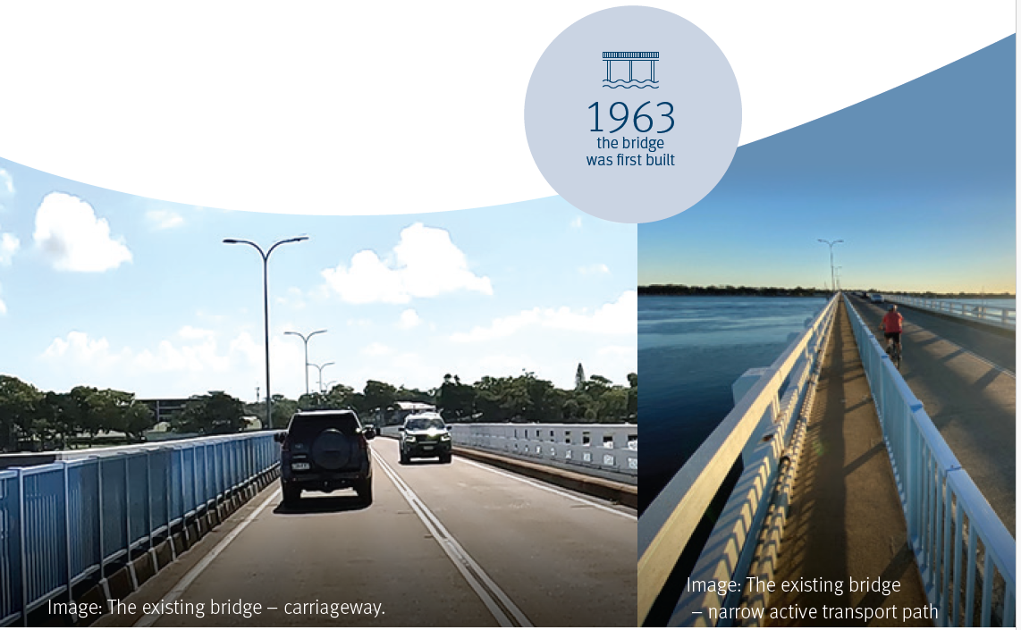

Project background
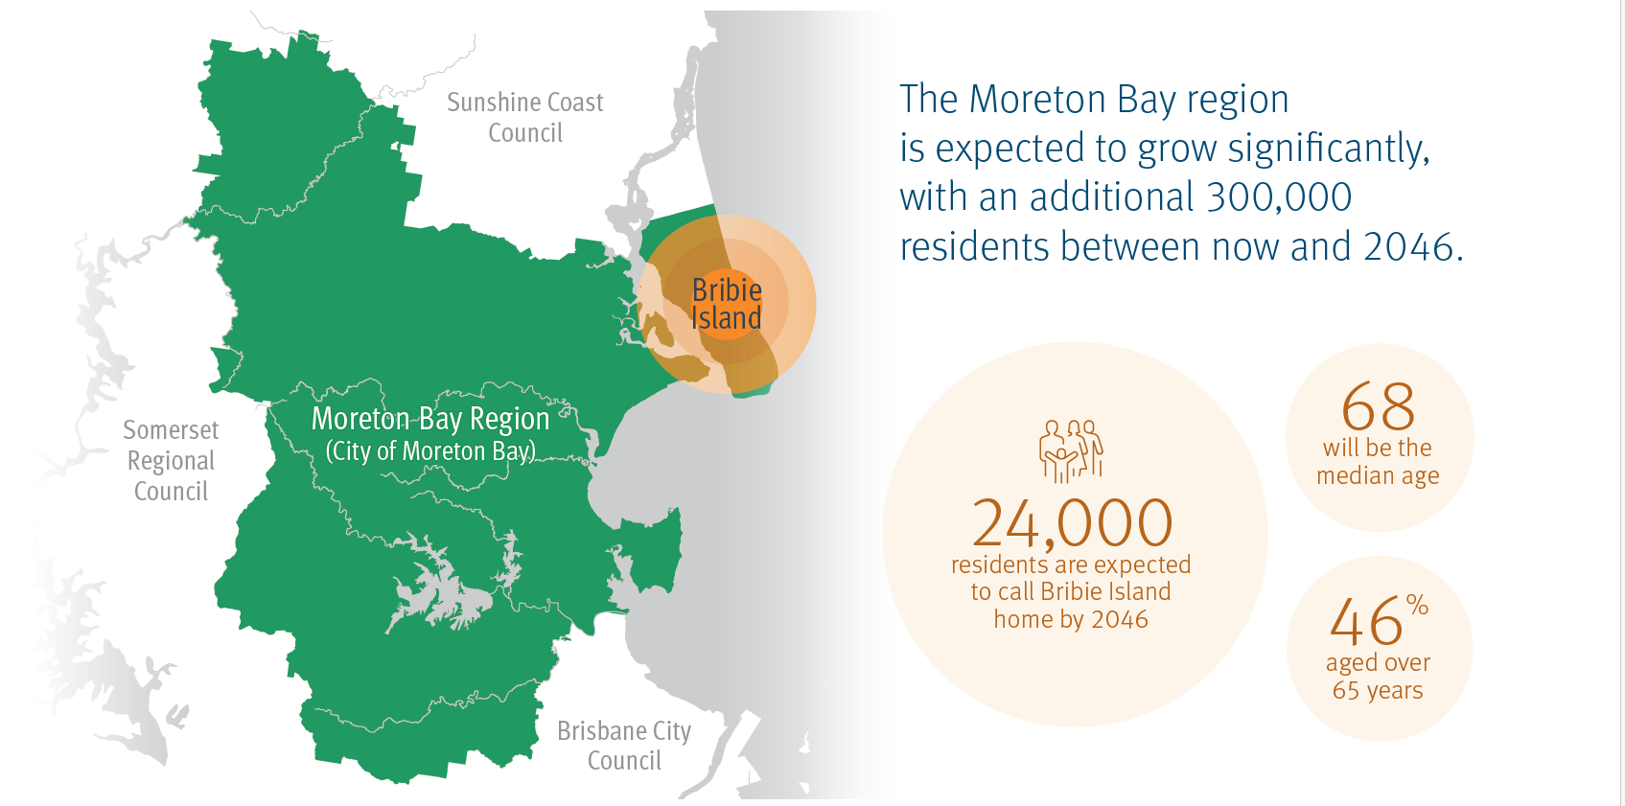
A growing region
The City of Moreton Bay is home to over 485,000 residents (2021), and tourism accounts for 4.2 per cent of the region’s economy.
In recent years, the region has attracted approximately 4.6 million visitors annually, with Bribie Island alone drawing about 820,000 guests, representing 18 per cent of all visitors to the region.
The local economy benefits significantly from the tourism industry, receiving around $1.3 billion each year. Given that Bribie Island is a key tourist destination, maintaining efficient and reliable access is crucial for the sector’s continued growth.
The Moreton Bay region is expected to grow significantly, with an additional 300,000 residents between now and 2046.
As growth occurs, more tourists are likely to travel to the island outside of peak periods, further increasing the need for reliable and resilient access, and safe and amenable active transport facilities.
Local context
The projected population growth for Bribie Island is modest, with an estimated increase from approximately 21,700 to 24,000 by 2046.
This slow growth rate is attributed to the island’s limited capacity for new developments. It is anticipated that the demographic composition will remain largely unchanged by 2046, with the median age rising to 68 years.
Additionally, a similar proportion of the population, constituting 46 per cent, will be individuals aged over 65 years. Residents within this age group are particularly vulnerable during emergency situations due to potential mobility challenges.

Project background
The existing bridge
The existing Bribie Island bridge is comprised of pre-stressed and post-tensioned concrete components (38 spans that are each 22m long).
The existing active transport path sits on a cantilevered kerb, offset from, and higher than the main carriageway. The cantilevered arrangement does not allow the path to be repurposed to provide additional width for vehicle traffic to increase safety or resilience of traffic movements.
Regular inspections inform the monitoring and maintenance of the existing Bribie Island bridge, which has been subject to routine visual inspections, with six undertaken since 2014.
TMR has undertaken ongoing maintenance and progressive rehabilitation of piles, including two piles rehabilitated in 1997 and a further six piles rehabilitated between 2013 and 2020.
Detailed investigations have also been undertaken as part of the current planning. The inspections indicate that the bridge is performing as is typical of a structure in a marine environment.
Detailed inspections and testing were undertaken on the existing structure in late 2022 to understand its current condition and inform maintenance requirements.
The inspection confirms the bridge structure is performing well and is deemed suitable for continued use as a transport bridge and has been considered as a component of options for access to Bribie Island into the future.
Piles will continue to be inspected, monitored, and rehabilitated when required to manage long- term performance.
Service need
Planning confirms the need to improve access resilience, improve active transport safety and amenity and address growing safety issues.
The impact of traffic incidents on the bridge is significant and the narrow bridge has insufficient room for effective incident management. The narrow bridge and the proximity of the nearby intersections contribute to poor safety and operational outcomes.
Eighteen (18) crashes have been reported within the project area between July 2018 and June 2023. Without intervention, the risk of crashes will continue to increase, particularly as the region grows and demand for travel to the island increases.
Without intervention, future incidents will continue to result in single lane or full closure of the bridge for periods, limiting access for emergency services and contributing to lengthy traffic delays and recovery times.

Project background
There are 25 records of unplanned incidents on the bridge since 2010 that have resulted in closures. The frequency of unplanned incidents has been increasing and without intervention, the current challenges will continue.
When full closures occur, emergency services are unable to access the closest regional hospital in Caboolture with urgent evacuation from the island requiring air transportation.
Single lane closures are more common and result in major delays, also impacting access for emergency services.
Closures resulting from unplanned events also impact productivity and public transport services.
Any major unforeseen incidents on the island (such as a bushfire) could make evacuation challenging due to lack of alternative road access.
The occurrence of a crash on the bridge during such an event is the worst-case scenario that could have major consequences for the safety of the island’s residents.
The existing active transport path does not meet current Disability Discrimination Act (DDA) standards and the path width does not facilitate two directional travel between passing bays. The narrow path also leads to poor amenity and accessibility for all active transport users.
The narrow width results in some bike riders electing to use the road, which increases the risk of bicycle crashes. In addition, when crashes damage the path railing, the path is often closed for several days to facilitate repairs.
There are no on-road cycle lanes on the existing bridge. The traffic lanes do not allow vehicles to pass on-road bike riders without encroaching into the opposing traffic lane.
These conditions contribute to poor safety and amenity for pedestrians, bike riders and mobility device users.
These problems contribute to reduced attractiveness of active transport as a mode of travel between the island and mainland, and likely results in a shift of some trips to motor vehicles.

Project options
The options below have been assessed for their ability to address the project issues, and:
- provide reliable access for the community and emergency services during unplanned incidents
- improve safe movement for all road users
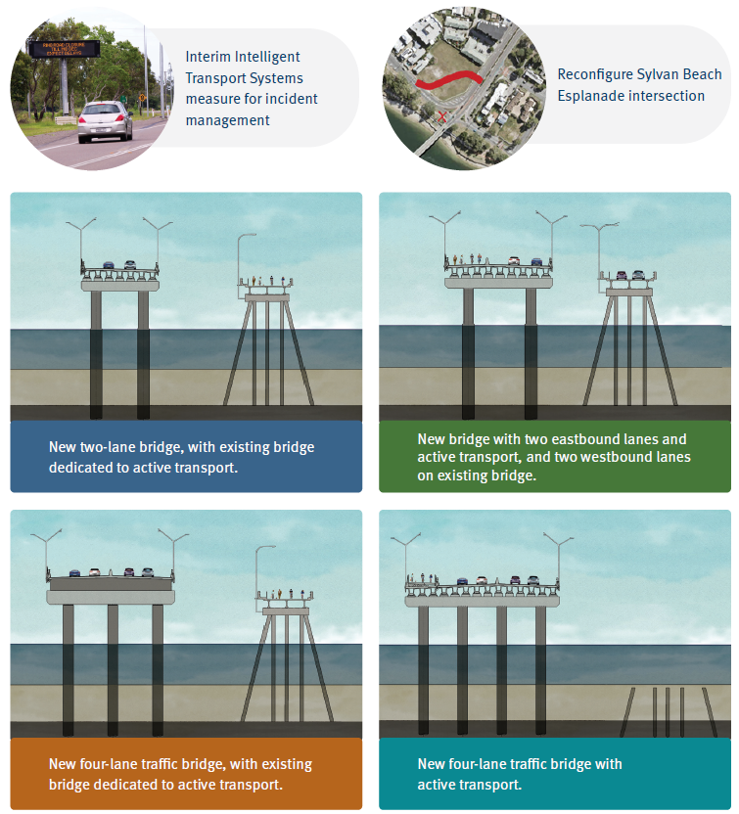
- improve accessibility and uptake of active transport modes.
New bridge with two eastbound lanes and active transport, and two westbound lanes on existing bridge.

New two-lane bridge, with existing bridge dedicated to active transport.

New four-lane traffic bridge with active transport.

New four-lane traffic bridge, with existing bridge dedicated to active transport.

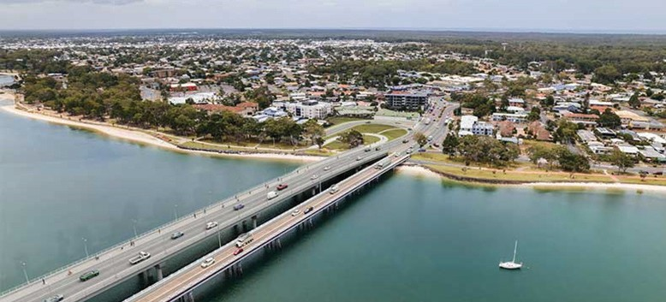

Shortlisted options
Following an assessment of the options against the service requirements, the below options were shortlisted for further technical development and assessment for the following reasons:
- they address the project needs and align with community consultation feedback
- both options satisfy all service requirements
- they achieve a sustainable outcome by retaining the existing bridge as either a traffic or active transport facility
- they align with the long-term Caboolture- Bribie Island Road Upgrade Strategy
- against the assessment criteria, they consistently perform better than other options.

Both shortlisted options achieve similar safety outcomes based on a safe systems assessment, with an estimated 40 per cent reduction in crash risk relative to the base (existing) case. The evaluation recognised that Intelligent Transport System (ITS) measures and Sylvan Beach Esplanade intersection upgrade should be incorporated in the future bridge upgrade.
In addition, the new four-lane bridge with active transport option was recognised as a potential long-term vision for access to Bribie Island that could be realised when the existing bridge has reached the end of its service life. The shortlisted options were further investigated and developed for detailed technical evaluation.
Details of shortlisted options
Consideration | New bridge with two eastbound lanes and active transport, and two westbound lanes on existing bridge | New four-lane traffic bridge, with existing bridge dedicated to active transport.
Bridge design | - 858m long with 22 spans  - Concrete cast-in place piles
Bridge configuration | - New 17.7m wide bridge, located north of the existing bridge  - Two x 3.5m eastbound lanes on the new bridge  - Wider shoulders are provided for incident management purposes  - New 5.5m segregated pathway on the new bridge  - Two westbound traffic lanes on the existing bridge  - Separation of carriageways on the new/existing bridges | - New 21 m wide bridge, located north of the existing bridge  - Four x 3.5m traffic lanes on the new bridge  - Existing bridge converted to a 7.3m wide active transport facility  - Median separation of carriageways
Active transport (AT) | - Segregated AT pathway on new bridge | - Segregated AT pathway on existing bridge
 | - Off-road shared paths on eastern and western approaches connect the bridge to existing networks
Western approach | - Signalisation of Sandstone Point Hotel access intersection  - Four traffic lanes from Bestmann Road East through to bridge
Eastern approach | - Upgrade of Sylvan Beach Esplanade intersection to improve safety  - Four traffic lanes from bridge through to Eucalypt Street roundabout
Incident management | - Ability to contraflow traffic during lane closures or incidents to maintain access (by running two-traffic on a single carriageway)

Preferred option
The second stage of the Options Analysis assessed the shortlisted options to determine a preferred option.
The multi-criteria assessment of the shortlisted options included a range of sensitivity test scenarios to confirm the robustness of the assessment. In all assessment scenarios, the new two-lane bridge with active transport was the preferred option.
The new bridge with two eastbound traffic lanes and active transport, and two westbound traffic lanes on the existing bridge, was selected as the preferred option for the following reasons:
- delivers positive outcomes across all service requirements
- improves safety for all users
- results in a reduced environmental impact in the Pumicestone Passage than the four-lane bridge option
- the initial construction cost (capital outturn cost) and whole of life cost is less than the four-lane bridge option
- increases resilience to unplanned events
- increases active transport accessibility and capacity
- supports sustainability objectives by maximising use of the existing bridge (as a traffic bridge)
- aligns with community and stakeholder feedback received from two phases of community engagement.
The preferred option addresses the service requirements, supports sustainability objectives by maximising use of the existing bridge (as a traffic bridge) and has a lower capital outturn cost, and whole of life cost, than the other shortlisted option, with similar economic performance.
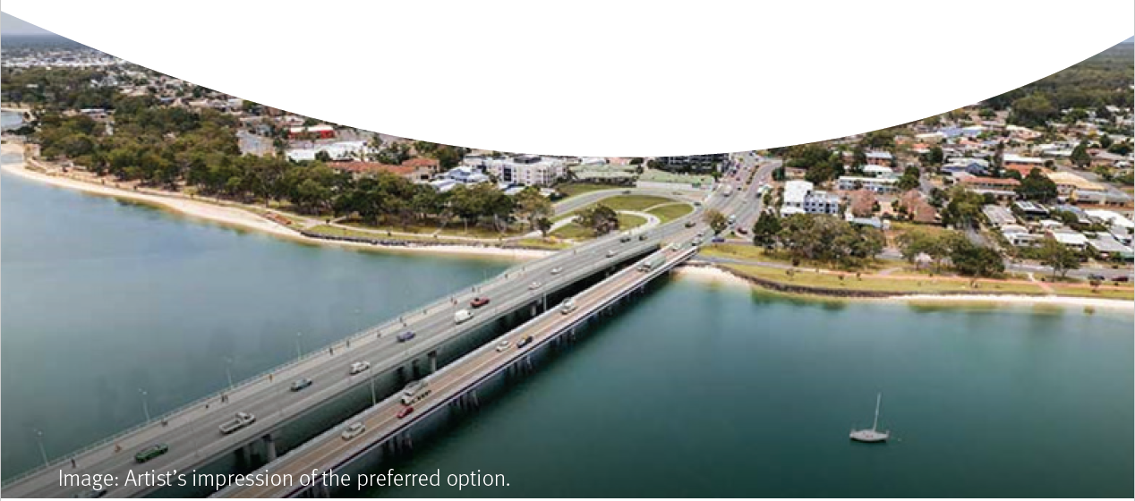
Suitability of the existing bridge has been confirmed through structural inspections and assessments, and this arrangement will remain until such time as the existing bridge is no longer serviceable. The preferred option will be designed to enable future widening to four lanes with an active transport path in the long-term, when the existing bridge is no longer cost effective to maintain.

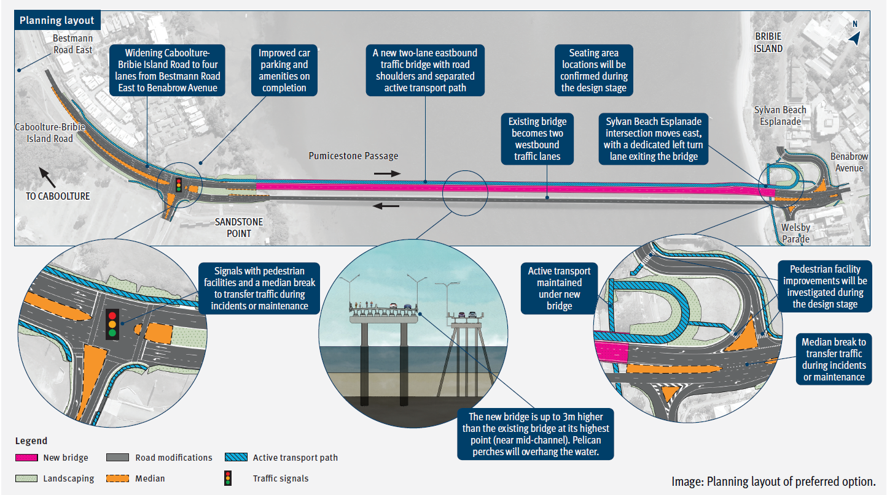

Preferred option

Seating area locations will be confirmed during the design stage
A new two-lane eastbound traffic bridge with road shoulders and separated active transport path

11 Transport and Main Roads, Business Case Summary, Bribie Island bridge upgrade, April 2025

Transport modelling and analysis

Since its opening in 1963, the bridge experienced steady traffic growth up to 2019, after which traffic volumes declined, coinciding with the COVID-19 pandemic years. Usage has since increased in 2022 and 2023, with approximately 27,200 vehicles traversing the bridge per day in 2023.
vehicles crossed the bridge daily in 2023
27,200













35,000

30,000

25,000
AADT

20,000

15,000

10,000

2012 2014 2016 2018 2020 2022 2024
Reporting Year

Figure: Historical Annual Average Daily Traffic on the bridge (both directions).

Transport models were developed for the project area to evaluate and compare shortlisted options against the base case (without the project) based on observed traffic volumes from 2019, and projected traffic volumes for 2036 and 2046.
The analysis demonstrates that without the project, the future road network has insufficient capacity to meet projected traffic demand in 2036 and 2046.
Modelling shows that without the proposed project upgrades, the bridge and its approaches are expected to form a capacity constraint, resulting in delays and queuing.
Both shortlisted options will provide a substantial improvement in the average network speed during typical weekdays in 2036 and 2046 and can be expected to reduce the total vehicle hours travelled. Analysis showed only marginal differences between the shortlisted options.
The preferred option resulted in a substantial improvement in travel time, compared to the base case (without the project). Whilst congestion is forecast on public holidays (due to increased traffic demand associated with increased tourism and visitors), it is noted that public holidays represent only three per cent of days throughout the year.

Transport modelling and analysis
Traffic demand
Maximum latent demand
VHT
VKT
Average network speed (km/h)
Modelling indicates that in the base case, a typical incident results in average network travel speed reducing to 20-30km/h over a prolonged 13-hour period on a typical weekday in 2046. During incidents, the preferred option provides an 87 per cent reduction in average vehicle delays compared to the base case.
Without the project, transport modelling indicates several Translink services (640, 641, 642, 643 and 644) will be impacted with additional delays potentially resulting in reduced patronage within the project area.
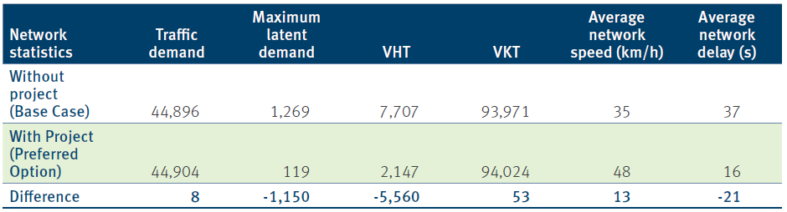

Table: 2046 modelled network performance comparison – “Average Day” without an incident. VHT= vehicle hours travelled. VKT = vehicle kilometres travelled.
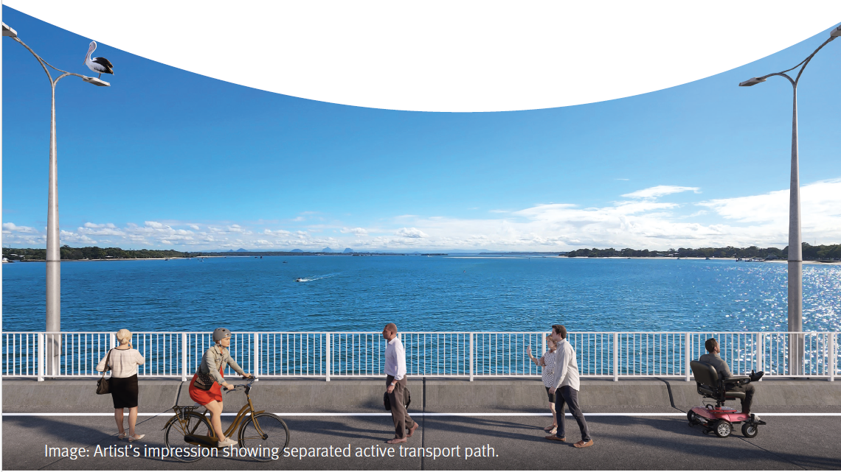

Environment and cultural heritage
The project is in the Pumicestone Passage, in an area that is within and adjacent to the Moreton Bay Ramsar Wetland (a Matter of National Environmental Significance) and the Moreton Bay Marine Park (a Matter of State Environmental Significance).
The environmental characteristics of the project area have considerable influence on the scope, approval requirements, investigation and project timeframes, construction methodology and costs. A Review of Environmental Factors (REF) was informed by water quality, soil and land management, biodiversity, cultural heritage, air, noise, amenity, resource use and land tenure assessments.
The REF identified that substantial approvals will be required for the project to progress exploratory, and investigation works, as well as the main construction activities. The project has prepared an Environmental Management Plan (Planning) and mapped the applicable legislation, referrals, approvals, and indicative timeframes for the project.
This will enable TMR to appropriately plan the investigation, development and delivery phases and manage any potential time risks associated with environmental and cultural heritage approvals.
The following approvals will be required prior to any construction:
- approval under the Environment Protection and Biodiversity Conservation Act 1999
- approval for works within the Moreton Bay Marine Park under the Marine Parks Act 2004 and the Marine Parks (Moreton Bay) Zoning Plan 2019 (Zoning Plan)
- development approval under the Planning Act 2016 for operational work within a coastal management district (CMD)
- development approval under the Planning Act 2016 for prescribed tidal works for the bridge construction and associated works within the CMD
- development approval for operational work under the Planning Act 2016 that is constructing or raising waterway barrier works for permanent or temporary works
- development approval under the Planning Act 2016 for impact to marine plants
- species management program under the Nature Conservation Regulation
- soil disposal permit under the Environmental Protection Act 1994.
The project may also trigger potential environmental offsets and require mitigation measures, depending on the footprint of construction activities and extent of impacts. Further detail will be provided in future project stages, subject to funding for additional assessment and investigation.
As legislation changes regularly and field investigations must be renewed each 12 months, it is appropriate for detailed investigations to occur during the preconstruction phase after the project is funded for delivery.
Further noise assessments are required during the detailed design phase to consider the need, potential location, and design of noise mitigation treatments.
TMR has and will continue to consult with the traditional owners, the Kabi Kabi people, regarding identification and management of cultural heritage issues and appropriate participation in future project phases.

Cost and risk
Risk adjusted cost estimates were prepared in accordance with TMR’s Infrastructure Cost Estimating Policy and Project Cost Estimating Manual, and the Project Risk Management and Contingency Development Process Manual (aligned to the International Standard for Risk Management ISO31000).
The P90* outturn cost estimate is $756.56 million.
Key project risks include:
- Environmental: approvals due to location in Pumicestone Passage, within and adjacent to Moreton Bay Ramsar Wetland and the Moreton Bay Marine Park. The environmental characteristics of the project area have considerable influence on the scope, approval requirements, investigation and project timeframes, construction methodology and costs.
- Geotechnical: while preliminary investigations have been undertaken for the bridge, further assessment is required to provide sufficient detail to inform the design and construction method. In addition, investigation to inform the approach road embankment is also required. Detailed investigations are recommended to occur during design.
- Community and stakeholders: while extensive community consultation has informed the planning and concept design process, the final project scope and impacts during construction will require additional consultation. It is imperative that road and marine traffic are appropriately managed during construction and the community is further consulted during design development.

Whole of Government policy issues

Analysis of government policy and legislation relating to procurement, employment, transport policy, climate change and sustainability revealed no issues that would prohibit the project proceeding. Queensland suppliers and contractors will be given full, fair, and reasonable opportunity to tender and participate in all stages of the project, and procurement policies will support the creation of local jobs.

* P90 - Project cost with sufficient contingency to provide 90 per cent likelihood that this cost would not be exceeded.

Public interest assessment

For the project to be in the public interest, there should be equity between the recipients of benefits and bearers of associated costs. The public interest assessment examined the project’s ability to meet the service requirements, ensure public access and equity, achieve accessibility compliance, ensure accountability and transparency in project activities and address consumer rights, security, and privacy.
The assessment found that residents of Bribie Island and surrounds will substantially benefit from delivering this project. The identified service requirements will be addressed by the upgrade which will improve the reliability of access for the community and emergency services during unplanned incidents, increase safety for all road users and improve accessibility and amenity for active transport movements.
Extensive community and stakeholder consultation has informed the planning and concept design. Two stages of formal community consultation were undertaken, with stage one in early 2023 seeking feedback on the issues and broader options, and stage two in early 2024 seeking feedback on the preferred option. This consultation revealed strong community support for an upgrade, desire to keep the existing bridge, the need to resolve accessibility issues for active transport users and the need to improve reliability of access during incidents.
The preferred option aligns well with the community and stakeholder feedback. The results of community consultation are available on the TMR website project page.

Project implementation

A delivery model assessment recommended that a Transport Infrastructure Contract – Construct Only (TIC-CO) with Early Tenderer Involvement (ETI) or Guided Tenderer Alternative (GTA) are the preferred contract forms. TMR is mature in delivering major projects of this nature, and TIC-CO is well understood by industry and suited to managing a wide range of construction and legal risks.

The GTA or ETI variant would provide the opportunity for TMR to seek contractor involvement in the design process to address potential constructability challenges. This delivery model will be subject to review when funding is allocated for construction.

Substantial investigation and approvals are required for the project to proceed. Once funding is committed, the development phase will progress investigations, approvals, and design, followed by construction activities. While an indicative program has been developed to inform project estimating, a detailed project schedule will be developed during future project stages.
The bridge construction program is expected to consist of two main construction phases: enabling works and construction works. The enabling works are expected to occur over a six-month duration and include all works required prior to the commencement of the main bridge and approach construction works.
Subsequent construction phase works are expected to occur over a 33-month (i.e. two years and nine months) duration for the preferred option.
The existing Bribie Island bridge is the only connection between the island and mainland and will remain open during construction, with only brief periods of temporary lane or path closures (for example, during the lifting of pile liners, or girder placement). The preferred option allows for construction of the new bridge offline. During the design phase TMR will undertake further consultation with the community around impacts during construction.
Water, energy and communications infrastructure on the existing bridge will be maintained with relocation of services on the bridge approaches required and further investigation to be undertaken during design.

Economic analysis
Economic analysis indicates benefits from travel time savings and reliability of access, vehicle operating costs, avoided crashes, improved incident response and access to essential services along with improved active transport access, encouraging walking and cycling, and improving health and wellbeing.
Improved access could provide the potential for the expansion or development of new tourism related businesses. It is estimated the project will support an average of 570 direct full-time equivalent jobs (noting this is subject to change as project design and costs are further refined and developed).

Next steps
Following consideration of the planning outcomes by the Queensland Government and funding commitment, TMR would undertake procurement activities for a detailed design and construction contractor.
TMR will keep the community updated on project progress as key milestones are reached.


25_002A
13QGOV (137468)
www.tmr.qld.gov.au
www.qld.gov.au

