|  |
| --- |
| Review of the Heavy Vehicle Registration Assessment Scheme (HVRAS)  Discussion Paper  October 2023 |

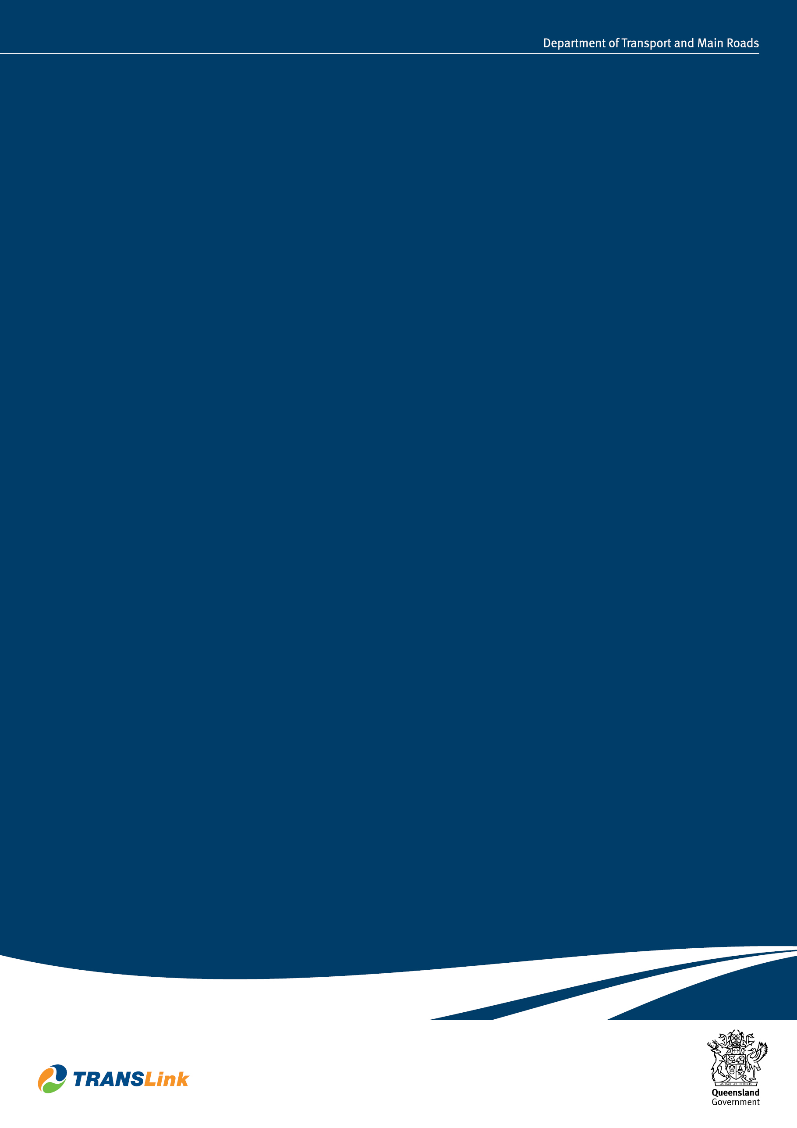

**Creative Commons information**

© State of Queensland (Department of Transport and Main Roads) 2023

88x31

<http://creativecommons.org.licences/by/4.0/>

This work is licensed under a Creative Commons Attribution 4.0 Licence. You are free to copy, communicate and adapt the work, as long as you attribute the authors.

The Queensland Government supports and encourages the dissemination and exchange of information. However, copyright protects this publication. The State of Queensland has no objection to this material being reproduced, made available online or electronically but only if it is recognised as the owner of the copyright and this material remains unaltered.

|  |  |
| --- | --- |
| Interpreter_Symbol | The Queensland Government is committed to providing accessible services to Queenslanders of all cultural and linguistic backgrounds. If you have difficulty understanding this publication and need a translator, please call the Translating and Interpreting Service (TIS National) on 13 14 50 and ask them to telephone the Queensland Department of Transport and Main Roads on 13 74 68. |

Disclaimer: While every care has been taken in preparing this publication, the State of Queensland accepts no responsibility for decisions or actions taken as a result of any data, information, statement, or advice, expressed or implied, contained within. To the best of our knowledge, the content was correct at the time of publishing.

Any references to legislation are not an interpretation of the law. They are to be used as a guide only. The information in this publication is general and does not take into account individual circumstances or situations. Where appropriate, independent legal advice should be sought.

Contents

[Chapter 1 – Introduction 4](#_Toc148360326)

[Chapter 2 – Compliance Considerations 6](#_Toc148360327)

[Register of Approved Vehicles (RAV) 6](#_Toc148360328)

[Vehicles not on the RAV 8](#_Toc148360329)

[Chapter 3 – Impact of Removing HVRAS 10](#_Toc148360330)

[Impacts on Compliance and Road Safety 10](#_Toc148360331)

[Impacts on Vehicle Owners 11](#_Toc148360332)

[Impacts on HVRAS Accredited Persons 11](#_Toc148360333)

[Appendix 1 – Requirements for RAV Entry by Vehicle Type 12](#_Toc148360334)

Chapter 1 – Introduction

The Department of Transport and Main Roads (TMR) requires an inspection to be completed prior to new business registrations for heavy vehicles over 4.5t gross vehicle mass (GVM) and trailers over 750kg aggregate trailer mass (ATM). The inspection can be performed by a TMR officer, Queensland Police Service (QPS) Officer, or in many cases, a Heavy Vehicle Registration Assessment Scheme (HVRAS) accredited person. New business refers to vehicles that have never been registered in Queensland before, interstate vehicles transferring to Queensland, and the re-registration of vehicles with expired or cancelled registration.

TMR approves HVRAS accredited persons to inspect heavy vehicles and trailers under the HVRAS Business Rules. The purpose of HVRAS is to provide an alternative to having the vehicle taken to TMR or QPS for this inspection. The inspection ensures the vehicle/trailer is compliant with dimensional and mass limitations prior to new registration and collects information for registration purposes. The HVRAS also reduces the need to have vehicle inspection facilities at all Transport and Motoring Customer Service Centres that meet workplace health and safety standards, and reduces the workload on TMR and QPS.

TMR has undertaken an internal review of HVRAS and identified that the information collected from a HVRAS inspection for registration purposes is either no longer used or is already collected by TMR in other ways. Additionally, new compliance processes introduced by the Commonwealth Government mean that a HVRAS inspection is an unnecessary duplication in some cases. It is therefore proposed that HVRAS inspections be discontinued. This would mean that the HVRAS accreditation scheme is no longer required.

The purpose of this discussion paper is to seek your views on the impact of removing HVRAS.

**Please note that a decision has not yet been made about the removal of HVRAS.**

**Who might have an interest in this consultation?**

This discussion paper is for anyone involved in, impacted by, or interested in the provision of HVRAS services. This includes:

* individuals who hold a current HVRAS accreditation
* individuals who employ HVRAS accredited persons (for example, vehicle/trailer dealers or manufacturers, Approved Inspection Stations (AIS), heavy vehicle mechanical workshops)
* groups that represent the above parties.

**How can I have my say?**

We want your feedback on the discussion paper. Please complete the attached consultation response survey. Responses to the survey are anonymous.

Alternatively, you can email your feedback to [HVRAS\_Policy@tmr.qld.gov.au](mailto:HVRAS_Policy@tmr.qld.gov.au). Questions you may wish to consider in providing your feedback include:

* What impact could the proposal to remove HVRAS have on you and/or your business, both positive and negative?
* Are there any issues that you think have not been considered in this discussion paper?
* Do you support the removal of HVRAS?

While this paper has identified TMR's proposed approach, this is based on current knowledge and is for discussion. TMR will consider all feedback received and may consult further with stakeholders to better understand the issues and impacts.

Chapter 2 – Compliance Considerations

The purpose of HVRAS is to provide people with accreditation to inspect heavy vehicles (more than 4.5 tonne GVM) and trailers (more than 750kg ATM) to ensure they comply with:

* dimensional limitations
* approved load sharing axle systems guidelines
* safe tyre limits
* vehicle identifiers (for example, engine number, vehicle identification number and chassis number).

TMR’s internal review of HVRAS identified that information about load sharing axle systems and safe tyre limits is no longer recorded or utilised by TMR. While a HVRAS accredited person must record the vehicle identity to link the information collected to the vehicle, it is not recognised by TMR as an official identity verification check. TMR has other processes in place for identity management of vehicles and trailers and in some cases the vehicle will need to be presented separately to either a TMR or QPS Officer for an official identity verification.

Additionally, recent changes to Commonwealth legislation for the provision of road vehicles in Australia has seen improvements in compliance verification before a vehicle is presented for registration in state and territory jurisdictions. Prior to the implementation of the *Road Vehicle Standards Act 2018 (CTH)* (RVSA)*,* TMR needed to check the vehicle to ensure it was manufactured to comply with national standards.

Following full implementation of RVSAon 1 July 2023 there are a range of verification documents which are checked by the Commonwealth Government prior to first registration, and new processes for enforcing the correction or recall of non-compliant vehicles. As a result, TMR no longer needs to verify these details by conducting individual inspections of every vehicle.

Register of Approved Vehicles (RAV)

From 1 July 2023, all vehicles and trailers provided to the Australian market must be certified under the RVSA and entered on the RAV. There are two types of RAV entries:

* Vehicle Type Approvals
* Concessional RAV entry approvals

See Appendix 1 - Requirements for RAV entry by vehicle type.

##### Vehicle Type Approval (VTA)

A Vehicle Type Approval (VTA) allows a type of vehicle/trailer to be provided to the Australian market in unlimited quantity. To obtain a VTA, the applicant must provide:

* information about the level of control they have over the design and manufacture of the vehicles,
* a quality management system summary or certificate,
* information about the extent of compliance with ADRs (including ADR43 – Vehicle Configuration and Dimensions),
* supporting information, including, but not limited to, test reports, design manuals, procedures for manufacture, design drawings and specification documentation,
* a declaration that the accuracy and currency of supporting information will be maintained for the period of the approval, and a period of seven years after it expires, and
* a declaration that the applicant will comply with all conditions of the approval and any other requirements under the RVSA.

The above supporting information provided to the Commonwealth Government validates compliance for vehicles/trailers supplied to the Australian market under a VTA. For this reason, requiring HVRAS accredited persons to inspect vehicles/trailers that are entered on the RAV under a VTA duplicates the Commonwealth Government's compliance process and creates an unnecessary burden on the vehicle/trailer owner.

##### Concessional RAV Entry Approval

A concessional RAV entry approval is a pathway for entering certain vehicles onto the RAV.

##### Trailers

A concessional RAV entry approval for trailers allows an individual or business to import or manufacture four light trailers (<4.5t) and four heavy trailers (>4.5t) per year, without having to meet the requirements of a VTA. For heavy trailers, the applicant must provide an enforceable declaration that the trailer complies with national road vehicle standards and supporting information. The supporting information may include, but is not limited to, a model report, test reports, design drawings and specification documentation. The supporting information validates compliance with national road vehicle standards. Therefore, requiring HVRAS accredited persons to inspect heavy trailers that are entered on the RAV under a concessional entry would duplicate the checks already completed by the Commonwealth Government and create an unnecessary burden on the trailer owner.

For light trailers with concessional RAV entry, the applicant must provide photographs of the trailer and an enforceable declaration that the trailer complies with national road vehicle standards. Additionally, the applicant is required to keep supporting information for audit purposes. There is a higher risk that light trailers with concessional RAV entry may not be compliant with dimensional limitations, as compliance is self-declared. However, non-compliance can be detected through auditing actions by the Commonwealth Government, as well as on-road enforcement by TMR transport inspectors and the QPS. Due to these mitigants, requiring HVRAS accredited persons to inspect light trailers that have a concessional RAV entry is considered an unnecessary burden on trailer owners, as the risk of non-compliance is low.

##### Specialist and Enthusiast Vehicles (SEV)

Campervans and motorhomes are eligible for concessional RAV entry approval under the Specialist and Enthusiast Vehicles (SEV) pathway. The applicant must provide a model report, which sets out the requirements for the manufacture, modification (if applicable) and verification of the vehicle. These vehicles also require a physical inspection by a Commonwealth Government Authorised Vehicle Verifier (AVV). Requiring HVRAS accredited persons to inspect campervans and motorhomes that are entered on the RAV under a concessional entry would duplicate the collection of information already contained in the model report and the checks completed by the AVV.

Vehicles not on the RAV

There will continue to be new business registrations for vehicles that are not entered on the RAV, including vehicles manufactured prior to 1 July 2023 being re-registered in Queensland after cancellation/expiry and vehicles being transferred from interstate. Vehicles that are being re-registered in Queensland have previously met registration eligibility requirements, including the compliance information checked by HVRAS prior to the introduction of the RAV. Vehicles from interstate have previously been checked through pre-registration inspection processes in other jurisdictions, which are more robust than HVRAS. Vehicle dimension limits are national standards and, therefore, TMR does not need to check for compliance with specific requirements for Queensland.

If a vehicle has been modified in a way that would impact its dimensions, it is the responsibility of the vehicle owner to supply a certificate of modification with their registration application documents. If the modification documentation is from another jurisdiction and does not meet Queensland requirements, the vehicle owner is required to have the modification certified by an approved person (AP) in Queensland. While there is a risk that a vehicle may be modified in a way that makes it non-compliant, this is an existing risk that can occur after registration. TMR currently utilises on-road enforcement and complaints to identify and manage this risk.

For these reasons, requiring HVRAS accredited persons to inspect vehicles prior to re-registration in Queensland, or vehicles from interstate, would duplicate compliance checks previously completed or checks conducted under other schemes (such as the AP scheme).

Chapter 3 – Impact of Removing HVRAS

Impacts on Compliance and Road Safety

There may be a perceived road safety risk associated with HVRAS accredited persons no longer being required to confirm that a vehicle/trailer complies with dimensional limitations prior to registration. However, as discussed earlier in this paper, this will be largely mitigated by new Commonwealth Government compliance checks, including RAV entry processes.

The information collected by HVRAS accredited persons is not required for compliance or registration purposes and duplicates the Commonwealth Government's compliance checks. As a result, inspections by a HVRAS accredited person and therefore, HVRAS as an accreditation scheme, is no longer required to assure road safety.

Prior to the implementation of the RVSA there was limited ability to make the entity that originally provided the vehicle in Australia correct any non-compliance. Under the RVSA the Commonwealth Government has a range of new compliance and enforcement powers and functions to address this.

These new powers and functions can be used to assist them in making decisions on applications, monitoring compliance with the legislation and effectively responding to non-compliance. As a result, TMR does not need to duplicate Commonwealth responsibilities and functions currently provided by HVRAS.

Vehicles that are not on the RAV (Queensland vehicles being re-registered and interstate vehicles manufactured prior to 1 July 2023) have already been subject to other pre-registration inspections. Additionally, the existing AP scheme is intended to address the road safety risk associated with vehicle modifications. As noted previously, vehicle owners are required to get their modified vehicles certified prior to registration. Failure to do so is addressed through compliance under the AP scheme. As such, removal of the HVRAS scheme will not materially impact the road safety risk for non-RAV vehicles.

Impacts on Vehicle Owners

Removing HVRAS as a pre-registration requirement removes unnecessary red tape and reduces costs for vehicle owners, as it does not add value in the registration process and duplicates the new Commonwealth Government compliance checks.

There may be an impact on vehicle/trailer owners who utilise the service of HVRAS accredited persons to provide specifications of their vehicle/trailer to:

* complete the Vehicle Registration Application ([F3518](https://www.support.transport.qld.gov.au/qt/formsdat.nsf/forms/QF3518/$file/F3518_CFD.pdf)), particularly vehicle combination/configuration details,
* complete the Vehicle Details Inspection Sheet ([F3529](https://www.support.transport.qld.gov.au/qt/formsdat.nsf/forms/QF3529/$file/F3529_CFD.pdf)), or
* apply to NHVR for an oversize or over-mass permit.

Although HVRAS accredited persons may be used by some vehicle/trailer owners as a reliable source of this information, the purpose of HVRAS is not to assist with the completion of registration documentation or oversize/over-mass permit applications. Dealers, manufacturers, mechanics, APs and AIS are still available to vehicle owners for assistance collecting this information, with no need to further regulate these service providers under HVRAS. Additionally, most oversize and over-mass vehicle operators have the knowledge, skills and capability to collect this data without assistance from a HVRAS accredited person.

Impacts on HVRAS Accredited Persons

As of 28 August 2023, there are 2,245 HVRAS accredited persons in Queensland. The proposal to remove the requirement for HVRAS accredited persons to inspect vehicles and trailers and, therefore, HVRAS no longer being required as an accreditation scheme, will impact some of these accredited persons. The questionnaire associated to this paper aims to identify the size and extent of the impact.

Appendix 1 – Requirements for RAV Entry by Vehicle Type

|  |  |  |  |  |
| --- | --- | --- | --- | --- |
| **Requirements for Entry on the RAV by Vehicle Type** | | | | |
| **Vehicle Type (RAV entry type)** | **Light Trailer**  **(Concessional)** | **Heavy Trailer**  **(Concessional)** | **Light Trailer, Heavy Trailer or Heavy Vehicle**  **(VTA)** | **Heavy Vehicle**  **(Concessional)**  **Including Motorhomes** |
| **Application** | Apply to the Commonwealth Government's Department of Infrastructure, Transport, Regional Development and Communications and the Arts (DITRDCA) | | | |
| **Demonstrate Compliance** | * Self-declaration of compliance * Photographs | * Self-declaration of compliance * Supporting compliance information including (but not limited to) brake test reports, design drawings, specifications | * Full compliance documentation including but not limited to: * control over the design and manufacture * quality management system certificate * extent of compliance with ADRs * test reports * design manuals * procedures for manufacture * design drawings * specification documentation | * Compliance checked by Commonwealth Government Authorised Vehicle Verifier |
| **Non-compliance Permitted** | No | Under an exemption notice or with in-principle support from NHVR | No | No |
| **DITRDCA must be satisfied of compliance** | Yes | Yes | Yes | Yes |
| **Post-RAV entry** | A body or coupling fitted after RAV entry needs a modification certificate with a J or P code to confirm compliance, including dimensions | | | |