Appendix B

Guide to Incorporating Sustainability into Project Decision-Making

August 2020

Contents

1 Purpose of this document 1

2 Defining significant issues and decisions 1

3 Decision‑making tool process 1

3.1 Step 1 1

3.2 Step 2 2

4 Updates and reviews 3

# Purpose of this document

The purpose of this document is to facilitate the implementation of sustainability in decision‑making, specifically in relation to issues or decisions identified as significant for the Project. The process comprises of identifying significant issues / decisions and undertaking a scored multi-criteria analysis (MCA) in alignment with Infrastructure Sustainability (IS) credit Man‑7 Decision‑Making (Level 2). An associated spreadsheet / sustainable Decision-Making Tool has been developed comprising of a Decisions Flow Chart and an MCA tool. This Guide to incorporating sustainability into project decision‑making should be read in conjunction with utilisation of the tool.

In order to comply with Man‑7 requirements, the evaluated options must:

* consider the forecast useful life of the asset (as opposed to a narrow approach of only considering capital costs / benefits)
* include at least a business as usual (BAU) option and proven approaches taken in comparable situations, and
* incorporate at least one sustainability (non‑financial) criterion weighted greater than 20% in total.

# Defining significant issues and decisions

Significant issues and decisions have been defined as the following:

* a cost impact or cost benefit greater than x% of the project value [this value should be evaluated and nominated on a project by project basis and could be in the order of 5‑10% of the project value], OR
* an impact on the scope of the project AND a community impact and/or potential reputational impact.

All issues and decisions that generate a scope change or cost impact greater than 5‑10% must be recorded in Transport and Main Road's Project Scope Change Register and assessed against the Sustainable Decision‑Making Flow Chart. If the assessment outcome is 'yes' an MCA must be undertaken.

Directions by the Minister or Project Owner do not require an MCA.

Project Managers need to be aware of the potential for overlap or double counting if other MCAs are being completed to determine the preferred option.

# Decision‑making tool process

The process for using the Decision‑Making Tool during the concept and development comprises of two steps as outlined below:

## Step 1

Determine if a decision or issue is significant through the Decision‑Making Flow Chart (refer Figure 3.1). Ensure the decision / issue is recorded in the Issues, Decisions and Scope Change Register and identify whether an MCA is to be undertaken.

Figure 3.1 – Sustainable Decision-Making Flow Chart

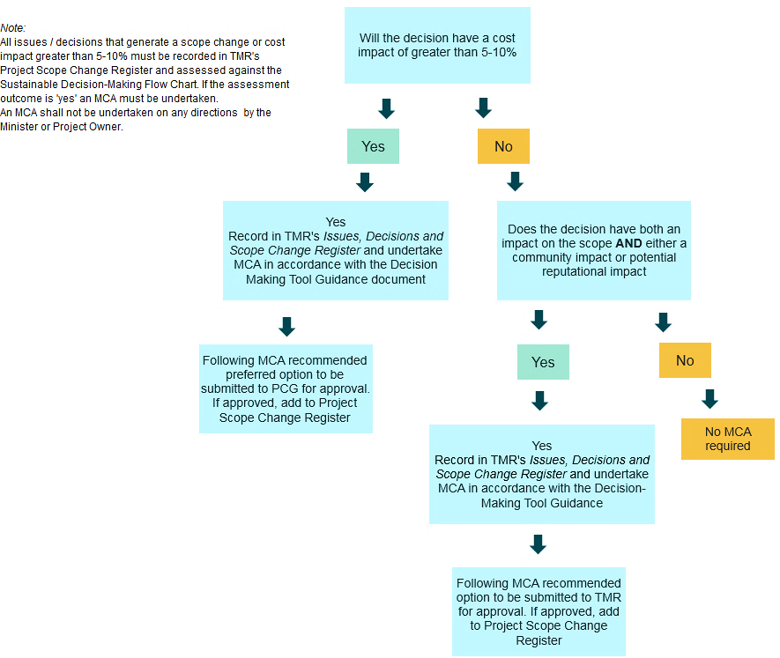

## Step 2

If a Multi‑Criteria Analysis (MCA) is required, define the options to be assessed using the Decision‑Making Tool (example provided in Figure 3.2). In accordance with IS criteria, the options considered must include at least a Business As Usual (BAU) option and proven approaches taken in comparable situations. The forecast useful life of the asset must also be considered, which is defined to be the length of time for which the asset has been designed to function until (i.e. includes construction and operation phases). The MCA Criteria must include at least one sustainability (non‑financial criteria) and consider environmental, social and economic aspects.

The MCA tool includes five aspects including customisable sub‑criteria and the relevant weightings have been determined as outlined in the following Table 3.2.1(a).

Table 3.2.1(a) – MCA tool aspects and weightings

|  |  |
| --- | --- |
| Aspect | Weighting |
| Constructability | 20% |
| Environmental | 15% |
| Economic / Financial | 35% |
| Social | 15% |
| Functionality | 15% |

The intention is that the aspect weightings remain the same, however project teams may customise the sub‑criteria and adjust the criteria weightings as required (ensuring the total weighting for each aspect totals 100%). Should the project team require the aspect weightings to change due to inapplicability or other factors, the revised weightings are to be agreed by the Project Senior Management team, ensuring that the weightings of sustainability criteria total at least 20%.

Project teams rate the decisions based on a score from 1 to 5 based on the criteria in Table 3.2.1(b) below.

Table 3.2.1(b) – Decision criteria ratings

|  |  |
| --- | --- |
| Rating | Decision criteria |
| 1 | Unacceptable, requires mitigation activity |
| 2 | Below average benefits |
| 3 | Average benefits |
| 4 | Above average benefits |
| 5 | Significant benefits |

Project teams review the results and determine the preferred option. It is important that the MCA process is undertaken in alignment with the steps described, and that the process and outcomes are recorded for review and approval by Transport and Main Roads. If approved, add to Project Scope Change Register. Outcomes and documentation must be provided to the Sustainability Representative.

# Updates and reviews

The Decision‑Making Tool will be reviewed regularly in order to ensure a robust and efficient process, as well as adding value to the decision‑making process and producing valuable and accurate outcomes.

Attachment 1 – Example of the Decision-Making Tool spreadsheet to assess options



