Appendix F

Guidance note – Project sustainability commitments and objectives

June 2022

Contents
1 Purpose 1
2 Background 1
3 Strategic context 1
4 Guidance 1
5 Actions 2
6 Process steps 3
7 Sustainability targets 3
8 Contact team 4

Purpose
This ‘Guidance note’ provides direction and consistency for setting sustainability objectives or targets to meet requirements of the Infrastructure Sustainability Council of Australia (ISCA) Rating Tool. It is also designed to inform project managers and support decision makers in establishing and publishing sustainability objectives or targets.

Background
The Department of Transport and Main Roads is committed to providing environmental, economic, social and cultural benefits to Queensland communities, as part of planning, designing, constructing and operating transport infrastructure. The department places great importance on the sustainability assessment process for all projects that trigger the threshold, ensuring this is part of any major transport project delivered in Queensland. For projects below the threshold sustainability practices are also applied, although not formally certified.
Embedding sustainability dimensions into the planning, design, construction and operation of projects will bring Transport and Main Roads closer to delivering on key government commitments, such as achieving zero net emissions by 2050.

Strategic context
The incorporation of sustainability objectives into project objectives is aligned with state and departmental imperatives, as represented in Figure 3 below.
Figure 3 – Relationship of sustainability projects to whole-of-government strategies and plans
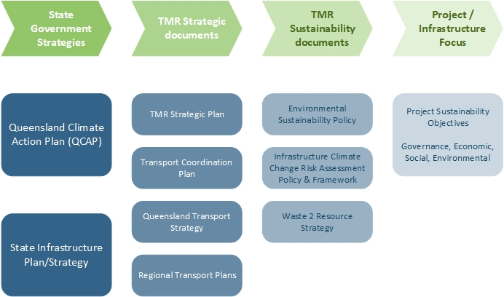

Guidance
The establishment of sustainability objectives, supported by targets, can optimise decision-making by setting a clear focus and direction. Measurable targets also enable consistent reporting on achievements. Key objectives have been set against the benefit areas Transport and Main Roads is targeting. The set of actions to achieve the related sustainability assessment is outlined in Section 5 which follows.

Actions
- Ensure a project web page has been established.
- Confirm or update the recommended sustainability objectives.
- Develop an ISCA-related statement of the sustainability commitments under the Project News heading on the webpage. An example mock-up is provided in Figure 5.
Figure 5 – Example of sustainability commitments statement
Sustainability commitments
The Australian Government and Queensland Government incorporate social, environmental and economic costs and benefits in project assessment and delivery.
These broad elements of sustainability are being optimised through the implementation of the Infrastructure Sustainability Council of Australia's (ISCA) Rating Tool.
The Rating Tool incentivises a range of sustainable initiatives, including best practice pollution control, ecology protection, community engagement and resource use.
The <insert name of project> is aiming to achieve a rating of ‘excellent' to maximise sustainable outcomes. To achieve this, Transport and Main Roads is committed to the following objectives:
Governance
- Embed sustainability into the planning, design, construction and operation of the <describe the asset>.
Environmental
- Minimise the greenhouse gas footprint of materials and whole-of-life emissions from the asset.
- Protect and enhance natural environment values.
- As part of the circular economy, maximise reuse and recycling of waste.
Economic
- Maximise asset whole-of-life value of the infrastructure and minimise whole-of-life costs.
- Minimise water use and consider non-potable water sources.
Social and cultural
- Develop active transport and accessibility improvements for the community.
- Support local industry participation and incorporate workforce development opportunities.
- Promote workforce health and safety.

Process steps
The process for adding ISCA-related details to the project webpage is outlined in Figure 6 below.
Figure 6 – Process for adding ISCA-related details to project webpage
Ensure a project webpage has been created
Confirm recommended sustainability objectives are appropriate for project
Develop a track changes Word Document mock-up of project sustainability commitments
Yes
Update sustainability objectives for the project
No
Proceed through project page update web management procedures
Include reference to IMD exemptions

Sustainability targets
To support the implementation of sustainability objectives, preliminary targets and metrics have been captured in Table 7 which follows.
Table 7 – Sustainability targets and metrics
Sustainability Objective | Sustainability Target | Sustainability Metric
Embed sustainability into the planning, design, construction and operation of the project
Reduce greenhouse gas footprint of infrastructure | 15% minimum reduction in greenhouse gas emissions from base case | Mat-1 15% reduction
Reduce whole-of-life greenhouse gas emissions | 5% minimum reduction of whole-of-life Greenhouse Gas emissions | Greenhouse gas emission footprint measured under ENE-1 credit
Develop active transport and accessibility improvements for the community
Protect and enhance the environment | No net adverse impact to water quality
Implement circular economy principles |  | Minimum benchmark Level 2 for Was-2
Building in resilience and adaptation to potential climate change |  | Minimum benchmark Level 2 for Cli-1 and Cli-2

Contact team
If you need any further assistance in relation to this material, please contact the Program Management and Delivery Unit, Environment, Cultural Heritage and Corridor Management Team by email: PMD_Environment@tmr.qld.gov.au.

