Job Number @ Type here

Functional Specification Template

C7522 – Infrastructure Sustainability Business Case Requirements Addendum

December 2021
- To be used as a guide when compiling project-specific specifications.
- @ = project-specific detail required.
- For clauses / items not required – insert text “Not Required” in clause heading, do not delete clause.
- Delete this table when document finalised.

Contents
1 Infrastructure Sustainability – Introduction 1
1.1 Definition of terms 1
1.2 Reference documents 1
1.3 Quality system requirements 1
1.3.1 Hold Points, Witness Points and Milestones 1
1.4 General 2
1.4.1 Sustainability representative 2
1.4.2 Transport and Main Road’s Environmental Sustainability Policy 2
1.4.3 Infrastructure sustainability integration 3
1.4.4 Principal retained infrastructure sustainability deliverables 3
1.5 Infrastructure sustainability as part of decision making 4
2 Previous infrastructure sustainability assessment 4
2.1 Preliminary evaluation handover 4
2.2 Additional evidence 5
3 Infrastructure sustainability in the Business Case 5
3.1 Scope of assessment 5
3.2 Project boundaries and base case assumptions 5
3.3 Supporting information for infrastructure sustainability 5
4 Infrastructure sustainability deliverables 5
4.1 Infrastructure Sustainability Management Plan (Planning) (ISMP(P)) 5
4.2 Sustainability commitments and objectives 7
4.3 Internal infrastructure sustainability workshop 7
4.4 Risk assessment 8
4.5 Business case design and scope input 8
4.6 Inclusion in project cost estimate 8
4.7 Infrastructure sustainability documentation 8
4.8 Progress reporting 9
5 Payment 9
Appendix A: Environmental Sustainability Policy 10
Appendix B: Guide to incorporating sustainability into project decision making 11
Appendix C: Guidance Note – Infrastructure Sustainability Base Case Framework 12
Appendix D: Supporting information for infrastructure sustainability 13
Appendix E: Sustainability business as usual assessment and recommended credits 14
Appendix F: Guidance Note – Project sustainability commitments and objectives 15
Appendix G: Infrastructure sustainability management plan outline 16
Appendix H: Preliminary evaluation handover package 17

Infrastructure Sustainability – Introduction
This Functional Specification applies to the Department of Transport and Main Road's requirement for the Consultant’s preliminary evaluation to contribute to the Infrastructure Sustainability Council (ISC) ratings of not less than excellent, independently verified by ISC for the design and construction.

Definition of terms
The terms used in this Business Case Functional Specification shall be as defined in Table 1.1.
Table 1.1 – Definitions
Term | Definition
ISC | Means the Infrastructure Sustainability Council.
ISMP | Means the Infrastructure Sustainability Management Plan.
Rating Tool | Means ISC's Infrastructure Sustainability Rating Tool v1.2, details of which are available at the website Infrastructure Sustainability Council (iscouncil.org)
Sustainability Representative | Means the Consultant’s Infrastructure Sustainability Accredited Professional under ISC who must have a minimum of two years’ experience delivering ISC ratings on linear infrastructure projects.
Weightings Assessment | Means the Weightings Assessment in accordance with ISC IS Technical Manual, v1.2.

Reference documents
Reference documents in this Business Case Functional Specification are listed in Table 1.2.
Table 1.2 – Reference documents
Reference | Title
Environmental Sustainability Policy | Transport and Main Roads' published Environmental Sustainability Policy (refer Appendix A).
IS Technical Manual, v1.2 | Infrastructure Sustainability Council’s Infrastructure Sustainability Technical Manual, v1.2.
IS Scorecard, v1.2 | Infrastructure Sustainability Council’s Infrastructure Sustainability Scorecard, v1.2.

Quality system requirements

Hold Points, Witness Points and Milestones
General requirements for Hold Points, Witness Points and Milestones are specified in MRTS01 Introduction to Technical Specifications. The Hold Points, Witness Points and Milestones applicable to this Project Specific Technical Specification are summarised in Table 1.3.
Table 1.3 – Hold Point, Witness Point and Milestones
Project Manager: delete / add relevant hold points, witness points and milestones as applicable.

Clause | Hold Point | Witness Point | Milestone
4.1 | @ Type here  Submission of ISMP(P) for deemed suitability from Principal. |  | @ Type here  The Consultant completes a review and update of the ISMP(P).
4.2 | @ Type here  The Consultant shall seek endorsement of the proposed project-specific infrastructure sustainability objectives from the Principal.
 | @ Type here | @ Type here | @ Type here

General
As part of the Queensland Government’s commitment to ensuring the long-term sustainability of infrastructure investment, this project, and all state government projects valued at more than $100 million, will be subject to a sustainability assessment.
The terms in this Functional Specification shall be read in conjunction with those identified in the IS Technical Manual, v1.2, unless IS Technical Manual, v2.1 is referenced for a specific purpose.
Where required by the methodologies prescribed in IS Technical Manual, v1.2, the assessment shall consider the whole of life of the asset.
While the Business Case contract will not involve the formal registration of the project with ISC, the assessment and documentation undertaken is expected to set the project up for success in the subsequent contracts through the provision of supporting evidence.

Sustainability representative
The Consultant must engage a Sustainability Representative for the Business Case contract. The Consultant must also ensure that sufficient resources are provided to address infrastructure sustainability and achieve the defined ISC rating. The Sustainability Representative must consult and liaise with the Consultant regarding infrastructure sustainability.

Transport and Main Road’s Environmental Sustainability Policy
Appendix A provides the department's published Environmental Sustainability Policy to set a clear direction for the project.
Further, Transport and Main Roads actively supports and strives to contribute to the State Government’s objectives for the community, which are:
- safeguarding our health
- supporting jobs
- backing small business
- making it for Queensland
- building Queensland
- growing our regions
- investing in skills
- backing our frontline services, and
- protecting the environment.

Infrastructure sustainability integration
The Principal draws the Consultant's attention to a number of 'touch points' between ISC's Rating Tool requirements and other deliverables for the Business Case. The infrastructure sustainability requirements shall be considered within the broader context of the contract.
While meeting the infrastructure sustainability deliverables outlined in Clause 4, the Consultant shall address the applicable infrastructure sustainability rating requirements relevant to all tasks being undertaken during the contract, such as:
- stakeholder engagement
- cultural heritage assessment
- environmental assessment
- landscape design assessment
- road design, and
- hydraulics.
The Consultant shall ensure that applicable assessments and evidence is documented sufficiently so that it may be captured and collated as evidence for future project rating submissions to ISC.

Principal retained infrastructure sustainability deliverables
Under this Contract, the Principal will retain responsibility for delivering the actions and evidence as outlined within Table 1.4.4.
Table 1.4.4 – Principal-retained responsibilities
Project Manager: delete / add relevant hold points, witness points and milestones as applicable.

ISC Credit | Benchmark Level | Deliverable / Evidence | Timeframe for Delivery
@ Type here  Example: Sta-1  Stakeholder Engagement | @ Type here | @ Type here  Community engagement plan | @ Type here
@ Type here  Example:  Pro-1 and Pro-2  Sustainable Procurement | @ Type here | @ Type here  Engagement with local suppliers to communicate sustainability intent.  Advise of environmental policy and sustainability policy requirements for future phases. | @ Type here
@ Type here | @ Type here | @ Type here | @ Type here

Infrastructure sustainability as part of decision making
The Consultant shall incorporate infrastructure sustainability into decision-making processes for significant decisions into the business case assessments (that is, economic, environmental and social outcomes are considered). This shall be documented to ensure it is available as evidence for achieving the formal ISC rating for the project (refer to Man-7). Appendix B provides guidance and a template for incorporating sustainability into decision-making to address ISC requirements.
The output of this deliverable is the documentation (forms, templates and tools) used for Business Case assessments showing the infrastructure sustainability considerations incorporated. A copy of the evidence collected for this deliverable shall be included in the Business Case Report as per Clause 4.

Previous infrastructure sustainability assessment
Prior to the Business Case, work has commenced on the infrastructure sustainability assessment. The deliverables and assessments completed to date are:
Project Manager: include any sustainability assessment work that has already been completed.

- @ Type here for example:
- @ Type here Infrastructure Sustainability Management Plan (Planning) – ISMP(P)

Preliminary evaluation handover
Documentation from the previous infrastructure sustainability assessments is made available to the Business Case Consultant in the form of a preliminary evaluation infrastructure sustainability handover. This will contain the documentation of infrastructure sustainability assessments completed to date (Appendix H).

Additional evidence
Upon review of the preliminary evaluation infrastructure sustainability handover the Consultant may seek clarification from the Principal whether there is additional evidence and documentation available from previous work that may be of use in compiling the design rating evidence submissions.

Infrastructure sustainability in the Business Case
The intent of the infrastructure sustainability assessment in the Business Case is the assessment of the proposed option in relation to infrastructure sustainability and identification of potential sustainability strategies for the project to achieve infrastructure sustainability outcomes. The infrastructure sustainability assessment in the Business Case involves undertaking a self-assessed gap analysis of the 'business as usual' sustainability score and the targeted excellent rating. Once the gap has been identified, the intent is to identify potential strategies and measures that could be applied to improve the sustainably outcomes with the intent of achieving an excellent score. The Business Case and project cost estimate should incorporate the costs and benefits of the sustainability strategies.

Scope of assessment
The scope of the Business Case infrastructure sustainability assessment shall incorporate consideration and assessment of the infrastructure sustainability parameters of:
- the whole of life benefits and impacts of the asset, including design, construction and operation of the final asset, and
- the whole of life costs of the asset (not just the capital cost of construction).

Project boundaries and base case assumptions
The project shall refer to the Principal's Guidance Note: Infrastructure Sustainability Base Case Framework provided in Appendix C to determine the most appropriate project boundaries and business as usual assumptions for the submissions to ISC.

Supporting information for infrastructure sustainability
Appendix D includes a suite of guidance materials and supporting documentation relating to infrastructure sustainability that the Consultant shall consider and/or reference where appropriate.

Infrastructure sustainability deliverables

Infrastructure Sustainability Management Plan (Planning) (ISMP(P))
The intent of the Infrastructure Sustainability Management Plan (ISMP) is that it provides a living document of infrastructure sustainability targets, management measures, and evidence requirements identified for the project.
The Consultant shall develop an ISMP(P) in accordance with the template in Appendix G, unless an alternate structure is approved by the Project Manager.
The Consultant may utilise the suggested actions and strategies included in Appendix E – Sustainability Business As Usual Assessment and Recommended Credits. The Consultant shall maintain the continuity of intent of previous plans, studies and assessments and include enough additional actions and documentation to deliver the ISC design rating of excellent.
The Consultant shall consider all previous infrastructure sustainability assessments (for example a climate change risk assessment) when developing their ISMP(P).
The ISMP(P) shall be:
- endorsed by the Consultant’s Sustainability Representative as suitable for achieving the nominated credit and levels
- submitted to the Principal for a direction as to its suitability within 30 business days of award of contract Hold Point
- in place for the duration of the contract, and
- reviewed and updated at least quarterly through the duration of the detailed design. Updates to the ISMP(P) shall be submitted to the Principal through the Consultant’s monthly report.
The Consultant shall ensure that the ISMP(P) and the associated sustainability strategies and actions are adequate to obtain an excellent design rating.
Furthermore, the Contractor shall target the following credits:
Project Manager: include sustainability assessment targets relevant to the project

- Ene–1 Benchmark Level 2 minimum – reduction of greenhouse gas footprint of a minimum of 15% over the base case
- Dis–1 Benchmark Level 2 minimum – consider land requirements for operational phase water quality and stormwater retention targets (required for projects in Great Barrier Reef catchments)
- Cli–1 and Cli–2 Benchmark Level 2 minimum – climate change risk assessment and adaptation
- Was–2 Benchmark Level 2 minimum – diversion from landfill, and
- @ Type here [add other specific credit objectives where applicable].
The Consultant shall undertake an options analysis of various infrastructure sustainability initiatives that would assist the project to achieve an excellent rating and achieve positive economic, environmental and social outcomes over the whole of life of the asset. The Consultant shall generate a list of infrastructure sustainability strategies and actions that could be considered for inclusion in the Business Case design to achieve the targeted infrastructure sustainability rating of excellent.
The infrastructure sustainability strategies and actions should include:
- design initiatives (pavement material options, alignment options), and
- construction inclusions (i.e. use of non-potable water, conservation of insitu topsoil), and other project initiatives such as procurement.
The potential infrastructure sustainability strategies and actions should be evaluated and prioritised based on:
- costs to the project to implement
- whole-of-life costs for the asset
- whole-of-life benefits including economic, social, environmental and sustainability outcomes
- payback period for investment, and
- infrastructure sustainability credits achieved.
The output of the ISMP(P) review and update is an updated ISMP(P) with specific credits and benchmarks proposed for targeting with:
- revised weightings assessment
- revised target credits and benchmarks, and
- matrix of proposed infrastructure sustainability strategies and actions and the applicable credit and benchmarks.
Project Manager: include delivery milestone timing.

These outputs must be completed by @ Type here Milestone
The Contractors ISMP(P) shall be maintained, reviewed, and updated to capture the latest decisions and targets as they evolve through the contract.

Sustainability commitments and objectives
The Infrastructure Weightings Assessment shall inform the development of specific sustainability objectives. Appendix F: Guidance Note – Project sustainability commitments and objectives provides guidance on sustainability commitments and objectives that could be considered. The Consultant shall develop recommended sustainability objectives and targets based on the guidance note and the outcomes of the weightings assessment.
Hold Point – The Consultant shall seek endorsement of the proposed infrastructure sustainability objectives from the Principal.
The endorsed infrastructure sustainability objectives shall be documented in the Business Case Report.

Internal infrastructure sustainability workshop
As part of developing or updating of the ISMP(P), the Consultant shall host and lead an infrastructure sustainability workshop with members from both the Principal and Consultant team to:
- raise awareness of infrastructure sustainability and the key areas of opportunity and constraint in relation to the project
- discuss and assign roles and responsibilities for sustainability assessment incorporation within other contract deliverables
- discuss and confirm or set project-specific sustainability objectives
- evaluate the proposed infrastructure sustainability initiatives (evaluation may involve evaluation of GHG emissions, whole-of-life material footprint, social impact, cost impacts), and
- determine the infrastructure sustainability initiatives to be incorporated into the project and the Business Case design and cost estimate.
The outputs of the internal infrastructure sustainability workshop shall be used to update the ISMP(P).

Risk assessment
Where the Business Case involves development of a risk profile for the project and asset, the risk assessment shall incorporate climate change risk assessment in accordance with the Transport and Main Roads documents – EP 170 Climate Change Risk Assessment Methodology and Climate Change Risk and Adaptation Assessment Framework for Infrastructure Projects. Links to these documents are provided within Appendix D: Transport and Main Roads Guidance and Policy table.

Business case design and scope input
The output of this deliverable is incorporation of the reviewed and revised infrastructure sustainability strategies and actions into the Business Case design and scope package containing the Principal agreed sustainability initiatives.
Depending on the specific sustainability targets, this will include consideration of such topics as:
- land resumption requirements for enhancing environmental measures such as operational water quality treatment devices
- land requirements for stormwater management to avoid increases in peak discharge from site (stormwater detention)
- ecological value and fauna connectivity enhancements
- avoidance of adverse community impacts
- active transport
- climate change resilience and adaptation service level requirements for the asset, and
- enhancement of community connectedness.

Inclusion in project cost estimate
The Business Case cost estimates shall incorporate an estimate of costs and benefits associated with infrastructure sustainability. This shall include as a minimum:
- cost incurred and cost avoided from initiatives to deliver infrastructure sustainability ratings of excellent for design and as built
- the ISC registration fees, and
- consultant fees for implementing, monitoring and documenting infrastructure sustainability.

Infrastructure sustainability documentation
The Consultant shall document infrastructure sustainability assessments undertaken as part of the Business Case in a manner suitable for evidence in later stage ISC submissions. Alignment with the Queensland Government Business Case Development Framework (Appendix D) should be ensured where projects are being supported through the Department of State Development, Infrastructure, Local Government and Planning. Similarly, Infrastructure Australia requirements must be addressed, including for resilience considerations.
The Consultant shall ensure that the required infrastructure sustainability documentation is generated from the Business Case.
In addition to documentation of the infrastructure sustainability assessment and outputs within the Project Business Case Report, the Consultant shall be responsible for preparing a handover evidence package from the Business Case process that relates to the future infrastructure sustainability rating for the project.
Evidence shall be recorded of:
- multi-criteria analysis and significant decision making incorporating social, environmental and sustainability outcomes
- stakeholder engagement processes, feedback and responses (where applicable)
- Business Case management team consideration and monitoring of sustainability outcomes throughout the Business Case
- climate change risk assessment
- procurement strategies for sub-Consultants (i.e. geotechnical investigations), and
- all other evidence as required by the rating submission and verification process.
The brief shall include a summary of tasks and outcomes achieved in relation to each ISC credit.
The outputs of the infrastructure sustainability assessments shall be documented in the updated project ISMP(P) and Business Case report.

Progress reporting
The Business Case Consultant shall provide the Principal with a quarterly infrastructure sustainability report as part of the overall project reporting. The infrastructure sustainability section shall report on the progress of the ISMP(P).
Content of the report should contain:
- progress of infrastructure sustainability deliverables under the Business Case contract
- risks and opportunities identified for the project in relation to infrastructure sustainability outcomes, and
- any progress or outcomes associated with key government priorities:
- greenhouse gas reduction for the project
- water quality improvements, and
- community connectedness and active transport.

Payment
Project Manager: include the associated Item No. for infrastructure sustainability.

The Lump Sum for Item No. BC @ Type here XX Infrastructure Sustainability shall include all works specified in Clause 4 of this Functional Specification – Business Case.

Appendix A: Environmental Sustainability Policy
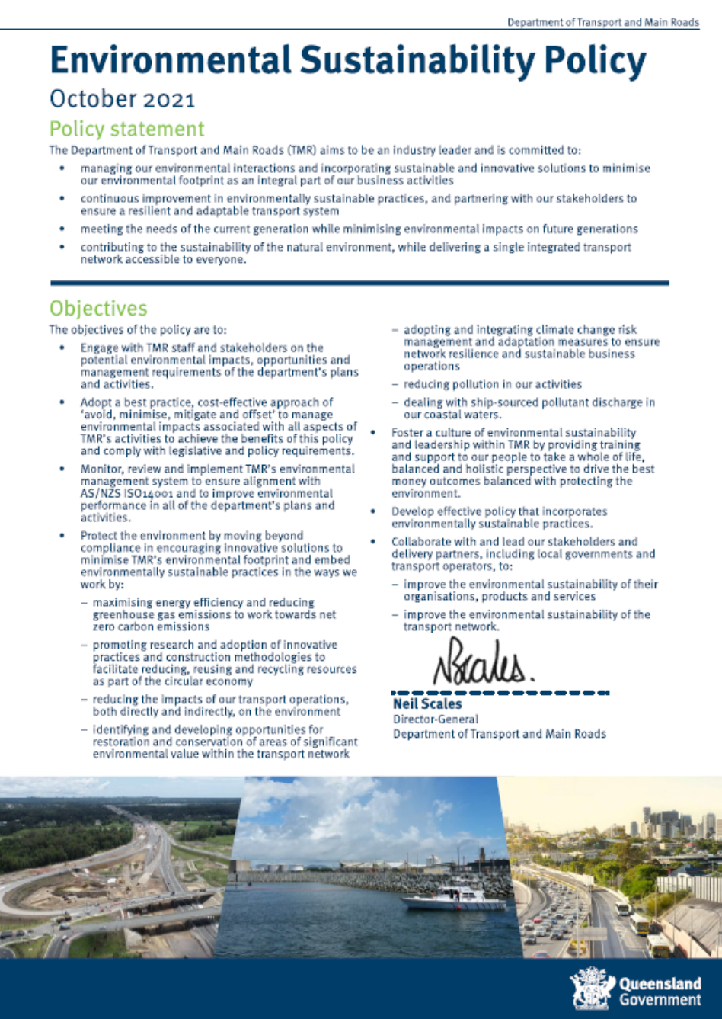

Appendix B: Guide to incorporating sustainability into project decision making

Appendix C: Guidance Note – Infrastructure Sustainability Base Case Framework

Appendix D: Supporting information for infrastructure sustainability
Table D1 – Queensland Government Guidance and Policy
Reference | Title
Protection of Great Barrier Reef | Reef 2050 Plan, Australian and, Queensland Government
Queensland Waste Management and Resource Recovery Strategy | Waste Management and Resource Recovery Strategy for Queensland, Queensland Government
Business Case Development | Business Case Development Framework, 2021
Queensland Procurement | Queensland Procurement Policy 2021, Queensland Government, Department of Housing and Public Works
Ethical Supplier Mandate | Ethical Supplier Mandate 2021, Office of the Chief Advisor – Procurement, Queensland Government
Indigenous Employment Policy | Queensland Indigenous (Aboriginal and Torres Strait Islander) Procurement Policy, Queensland Government
Climate Change Policy | Climate Change Adaptation Strategy 2017 - 2030, Queensland Government  Climate Change Transition Strategy, Queensland Government

Table D2 – Transport and Main Roads Guidance and Policy
Reference | Title
Transport and Main Roads Sustainability BAU Assessment and Recommended Credits | Transport and Main Roads Sustainability Business As Usual Assessment and Recommended Credits_Default – Appendix G
Hydraulic Climate Change Requirements | Road Drainage Manual, Transport and Main Roads
EP170 | Engineering Policy EP170 Climate Change Risk Assessment Methodology, Transport and Main Roads
Climate Change Risk and Adaptation Assessment Framework for Infrastructure Projects | Climate Change Risk and Adaptation Assessment Framework for Infrastructure Projects, March 2020, Transport and Main Roads

Appendix E: Sustainability business as usual assessment and recommended credits

Appendix F: Guidance Note – Project sustainability commitments and objectives

Appendix G: Infrastructure sustainability management plan outline

Appendix H: Preliminary evaluation handover package

