

Recycled materials in Queensland’s roads
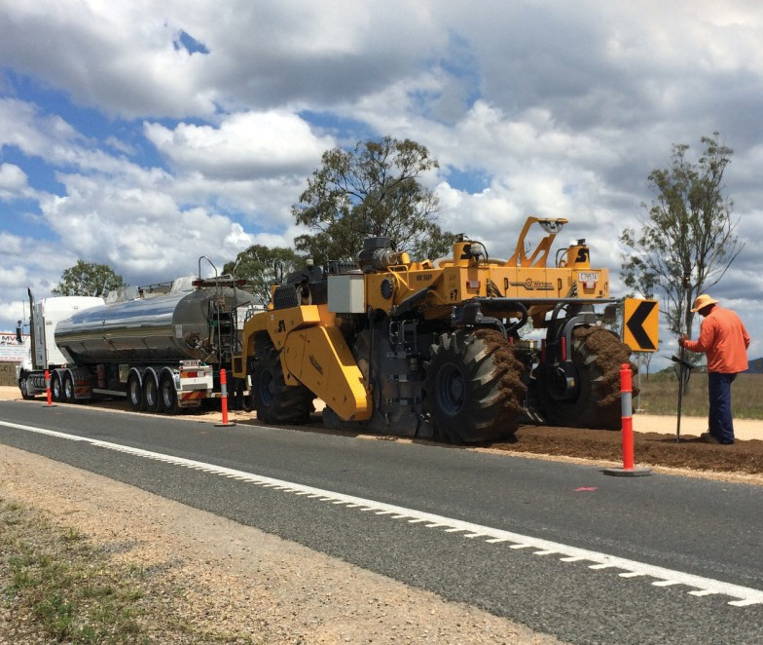

The Queensland Government’s Department of Transport and Main Roads (TMR) is committed to the government’s new Waste Management and Resource Recovery Strategy, particularly working towards a circular economy.
While research is continuing, many Queensland Government projects already identify ways to reduce waste and emissions to deliver sustainable, cost-effective infrastructure. This factsheet highlights how using recycled materials are helping build a reliable road network for all Queenslanders.



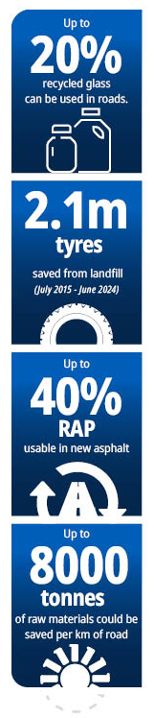
Recycled materials in Queensland’s roads


Glass
Up to 20% recycled glass can be used in roads
Circular economy, Reducing landfill
TMR is continually investigating innovative methods to utilise recycled crushed glass (RCG) as a sustainable replacement for sand and aggregate in road materials. RCG can be used in asphalt (up to 10%, excluding surfacing), granular sub-base layers (up to 20%), and normal concrete (up to 20% of fine aggregate). Also suitable for bedding, drainage, and backfill around pipes. In some fill applications, such as embankment cores, up to 100% RCG may be utilised.


Crumb rubber
2.1m tyres saved from landfill (July 2015 - June 2024)
Cost savings, Reducing landfill, Network performance.

End of life tyres can be recycled into crumb rubber, which is blended into bitumen to be used in asphalt and sprayed seals. This process diverts waste from landfill and enhances road durability and performance.
In spray seal applications, up to 18% crumb rubber is

typically permitted as a substitute for synthetic polymers.
Reclaimed Asphalt Pavement
Up to 40% RAP useable in new asphalt

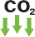
Cost savings, Circular economy, Reducing emissions.
When pure asphalt is removed from existing roads it can be
processed into reclaimed asphalt pavement (RAP) material which can be incorporated back into new asphalt.
Incorporating pure RAP into new asphalt reduces reliance on non-renewable resources, lowers landfill waste, and cuts greenhouse gas emissions from producing new materials.



Insitu stabilisation
Up to 8000 tonnes of raw materials could be saved per km of road
Cost savings, Reducing landfill, Network performance, Circular economy.
In situ stabilisation strengthens deteriorated roads by pulverising existing pavement layers and mixing them with stabilising agents such as cement, lime, fly ash, or foam bitumen. This method reduces landfill waste, conserves natural resources, and lowers environmental impacts from quarrying and transporting new materials.
Techniques include lime stabilisation for subgrades, triple blend for subbase layers, and cement or foam bitumen stabilisation for granular pavements.
Recycled materials on Queensland roads

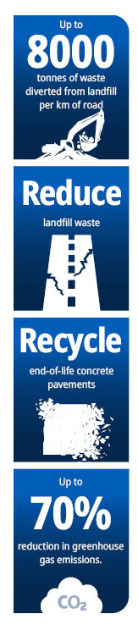

Construction and demolition waste (C&D)
Up to 8000 tonnes of waste diverted from landfill per km of roada
Cost savings, Reducing landfill, Circular economy. d

C&D waste such as concrete, brick, and glass can replace natural aggregates and sand in road bases, concrete, pavement stabilisation, drainage, and earthworks.
In concrete, up to 20% of coarse and fine aggregates can be replaced with recycled crushed concrete and glass respectively. For unbound pavements, up to 100% recycled concrete, 45% brick, and 20% glass may be used, depending on the subtype.

Rubblisation of old concrete pavements
Reduce landfill waste

Reducing landfill, Environment and lifestyle protection, Circular economy.

Rubblisation fractures existing concrete pavements into required sizes and interlocking, allowing a new road to be built over the top.
This technique recycles old concrete, reducing landfill waste and offering cost benefits.

Crack and Seat of old concrete pavements

Recycle end-of-life concrete pavements
Reducing landfill, Environment and lifestyle protection, Circular economy.
Crack and seat treatment recycles end-of-life concrete pavements by fracturing them at designed intervals to create required patterns and seating them firmly on the underlying layer.
A thick asphalt overlay is then applied, allowing the reused concrete to serve as a stable foundation in flexible pavement construction.

Fly ash and ground granulated blast furnace slag

Up to 70% reduction in greenhouse gas emissions
Circular economy, Reducing emissions.
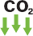
Up to70% reduction in greenhouse gas emissions from the use of flyash and ground granulated blast furnace slag (GGBFS) in concrete.
Fly ash and GGBFS are by-products of coal-fired power and iron production which can replace up to 70% of cement in normal concrete, reducing costs and improving durability.
Structural concrete can include up to 35% fly ash, 60% combined fly ash and GGBFS, or 60 to 70% GGBFS alone.
Recycled materials on Queensland roads

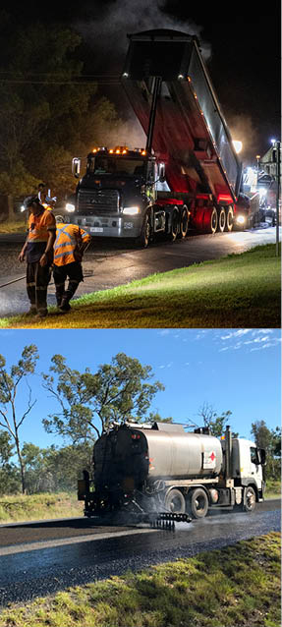

The Queensland Government is continually researching innovative technologies and using recycled materials to construct sustainable resilient infrastructure that benefits the environment, community,
and economy.

Recycled materials in earthworks drainage and concrete
TMR is exploring new opportunities for the use of recycled materials in road embankments and drainage materials,
focusing on diverting waste from landfill and
supporting a circular economy.

Recycled materials such as glass, run of station ash from coal fired power plants and construction and demolition waste have the potential to be used in these applications.

Use of limestone cement
The department is exploring the use of limestone cement in road pavements and concrete. Use of limestone cement reduces carbon emission compared to use of traditional general-purpose cement.

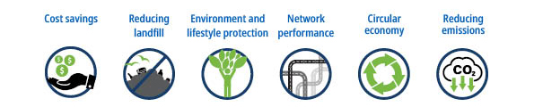

Learn more: tmr.techdocs@tmr.qld.gov.au
13 QGOV (137468)
www.tmr.qld.gov.au | www.qld.gov.au

