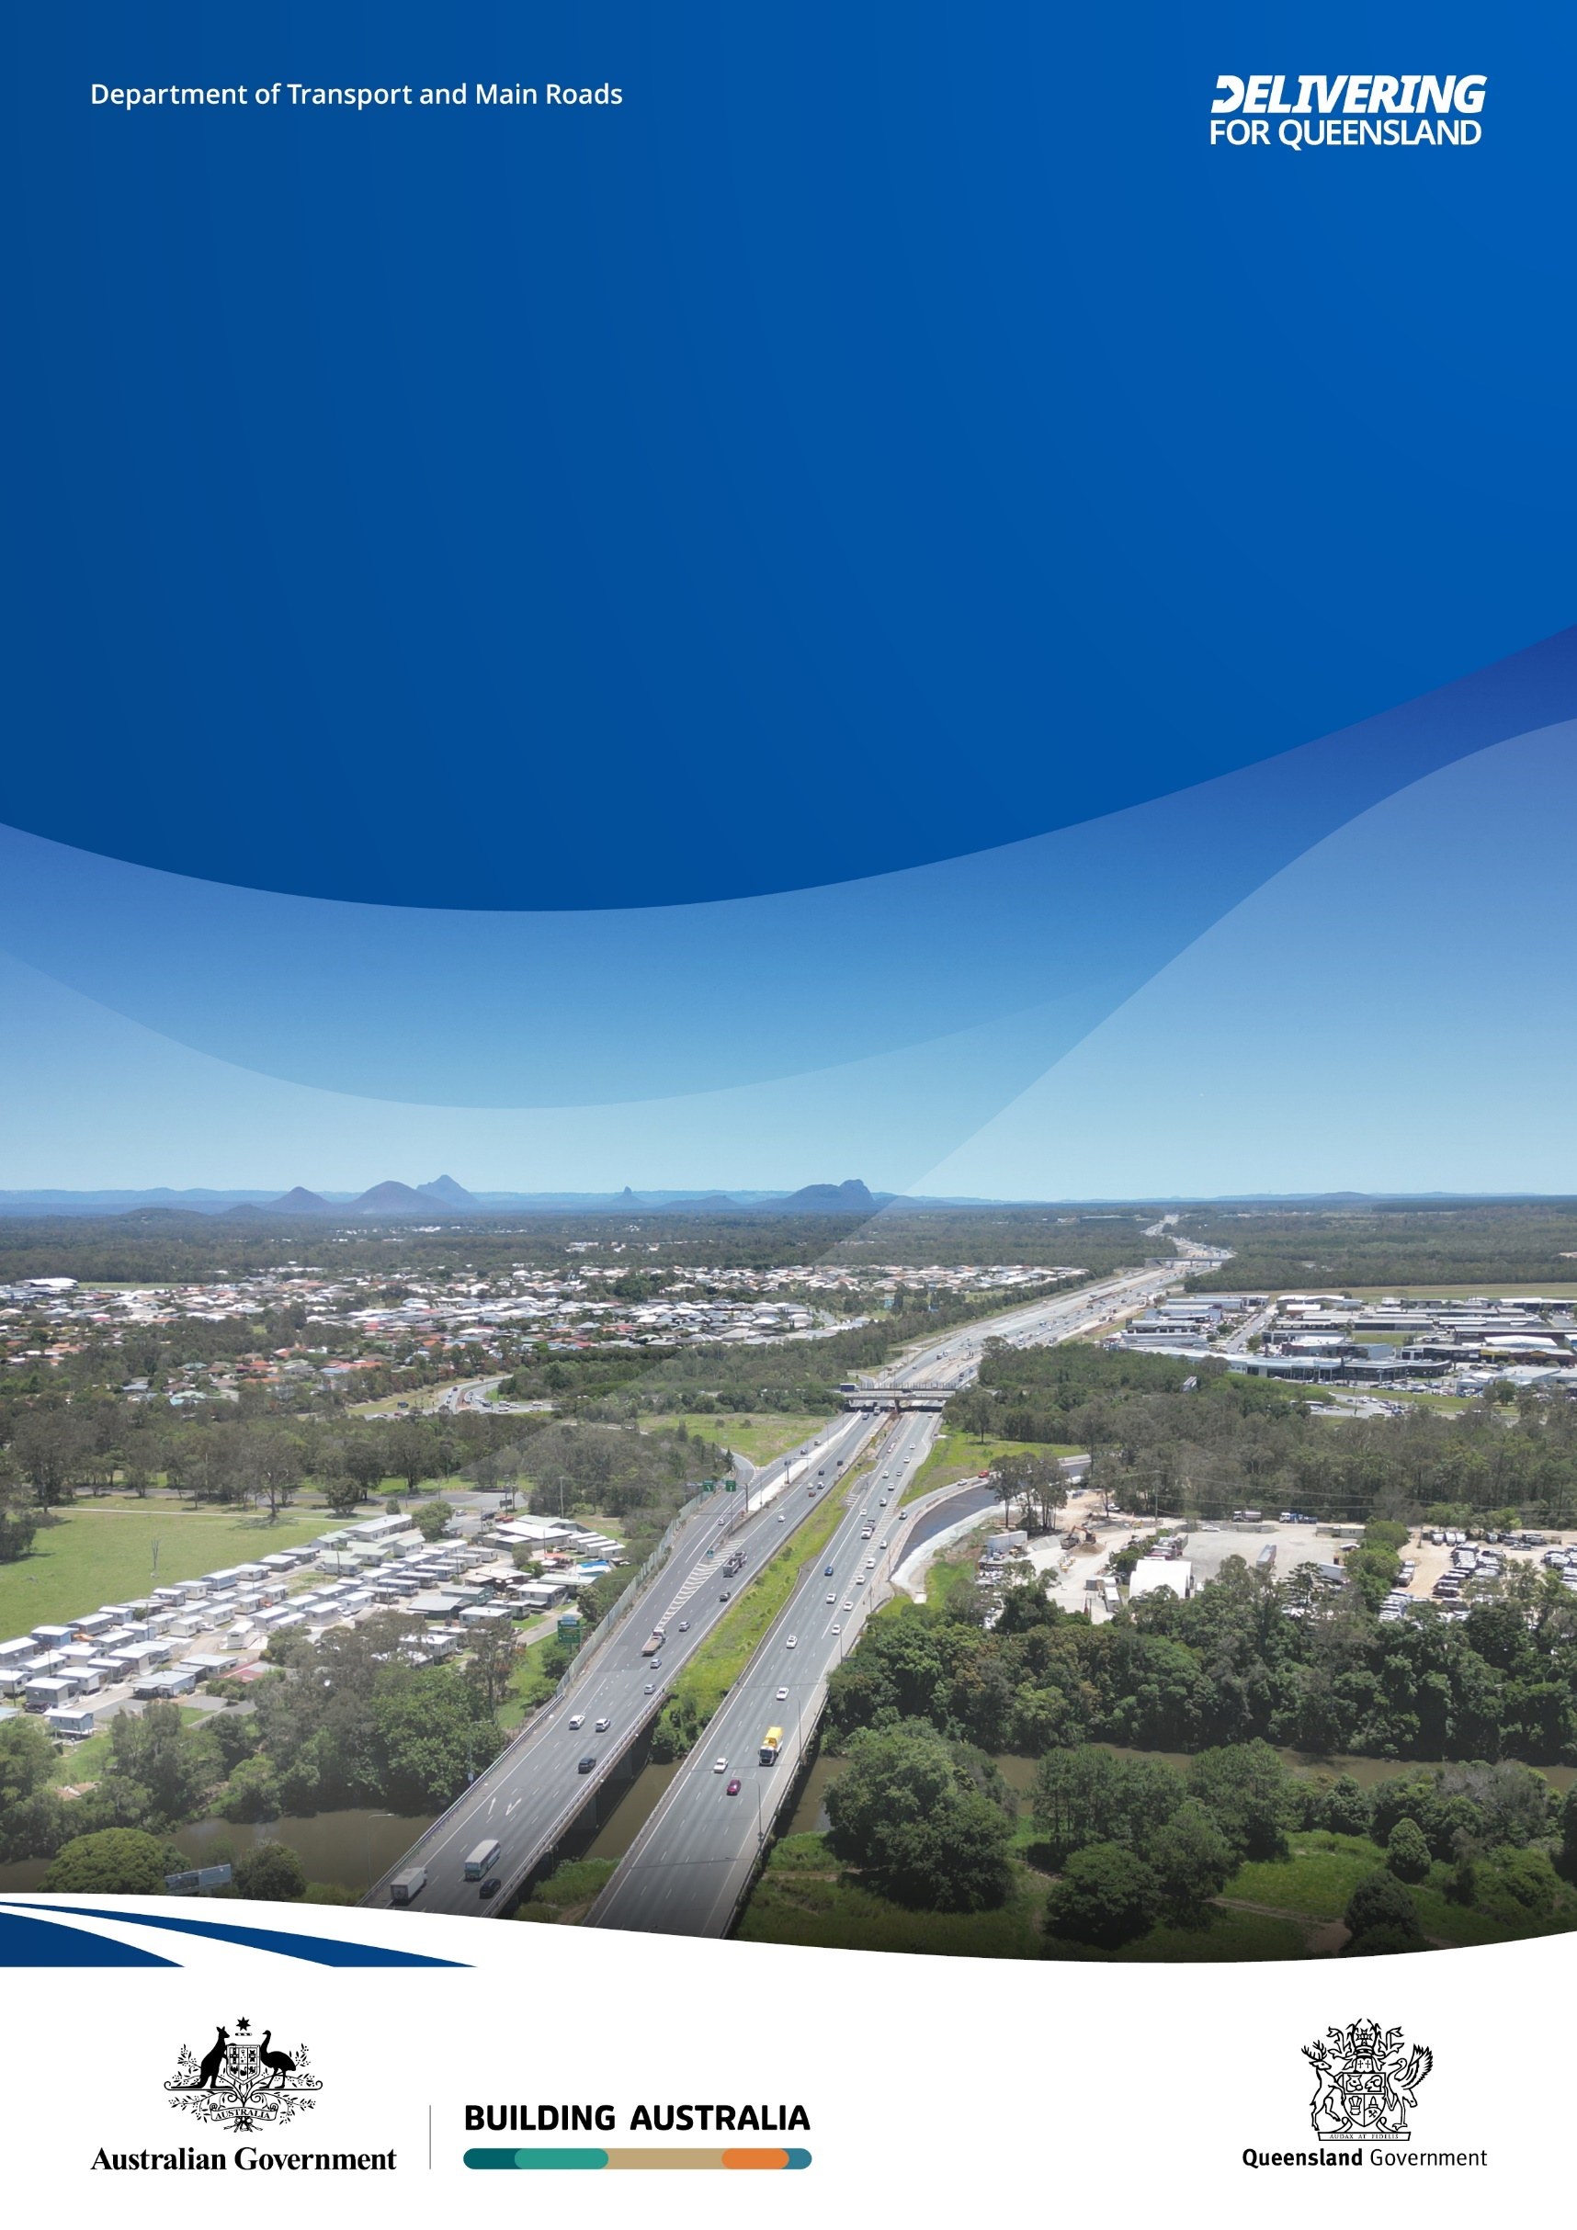
Image: Bruce Highway looking north towards Caboolture-Bribie Island Road interchange. Source: TMR
Bruce Highway Upgrade
Anzac Avenue to Caboolture
-Bribie Island Road

July 2025
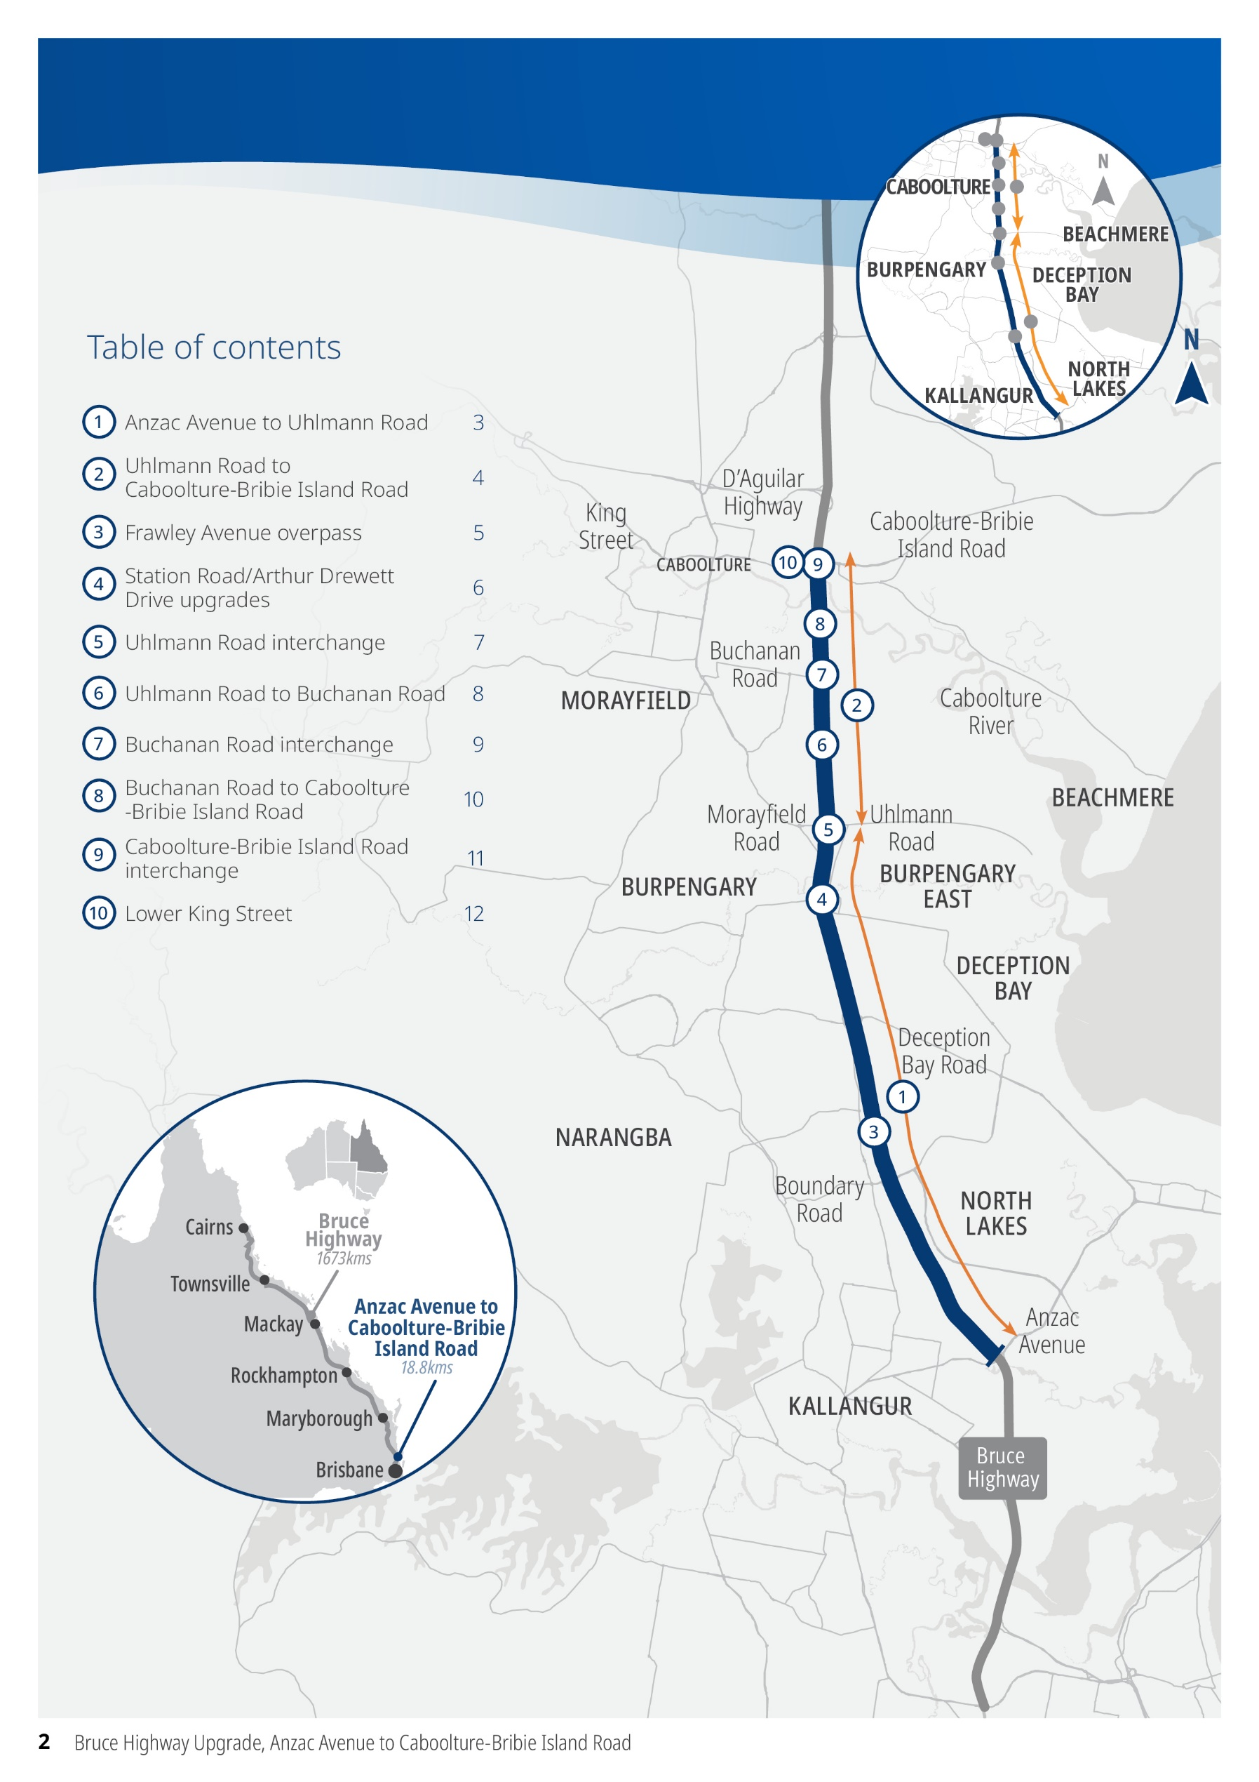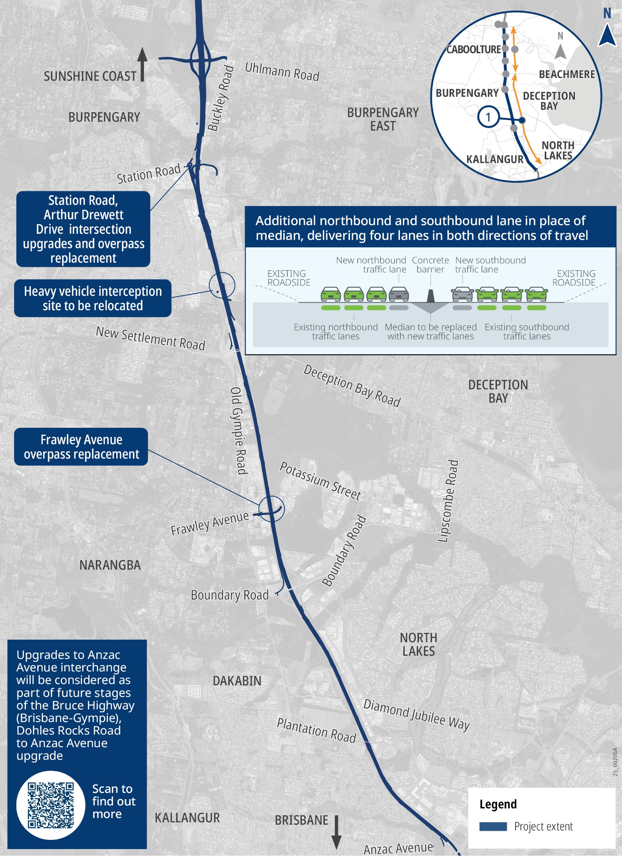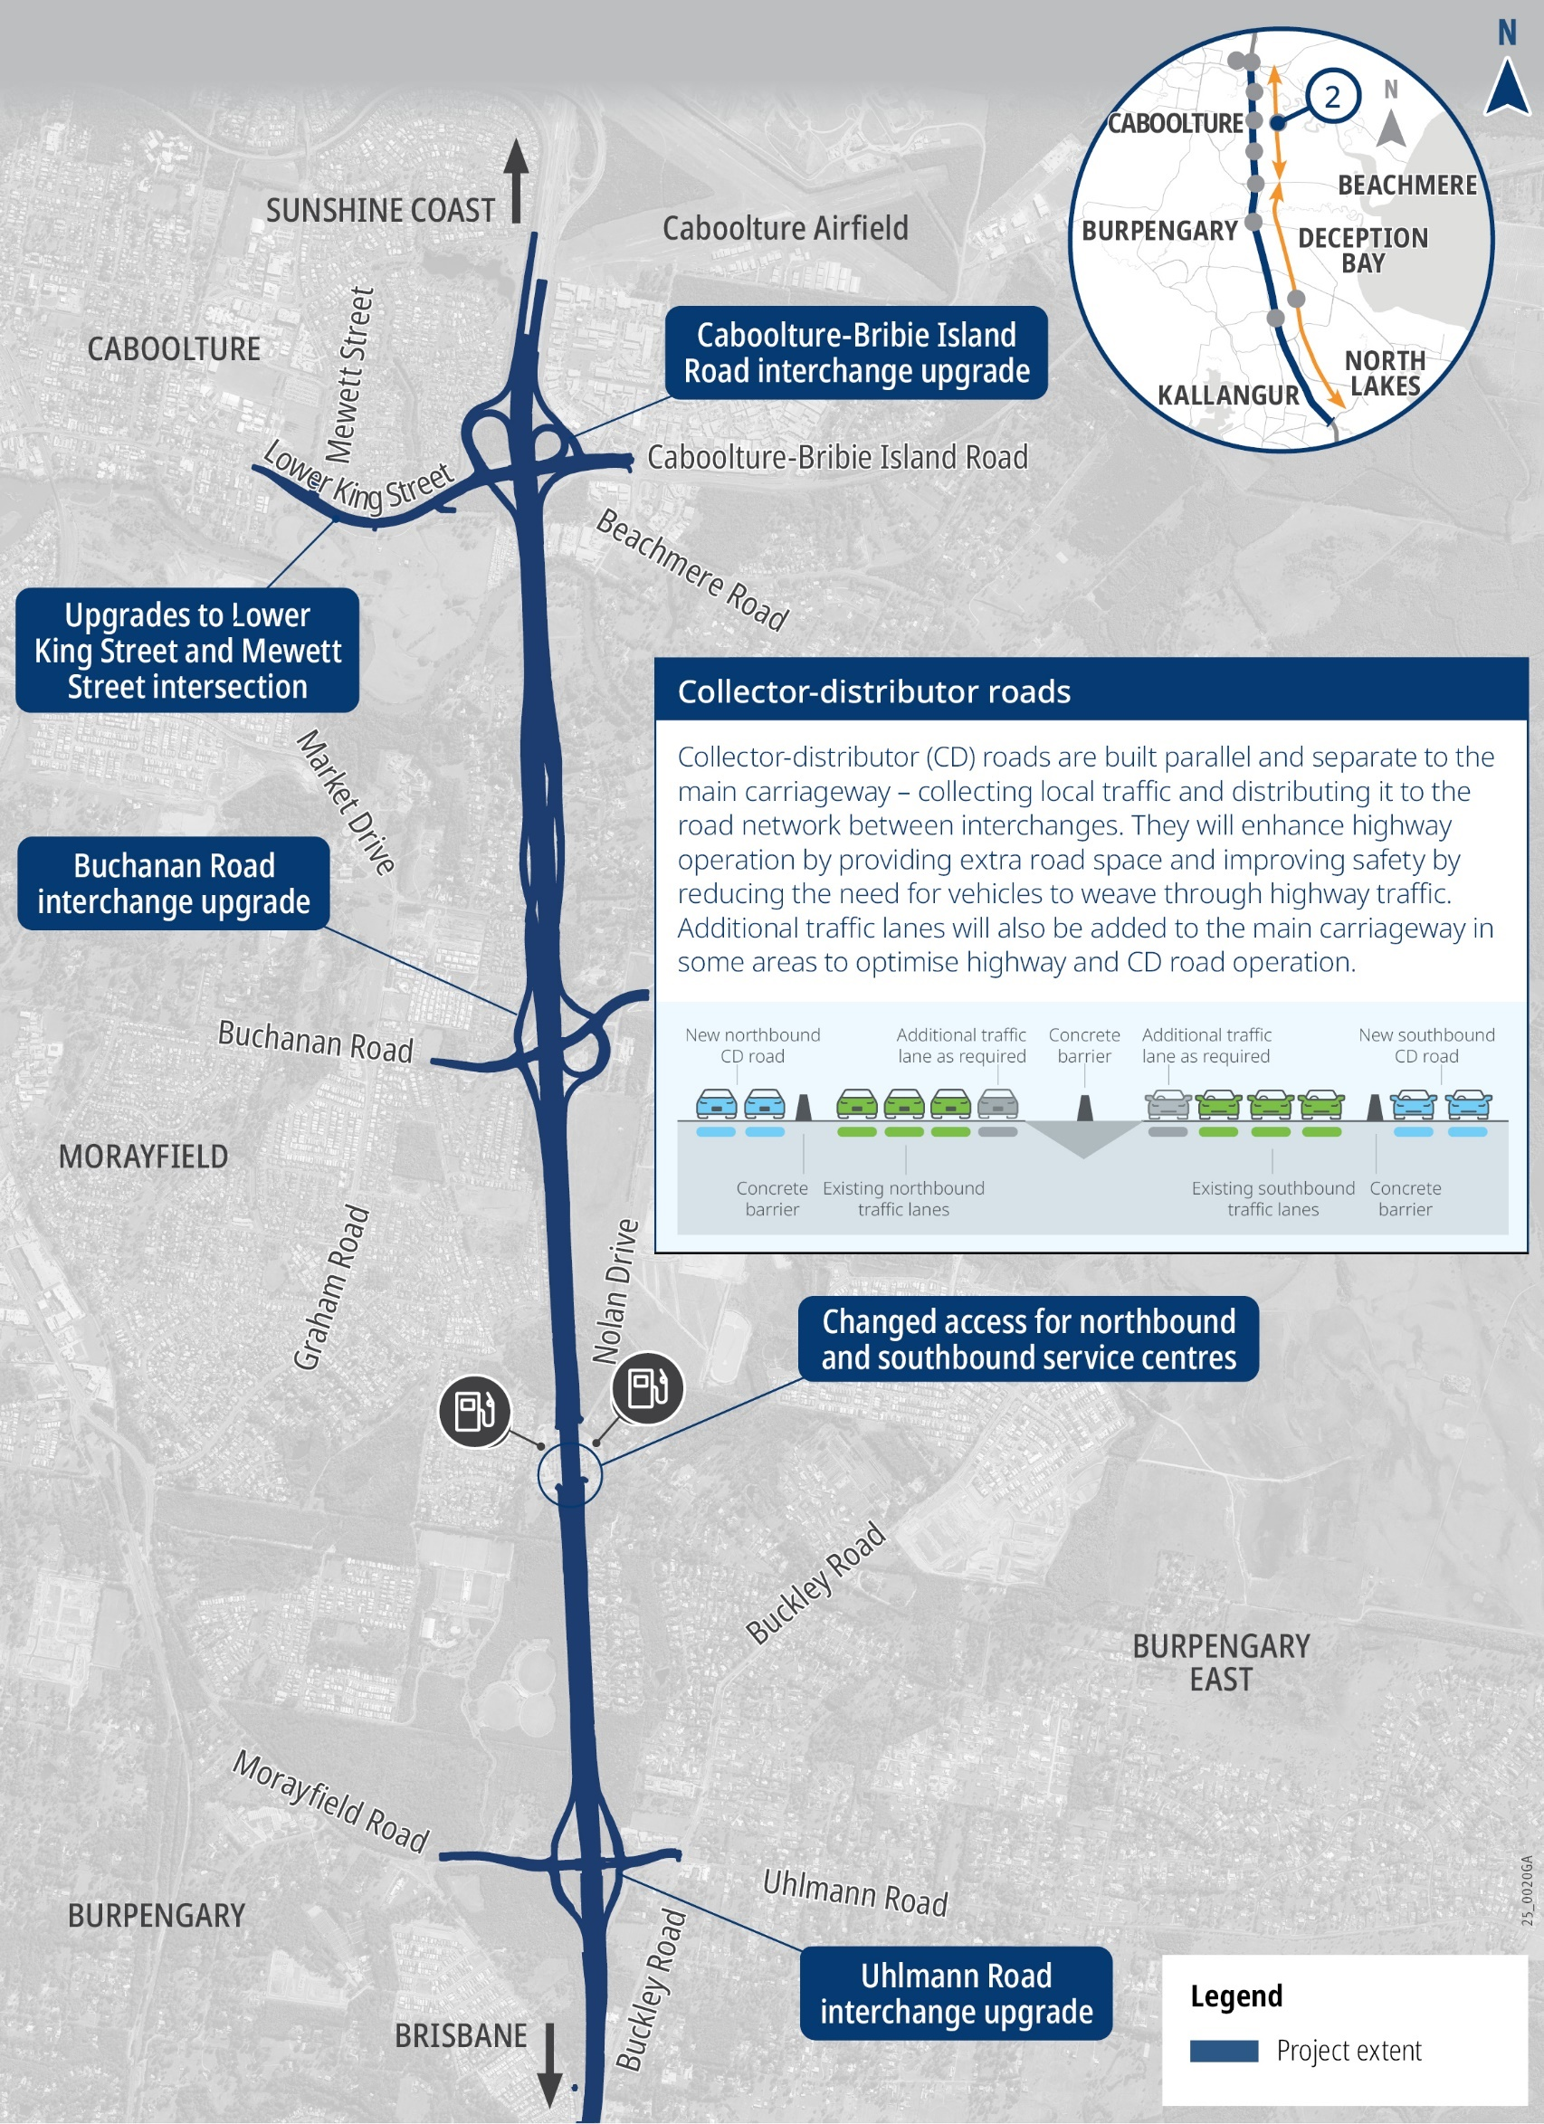
- Anzac Avenue to Uhlmann Road. Map 1 of 10
- Uhlmann Road to Caboolture-Bribie Island Road. Map 2 of 10
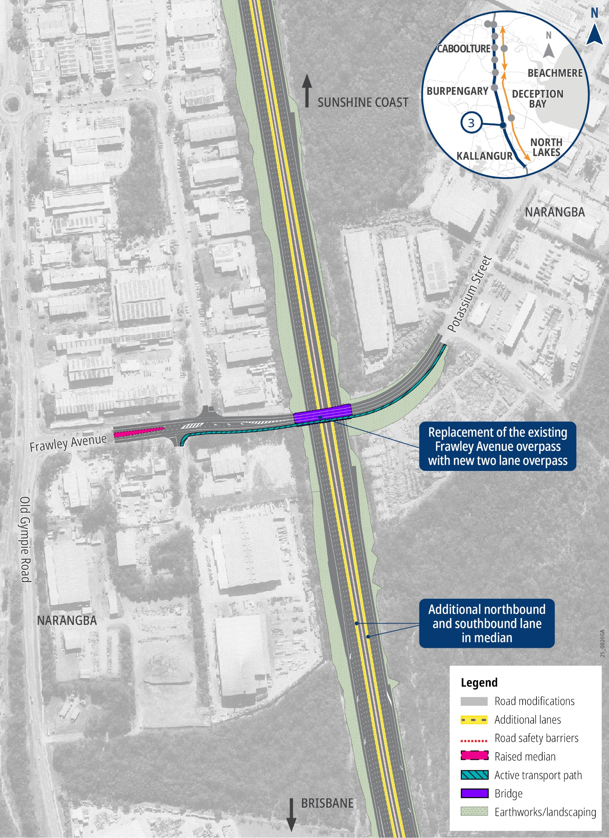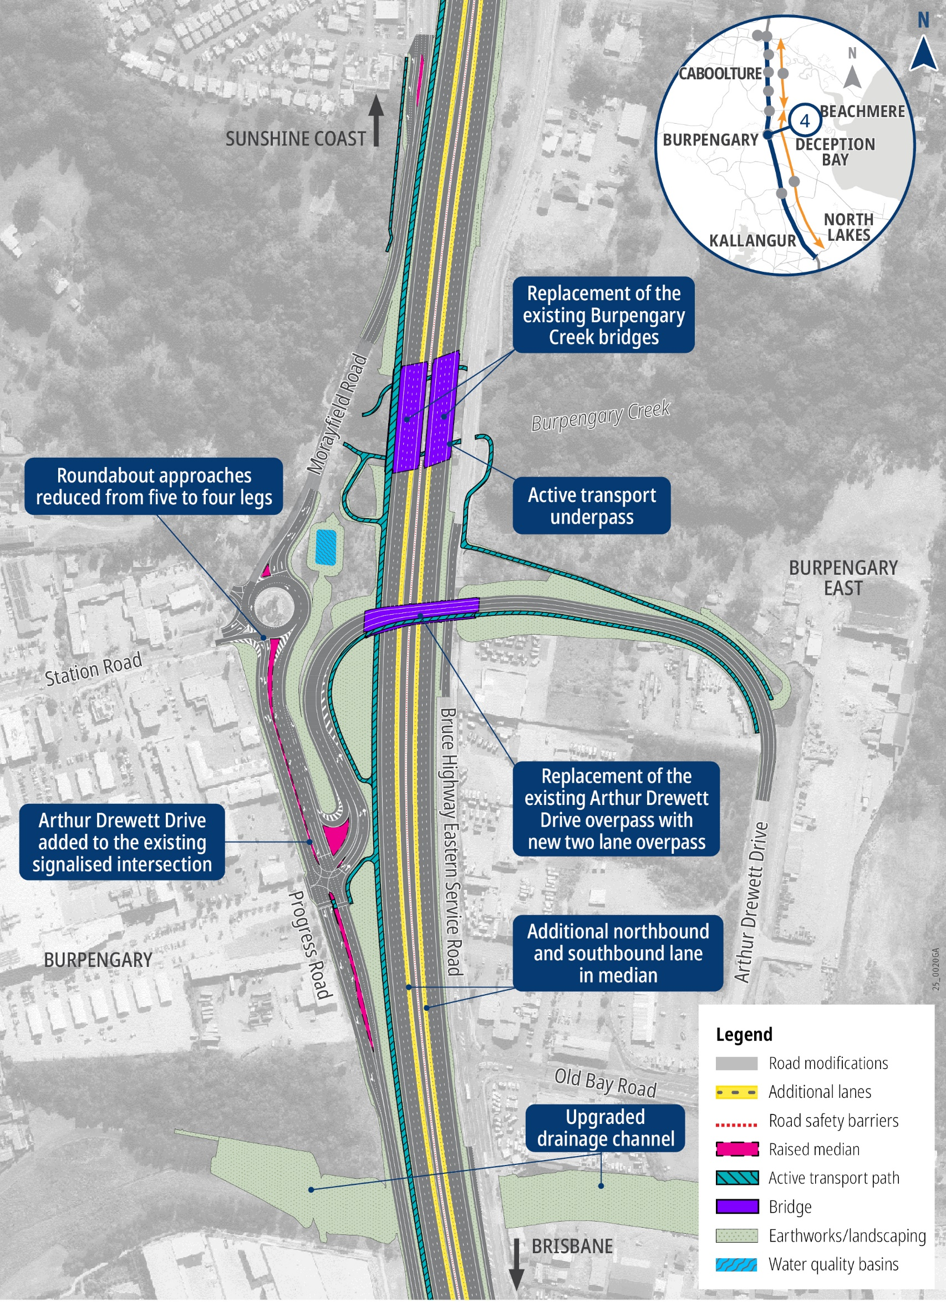
- Frawley Avenue overpass. Map 3 of 10
- Station Road / Arthur Drewett Drive upgrades. Map 4 of 10
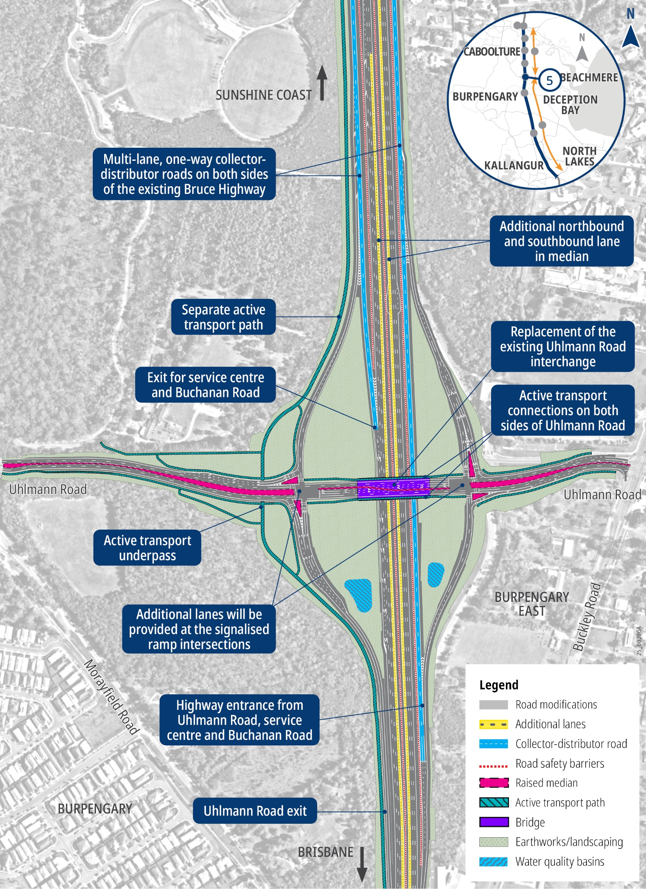
- Uhlmann Road interchange. Map 5 of 10
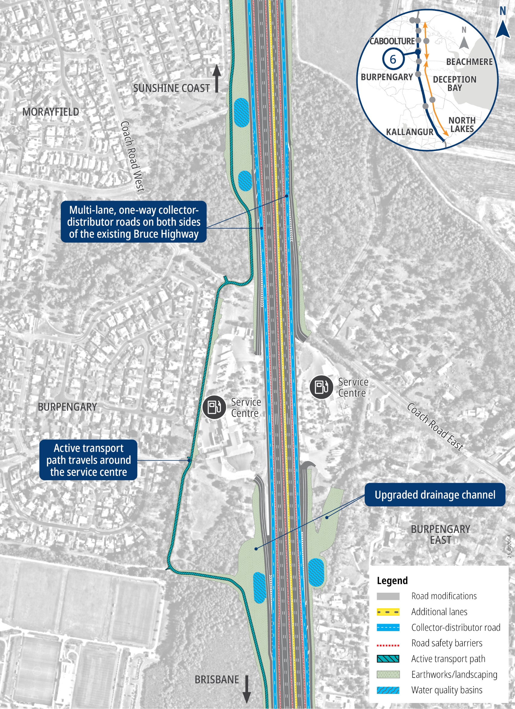
- Uhlmann Road to Buchanan Road. Map 6 of 10
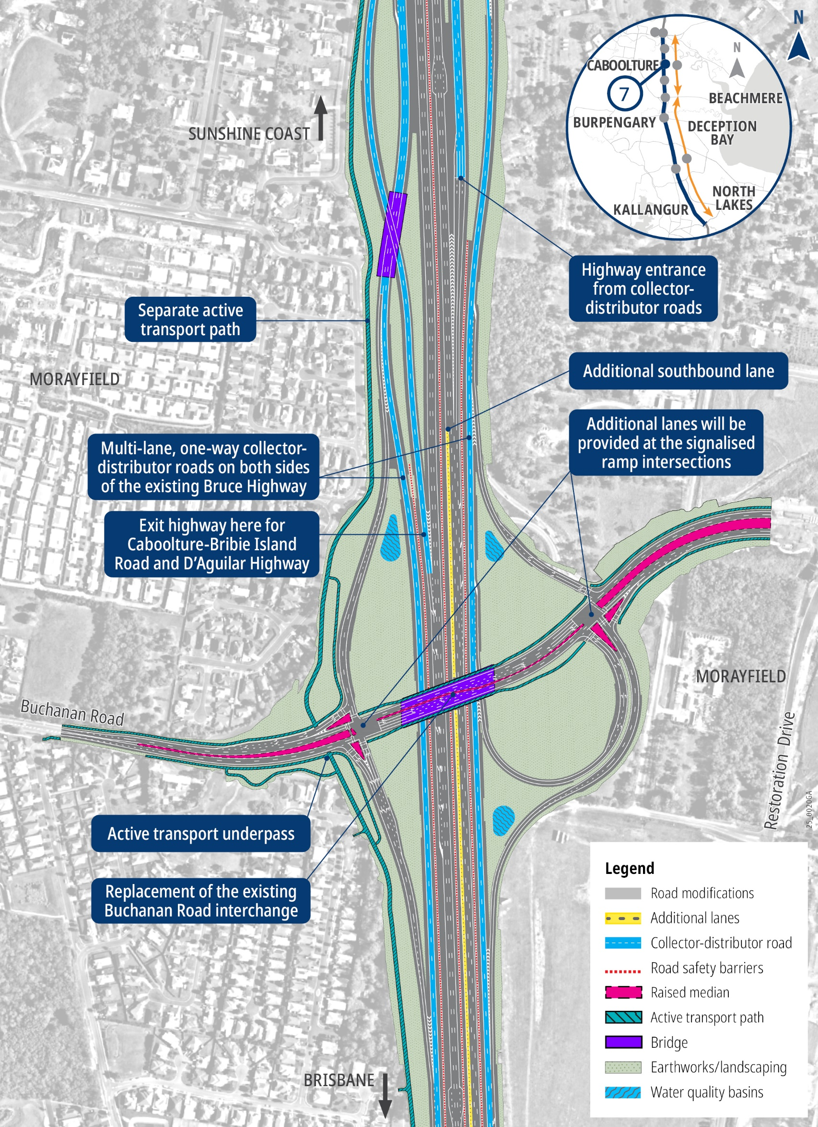
- Buchanan Road interchange. Map 7 of 10
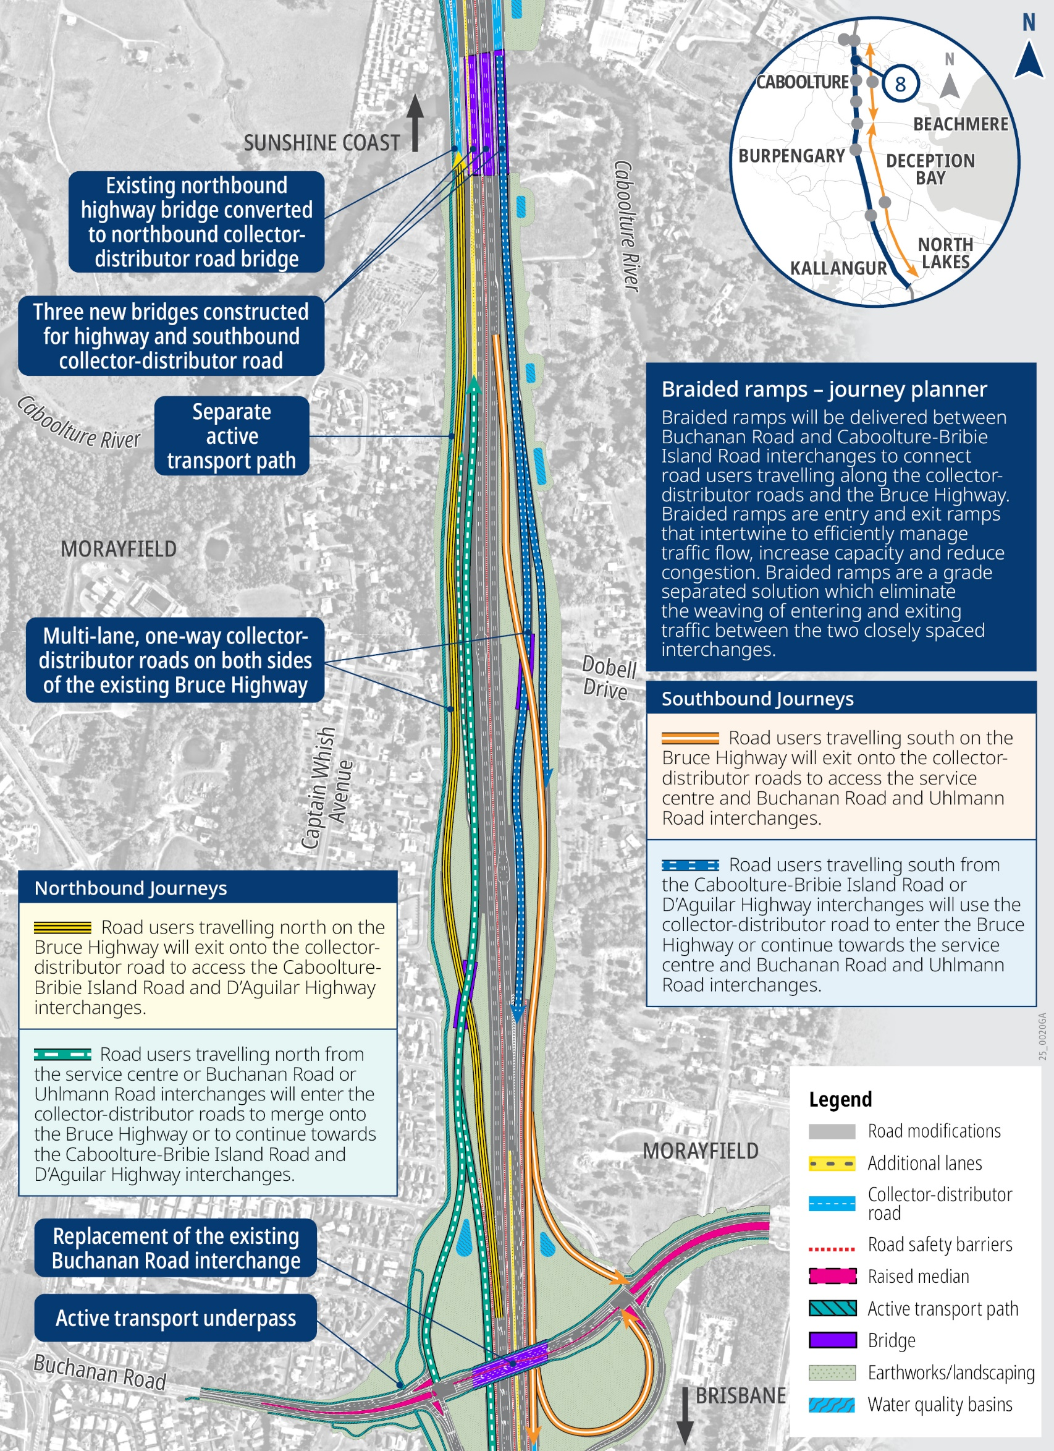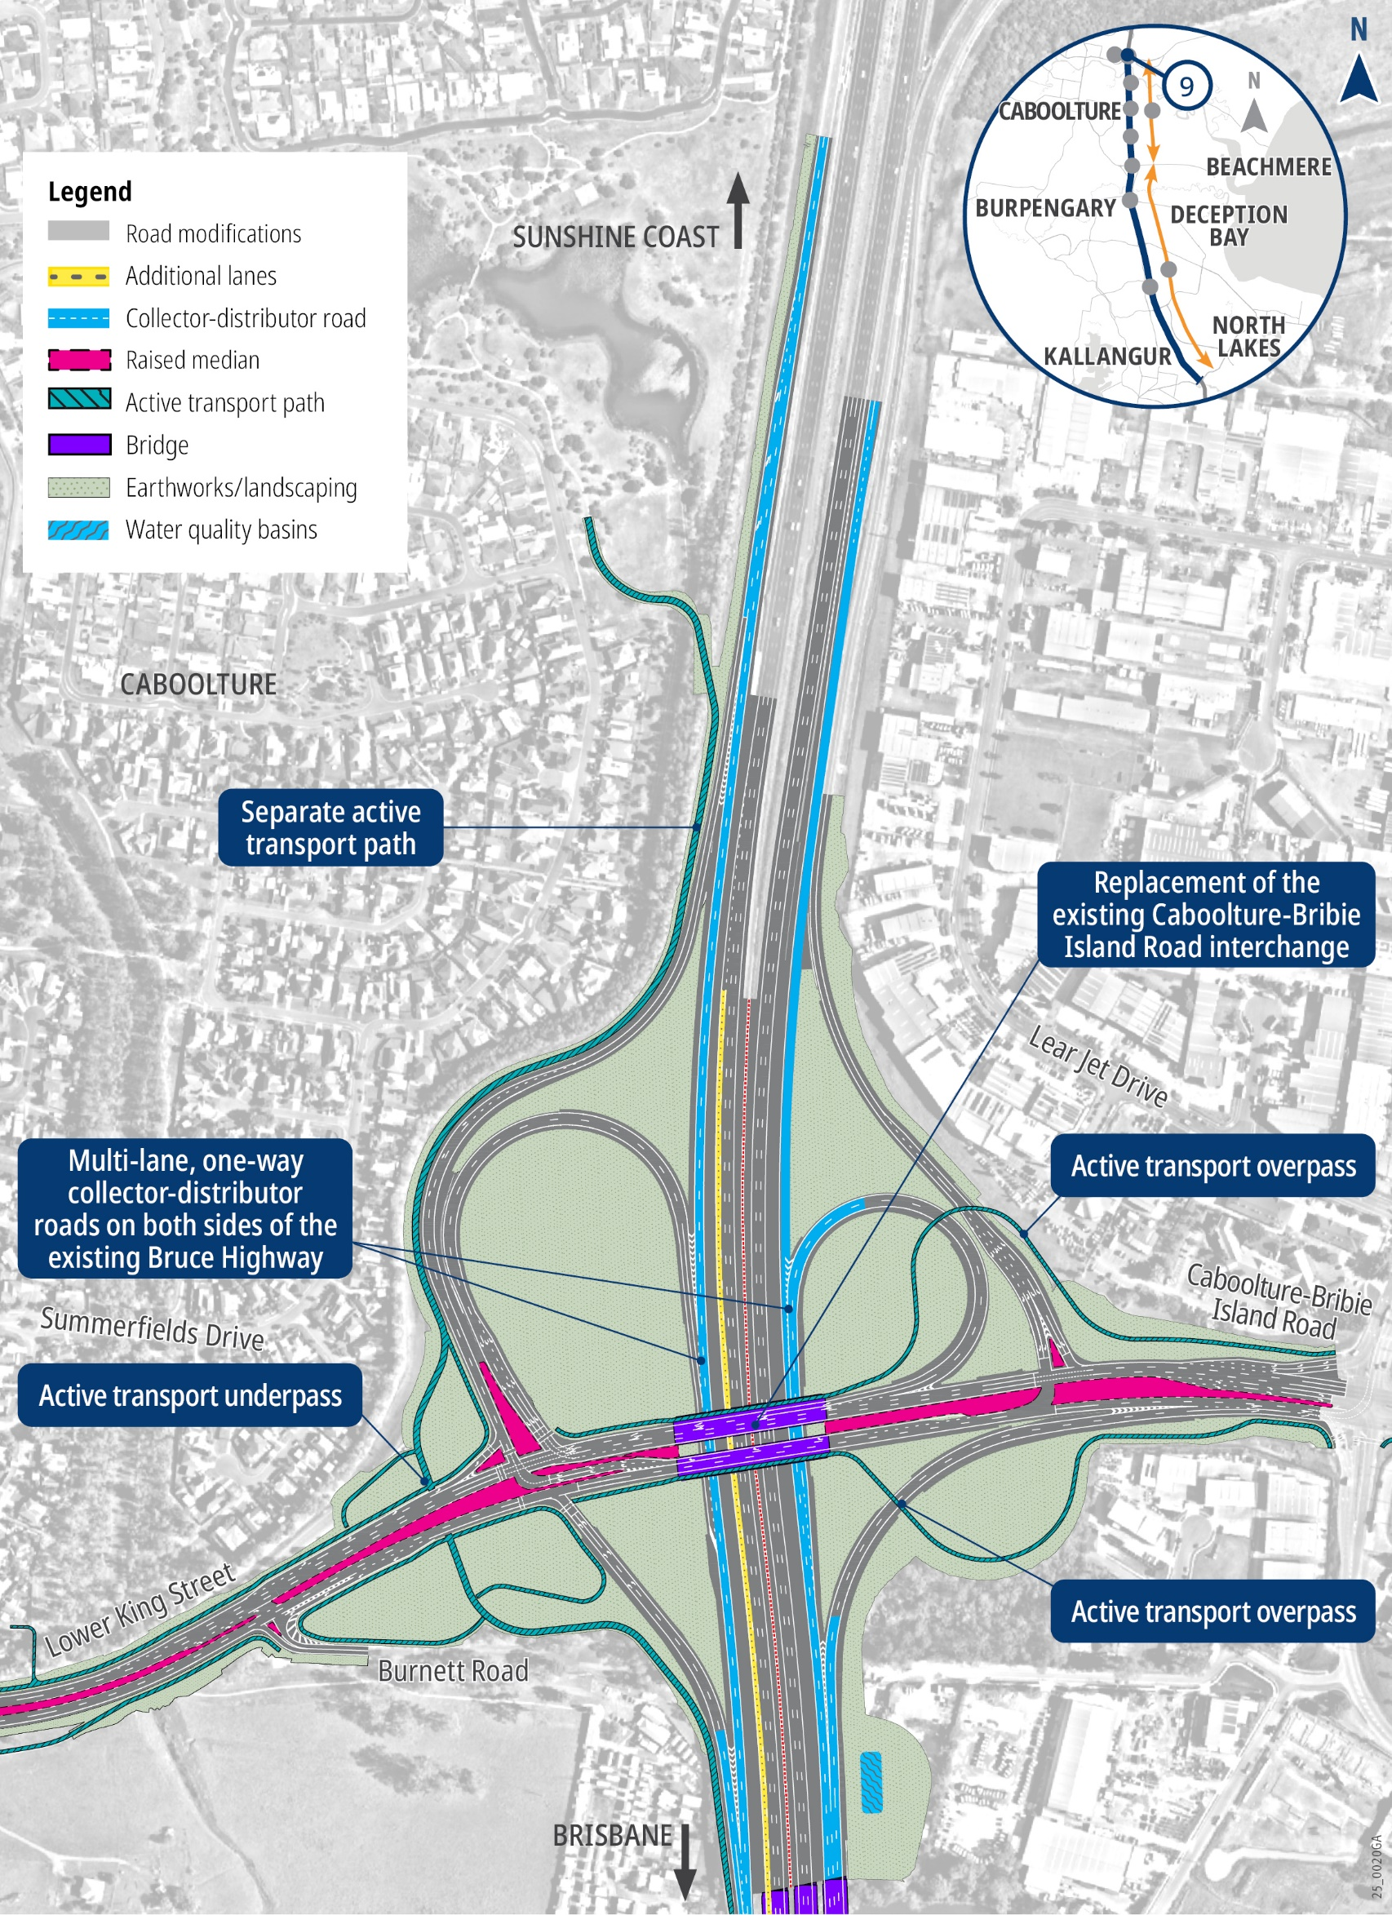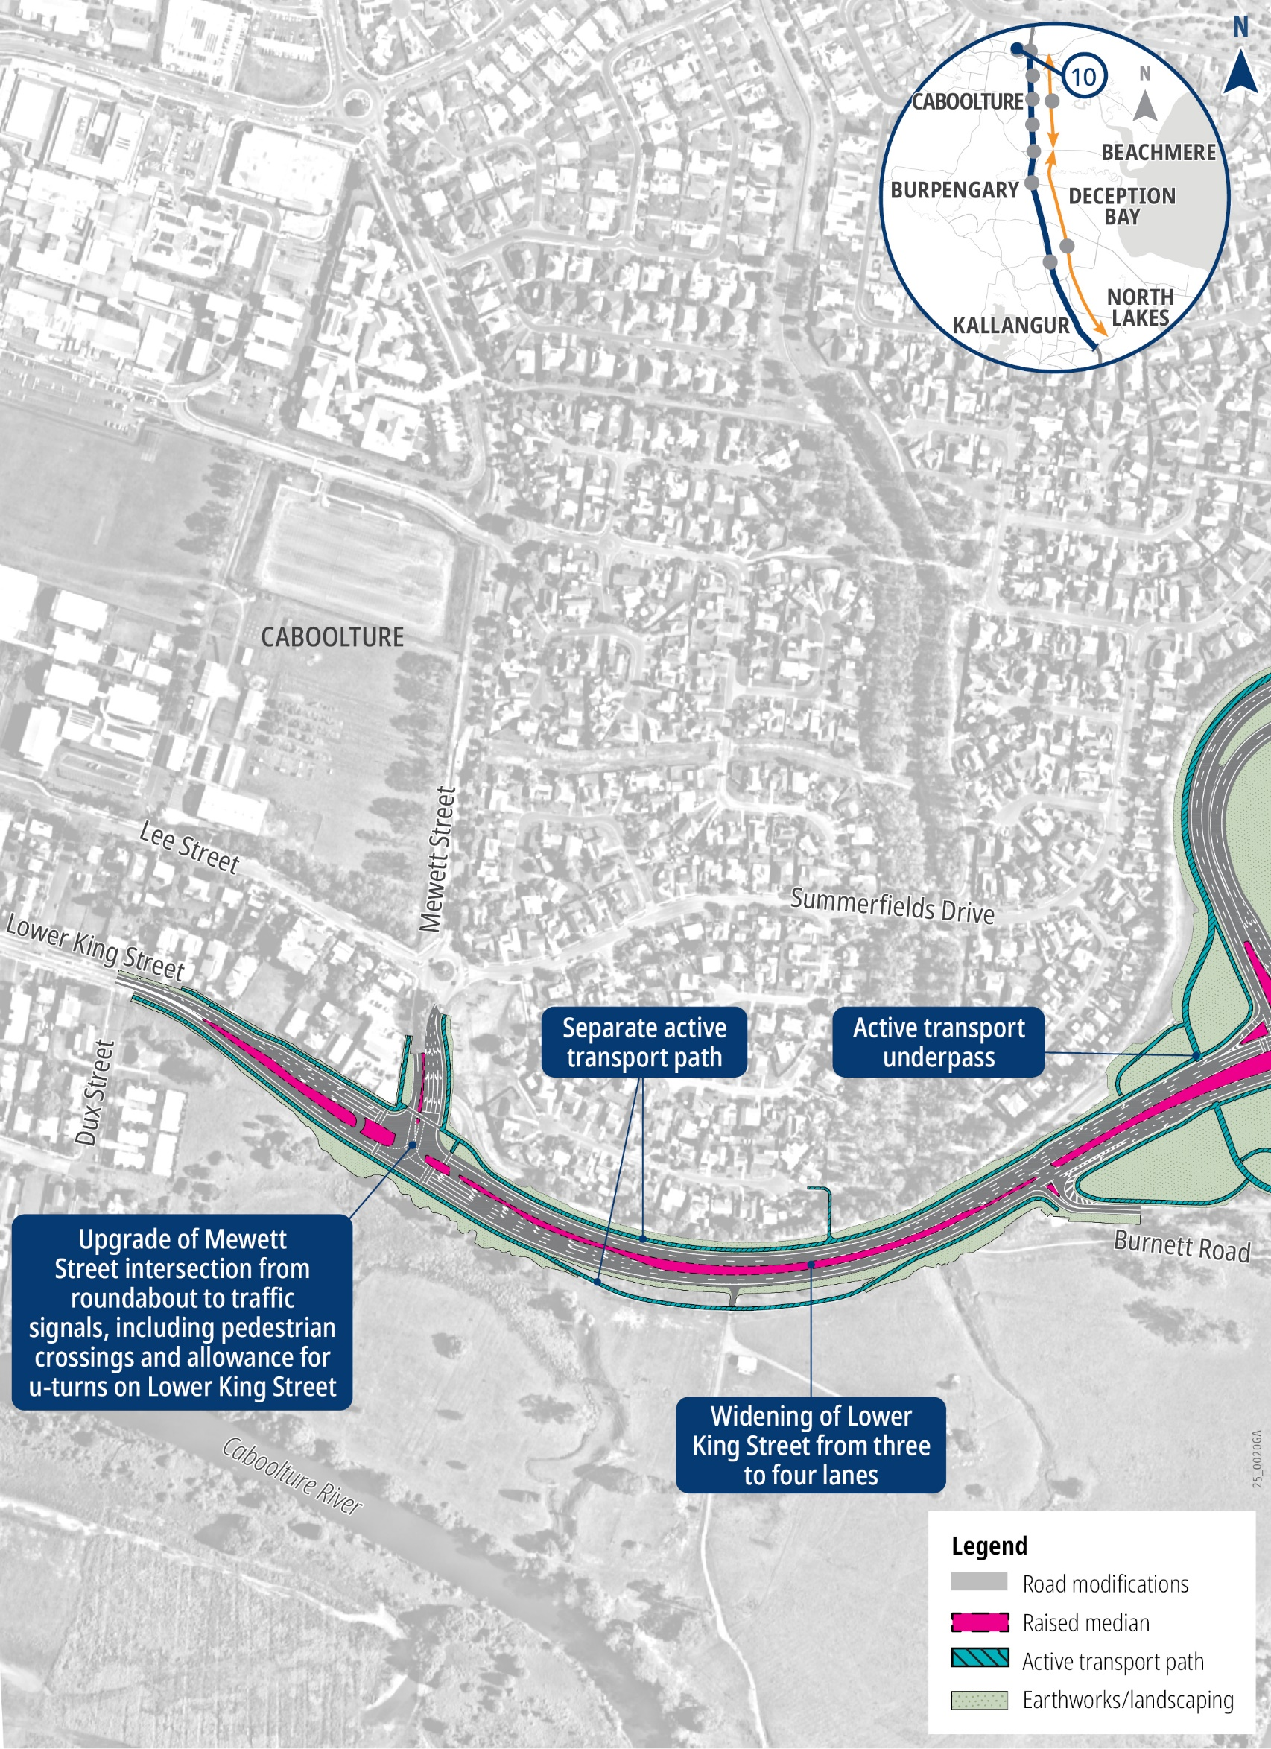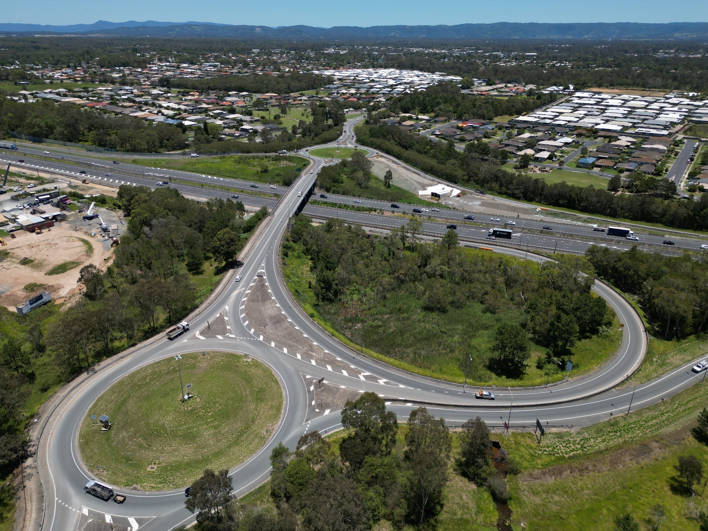
- Uhlmann Road interchange. Map 8 of 10
- Caboolture-Bribie Island Road interchange. Map 9 of 10
- Caboolture-Bribie Island Road interchange. Map 10 of 10
Image: Bruce Highway viewing south-west towards the Buchanan Road interchange. Source: TMR.
Timeline
COMPLETE  | EARLY 2023 | EARLY 2026
Initial planning | Business cases  commenced | Business cases  completed

The Department of Transport and Main Roads (TMR) welcomes your feedback on this planning for the Bruce Highway upgrades. Feedback will inform the detailed design phase of the project. To find out more and have your say before 14 September 2025 go to www.tmr.qld.gov.au/projects/programs/bruce-highway-upgrade-anzac-avenue-to-caboolture-bribie-island-road.

TMR aims to create more opportunities for people to provide feedback. Contact the project team about any accessibility requirements you may have.

Translating Interpreter Services (TIS) - 13 14 50.
If you are deaf, hard of hearing, or have a speech difficulty please contact us by the National Relay Service (NRS) Select NRS call numbers and links and ask for 13 23 80 www.accesshub.gov.au/ about-the-nrs.

Contact us

Phone: 1800 161 135 (Monday to Friday, 8.30am - 4.30pm)
Email: NCR_Planning_Comms@tmr.qld.gov.au
Post: Bruce Highway Upgrade
Anzac Avenue to Caboolture-Bribie Island Road Department of Transport and Main Roads
PO Box 1600 Maroochydore QLD 4558

13 QGOV (137468)
www.tmr.qld.gov.au I www.qld.gov.au

