Cunninghams Gap Reconstruction Project

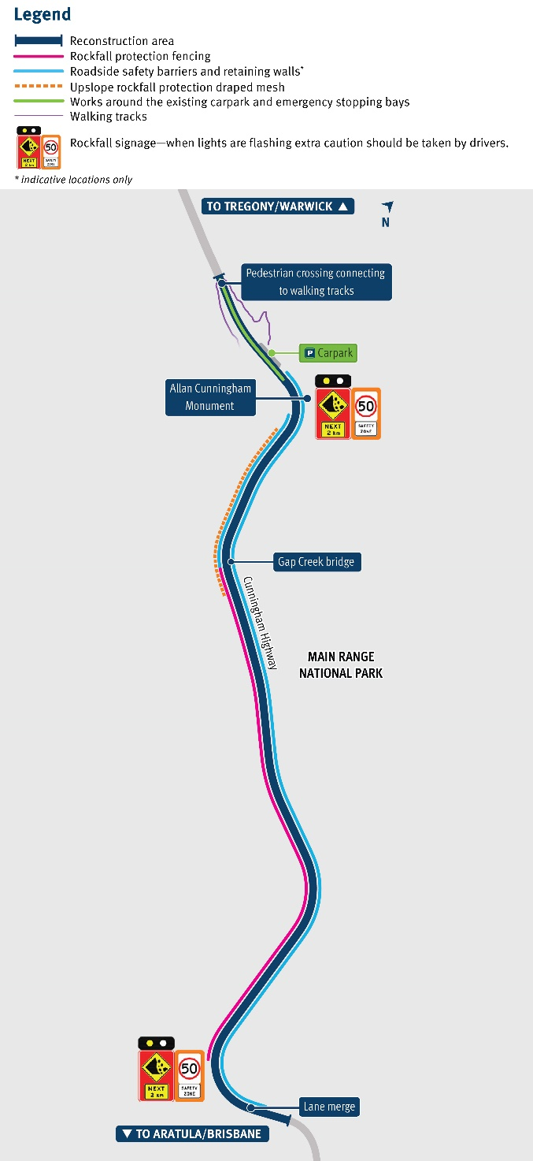
Keeping traffic safely moving through the Gap
August 2025

The Department of Transport and Main Roads (TMR) is restoring the damaged section of the Cunningham Highway at Cunninghams Gap. This two-kilometre stretch, leading up to the Allan Cunningham monument, suffered significant road damage during the bushfires in 2019. Repair works on several fronts have been underway since late 2022. Due to safety and constructability challenges associated with the original design, TMR commissioned a partial redesign with a continued focus on stakeholder feedback and reducing ongoing closures of the highway. The redesign allows the project to be delivered without the significant impacts to communities and industries.

The Cunningham Highway range ascent at Cunninghams Gap will maintain an uphill overtaking lane of 6.5 kilometres long that provides an opportunity to overtake heavy vehicles and slow-moving vehicles.

The project will deliver road safety and efficiency improvements:
- reducing the steep grade of the road at the crest
- a wide centre line treatment, wider traffic lanes and road shoulders to improve road safety for vehicle breakdowns
- an emergency stopping bay around one kilometre from the Allan Cunningham Monument and two emergency stopping bays near the crest carpark.
In September 2024, the grade at the steepest part of the road was reduced and heavy vehicles have experienced a smoother ascent at the final bend of the highway with fewer breakdowns. Completion of the recovery works is scheduled for early to mid-2027.

Cunninghams Gap Reconstruction Project
Why can’t we widen the road?

Widening the road is not within the scope of this reconstruction project, which is to restore bushfire damage at this site. In addition to this, widening the road in this area would require special considerations including mandatory environmental regulations that must be met to protect nature and wildlife. This is particularly important for the Cunningham Highway at Cunninghams Gap, which is situated within the Main Range National Park, part of the Gondwana Rainforests World Heritage Area. It is also essential to preserve any important historical or cultural sites in the area. Additionally, there is a potential safety risk of landslips or rockfalls when excavating mountains to widen a road.
Work activities | Completed | Underway | Upcoming
Removal of loose and unstable rocks from the slope above the road
Installation of rockfall protection drape mesh
Works at the West Gap Creek picnic area
Reduction of the steep grade at the top of the crest
Foundations, posts and fencing to catch falling rocks at road level
Replacing and constructing additional concrete barriers
CCTV and monitoring systems
Construction of downslope retaining walls
Construction of soil nail walls
Construction of emergency stopping bays
Installation of guardrail with rubrail (for motorcyclist safety)
Wide centre line treatment
Pavement works
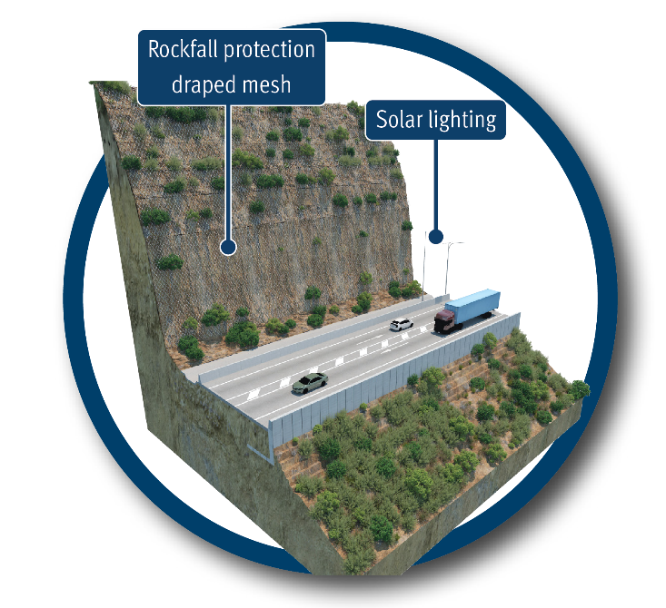
This draped mesh material is crucial for rockfall protection to safely redirect falling rocks to the base of the slope and away from the road. About 20,000m2 of draped mesh has been installed with over 200 rock anchors that have been drilled and secured to fit the unique and natural rockfaces at Cunninghams Gap.
Why can’t a tunnel be built?

Building a tunnel at Cunninghams Gap is not under consideration as it is outside the permitted scope of this project. Funding for this reconstruction project under the Disaster Recovery Funding Arrangements (DRFA) is bound by strict requirements and is provided to restore bushfire damage at the site.

Project funding: The recovery works are jointly funded by the Australian and Queensland Governments through the Disaster Recovery Funding Arrangements (DRFA).

Speed limit
The speed limit is currently reduced to 40km/h. On completion of the project, the posted speed limit will be 50km/h for road safety. The speed limit has been approved by the Speed Management Committee, consisting of representatives from TMR, Queensland Police Service and Scenic Rim Regional Council.

Traffic conditions
Currently, traffic is held intermittently for up to 15 minutes for the movement of plant and equipment and to undertake construction activities at Cunninghams Gap from 6am to 6pm, Monday to Friday (excluding public holidays).
Road users may experience longer delays due to oversize overmass (OSOM) vehicles. This is due to the Cunningham Highway being a National Freight Route for OSOM vehicles. All eastbound and westbound traffic is held each time an OSOM vehicle travels through the project site.
Traffic changes will continue to be provided to the community in advance through electronic roadside signage, the QLDTraffic website (www.qldtraffic.qld.gov.au) and app and to subscribers for SMS or email updates. Road users are advised to follow directional signage and allow extra travel time. Priority access through the project site will be given to emergency vehicles where possible.

Requirements for OSOM operators
Operators must apply through the National Heavy Vehicle Regulator Portal for special permits to access this route. Operators must check the Conditions of Operations Database before starting their journey. Before travelling, operators must ensure they comply with the Queensland Access Conditions Guide.
When approaching the project site, operators must contact the project team on UHF channel 40. All daytime OSOM vehicles will be held by traffic controllers in dedicated OSOM holding bays within the project site area until it is safe to travel through the project site.

Contact us
Phone: 1800 497 100* (9am to 5pm, Monday to Friday)
Email: cunninghams_gap@tmr.qld.gov.au
Website: www.tmr.qld.gov.au/cunninghamsgap
Mail: PO Box 442, Nerang QLD 4211
*Free call from anywhere in Australia, call charges apply for mobile phones and payphones. Check with your service provider for call costs.


Interpreter and accessibility services Translating Interpreter Services (TIS): 13 14 50
If you are deaf, hard of hearing, or have a speech difficulty please contact us by the National Relay Service (NRS). Select NRS call numbers and links and ask for 13 23 80.

For more information scan the QR code to visit TMR’s project webpage.


