Project update
August 2026

Logan and Gold Coast Faster Rail
The Australian and Queensland governments are delivering the Logan and Gold Coast Faster Rail (LGC) project to meet the growing travel demand between Brisbane and the Gold Coast.
Here’s what’s been happening on the project.
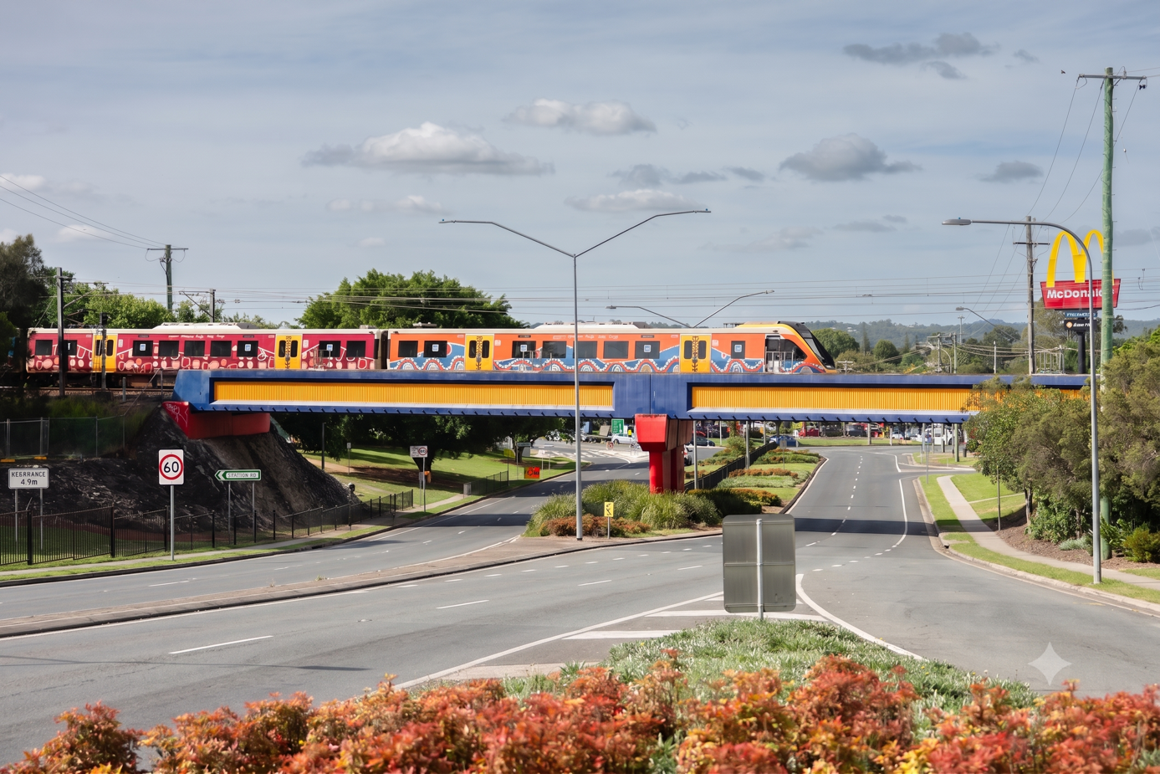
Image: NGR train crossing the rail bridge at Woodridge.

Key benefits for the community
- Improved accessibility at stations
- Increased the rail network capacity by doubling tracks
- Improved safety by removing level crossings
- Safer and easier to walk and cycle to stations

Your feedback is helping shape the project
Since late 2025, we have been engaging with local communities across all station precincts along the project corridor to gather feedback on the latest designs and inform final design development. Engagement is complete for all precincts except Holmview, which will commence in the coming months.
Summaries from engagement completed last year are available on the project website, and a detailed report of key findings from all station precincts will be released later this year.

Topics of most interest so far
- station accessibility and design
- road and traffic changes
- parking and access
- heritage and environment
- bus routes and stop locations
- active transport connectivity and access
- impacts to existing rail and bus services
- construction timing and impacts.

Building the new Loganlea station
If you travel by train through Loganlea, you will now be travelling on brand new tracks and get an up-close look at the new station under construction. This switch of train services to the new tracks marks a major milestone for the project, which is now over 50% complete.
Other recent progress:
- Installed the first section of the pedestrian footbridge
- Completed the first island platform structure
- Completed the realignment of Valencia Street
- Progressed the new park ‘n’ ride on Valencia Street.
Beyond construction, we have enjoyed working with the community.
We have:
- hosted local high school students for work experience
- partnered with Loganlea State High School to create a new on-campus community garden to benefit both the school and wider community
- worked with Logan Hospital to teach paediatric patients about rail safety.
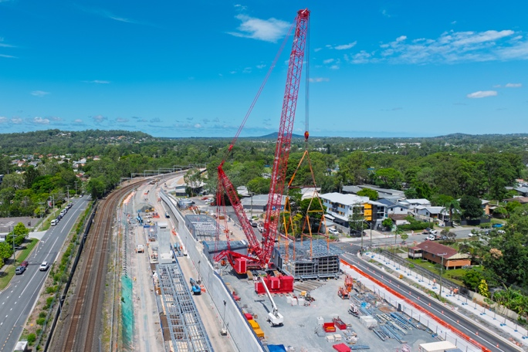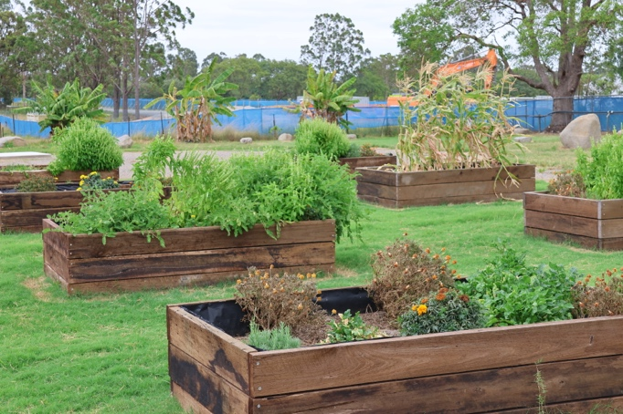
Left image – A 480-tonne crane lifting pedestrian footbridge at Loganlea station.
Right image – Community garden partnership with Loganlea State High School.

Interesting facts
- A 480-tonne crane was used to lift the pedestrian footbridge into place at the new Loganlea station. That’s the weight of about 320 average cars.
- Concrete piles for the bridge foundations at Kuraby are up to 22m deep, which is equivalent to a 7-storey building.
- One train can take more than 600 cars off the road.
- The LSR site compound is 100% powered by renewable energy.

Kuraby Open Level Crossing Removal
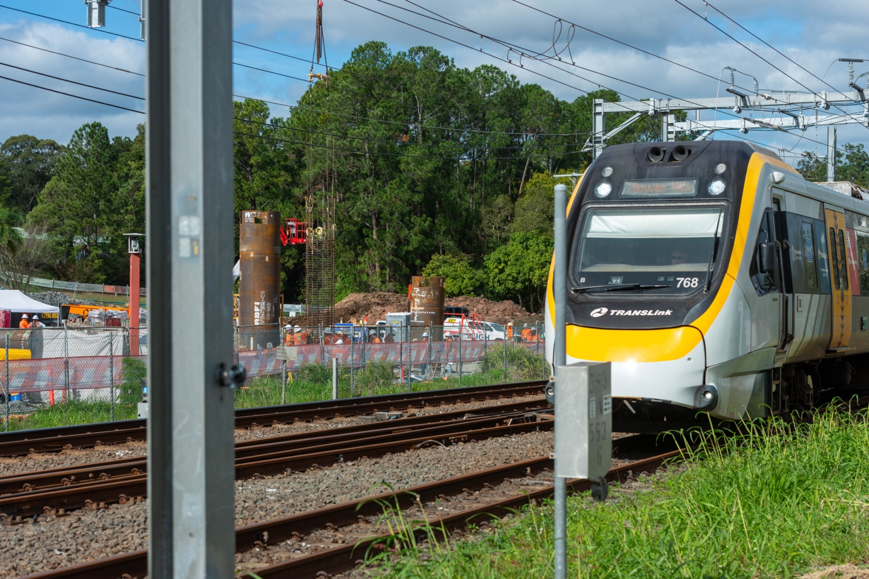
Image: In the background, pilling works for the new road-over-rail bridge at Kuraby.

We are building a safer way for the community to cross the rail tracks at Kuraby with construction now in progress on the new road-over-rail bridge at Beenleigh Road. This will replace the existing level crossing and is the first of five level crossings being removed as part of the LGC project.
Recent progress includes:
- establishing multiple work sites along Beenleigh Road
- completing piling works to construct 31 concrete piles for bridge foundations
- relocating public utilities.
The Kuraby community will continue to see the bridge take shape over the coming months, as we build the substructure on either side of the rail tracks – ready for the bridge girders to be crane-lifted into place.

Welcome to the new Kids’ Corner
Now available online, our new range of kids’ activities makes it fun for families to learn about the LGC project. Designed for a variety of age groups the activities range from connect the dots and colour by numbers for our youngest passengers, to a word search and project quiz for older student rail enthusiasts.
Download at: https://www.yoursay-projects.tmr.qld.gov.au/logan-and-gold-coast-faster-rail

Rail package update
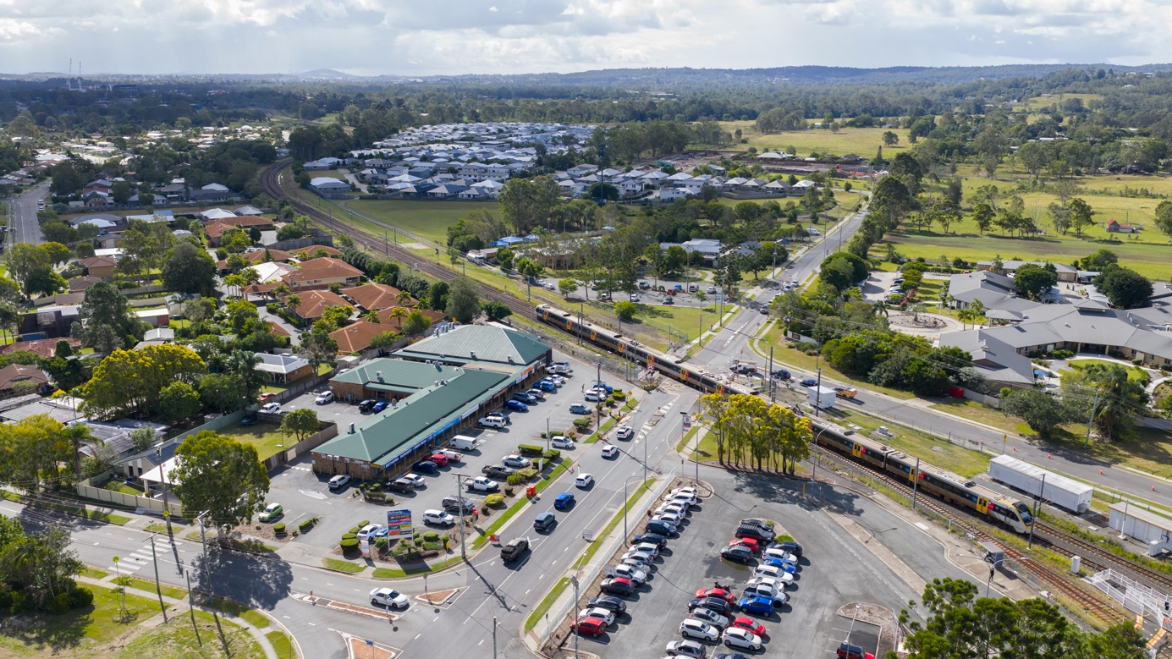
Image: Station Road, Bethania level crossing.

The LGC project is entering a significant delivery stage with early works well underway at multiple locations for the Rail package of works.
Updates:
- Site establishment and enabling works have commenced at Bethania, Kingston, Edens Landing and Beenleigh station precincts
- Major construction will commence at these locations from late 2026 into 2027
- Construction will be staged for each station precinct and will begin at different times
- Design activities will continue over several years for the track, civil, structural, systems and signalling works.

Walking and cycling connections
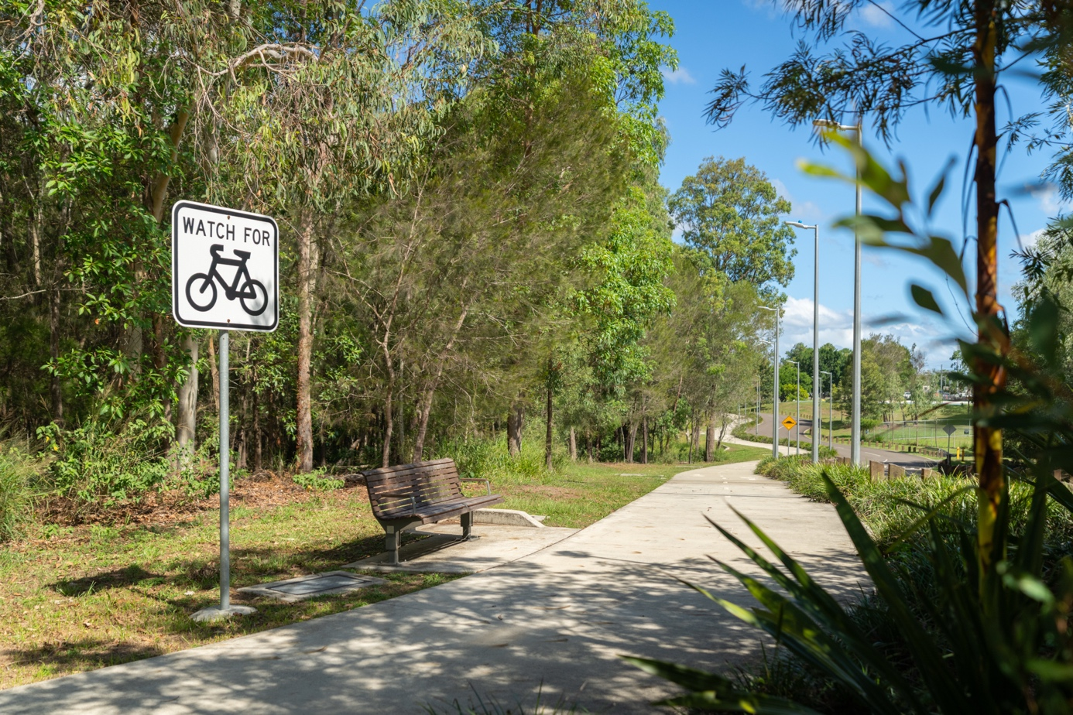
Image: new walking and cycling connections to stations.

The LGC project is providing more accessible connections for pedestrians and bike riders making travel to public transport easier.
The updated design:
- includes 14 kilometres of new active transport infrastructure, together with four kilometres of existing on-road infrastructure
- improves local walking and cycling connections to stations and community facilities such as schools, hospitals and places of worship
- delivers new segments of and improved links to the Principal Cycle Network
- provides new pedestrian crossings at stations
- includes secure bicycle storage at each station.

Stay up to date
Search on tmr.qld.gov.au: ‘Logan Gold Coast Rail’
Email: logangoldcoastrail@tmr.qld.gov.au
Call: 1800 957 066
For further information, or if you require translation or support services to access the documentation, please contact the project team on 1800 957 066 (9am – 5pm Monday to Friday).

www.tmr.qld.gov.au/logangoldcoastrail
13 QGOV (137468)
www.tmr.qld.gov.au | www.qld.gov.au

