Logan and Gold Coast Faster Rail

Trinder Park station precinct, November 2025

Updated design
The 2023 Refined Reference Design (RRD) included a new location for Trinder Park station with a section of track to be reconstructed, straightening the track and eliminating the existing curve in the line improving safety, network efficiency, and reducing operational noise.
As part of the tender process for the Logan and Gold Coast Faster Rail (LGC) project, the Department of Transport and Main Roads (TMR) asked proponents to innovate and consider options to address prior community feedback.
As a result, TMR has adopted a design which sees an improved location for Trinder Park station, moving it to the edge of Acacia Forest Park minimising environmental impact, and a new pedestrian connection to both sides of the corridor.
Other updates to the design include:
- the new station location allows for construction of the station ‘offline’ while keeping the existing station open to customers
- moving the park ‘n’ ride to Candish Street provides greater connectivity for the local community, improves commuter safety and minimises disturbance to vegetation in Acacia Forest Park
- moving the bus connections to Acacia Road improves access to the broader local bus network
- a new road-over-rail bridge will be constructed linking to Acacia Road, together with walking and cycling connections.
Trinder Crossing level crossing, between Railway Parade and Station Road, Woodridge will be removed.

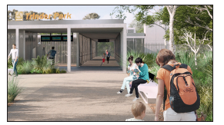

Figure 1 Artist impression of new Trinder Park station, subject to change

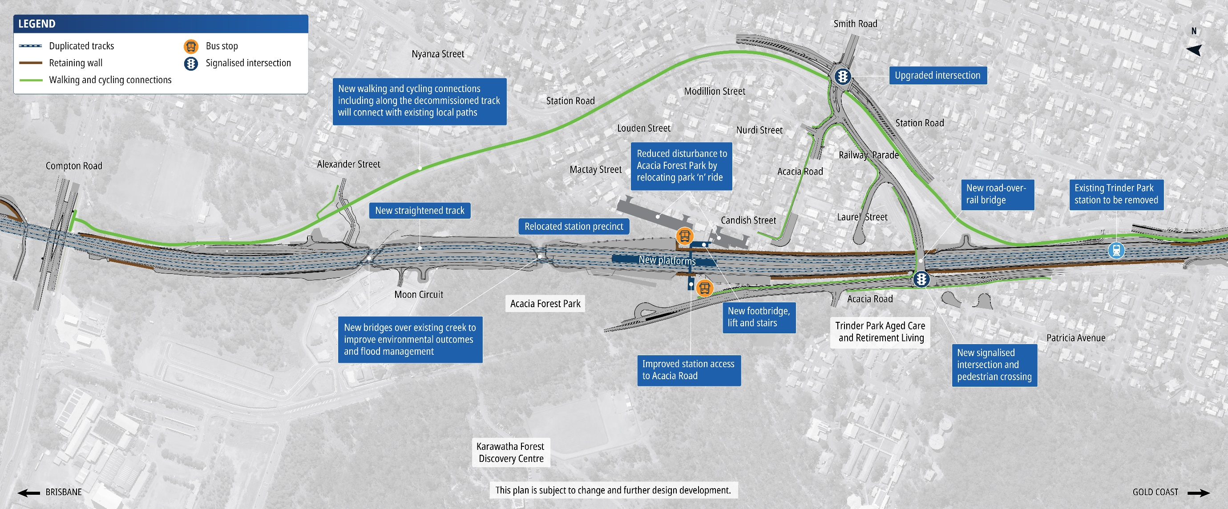
Trinder Park station precinct design

.

How community feedback shaped the updated design
In late 2023, TMR sought public feedback on the Refined Reference Design for the whole LGC project, including the removal of five level crossings between Kuraby and Beenleigh. TMR has worked with ActivUs to incorporate community feedback into the updated design for the Trinder Park station precinct, to further improve accessibility, safety and customer experience.

What you told us
- Feedback about pedestrian connections to and from the relocated Trinder Park station and suggestions for access from Acacia Road.
- Feedback regarding environmental management through Acacia Forest Park and the surrounding area, and environmental offsets.

What we are doing
- The new station location allows for pedestrian connectivity to both side of the station including improved local road connectivity on Railway Parade, Acacia Road and Laurel Street.
- Relocation of the road-over-rail bridge to Acacia Road and Railway Parade creates a walkable connection across the rail corridor.
- Significantly reduced impacts to Acacia Forest Park through a repositioned station and park ‘n’ ride, while also allowing the new station to be built ‘offline’, keeping the existing station open to customers during construction.
- In mid-2025, the Australian Government provided the project with formal environmental approval, which the project continues to work within.

Next steps
TMR, Queensland Rail and ActivUs have formed the LGC Rail Alliance to deliver the LGC Rail package.
The LGC Rail package scope of work includes doubling the number of tracks between Kuraby and Beenleigh from two to four, removing level crossings, modern station upgrades, and improving access and connectivity along the complex 20-kilometre project corridor.
ActivUs is currently undertaking site investigations to inform further design development ahead of major construction works starting later in 2026.
The $5.75 billion LGC Rail project is jointly funded (on a 50:50 basis) by the Australian and Queensland governments.
Scan the QR code to visit the online engagement hub at www.yoursay-projects.tmr.qld.gov.au/logan-and-gold-coast-faster-rail to have your say and sign up for updates.
1800 957 066 (all hours)
lgcrail@activusalliance.com.au
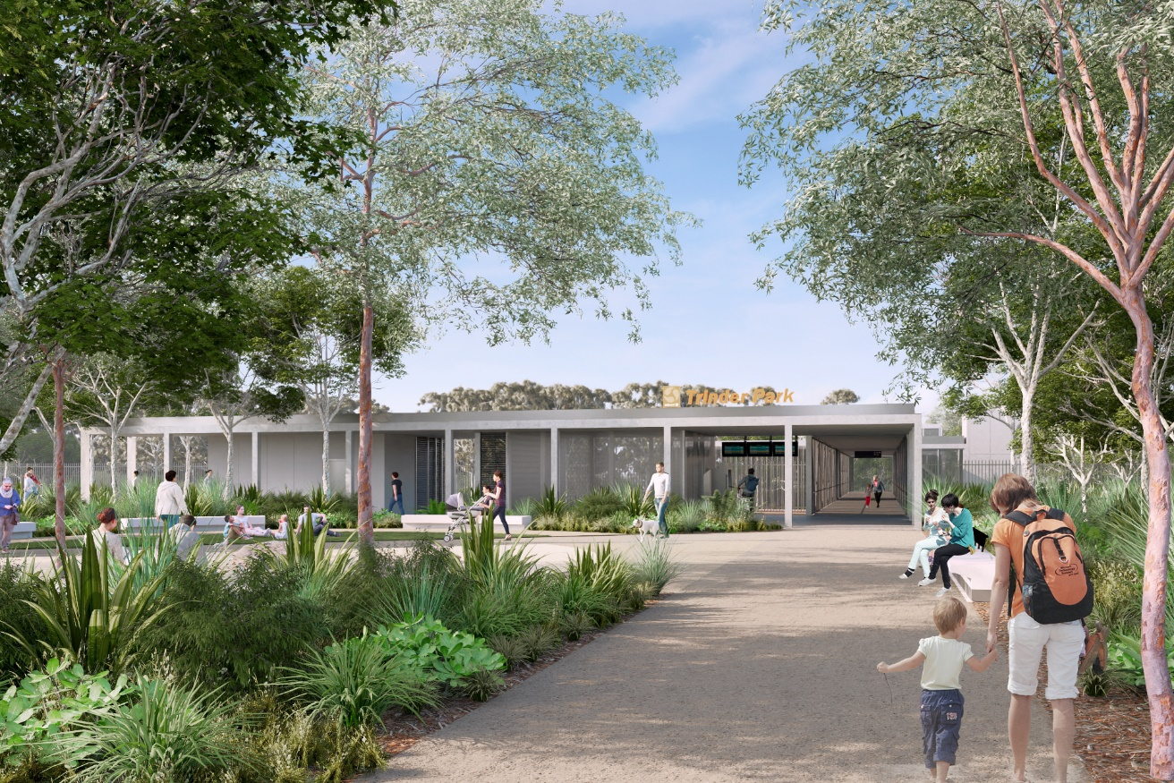
Figure 2 Artist impression of new Trinder Park station, subject to change.

