Attachment A (refer EP169) – Statutory Declaration

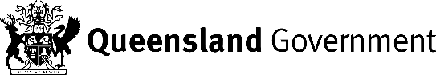
Oaths Act 1967
Statutory Declaration

I, | [insert your full name here]
of | [insert address here] |  |  | in the State of Queensland
do solemnly and sincerely declare that
[Matters to be declared]

And I make this solemn declaration conscientiously believing the same to be true, and by virtue of the provisions of the Oaths Act 1867.
 |  |  |  | Signature of declarant/deponent
Taken and declared before me at |  |  | [Location]
this | [day] | day of | [month, year]
 |  |  |  | A Justice of the Peace/Commissioner for Declarations.

Notes:
- This Statutory Declaration must be witnessed by a solicitor, barrister, Justice of the Peace, Commissioner of Declarations or other person authorised under the Oaths Act 1867 as amended.
- A person who wilfully makes a false statement in a statutory declaration under the Oaths Act 1867 as amended is guilty of an offence under that Act, punishment for which may include a fine and/or imprisonment.

[end of document]

