Waste 2 Resource – Annual Status Report 2022–2023

October 2023

Copyright
This publication is protected by the Copyright Act 1968.
© The State of Queensland (Department of Transport and Main Roads) 2023. All rights reserved.
Disclaimer
This publication is provided as a source of information only and the State of Queensland makes no statements, representations or warranties about its accuracy or completeness. To the extent permitted by law, the State of Queensland disclaims all responsibility for decisions or actions taken as a result of any data, information, statement or advice, expressed or implied, contained within and excludes all liability (including, without limitation, liability in negligence) for all expenses, losses, damages and costs that may be incurred.
Translating and Interpreting Services
The Queensland Government is committed to providing accessible services to Queenslanders of all cultural and linguistic backgrounds. If you have difficulty understanding this publication and need a translator, please call the Translating and Interpreting Service (TIS National) on 13 14 50 and ask them to telephone the Queensland Department of Transport and Main Roads on 13 74 68.

Front cover images (left to right and top to bottom): Crushed concrete; placement of subgrade material on the May Downs Road, pave and seal project in Central Queensland Region © Cooper McCullough Group; crushed concrete; and rubbled concrete from the Varsity Lakes to Burleigh (VL2B) project in South Coast Region. Top left and bottom left and right images © The State of Queensland.

Contents
Executive summary 1
Introduction 2
Targets 2
Waste reporting 3
Case study 1: eMesh used on the Edmonton to Gordonvale project 5
Waste reuse and recycling 6
Case study 2: Varsity Lakes to Burleigh (VL2B) 8
Using recycled materials 9
Case study 3: May Downs Road, pave and seal project 10
Case study 4: ‘Big Jack’ Sarawak Avenue and Currumbin Creek Road bridges 11
W2R Strategy implementation 11
Case study 5: Recycled materials in earthworks 13
Case study 6: Recycled material supplier database 13
Case study 7: Sustainability Assessment Tool for Pavements (SAT4P) 14
Appendix A: Department of Environment and Science
State Entity Reporting Template 15

Executive summary
The Department of Transport and Main Roads’ (TMR) current Waste Reduction and Recycling Plan, the Waste 2 Resource Strategy, was published in 2022. It sets out the strategy for TMR to reduce waste and to monitor waste generation and diversion from landfill.
Figure 1 and Table 1 below provide a summary of the waste data for the 2022–2023 reporting year and the following report outlines how these outcomes were achieved.
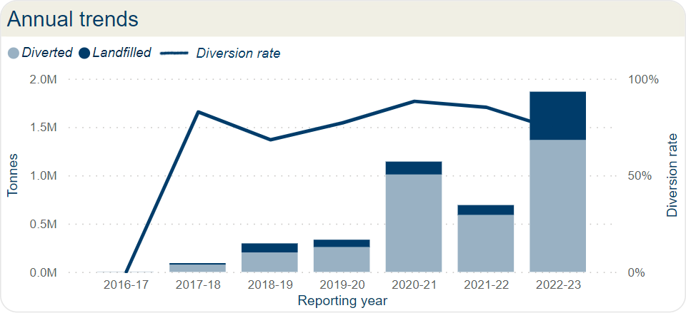
Figure 1: Annual trends.
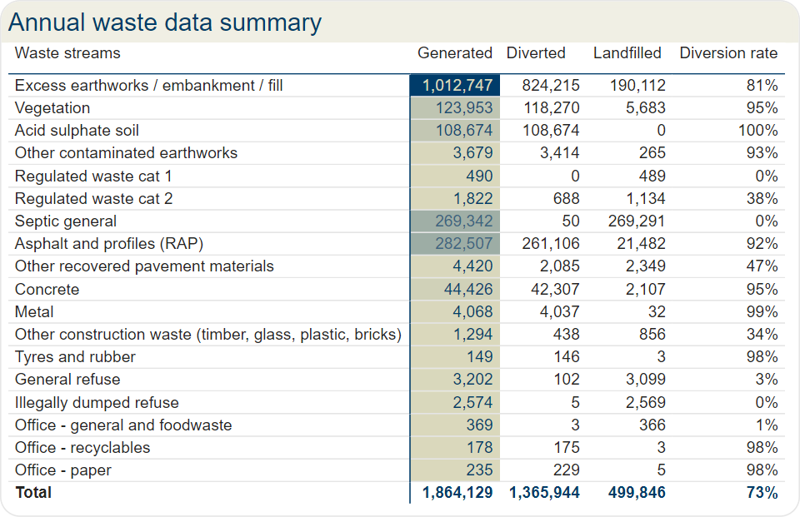
Table 1: Annual TMR Waste Data Summary 2022–2023 (highlighted are quantities).

Introduction
TMR is a large, complex, diverse, and decentralised organisation, responsible for the management of different modes of transport including motor vehicle, rail, bus, bike, pedestrian, personal mobility devices and boating. TMR operations include the construction and maintenance of linear transport infrastructure, transport and office facilities, public rest areas, and customer service centres all of which generate a wide variety of waste streams due to the diversity and scale of operations.
The Queensland Government has a vision to become a zero-waste organisation, where waste is avoided, reused, and recycled to the greatest extent possible. The 2020 Waste Management and Resource Recovery Strategy (WMRRS) released by the Department of Environment and Science identifies strategic targets that support this vision.
Queensland’s Waste Reduction and Recycling Act 2011 also imposes a requirement on each Queensland Government department to develop a Waste Reduction and Recycling Plan and to report on waste management achievements.

Targets
The WMRRS identifies four main destinations for waste: landfill, recycling, reuse, and energy recovery. Waste diversion is a measure of waste that is not sent to landfill and includes waste that is sent for recycling, reused, or is used for energy recovery. As TMR does not direct any waste to energy recovery, waste diversion in this report only includes materials that are recycled or reused.
The WMRRS identifies waste diversion targets and recycling rate targets. Recycling rate targets are based on materials that are recycled or reused. For TMR, waste diversion targets and recycling rate targets measure the same thing as waste can only be diverted from landfill by either recycling or reusing it. As most waste in TMR is generated from construction and demolition activities, TMR has adopted the waste diversion targets for construction and demolition as described in the WMRRS.
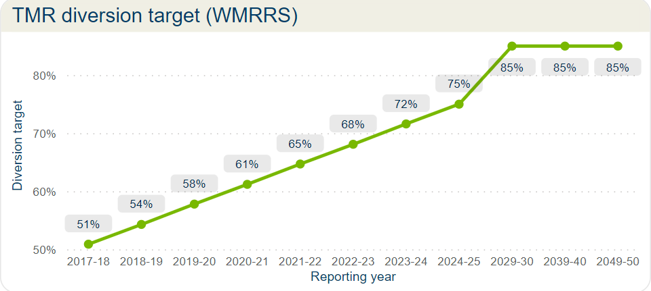
Figure 2: TMR diversion target (WMRRS).

Waste reporting
The following are highlights of the waste data from TMR for 2022–2023. The 2022–2023 year was the largest mass of waste reported since the reporting commenced in 2017. This is due to the number of projects reaching practical completion when there is a contractual reporting requirement, and a lot of these projects’ duration has been over a few years.
The illegally dumped refuse waste stream encapsulates the roadside litter and War on Wrecks (WOW) program. The WOW program is the collection of derelict and illegally dumped vessels from Queensland waterways. Roadside litter includes rubbish from rest stops and rubbish that is left on TMR land and construction sites. The amount of illegal waste roadside litter has increased, and WOW has decreased from previous years.
As TMR's work is civil, most of its waste is generated by the removal and construction of roads, with the addition of septic, due to the amount of temporary septic systems set up on projects and removed by contractors.
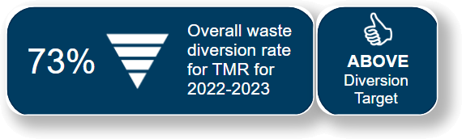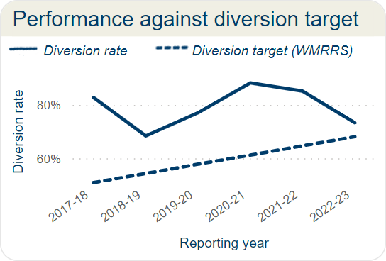Figure 3: Performance against diversion target. | 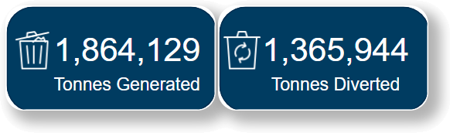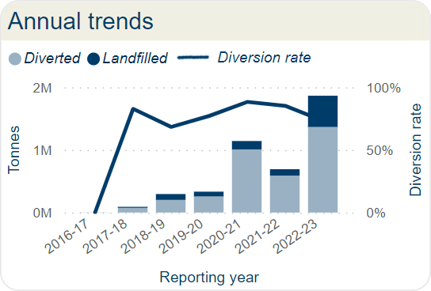 Figure 4: Annual trends.

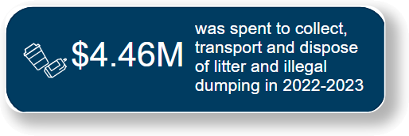  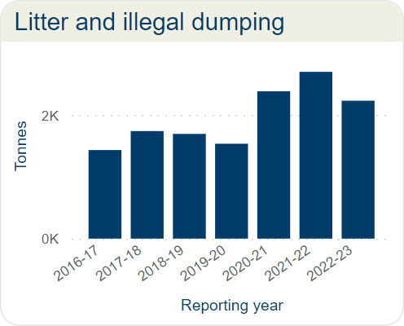  Figure 5: Litter and illegal dumping. | 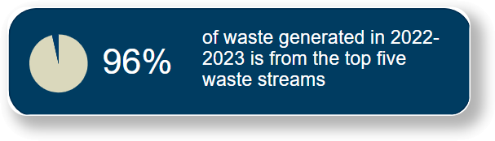  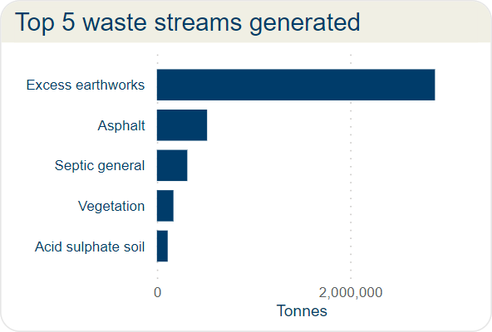  Figure 6: Top 5 waste streams generated.
The overall decrease in the waste diversion rate in 2022–2033 (compared to 2021–2022) is mostly due to a reduction in the diversion rate of excess earthworks. Excess earthworks, including embankment and fill, is the dirt that is removed from site and not required for the construction of the road. In 2021–2022, the diversion rate for excess earthworks was 94 per cent but this dropped to 81 per cent in 2022–2023. There was an increase in the contracts reporting in 2022–2023 so the excess earthworks diversion rate is more representative of the current diversion rate for this waste stream.
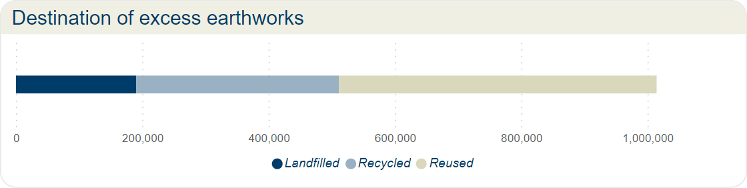
Figure 7: Destination of excess earthworks/embarkment/fill.
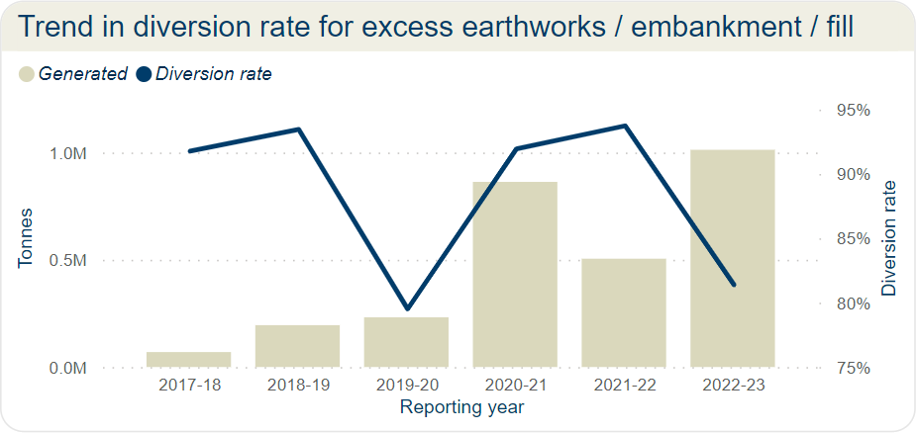
Figure 8: Trend in diversion rate for excess earthworks/embarkment/fill.
Case study 1: eMesh used on the Edmonton to Gordonvale project  TMR pioneered an Australian-first method to reduce raw material consumption that was developed with the project's concrete supplier for the Edmonton to Gordonvale project.  The project involved the construction of more than 10 kilometres of concrete pavements for cycleways, footpaths, and shared paths using a concrete extruding slipform paver with a custom mould, and a 100 per cent recycled plastic fibre reinforcement product called eMesh.  The slipform paver was used to mechanically place the concrete during pavement construction, reducing project construction times and lowering greenhouse gas footprints. This innovation resulted in a reduction of raw material consumption, significantly increased productivity, enhanced personnel safety, and supported waste repurposing.  The eMesh product aligns with circular economy principles, repurposing waste into new products, diverting waste from landfills, and strengthening the market for sustainable materials.  For more information visit: www.tmr.qld.gov.au/projects/bruce-highway-cairns-southern-access-corridor-stage-3-edmonton-to-gordonvale  Image: Aerial view of the E2G project site where eMesh was used. © The State of Queensland. | 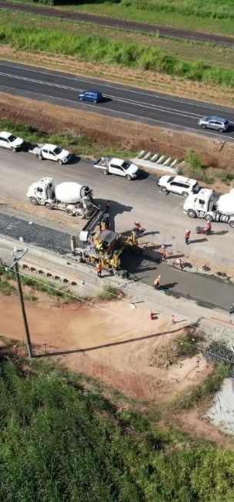

Waste reuse and recycling
An objective of TMR's Waste 2 Resource Strategy is to support the circular economy, and this can be achieved by directing suitable wastes for reuse and recycling. A waste is reused when no additional processing (other than transporting) is required for it to be productively used again. An example of this is directing excess earthworks from one project to another that needs fill material. A waste is recycled when some processing is required to make it into a usable product, for example crushing concrete to supplement road base materials.
The following are highlights of the waste that was generated by TMR in 2022–2023 and either reused or recycled. Reuse and recycling are more common along the coastal regions of Queensland due to the current distribution of licenced recycling facilities.
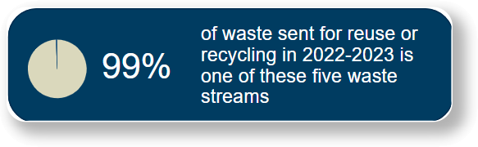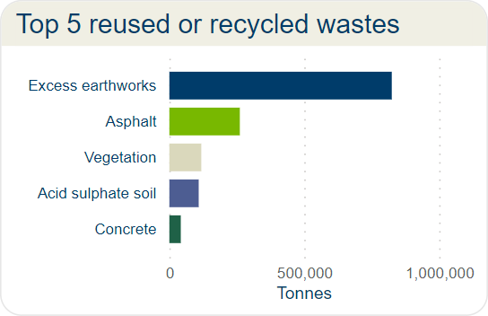  Figure 9: Top 5 reused or recycled wastes. | 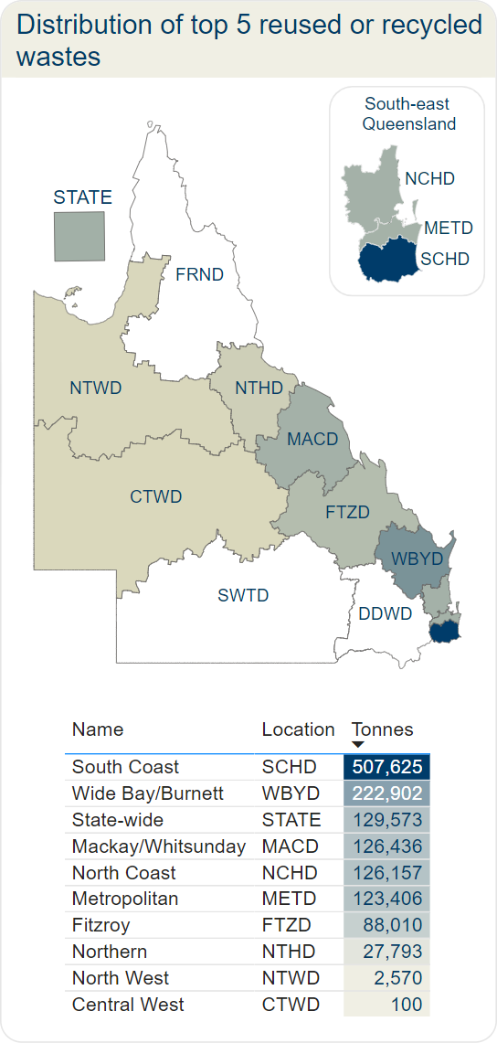  Figure 11: Top 5 reused or recycled wastes.
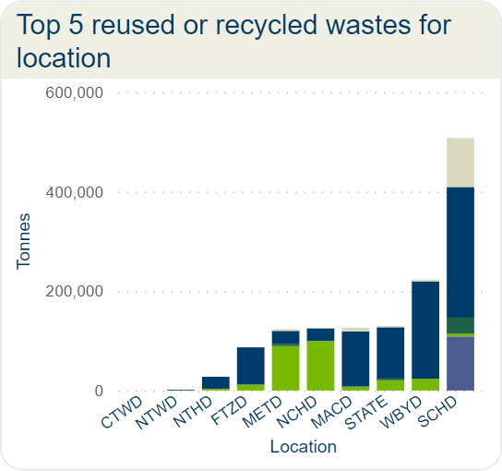
Figure 10: Reused or recycled wastes.

Table 2: Top 5 reused or recycled wastes for location.
Location | Acid Sulphate Soil  (tonnes) | Asphalt  (tonnes) | Concrete  (tonnes) | Excess Earthworks  (tonnes) | Vegetation  (tonnes)
CTWD |  |  |  | 100
FTZD |  | 12,000 | 10 | 75,000 | 1,000
MACD |  | 7,358 | 920 | 110,658 | 7,500
METD |  | 89,426 | 4,698 | 25,768 | 3,514
NCHD |  | 99,401 | 422 | 25,190 | 1,144
NTHD |  | 3,242 | 432 | 24,110 | 9
NTWD |  |  |  | 1,652 | 918
SCHD | 108,674 | 5,341 | 2,534 | 262,612 | 98,464
STATE |  | 20,849 | 3,291 | 103,112 | 2,321
WBYD |  | 23,489 |  | 196,013 | 3,400
Total | 108,674 | 261,106 | 42,307 | 824,215 | 118,270

Case study 2: Varsity Lakes to Burleigh (VL2B)
The project is part of the upgrade to the Pacific Motorway (M1) in the South Coast Region. As the project undertook an Infrastructure Sustainability Assessment (part of the IS Rating Scheme of the Infrastructure Sustainability Council), it had a focus on tracking and minimising waste going to landfill.
During the construction all waste streams were tracked monthly and input into the VL2B Waste Register. The aim was to utilise suitably qualified and experienced waste subcontractors to provide collection points, transport, sorting, disposal, recycling, and reuse/resource recovery options for all waste streams generated on the project.
The project generated approximately 30,000T of concrete which was partially processed on site before being taken for recycling (as shown in the images below from the project site). Overall, the project was able to achieve an outstanding result of more than 99 per cent diversion of wastes from landfill.
For more information visit:
www.tmr.qld.gov.au/projects/pacific-motorway-m1-varsity-lakes-to-burleigh
Images: Pictures taken on the VL2B project site. © The State of Queensland.
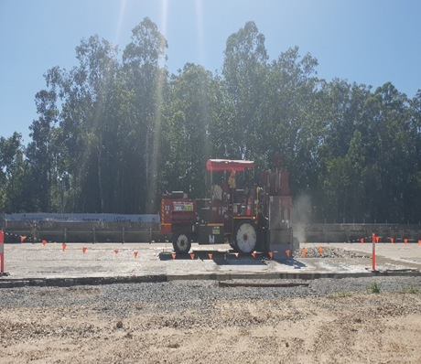 | 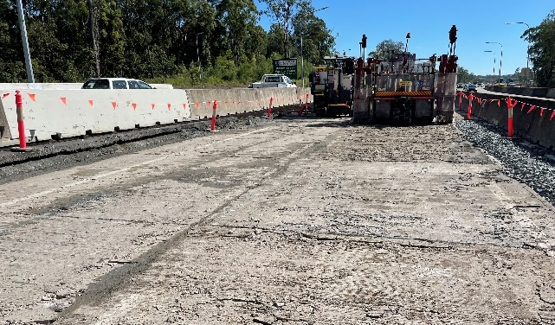

Using recycled materials
In addition to collecting information on the destination of wastes that are generated, TMR collects information on the recycled materials that are used to construct infrastructure. TMR prefers to use recycled materials on transport infrastructure projects, and this is discussed more in the ‘Waste 2 Resource Strategy Implementation’ section (from page 11).
The use of recycled materials is more common in South-east Queensland due to the concentration of recycled material suppliers. In-situ materials, or material that are already available on site, and recovered pavement material, are the most used recycled materials in 2022–2023. The Mackay/Whitsunday District reported the highest use of recycled materials, and this is highlighted in the May Downs Road, pave and seal project case study on page 10.
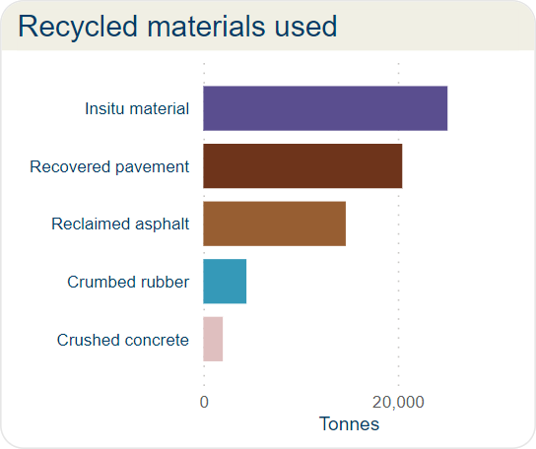  Figure 13: Recycled materials used. | 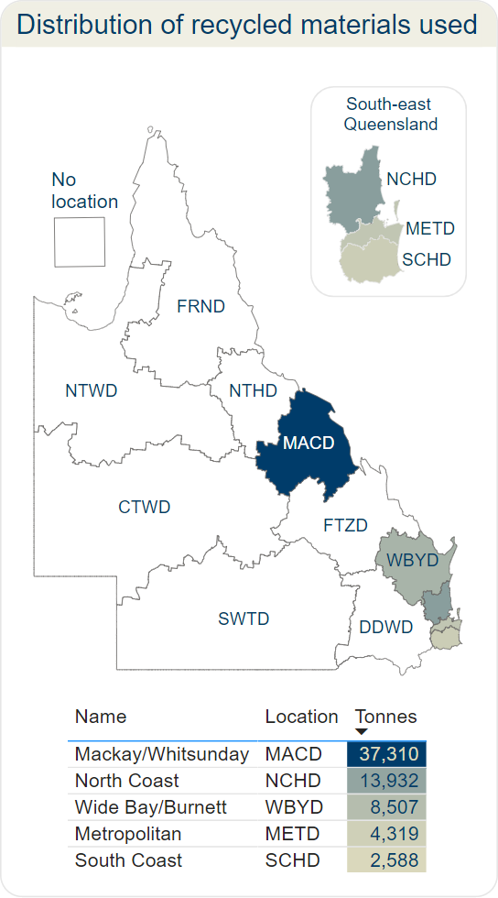  Figure 15: Distribution of recycled materials used.
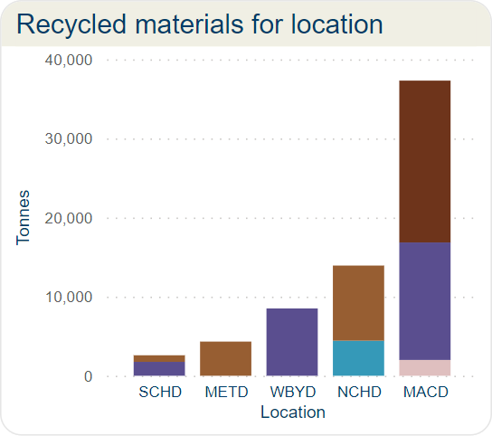
Figure 14: Recycled materials for location.

Table 3: Recycled materials used for location.
Location | Crumbed rubber  (tonnes) | Crushed concrete  (tonnes) | In situ material  (tonnes) | Reclaimed asphalt  (tonnes) | Recovered pavement  (tonnes)
MACD |  | 2,000 | 14,850 |  | 20,460
METD |  |  |  | 4,319
NCHD | 4,432 |  |  | 9,500
SCHD |  |  | 1,760 | 829
WBYD |  |  | 8,507
Total | 4,432 | 2,000 | 25,117 | 14,648 | 20,460

Case study 3: May Downs Road, pave and seal project
The May Downs Road, pave and seal project undertaken in Central Queensland Region incorporated an alternative pavement design developed in consultation with the Department of Transport and Main Roads, Cooper McCullough Group, Isaac Regional Council and GBA Consulting Engineers. The project commenced in August 2022 and was completed in April 2023.
The revised pavement design and construction methodology included a combination of materials such as in-situ materials, quarried products, and recycled sources which in turn supplied the project with environmental and commercial savings while still conforming to MRTS Quality System Requirements and other Technical Specifications.
The project utilised 20,460T of recovered pavement, 14,850T of in-situ materials, and 2000T of crushed concrete.
For more information visit:
www.tmr.qld.gov.au/projects/may-downs-road-pave-and-seal
Images (left to right): Placement of subgrade material on the May Downs Road, pave and seal project and the completed project. © Cooper McCullough Group.
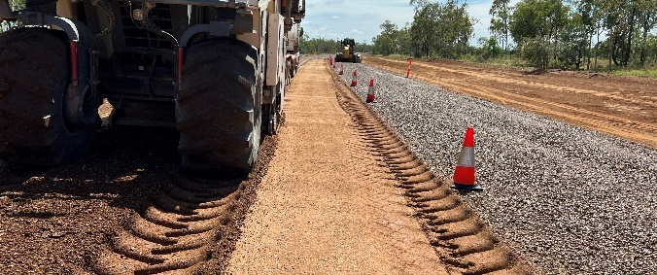 | 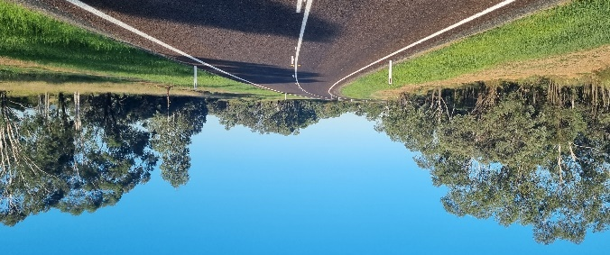

Case study 4: ‘Big Jack’ Sarawak Avenue and Currumbin Creek Road bridges
There has also been a lot happening in our South Coast Region when it comes to recycling and reusing. 'Big Jack' – a specialist demolition machine – demolished the 270T Sarawak Avenue and Currumbin Creek Road bridges (that’s 570T in total!).
The concrete from each bridge was crushed into smaller pieces to be used as a base course for future roads built throughout Queensland. Pay a thought when you’re next driving on a newly constructed road as you may just be driving over a bridge from the South Coast.
This is proof that TMR is looking for many opportunities to recycle and will give a new life to old materials. The recently demolished Sarawak Avenue and Currumbin Creek Road bridges are just one example of how the department is reusing and recycling materials to provide benefits for many years to come.
For more information visit:
www.tmr.qld.gov.au/projects/pacific-motorway-m1-palm-beach-nineteenth-avenue-to-tugun
Images (left to right): ‘Big Jack’ demolishing the Currumbin Creek Road Bridge and an aerial view of ‘Big Jack’ having a rest on site during the demolition of the Sarawak Avenue Bridge. © The State of Queensland.
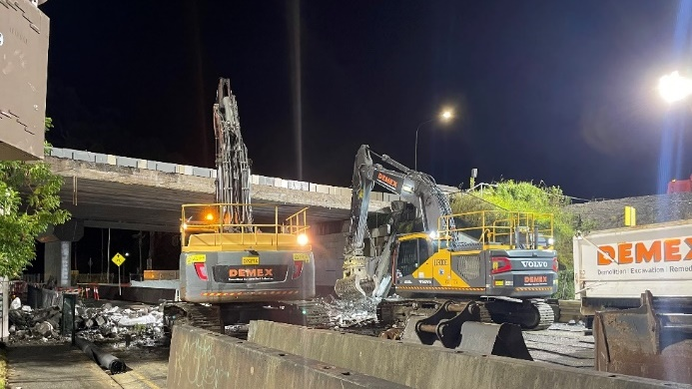 | 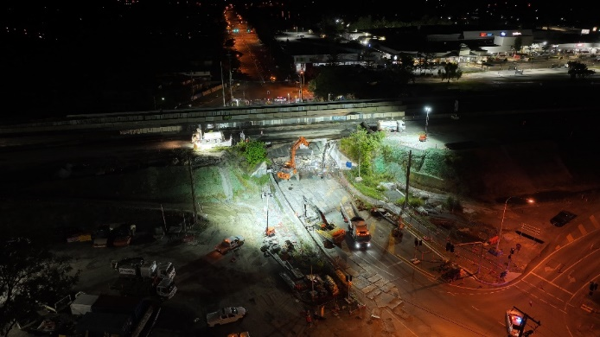

W2R Strategy implementation
TMR's current Waste Reduction and Recycling Plan, the Waste 2 Resource (W2R) Strategy, was published in 2022 and sets out the strategy for TMR to reduce waste and monitor waste generation and diversion from landfill. Previous actions to support the strategy include the publication of the TMR waste 2 resource calculator, and a requirement for tenderers on transport infrastructure contracts to submit the Tender Schedule S12 - Waste to Resource Plan.
Actions during 2022–2023 have been focused on supporting the implementation of these previous actions and monitoring the results. Consistent with previous years, the main source of waste from TMR operations was contract waste from infrastructure projects. A process for internal reporting on the Contract Waste data submission was implemented during 2022–2023 and this has resulted in an increase in the number of transport infrastructure contracts contributing data to the annual status report.
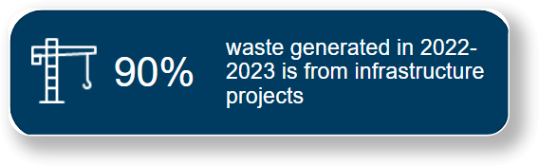  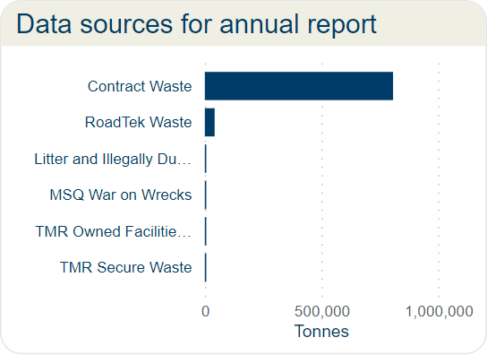  Figure 16: Data sources for annual report. | 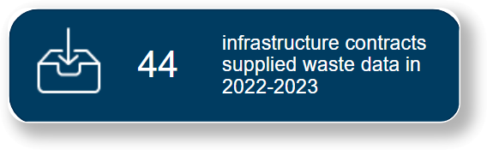  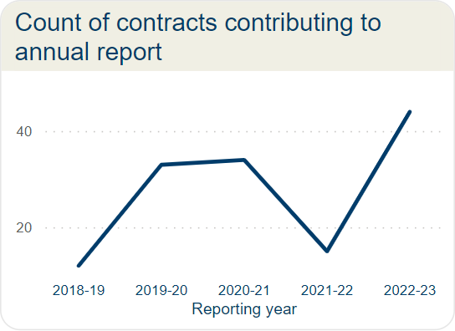  Figure 17: Count of contracts contributing to annual report.
TMR’s Waste 2 Resource Strategy addresses opportunities for greater uptake of recycled materials in infrastructure projects and circular economy principles. The Waste 2 Resource Strategy does not mandate the use of recycled materials but instead clearly states that TMR prefers the use of recycled materials on transport infrastructure projects where they are:
- permitted in accordance with TMR’s technical specifications
- cost competitive with conventional materials
- available in quantities required for the specific project.
As part of the actions under the current Waste 2 Resource Strategy, TMR has continued to use the National Asset Centre of Excellence (NACOE) Program, a collaborative research agreement with the Australian Road Research Board, to conduct research and development on use of recycled materials in infrastructure.
Considerable work has been undertaken to:
- test and verify the feasible use of alternative recycled materials within pavements structures and earthworks
- understand emissions profiles of the use of innovative pavement materials
- quantify the sustainability of pavement materials.
The following case studies provide more information about three current projects. There is a full list of all NACOE projects that contribute to the Waste 2 Resource Strategy in Appendix A (from page 15).

Case study 5: Recycled materials in earthworks
– NACOE O25
TMR are conducting extensive testing on recycled materials to provide the industry with confidence in recycled materials.
This project is part of a multi-year project to explore the safe and sustainable use of recycled materials in earthworks and drainage including recycled crushed glass, recycled crushed concrete, Reclaimed Asphalt Pavement (RAP) materials that are not suitable for reuse in asphalt, and coal combustion by-products. These recycled and by-product materials may be able to replace virgin and naturally occurring materials.
The project is investigating the potential use of recycled materials for road embankment and drainage. This research has included literature reviews and benchmarking to other Australian state transport agencies and selected international road agency requirements regarding the use of recycled products in these road construction applications. Several potential uses have been identified and future years of the project will include additional testing and calibration as part of field trials.

Case study 6: Recycled material supplier database
– NACOE O28
Lack of awareness about allowable uses for recycled materials and suppliers has been identified as a barrier to the uptake of recycled materials. This project is a multi-year project to develop a dashboard of statewide recycled material suppliers to support the use of local recycled materials in road projects across Queensland.
The purpose of this project is to raise awareness and promote the recycling industry to facilitate increased use of recycled products on TMR projects. Under TMR’s Building Sustainable Roads initiative and the Waste 2 Resource Strategy, TMR prefers recycled material in many of its construction activities. Also under the strategy, contractors are required to report what recycled materials will be used on a project through the W2R Tender Schedule.
This dashboard will align with the W2R tender schedule and will provide information about the location of recycled materials suppliers and will assist project teams and contractors to identify how and where to source these materials. Ultimately, this will facilitate market growth of recycled materials.

Case study 7: Sustainability Assessment Tool for Pavements (SAT4P)  – NACOE P117  This project is being undertaken in partnership with Western Australia’s Road Research Innovation Program and will facilitate more sustainable methods and materials in road construction. This is a multi-year project to develop an online SAT4P tool to assess the cost and emissions using recycled materials.  This project builds on the case studies in NACOE P106 that showed that many innovative and recycled materials can provide both cost and emissions savings to TMR projects.  It is anticipated that the SATP tool will contribute to TMR and its road research and its project partners better quantifying and comparing pavement options and will:  - improve capability in assessing sustainability impacts of innovative pavement designs and technology  - inform improved pavement designs, leading to better long-term investment decision-making  - contribute to emissions reductions decision-making  - give confidence for cost savings and improved pavement performance  - inform to promote technologies for increased recycling and reduced landfill to support circular economy goals and recycling industry viability.  Image: Sealing works of pavement on Blackall-Jericho Road, 2019. © The State of Queensland. | 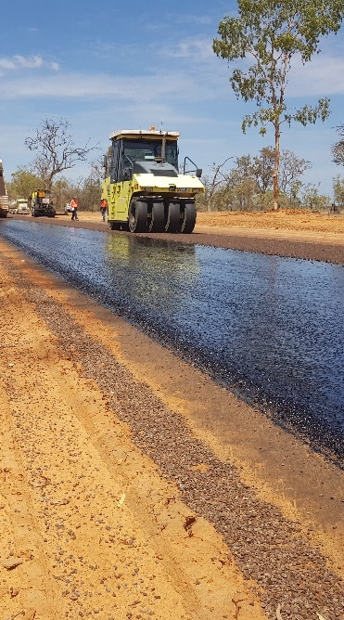

Appendix A: Department of Environment and Science State Entity Reporting Template
State Entity Waste Reporting 2023
- Name of the State Entity
Department of Transport and Main Roads

- Please list the types and amounts of waste generated, recycled or disposed of by your department/agency in carrying out its activities during 2022–23.

A summary of the combined TMR waste amounts from all sources is provided in Table 4. The table identifies the amounts generated, diverted (reused and recycled combined) and disposed to landfill. The summarising diversion rate is the amount diverted from landfill as a percentage of the amount generated by waste stream.
Table 4: Annual TMR waste data summary 2022–2023.
Waste stream | Generated (t) | Diverted (t) | Landfilled (t) | Diversion rate
Excess earthworks/embankment/fill | 1,012,747 | 824,215 | 190,112 | 81%
Vegetation | 123,953 | 118,270 | 5,683 | 95%
Acid Sulphate Soil | 108,674 | 108,674 | 0 | 100%
Other contaminated earthworks | 3,679 | 3,414 | 265 | 93%
Regulated waste cat 1 | 490 | 0 | 489 | 0%
Regulated waste cat 2 | 1,822 | 688 | 1,134 | 38%
Septic general | 269,342 | 50 | 269,291 | 0%
Asphalt and profiles (RAP) | 282,507 | 261,106 | 21,482 | 92%
Other recovered pavement materials | 4,420 | 2,085 | 2,349 | 47%
Concrete | 44,426 | 42,307 | 2,107 | 95%
Metal | 4,068 | 4,037 | 32 | 99%
Other construction waste (timber, glass, plastic, bricks) | 1,294 | 438 | 856 | 34%
Tyres and rubber | 149 | 146 | 3 | 98%
General refuse | 3,202 | 102 | 3,099 | 3%
Illegally dumped refuse | 2,574 | 5 | 2,569 | 0%
Office - general and food waste | 369 | 3 | 366 | 1%
Office - recyclables | 178 | 175 | 3 | 98%
Office - paper | 235 | 229 | 5 | 98%

Table 5 (page 16) describes how TMR’s waste streams align with the Department of Environment and Science waste classification.

Table 5: TMR waste stream descriptions.
General waste | TMR waste streams | Description
Office waste | Office – recyclables | Mixed recyclables including plastic plates, bottles, aluminium cans etc.
 | Office – paper | Paper and cardboard recyclable waste.
Construction and demolition waste | Excess earthworks/ embankment/fill | Any excess earthworks, embankment or fill generated by a project which is then exported outside the project boundary for either reuse, recycle or landfill beyond the project boundary.
 | Other contaminated Earthworks | Any other contaminated earthworks, but not acid sulphate soils.
 | Asphalt and profiles (RAP) | Asphalt only (not chip seals and other pavements).
 | Other recovered pavement materials | Spray seal pavements, stabilised pavements (not asphalt).
 | Concrete | Structural concrete, shotcrete, hardened grout, concrete washout.
 | Metal | Signposts, guardrails etc.
 | Other construction waste (timber, glass, plastic, bricks) | Any construction waste not accounted for in other construction waste categories, such as uncontaminated timber, glass, plastic and bricks).
 | Acid Sulphate Soil | Acid Sulphate Soils.
 | General refuse | Cardboard, plastic packaging.
Green waste (land clearance, parks and gardens) | Vegetation | Timber vegetation, stripped grasses etc.
Food waste (kitchen waste) | Office – General and food waste | Putrescibles, kitchen waste, non-recyclable packaging.
Mechanical/workshop waste | Tyres and rubber | Waste tyres.
E-waste | Regulated waste cat 2 | N/A
Clinical wastes | N/A | N/A
Chemical wastes | Regulated waste cat 1 | Regulated waste is category 1 regulated waste if it meets the requirements of section 43 of the EP Regulation.
 | Regulated waste cat 2 | Regulated waste is category 2 regulated waste if it is not category 1 regulated waste.
Sewage | Septic general | Septic waste generated by projects.
Litter or illegally dumped waste | Illegally dumped refuse | Waste collected from road reserve.

- Please list actions taken by your department/agency to reduce the amount of waste generated during 2022–23.

In the 2022–2023 period, TMR monitored the success of previously identified strategies to reduce waste generation. Previous strategies have included the use of the Waste and Recycling Calculator during the development phase of projects to identify potential waste streams and determine management strategies to minimise or divert waste from landfill. Additional strategies have included the requirement for large projects to have a Sustainability Assessment.

Case study 2 (page 8) is an example of the success of these strategies.

- Please discuss actions taken by your department/service to recover, and re-use or recycle waste during 2022–23.

In the 2022–2023 period, TMR has monitored the success of previously identified strategies to increase diversion rates and increase the use of recycled materials on infrastructure projects. Previous strategies have included the Waste and Recycling Calculator and Tender Schedule S12.

There has been ongoing communication with industry regarding these initiatives with information being provided at the following events:

- Local Authority Waste Management Action Committee meeting
- Tyre Stewardship Australia workshop
- TMR Consultant Industry Association Group meeting
- Engineers Australia Southern Regional Forum
- Civil Contractors Federation Sustainability Committee meeting.

Overall, the feedback from these events is that the changes to TMR specifications to increase the use of recycled materials are not well known and that further work is needed to increase industry awareness that TMR supports the use of recycled materials where they are:

- permitted in accordance with TMR’s technical specifications
- cost competitive with conventional materials
- available in quantities applicable to the specific project.

- Please discuss actions taken by your department/agency to increase the use of recycled materials during 2022–23.

TMR has continued to use the National Asset Centre of Excellence (NACOE) Program, a collaborative research agreement with the Australian Road Research Board, to conduct research and development on use of recycled materials in infrastructure. The NACOE projects often support multiple strategic objectives and the following projects have been identified as supporting the Waste 2 Resource Strategy:

- P43 – Long Term Pavement Performance Project
- P111 – Improved Crumb Rubber Modified Binder Sprayed Sealing Practices
- P135 – Optimisation of quarried/recycled pavement material blends
- P159 – Strategy, research program, implementation plan, resource planning for the full-scale APT testing
- P162 – Accurate binder content determination of crumb rubber asphalt mixes (and potentially metal content testing)
- P163 – Performance assessment of selected LTPP sites
- P166 – Synthesis and dissemination of research findings and implementation concepts for pavements and sustainability
- S67 – Future availability of fly ash for concrete production in Queensland
- S73 – Sustainability for structures
- P117 – Sustainability Assessment Tool – Joint Project with MRWA
- O24 – Recycle materials in stabilisation
- O25 – Use of recycled materials in earthworks and drainage
- O28 – Recycled materials supplier database
- O31 – Regulated waste reduction through recycling paint wash water and raised pavement markers (RPMs)
- O38 – Decarbonised Construction
- O37– Railway Ballast recycling (joint project with Queensland Rail).

There are case studies for P117, O25 and O28 in the W2R Strategy implementation section of this report (page 13).

- Please discuss progress made by your department/agency in relation to its waste and recycling performance indicators during 2022–23.

The focus for 2022–2023 has been to improve data collection and analysis to support the other strategy pillars in the TMR Waste to Resource Plan. A process for internal reporting on the Contract Waste data submission was implemented during 2022–2023 as contract waste represents the primary source of waste data for TMR. Increased visibility of transport infrastructure contracts that were anticipated to submit waste data and contracts that had submitted waste data has resulted in an increase in the contract waste reported for the period. There were 44 contracts reported in 2022–2023 compared to 15 contracts reported in 2021–2022.There is ongoing work to raise awareness of the use of contract waste data to ensure that this improvement can be maintained.

- Please discuss the ways in which your department/agency has contributed towards achieving the goals and targets under Queensland's waste management strategy during 2022–23.

The performance against the targets in the Queensland's waste management strategy are shown in Table 6. There has been a reduction in the diversion rate compared to the last reporting year, but the diversion rate continues to be above the diversion target. TMR has adopted the waste diversion targets for construction and demolition waste as described in 2020 Waste Management and Resource Recovery Strategy.
Table 6: Annual trend – diversion rate and diversion target.
Reporting year | 2017-2018 | 2018-2019 | 2019-2020 | 2020-2021 | 2021-2022 | 2022-2023
Diversion rate | 83% | 68% | 77% | 88% | 85% | 73%
Diversion target (WRRS) | 50.90% | 54.30% | 57.80% | 61.20% | 64.70% | 68.10%

A diversion rate of more than 80 per cent has been achieved for the following waste streams:
- excess earthworks/embankment/fill
- vegetation
- acid sulphate soil
- other contaminated earthworks
- asphalt and profiles (RAP)
- concrete
- metal
- tyres and rubber
- office – recyclables
- office – paper.

The total waste generated by TMR in 2022–2023 is 1,864,129 tonnes, of which 73 per cent was diverted (reused or recycled) and remaining 27 per cent was disposed to landfill.

There was a substantial increase of 1,172,035 tonnes of waste generated in 2022–2023 from that generated in 2021–2022. This is due to the increase in contract waste reported in this period. There were 44 contracts reported in 2022–2023 compared to 15 contracts reported in 2021–2022. Contract waste data is collected at the end of the contract and included in reporting in the year the waste data is supplied to TMR. There were several contracts included in the current report that had a duration of more than two (2) years. Therefore, the increase in waste generated is due to both an increase in contracts that have supplied data and increase in contract durations.

- Please list the amounts and types of litter or illegally dumped waste that were collected by your department/agency during 2022–23.

TMR regularly removes litter and illegally dumped items from the state-controlled road network. Included in this report are the following:

- The cost and amounts of rubbish collected from bins along the road, litter dumped along the road, and other waste that may be dumped adjacent to the road or on other land managed by TMR.
- Estimated weight of vessels removed from Queensland waterways by Maritime Safety Queensland or its compliance partners as part of the War on Wrecks (WoW) Program. Estimates are based on the length of the vessel. The costs have not been included as this information is not collected.
Table 7: Annual trend – litter and illegally dumped waste.
 | 2017-2018 | 2018-2019 | 2019-2020 | 2020-2021 | 2021-2022 | 2022-2023
Cost ($) | $5,670,602 | $5,770,248 | $4,636,566 | $4,116,861 | $4,479,020 | $4,456,698
Mass (tonnes) | 1,743 | 1,697 | 1,538 | 2,387 | 2,702 | 2,235

